Object Tracking in the Maritime Environment

Chun Wei Jie Benjamin
Nanyang Technological University
School of Computer Science and Engineering

Associate Professor Deepu Rajan
Nanyang Technological University
School of Computer Science and Engineering

Abstract - This paper aims to make use of DeepSORT to perform object tracking and compare that to other conventional object tracking algorithms. DeepSORT is an algorithm that makes use of Kalman filter to predict object motion across time and convolutional neural networks to calculate appearance descriptors to classify objects according to their appropriate classes. DeepSORT can track multiple objects due to these features. We used the metric Intersection Over Union (IOU) of bounding boxes produced by the algorithms and compared it to bounding boxes of the ground truth dataset. This metric allows us to measure the precision of the algorithm. However, this does not fully measure how well the algorithm is since we are missing the accuracy of associating objects across different frames.
Keywords – DeepSORT, Object Tracking, Intersection over Union, Pytorch, Multiple Object Tracking, Maritime Environment, Intersection over Union

1 Introduction
Computer Vision, specifically Object detection and tracking, is a heavily researched topic within the computing community and soon applications of it will soon be prevalent. Examples include autonomous ships which will make use of computer vision to stay clear of obstacles and also to steer the ship to its intended destination. Although there have been modern object detection and tracking algorithms developed for autonomous cars, there is a lack of research done in the maritime environment. Additionally, the modern algorithms might not be well suited for the maritime environment given that the video feed from the ship will be unstable relative to the ground and also there is a strong backdrop of light in the horizon, making it difficult to accurately detect and gauge distance of objects. This paper aims to test the accuracy of a well-known algorithm, DeepSORT, in the maritime environment and put it up against other modern algorithms for comparison using the Intersection over Union (IOU) metric. Note that this is an incomplete comparison between algorithms as we are still missing a metric for comparing the accuracy of tracking.

2 Deepsort
DeepSORT is an extension of SORT (Simple Real time Tracker). It makes use of concepts such as the Kalman Filter, Hungarian algorithm and the Deep Appearance Descriptor. These concepts are what makes DeepSORT well-suited for multi-object tracking and also for object tracking in unstable environments. In the complex problem of object tracking, we have broken it down into subproblems that DeepSORT solves. These problems are namely assignment/association problem. [5]

Fig 1 Illustration of components of DeepSORT

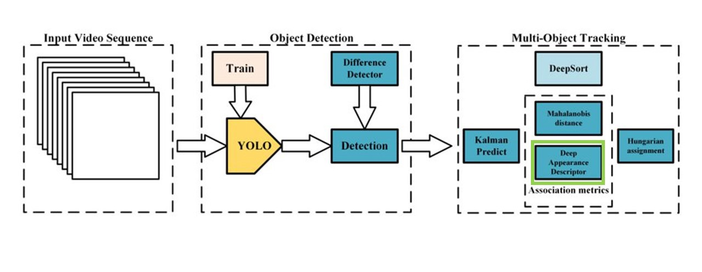[5]

2.1 Kalman filter
Kalman filtering is an algorithm that estimates the present values of variables, that might not be measurable for any reason, given the past measurements on the variable. This feature is especially useful in tackling the problem of occlusion where the tracked object is temporarily obstructed from camera view. It has relatively simple form and require small computational power yet produces the best compromise between measurement and prediction, making it a powerful tool for association of detections and tracked objects.

2.2 Hungarian algorithm
This algorithm is a well-known algorithm used for data association. It enables us to efficiently assign new ids to new objects and old ids to tracked objects. In other words, it could tell if an object in current frame is the same as the one in the previous frame. [3]

2.3 Deep Appearance descriptor
On top of using the Hungarian algorithm to efficiently associate tracks and objects, the deep appearance descriptor or appearance feature vector makes use of convolutional neural networks (CNN) to aid in classifying objects. Although the Hungarian Algorithm and the Kalman filter is able to efficiently assign tracks to objects, they are not enough when occlusion is involved, hence the need for an additional tool, the appearance descriptor which enables tracks to be associated to partially occluded objects which would otherwise have been unidentified. [6]

3 Methodology
We would like to investigate if the DeepSORT algorithm is well suited for the complex maritime environment. We will focus on the precision of the algorithm in identifying the bounding boxes of the objects tracked.

3.1 dataset and algorithms
The dataset we would like to use is the Singapore Maritime Dataset captured by Dilip K. Prasad and annotated by student volunteers. Videos in the dataset has been captured on various weather and visibility conditions from July 2015 to May 2016. This dataset is the only publicly available annotated video dataset of the maritime environment hence it is well-suited for this paper. [7]
The algorithms that we will be using are DeepSORT [12], and a multiple object tracker built which allows user to toggle between different types of trackers as they please. The types of trackers available include CentroidKF Tracker, Centroid Tracker and SORT. [13]

3.2 Intersection over union
In order to measure the precision of the algorithms detection of the object, we can use a well-known metric called the Intersection over Union (IOU). It is used to measure the extent of overlap between two bounding boxes, in this case we would be comparing the bounding box produced by the algorithms and the annotated bounding boxes from ground truth taken from the dataset. It is measured by find the area of intersection of two boxes divided by the area of union of the two boxes.
Figure 1 Formula for Intersection over Union (IOU) [11]
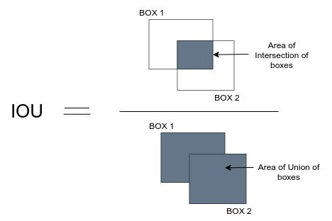

3.2 test implementation
I referenced online resources for implementation of DeepSORT and other tracking algorithms. [12] [13] The code was edited to incorporate the IOU tests. I chose to include the implement the reading of data from ground truth before the tracking begins and implemented the IOU calculation as each frame was tracked by the algorithm. All implemented algorithm had the same method of calculation of IOU.
There were both pytorch and keras implementations of the DeepSORT algorithm. However the keras implementation had bugs and unmaintained, hence the decision to use pytorch for the implementation. Also, to ensure consistency, pytorch was also selected for the implementation of the other tracking algorithms to compare against DeepSORT.

4 RESULTs and analysis
This table shows the results of the IOU testing done.

Table 1 IOU results for various tested algorithms
IOU Score
DeepSORT | 0.7073713046936371
CentroidKF Tracker | 0.6386580057437571
Centroid Tracker | 0.6223425624219343
SORT | 0.6432902156847292

Since the score is highest for DeepSORT, we can see that DeepSORT is the better algorithm in terms of precision of bounding boxes. But we also must note that this is only one metric to measure one component of object tracking. Data association accuracy, speed of algorithm are also important components of what makes a good object tracking algorithm. Just by running the individual programs, we can see a significant difference in time, which is inline with our initial hypothesis that the DeepSORT algorithm is well-suited for multiple object tracking in the maritime environment.
Linking back to why DeepSORT would be successful in real-time object tracking, it has been proven to have the speed and responsiveness to accurately and precisely detect objects in an unsteady environment without compromising on speed with the help of concepts such as Kalman filter which provides a simple yet efficient implementation of overcoming occlusion or uncertainty in an unstable environment.

5 Conclusion
In conclusion, we found that the DeepSORT algorithm is better than other common tracking algorithm in terms of precision measured using the IOU metric. Furthermore, it is fast and capable of handling real-time object tracking. Given its features, it would also be able to track objects well even with occlusion. All these features therefore make DeepSORT a very promising algorithm for object tracking in the maritime environment.
However, it should be noted that this paper does not measure and test other features of DeepSORT such as the accuracy of object association. These are the research gaps in this paper.

Acknowledgment
I would like to acknowledge the funding support from Nanyang Technological University – URECA Undergraduate Research Programme for this research project..
I would also like to extend my gratitude to my supervisor in charge, Associate Professor Deepu Rajan, for helping me with this project and answering my questions in a timely fashion as well as providing me with the resources I needed to get started and guiding me in the right direction for the project
.

References
- A. (2021, March 3). How to do multiple object tracking using opencv. Automatic Addison. Retrieved June 29, 2022, from https://automaticaddison.com/how-to-do-multiple-object-tracking-using-opencv/
- Bonn, D., Rosebrock, A., Farshad, AbuHelweh, H., Zuroske, T., Lode, Griffey, Zikopoulos, P., Tamoghna, Amm, Corentin, Reddy, M., Shraddha, Marcel, Oanh, TOUATI, M., Ll, Niko, Lgenzelis, … Mehmet. (2021, April 17). Fine-tuning with Keras and deep learning. PyImageSearch. Retrieved June 29, 2022, from https://www.pyimagesearch.com/2019/06/03/fine-tuning-with-keras-and-deep-learning/
- Cohen, J. (2021, August 3). Computer Vision for tracking. Medium. Retrieved June 29, 2022, from https://thinkautonomous.medium.com/computer-vision-for-tracking-8220759eee85
- Georgievski, B. (2020, November 17). Object detection and tracking in 2020. Medium. Retrieved June 29, 2022, from https://blog.netcetera.com/object-detection-and-tracking-in-2020-f10fb6ff9af3
- Kanjee, R. (2022, May 9). DeepSORT - deep learning applied to object tracking. Medium. Retrieved June 29, 2022, from https://medium.com/augmented-startups/deepsort-deep-learning-applied-to-object-tracking-924f59f99104
- Maiya, S. R. (2019). [https://nanonets.com/blog/object-tracking-deepsort/]. DeepSORT: Deep Learning to Track Custom Objects in a Video. Retrieved 2022, from https://nanonets.com/blog/object-tracking-deepsort/
- Mallick, S. (2021, May 5). Multitracker : Multiple Object Tracking using opencv (c++/python): LEARNOPENCV #. LearnOpenCV. Retrieved June 29, 2022, from https://learnopencv.com/multitracker-multiple-object-tracking-using-opencv-c-python/
- Mao, L., Rosebrock, A., Cagdas, Tom, Austin, Alex, Ata, Izak, Akhtar, T., Marco, Phil, Lionel, Dheeraj, Vinod, Thakur, R., Trinity, Luke, Wildan, C, M., … Abdullah, M. (2021, April 17). Tracking multiple objects with opencv. PyImageSearch. Retrieved June 29, 2022, from https://pyimagesearch.com/2018/08/06/tracking-multiple-objects-with-opencv/
- Prasad, D. K., Prasath, C. K., Rajan, D., Rachmawati, L., Rajabally, E., &amp; Quek, C. (2019). Object detection in a maritime environment: Performance evaluation of background subtraction methods. IEEE Transactions on Intelligent Transportation Systems, 20(5), 1787–1802. https://doi.org/10.1109/tits.2018.2836399
- Singapore maritime dataset. dilipprasad. (n.d.). Retrieved June 29, 2022, from https://sites.google.com/site/dilipprasad/home/singapore-maritime-dataset
- Subramanyam, V. S. (2021, January 28). IOU(intersection over union). Medium. Retrieved June 29, 2022, from https://medium.com/analytics-vidhya/iou-intersection-over-union-705a39e7acef
- theAIGuysCode. (n.d.). TheAIGuysCode/yolov4-deepsort: Object Tracking implemented with Yolov4, DeepSort, and tensorflow. GitHub. Retrieved June 29, 2022, from https://github.com/theAIGuysCode/yolov4-deepsort
- Welcome to multi-object Trackers in python's documentation!. Welcome to Multi-object trackers in Python's documentation! - Multi-object trackers in Python 1.0.0 documentation. (n.d.). Retrieved June 29, 2022, from https://adipandas.github.io/multi-object-tracker/

