**Twitter Data Insight Report**

## I collected data from 3 different sources:

## Udacity-given-csv file

1. Download data from an URL: <https://d17h27t6h515a5.cloudfront.net/topher/2017/August/599fd2ad_image-predictions/image-predictions.tsv>
2. Gather data from Twitter API

I removed unnecessary data and combined all data together into one file, so it will be easy for me to analyze. Here are 3 insights that I made:

## Insight 1:

**By looking at the graph below, I see that most tweets have one picture. There are 1780 tweets that are posted with one picture. There are 198 tweets with two pictures, 66 tweets with three pictures, and 31 tweets with three pictures. It’s easier to tweet with one picture, right?**

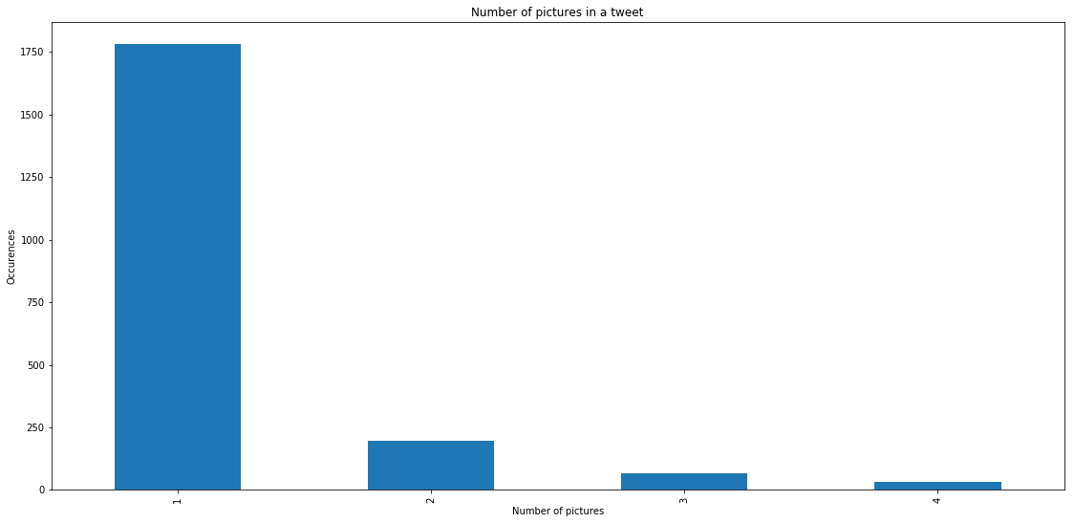

## Insight 2:

**By looking at the graph below, I see that favorite_count has positive correlation with retweet_count. It means that the more people favorite a tweet, the more people will retweet it. Moreover, there are some tweets has high retweet_count, but no favorite. That’s explained the vertical line at favorite count equal zero. However, I will ignore that vertical line. This graph tells me that a tweet with high favorite_count will have high retweet_count.**

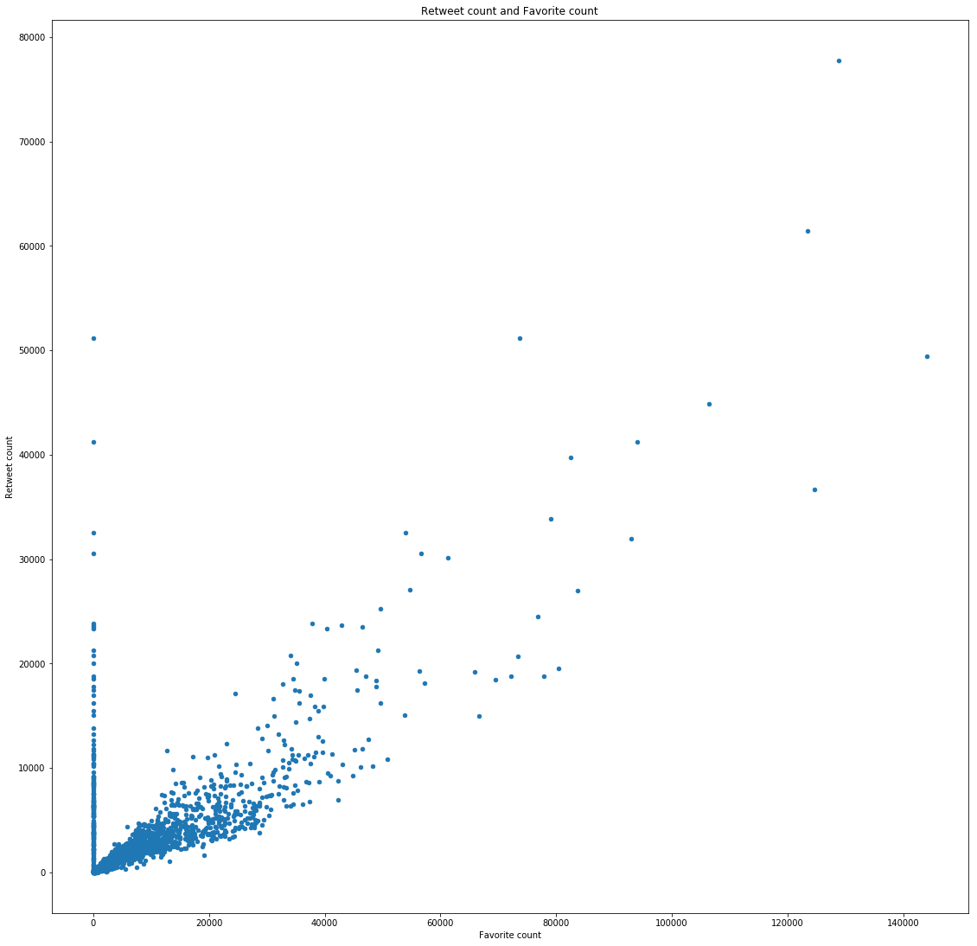

## Insight 3:

**By looking at the graph below, I see that people post their dogs at pupper stage the most.**

* pupper 245
* doggo 97
* puppo 29
* floofer 9

Pupper is younger dog. Most people and myself see that dogs are really cute when they are young. That’s why people tend to share pictures of younger dogs.

