B — Conception and organization
Project: Study Flashcard Bot — a conversational study assistant that quizzes and explains any subject the user types in.

1. Software architecture
The system is a classic 3-tier client-server architecture: a static frontend, a REST API backend, and two external dependencies (a local database and a remote LLM provider).
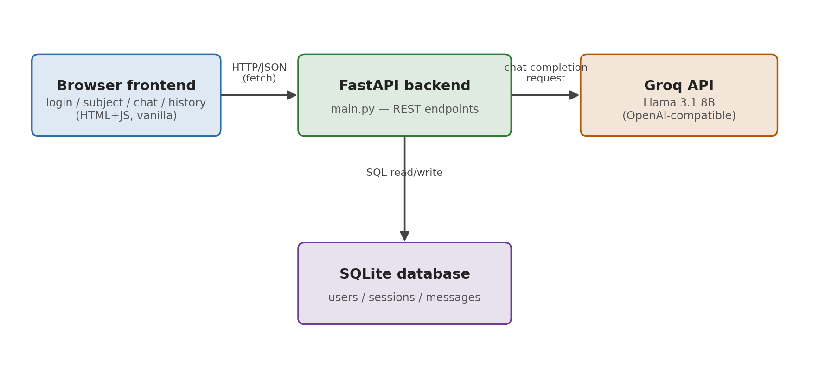
Figure 1 — System architecture
- Frontend: 4 plain HTML/JS/CSS pages, no framework, talking to the backend via fetch() calls.
- Backend: FastAPI, chosen for built-in request validation (Pydantic models) and automatic OpenAPI docs, useful for testing endpoints during development.
- Database: SQLite, accessed with raw SQL (no ORM) so every query is visible and explainable in the code walkthrough.
- LLM provider: Groq's OpenAI-compatible chat completions API, isolated in a single module (llm.py) so the model or provider can be swapped without touching the rest of the app.

2. Request flow: sending a chat message
The sequence below shows what happens end-to-end when a user sends one message, from the click in the browser to the bot's reply appearing on screen.
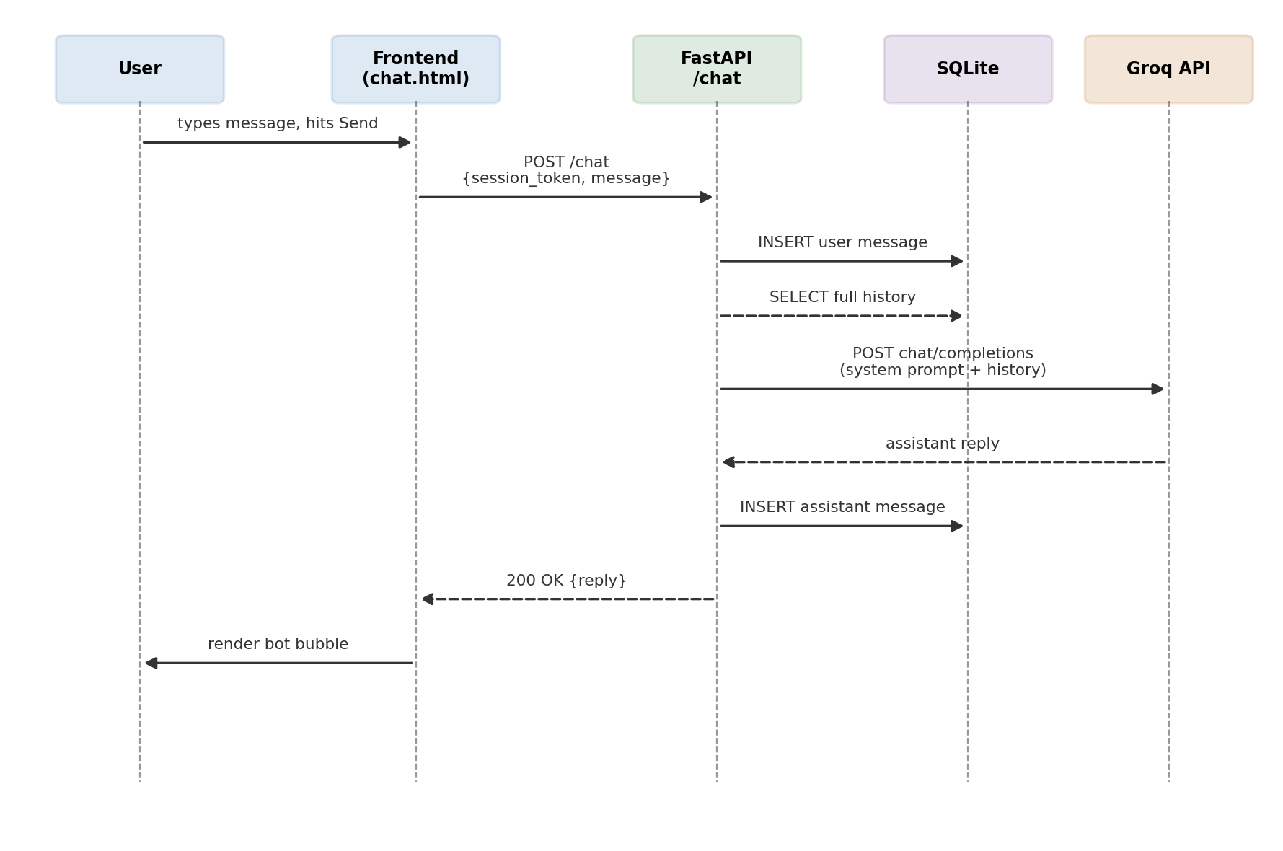
Figure 2 — Sequence diagram for POST /chat
Two design choices worth noting: the full message history is reloaded from the database on every request (rather than kept in memory) so the conversation survives a page refresh or server restart; and the subject is injected as a system prompt rather than appended to the user's message, so it can't be overridden by user input alone.

3. Database schema
Three tables, intentionally minimal: a user can have many study sessions (one per subject), and each session has many messages.
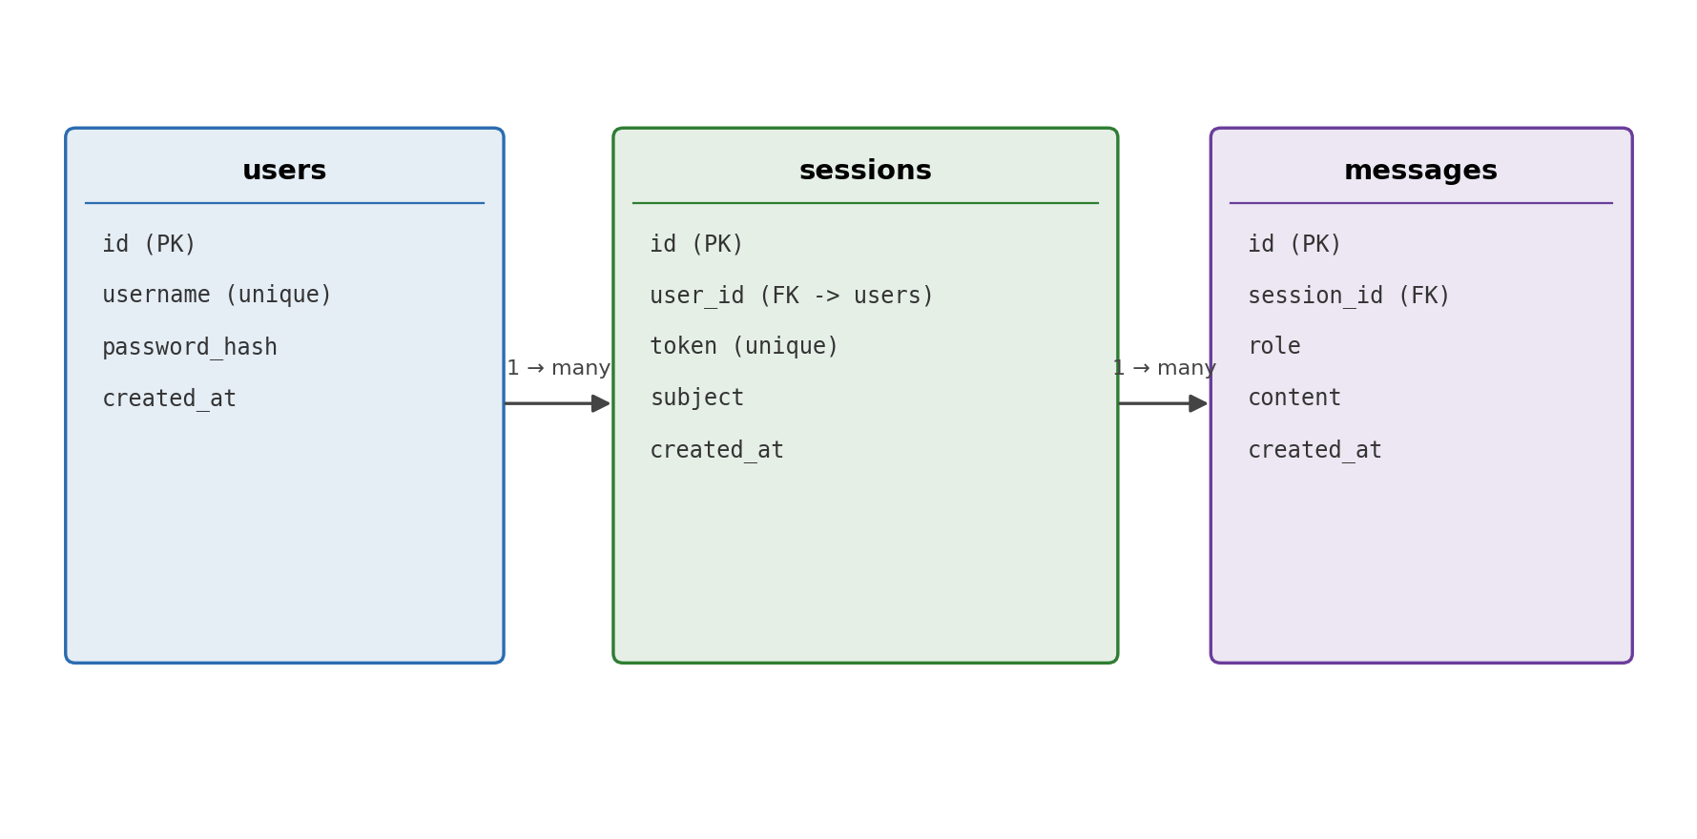
Figure 3 — Database schema (users / sessions / messages)

4. Task breakdown and tracking
Tasks were tracked as a running checklist (below), updated as the project progressed. Each task records its status, the key decision made while doing it, and the date completed — this doubles as the project's task-tracking tool for the rubric's organization criterion.
# | Task | Status | Key decision | Date
1 | Scope the project (full rubric vs. simplified Sem4 instructions) | Done | Defined MVP: auth + 1 LLM use case + min. 3 frontend pages | 23/06/2026
2 | Choose concept: study/flashcard chatbot, any subject | Done | Picked a conversational quiz/explain loop over a file-upload flashcard generator | 26/06/2026
3 | Design DB schema (users, sessions, messages) | Done | Chose token-based sessions over JWT for simplicity | 26/06/2026
4 | Build backend: auth, sessions, chat, history endpoints | Done | Raw SQL instead of an ORM, for transparency in the code walkthrough | 26/06/2026
5 | Integrate Groq API with subject-locked system prompt | Done | Isolated in llm.py so the provider can be swapped/benchmarked later | 26/06/2026
6 | Build frontend: login, subject picker, chat, history pages | Done | Plain HTML/JS chosen over React to keep the stack simple per instructions | 26/06/2026
7 | Manual end-to-end testing of all endpoints | Done | Found and fixed a process issue (server/curl needed to run in one shell session) and a UI toggle bug | 26/06/2026
8 | Write innovation research + A-innovation.docx | Done | Classified honestly as “Common” after competitor research, argued real differentiators instead | 26/06/2026
9 | Write conception/architecture doc (this document) | Done | — | 26/06/2026
10 | Write data privacy & security docs | To do | — | —
11 | Get real Groq API key and test live chat end-to-end | To do | — | —
12 | Record video presentation | To do | — | —

5. Self-organization feedback
What worked well:
- Scoping the MVP first (auth + 1 use case + minimal pages) before writing any code avoided over-building given the tight deadline.
- Testing each backend endpoint manually with curl immediately after generating it caught two real issues early (a process/testing mistake, and a frontend logic bug) rather than discovering them during the live demo.
- Isolating the LLM call in its own module made it easy to reason about and would make swapping providers for a benchmark straightforward if there's time.
What I would do differently with more time:
- Start the data privacy and security analysis earlier in parallel with backend development, since several design choices (e.g. plaintext message storage) were made for speed and should have been weighed against privacy concerns from the start, not after the fact.
- Set up the Groq API key and test the live chat endpoint before building the frontend, to catch any LLM integration issues earlier instead of leaving it as a final step.

