STM32 what to activate:
GROISNE Benjamin

Page 112
Reset and clock control (RCC):

Reset GPIO:
RCC_AHB1RSTR |= RCC_AHB1RSTR_GPIOBRST | RCC_AHB1RSTR_GPIOARST | RCC_AHB1RSTR_GPIOCRST

Reset USART2:
RCC_APB1RSTR|= RCC_APB1RSTR_USART2RST
Reset TIM:
RCC_APB1RSTR|=RCC_APB1RSTR_TIM2RST | RCC_APB1RSTR_TIM3RST | RCC_APB1RSTR_TIM4RST | RCC_APB1RSTR_TIM5RST

Reset TIM1:
RCC_APB2RSTR|=RCC_APB2RSTR_TIM1RST

Reset SYSCFGRST:
RCC_APB2RSTR|= RCC_APB2RSTR_SYSCFGRST
Reset ADC:
RCC_APB2RSTR|= RCC_APB2RSTR_ADCRST

ENABLING RCC

Enable GPIOA & GPIOB:
RCC_AHB1ENR|= RCC_AHB1ENR_GPIOBEN | RCC_AHB1ENR_GPIOAEN

Enable USART & TIM:
RCC_APB1ENR|= RCC_APB1ENR_USART2EN | RCC_APB1ENR_TIM2EN

Enable SYSCFGEN, ADC1EN:

RCC_APB2ENR|= RCC_APB2ENR_SYSCFGEN | RCC_APB2ENR_ADC1EN

Sleep MODE all already activated at reset:
gpio alr enable with reset value
Page 140

System configuration controller (SYSCFG)
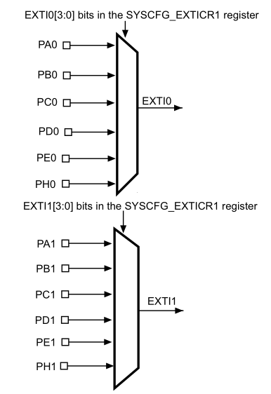

each EXTI has a range of PINS attributed.
EXTI0 will have the pins P[A-E]0 + PH0
so EXTIx will have the pins P[A-E]x + PHx
The role of SYSCFG_EXTICR[1-4] is to choose the letter for each EXTI

each EXTICR controls 4 exti
EXTICR1 contols EXTI0 to EXTI3.

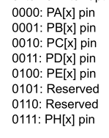
input EXTICR1 |= 11 to enable PD0 ,PD1 or PD2 or PD3

Page 158
GPIO CONFIG
USEFUL REGISTERS:
GPIOx_MODER (Input ; Output ; alternate ; analog)
Each 16 Pins will have one of those 3 modes

GPIOx_OTYPER (push-pull ; open-drain)

GPIOx_OSPEEDR (choose speed pretty simple

GPIOx_PUPDR (00:No pull-up, pull-down ;01:Pull-up ; 10:Pull-down)
00 means if button gives high tension we’ll have high tension same for low tension
01 means if button not pressed IDR will show 1 and 0 if pressed
10 reverse of 01 (not sure though )
GPIOx_IDR (all 15 pins, shows input state)
GPIOx_ODR (all 15 pins, shows output state)
GPIOx_BSRR (bits 0-15 set ODR to 1 if 1 ; bits 16-31 reset ODR bit to 0)

GPIOx_AFRL AFR[0](Pins 0-7 )
GPIOx_AFRH AFR[1](Pins 0-7 )
Each alternate function already has a predestined use (GPIO, USART, TIM)
no point in ODR and IDR if alternate function has been chosen. PUPDR still has utility though

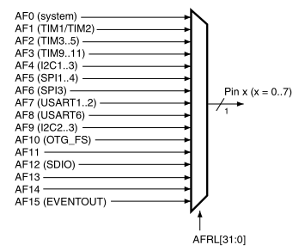

DMA SKIP
Page 202

Interrupts and Events

Nested vectored interrupt controller (NVIC)

The SysTick calibration value is fixed to 10500, which gives a reference time base of 1 ms
with the SysTick clock set to 10.5 MHz

NVIC_EnableIRQ(EXTI0_IRQn);

22 lines of events/ interrupt

lines 0-15 are for EXTI0-15
LINES 16-22 ARE FOR other things

EXTI registers:
EXTI_IMR Interrupt mask register
mask or unmask an interrupt from a line

(EXTI_EMR) Event mask register
mask or unmask an event from a line

(EXTI_RTSR) Rising trigger selection register
(EXTI_FTSR) Rising trigger selection register

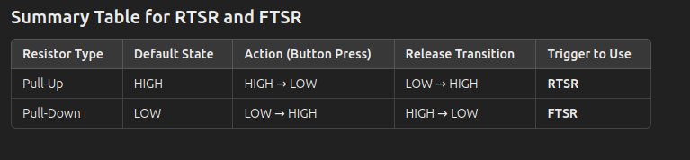
in that example with Pull up and Pull down the interrupt will be at Release.
If we switch the trigger to use it will be when we press the button.
We can enable an interrupt for every case though.
THE RISING DOWN OR FALLING REFERS TO THE PIN ASSOCIATED WITH EXTI line

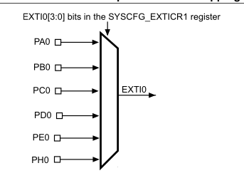

(EXTI_PR) Pending register
0 if no event occurred
1 if trigger request occured

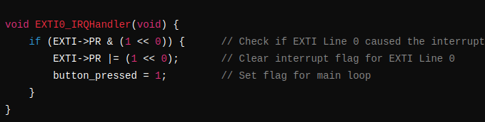
Small procedure do validate PR.

Page 213
Analog-to-digital converter (ADC)

19 multiplexed channels

ADC on-off control
Turn On ADON in ADC_CR2

start conversion with SWSTART (Regular channel) or JSWSTART (injected channel)

ADC clock:
enable in RCC_APB2ENR

Regular vs Injected channel ?

The temperature sensor is internally connected to ADC1_IN18

16 multiplexed channels
2 groups:
- A regular group is composed of up to 16 conversions. The regular channels and their order in the conversion sequence must be selected in the ADC_SQRx registers. The total number of conversions in the regular group must be written in the L[3:0] bits in the ADC_SQR1 register.
- An injected group is composed of up to 4 conversions. The injected channels and their order in the conversion sequence must be selected in the ADC_JSQR register. ON SEN BALEC

Single conversion mode
If regular channel converts, result STORED in ADC_DR
If injected channel converts result STORED in ADC_JDR1
it then stops conversion and sets EOC and JEOC flag to 1

EOC (end of conversion bit) relevant

Continuous Conversion mode

Only for regular channels (don’t care abt injected ones)
same as single conversion mode but it repeats indefinitely
which means the value in ADC_DR could be overwritten.
Might need to generate an interrupt with EOCIE.

Discontinuous mode

Used to convert a sequence of channels n times. It only converts when there’s a change in the input (less cpu usage) need to check interrupt though. Check meaning of DISCNUM.

Temperature Sensor:

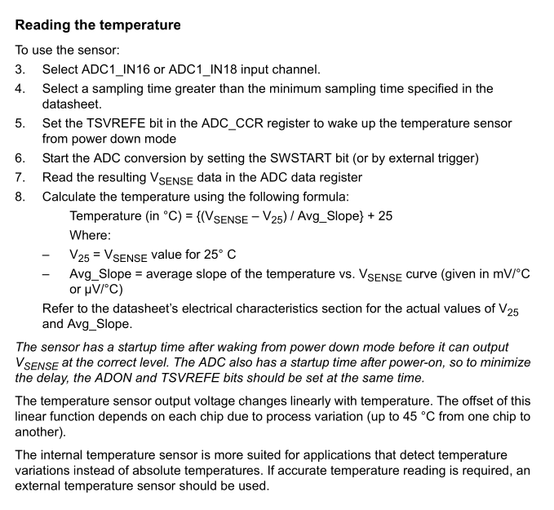
VBAT AND temperature sensor connected to ADC1_IN18 both need to choose only one at a time

Analog Watchdog sends an interrupt if the ADC input voltage it outside the predetermined range.
So it’s a protective measure and we don’t really need it.

Registers:

ADC status register (ADC_SR)
Many useful flags:
STRT: regular channel starts conversion
JSTRT: injected channel starts conversion
EOC: End of reg channel conversion
JEOC: End of injected channel conversion
AWD and OVR (Not sure if really useful)

ADC control register 1 (ADC_CR1)
OVRIE: Enable OVR interrupts ACTIVATE
RES: can speed up the conversion speed NOT TOUCH for now
AWDEN && JAWDEN: NOT TOUCH for now to activate watchdog
DISCNUM: Define nb of reg channels in Discontinuous mode USEFUL
SCAN: group of channels to be converted USELESS
EOCIE: enable interrupt for each conversion USEFUL
other useless flags for us

ADC control register 2 (ADC_CR2)
SWSTART: Start converting regular channels USEFUL
EXTEN && EXTSEL : can select an external event to begin the conversion, seems to work in tandem
ALIGN: Right Alignment (0s will be on the left) USEFUL (alr at reset)
EOCS: enable EOC bit at 1 when end of channel conversion USEFUL
CONT: enables continous conversion USEFUL choose either disc or continuous
ADON: ENABLES AD VERY USEFUL

ADC sample time register 1 (ADC_SMPR1)
select number of cycle needed for a conversion for channels 18-10

ADC sample time register 2 (ADC_SMPR2)
same but for channels 0-9

ADC regular sequence register 1 (ADC_SQR1-3)
The objective is to have a sequence of channels to convert.
there’s 16 SQ fields in the 3 SQR registers
SQR1: SQ16-13
SQR2: SQ12-7
SQR3: SQ1-6
each field has 5 bits and will correspond to one of the 0-18 channels.
Each field will be read in order from SQR3 TO SQR1
SQR1 has field L that takes 4 bits and indicates the length of the sequence

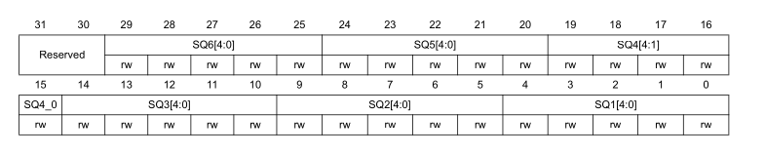
If I want only channel 3 set in the sequence:
ADC- >SQR1 &= ~0xF <<20 // set L field to length 1 (0000)
ADC- >SQR3 |= 3 ; //set channel 3 in SQ1 (in SQR3);

ADC regular data register (ADC_DR)
result of conversion 16 bits VERY IMPORTANT

ADC common control register (ADC_CCR)
TSVREFE: enable temperature sensor and Vrefint USEFUL
VBATE: enable VBAT channel Not useful (to check on battery)
disable VBATE
ADCPRE:
ADC clock prescaler, the higher it is, the less consumption there is.
We’ll keep it at 2

END OF ADC

page 506

Universal synchronous asynchronous receiver
transmitter (USART)

Data exchange with external components
2 pins: RX (receive) and TX (transmit)

word length either 8 or 9 bits

Baud Rate Formula

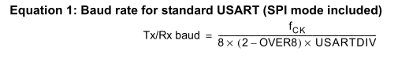

Definitions:

Tx/Rx baud : Number of symbols per second (we choose one arbitrarily)
fCK : (FUCK), frequency of the peripheral clock can use SystemCoreClock
OVER8: specific bit in usart_CRR to force the oversampling to 8
USARTDIV: The unknown value you have all others, to configure it after computing it you need to
write it in USART_BRR register

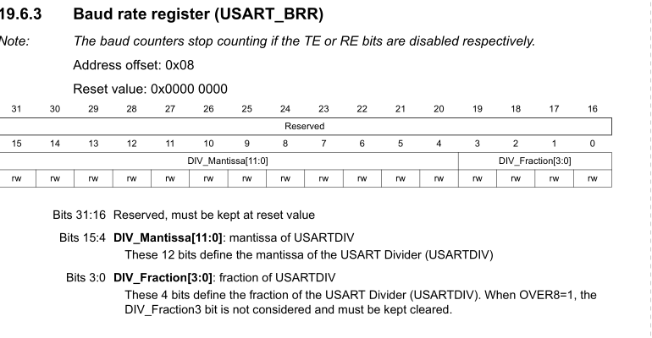

Mantissa: integer part
Fraction: decimal part

Overall the fact that you need to move USARTDIV decimal part 4 times to the right simplifies with the /16
and the final formulae with oversampling 16 and OVER8 0 is

BRR= SystemCoreClock/baud rate

Man so much shit
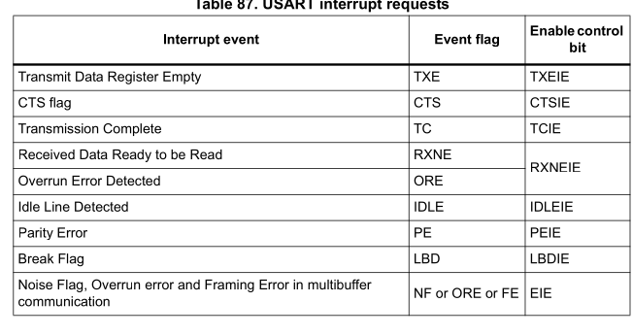

USART registers

Status register (USART_SR)
CTS: clear to send
LIN: USELESS
TXE: 1 if the TDR (transmit) has finished transmitting. Interrupt if TXEIE is at 1 USEFUL
TC: A bit different from the TXE I think because TXE is the waiting room and TC is the one that transmits, so not that useful but can use it
RXNE: 1 if there’s data to be read. USEFUL
IDLE: might be useful, apparently when register full of 0s or 1s
PE: parity error, check if there’s an even or uneven number of 1 in the message not that useful

Data register (USART_DR)
Contains the Received or Transmitted data character, depending on whether it is read from or written to. 9 BITS

Baud rate register (USART_BRR)
to configure USARTDIV value explained above

Control register 1 (USART_CR1)
OVER8: force oversampling, complicates things NOT USEFUL
UE: ENABLE USART USEFUL
M: Word length STAY at 8 bits data (0)
PCE: enable parity control might do it
PS: select even or odd parity
PEIE: enable PE interrupt MAYBE
TXEIE: enable TXE interrupt USEFUL
RXNEIE: enable RXNE interrupt USEFUL
TE: enable Transmitter USEFUL
RE: enable Receiver USEFUL

and rest not that useful

FINAL CHAPTER :
page 316

General-purpose timers (TIM2 to TIM5)

The main block of the programmable timer is a 16-bit/32-bit counter with its related auto-
reload register. The counter can count up. The counter clock can be divided by a prescaler.

The time-base unit includes:
• Counter Register (TIMx_CNT)
• Prescaler Register (TIMx_PSC):
• Auto-Reload Register (TIMx_ARR)

Can count up or down depending on the config, we’ll stick with up.

Capture/Compare register, they are use to capture a point in time. This point in time will have different meanings depending on the capture mode.
IC: input capture they record the timer’s value

multiple input capture channel: TIMx_CH1 TIMx_CH2 TIMx_CH3 TIMx_CH4

TI: Timer input, source signal not important

Input Capture Mode: when there’s a change in a gpio pin (TI) the time is captures and put into a CCR register. So it detects an external input.

PWM input mode: can measure frequency and period of input follow procedure page 334

Output compare mode:
sends output when a fixed amount of time has elapsed

PWM mode: generate signal with a frequency

Registers:

TIMx control register 1 (TIMx_CR1)
CKD: keep at 00 USELESS
ARPE: adds delay USELESS
CMS: 00 keep counting one direction MID USEFUL
DIR: Direction (0) upcounting USEFUL
OPM: one pulse mode MAYBE
URS and UDIS stay at 0 MAYBE ?
CEN: Counter enable (1) USEFUL

TIMx control register 2 (TIMx_CR2)
TI1S:Connects CH1 to TI1 DO NOT CHANGE
MMS: Master mode selection MIGHT BE USEFUL
ECE: enable external clock MAYBE USEFUL

TIMx DMA/Interrupt enable register (TIMx_DIER)
TIE: might be useful with MMS
CC4IE: interrupt enable CC4 USEFUL
CC3IE: interrupt enable CC3 USEFUL
CC2IE: interrupt enable CC2 USEFUL
CC1IE: interrupt enable CC1 USEFUL (Maybe not every CC)
UIE: Update interrupt enable USEFUL
TIMx status register (TIMx_SR)
CCxOF (x[4-1]): raised if previous data was not read it time in ccr1 so USELESS
CcxIF (x[4-1]): capture compare interrupt flag (1)
UIF: update Interrupt flag COULD BE USEFUL (1)

TIMx event generation register (TIMx_EGR)
TG: creates trigger generation (TIF flag set) DUNNO
all bits can create an event

TIMx capture/compare mode register 1 (TIMx_CCMR1)
later

TIMx capture/compare enable register (TIMx_CCER)
CC1NP: conf polarity USELESS
CC1P: stay at 0 useful (rising edge)
CC1E: ENABLE CAPTURE (1)
same for CC[2-4][E-P-NP]

TIMx counter (TIMx_CNT)
counter register

TIMx prescaler (TIMx_PSC)
The counter clock frequency CK_CNT is equal to fCK_PSC / (PSC[15:0] + 1).

TIMx auto-reload register (TIMx_ARR)
ARR is the value to be loaded in the actual auto-reload register.

TIMx capture/compare register x (TIMx_CCRx)
if output:
contains the value to be compared with TIMx_CNT
if input:
contains the counter value of last input capture event (ICx)

CCR1-4

