2]

public class Main {

public static void main(String[] args) {

int A_dice[] = {1, 2, 3, 4, 5, 6};

int B_dice[] = {1, 2, 3, 4, 5, 6};

int Sum_old[][] = new int[A_dice.length][B_dice.length];

int count = 0;

int temp = 0;

for (int i = 0; i < A_dice.length; i++) {

for (int j = 0; j < B_dice.length; j++) {

count++;

Sum_old[i][j] = A_dice[i] + B_dice[j];

}

}

int frequency_old[] = new int[13];

for (int row_old[] : Sum_old) {

for (int ele_old : row_old) {

frequency_old[ele_old]++;

}

}

int flag=0;

int o_count_A=0;

int e_count_A=0;

int new_A[] = {1, 2, 3, 2, 3, 4};

for(int i=0;i<6;i++)

{

if(new_A[i]>4)

{

flag=1;

break;

}

if(new_A[i]%2==0)

{

e_count_A++;

}

if(new_A[i]%2!=0)

{

o_count_A++;

}

}

int new_B[] = new int[6];

new_B[0] = 1;

new_B[5] = 8;

//Assuming odd_digit and even_digit frequency to be same as in normal dices and consecutive sides have it's digit's difference as 1 in the 4 spots left in B

new_B[1]=3;

new_B[2]=4;

new_B[3]=5;

new_B[4]=6;

//there are 2 more combinations for these elements but got this satisfying by Brute-Force method in 1st attempt itself

int o_count_B=0;

int e_count_B=0;

for(int i=0;i<6;i++)

{

if(new_B[i]%2==0)

{

e_count_B++;

}

if(new_B[i]%2!=0)

{

o_count_B++;

}

}

if(flag==1)

{

System.out.println("A has element greater than 4 which breaks condiition");

}

if(o_count_A==e_count_A&&o_count_B==e_count_B&&flag==0)

{

System.out.println("conditions met proceed to frequncy check!");

}

else{

System.out.println("conditions not met hence failed!");

System.exit(0);

}

if(checkFrequency(new_A, new_B,frequency_old))

{

System.out.println(" new dice A:");

for(int i=0;i<6;i++)

{

System.out.println(new_A[i]);

}

System.out.println(" new dice B:");

for(int i=0;i<6;i++)

{

System.out.println(new_B[i]);

}

}

else

{

System.out.println("new Dices do not have the same frequency distribution as old.");

}

}

public static boolean checkFrequency(int []new_A,int []new_B,int []frequency_old)

{

int Sum_new[][] = new int[new_A.length][new_B.length];

for (int i = 0; i < new_A.length; i++)

{

for (int j = 0; j < new_B.length; j++)

{

Sum_new[i][j] = new_A[i] + new_B[j];

}

}

int frequency_new[] = new int[13];

for (int row_new[] : Sum_new)

{

for (int ele_new : row_new)

{

frequency_new[ele_new]++;

}

}

for(int i=2;i<=12;i++)

{

if(frequency_old[i]!=frequency_new[i])

{

return false;

}

}

return true;

}

}

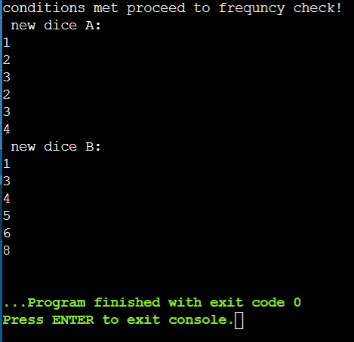

The corner cases sum of 1 and 12 was took care with {1,4} in A and{1,8} in B ,the rest just had to be consecutive elements in all 4 spots to have a difference by 1 and to maintain odd_frequency =even_frequency throughout the arrays.