# Exercise 1: Getting started with Matplotlib

## Aim: Introduce the Matplotlib interactive plotting tool

**Issues covered:**

If you get bored of having to close the interactive plotting window use:

plt.pause(1)

instead of:

plt.show()

* Importing Matplotlib
* Using the interactive plotting tool
* Generating some simple line graphs
* Saving a figure

**1. Let's import Matplotlib and create our first plot.**

1. Type the "import matplotlib.pyplot as plt" in the Python prompt.
2. Plot the line defined by range(10).
3. Display the plot using "plt.show()".
4. Click the zoom button and then highlight a rectangle in the centre of the plot.
5. Click the pan button and then move around the plot (whilst zoomed in).
6. Click the back and forward buttons to move through a history of the plots you have generated.
7. Click the save button and save your plot as a PNG file.
8. Finally, close the plot using the "X" button in the top right corner.

**2. Let's create a pretty plot of save chemistry data.**

1. Our data set is:

Time (decade): 0, 1, 2, 3, 4, 5, 6.

CO2 concentration (ppm): 250, 265, 272, 260, 300, 320, 389

1. Create a line graph of CO2 versus time. View the plot.
2. Re-draw the graph with a blue dashed line.
3. Add a title and axis titles to the plot.

**3. Let's add a second line to our example.**

1. Continuing with the above data plot, add some additional data:

Temp (°c): 14.1, 15.5, 16.3, 18.1, 17.3, 19.1, 20.2

1. Save the output (using Python code) to a PDF file.

# Solution 1: Getting started with Matplotlib

1.

>>> import matplotlib.pyplot as plt

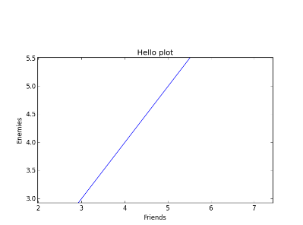>>> plt.plot(range(10))

>>> plt.show()  
  
E.g.

2.

>>> times = range(7)

>>> co2 = [250, 265, 272, 260, 300, 320, 389]

>>> plt.plot(times, co2)

>>> plt.plot(times, co2, 'b--')

>>> plt.title("Concentration of CO2 versus time")

>>> plt.ylabel("[CO2]")

>>> plt.xlabel("Time (decade)")

>>> plt.show()

3.

>>> times = range(7)

>>> co2 = [250, 265, 272, 260, 300, 320, 389]

>>> temp = [14.1, 15.5, 16.3, 18.1, 17.3, 19.1, 20.2]

>>> plt.plot(times, co2, 'b--', times, temp, 'r*-')

>>> plt.savefig("co2_temp.pdf")

>>> plt.show()

# Exercise 2: Multiple axes and multiple graphs

## Aim: Introduce plotting with multiple axes and multiple graphs on the page

**Issues covered:**

If you get bored of having to close the interactive plotting window use:

plt.pause(1)

instead of:

plt.show()

* Plotting lines with different axes
* Using the subplot function to create multiple graphs   
  on a single page

**1. Let's re-use our previous example with different axes.**

1. Import pyplot as "plt" (as before).
2. Run the line: fig, ax1 = plt.subplots()
3. You can now create your first plot using "ax1" instead of "plt".
4. Our data set is:

Time (decade): 0, 1, 2, 3, 4, 5, 6.

CO2 concentration (ppm): 250, 265, 272, 260, 300, 320, 389

1. Create a line graph of CO2 versus time. Do not view the plot yet.
2. Set the y-axis label to "[CO2]" using the "ax1.set_ylabel" method.
3. Get a second axis object using: ax2 = ax1.twinx()
4. Plot the following temperature values to this second axis:

Temp (°c): 14.1, 15.5, 16.3, 18.1, 17.3, 19.1, 20.2

1. Set the second y-axis label to "Temp (degC)" using the "ax2.set_ylabel" method.
2. Display the plot using "plt.show()".

**2. Let's draw three graphs side by side on a single page.**

1. Use the "subplot" function to select the first of three plots (side-by-side).
2. Plot a line of values: range(0, 10, 1).
3. Select the second plot with "subplot".
4. Plot a line of values: range(10, 0, -1).
5. Select the third plot with "subplot".
6. Plot a line of values: [4] * 10
7. Display the plot using "plt.show()".

# Solution 2: Multiple axes and multiple graphs

1.

>>> import matplotlib.pyplot as plt

>>> fig, ax1 = plt.subplots()

>>> times = range(7)

>>> co2 = [250, 265, 272, 260, 300, 320, 389]

>>> ax1.plot(times, co2, "b--")

>>> ax1.set_ylabel("[CO2]")

>>> ax2 = ax1.twinx()

>>> temp = [14.1, 15.5, 16.3, 18.1, 17.3, 19.1, 20.2]

>>> ax2.plot(times, temp, "r*-")

>>> ax2.set_ylabel("Temp (degC)")

>>> plt.show()

2.

>>> plt.subplot(1, 3, 1)

>>> x = range(0, 10, 1)

>>> plt.plot(x)

>>> plt.subplot(1, 3, 2)

>>> y = range(10, 0, -1)

>>> plt.plot(y)

>>> plt.subplot(1, 3, 3)

>>> z = [4] * 10

>>> plt.plot(z)

>>> plt.show()

# Exercise 3: Plotting gridded data on a map

## Aim: Introduce plotting gridded data using Basemap

**Issues covered:**

* Importing Basemap
* Using Basemap for geospatial plotting
* Integration with Matplotlib

**1. Let's grab some data from a NetCDF file and quickly plot it.**

1. The file "example_data/tas.nc" contains surface air temperature differences. We can extract the data and prepare it by importing the "example_code/map_data.py" module.
2. Import eveything to the local scope: from example_code.map_data import *
3. The following variables now exist in the local scope: tas (temperature), lons (longitudes for all grid boxes), lats (latitudes for all grid boxes).
4. Import Basemap and Pyplot with:

from mpl_toolkits.basemap import Basemap

import matplotlib.pyplot as plt

1. Create a new figure: fig = plt.figure()
2. Set up a Basemap instance with a regular lat/lon coordinate reference system:

m = Basemap(projection='cyl', llcrnrlat=-90, urcrnrlat=90,   
 llcrnrlon=-180, urcrnrlon=180, resolution='c')

1. Add coastlines: m.drawcoastlines()
2. Create a "Jet" colour map to plot the data:

im1 = m.pcolormesh(lons, lats, tas, shading='flat',   
 cmap=plt.cm.jet, latlon=True)

1. Save the plot as "tas1.png".
2. Display the plot.

**2. Let's jazz up the plot by adding some features.**

1. Follow the instructions above but this time we'll add in some features.
2. Add a title: "Change in Surface Air Temperature from MOHC HadGEM2-ES"
3. Add some vertical and horizontal grid lines using:

m.drawparallels(np.arange(-90.,99.,30.))

m.drawmeridians(np.arange(-180.,180.,60.))

1. Add a colour bar after generating the colour map "im1", with:

cb = m.colorbar(im1, "bottom", size="5%", pad="2%")

1. Save the plot as "tas2.png". Compare the plot with that produced above.
2. Display the plot.

# Solution 3: Plotting gridded data on a map

1.

>>> from example_code.map_data import *

>>> from mpl_toolkits.basemap import Basemap

>>> import matplotlib.pyplot as plt

>>> fig = plt.figure()

>>> m = Basemap(projection='cyl', llcrnrlat=-90, urcrnrlat=90, llcrnrlon=-180, urcrnrlon=180, resolution='c')

>>> m.drawcoastlines()

>>> im1 = m.pcolormesh(lons, lats, tas, shading='flat', cmap=plt.cm.jet, latlon=True)  
  
>>> plt.savefig("tas1.png")

>>> plt.show()

2.

>>> from example_code.map_data import *

>>> from mpl_toolkits.basemap import Basemap

>>> import matplotlib.pyplot as plt

>>> fig = plt.figure()

>>> plt.title('Change in Surface Air Temperature from MOHC HadGEM2-ES')

>>> m = Basemap(projection='cyl', llcrnrlat=-90, urcrnrlat=90, llcrnrlon=-180, urcrnrlon=180, resolution='c')

>>> m.drawcoastlines()

>>> m.drawparallels(np.arange(-90.,99.,30.))

>>> m.drawmeridians(np.arange(-180.,180.,60.))

>>> im1 = m.pcolormesh(lons, lats, tas, shading='flat', cmap=plt.cm.jet, latlon=True)

>>> cb = m.colorbar(im1, "bottom", size="5%", pad="2%")

>>> plt.savefig("tas2.png")

>>> plt.show()

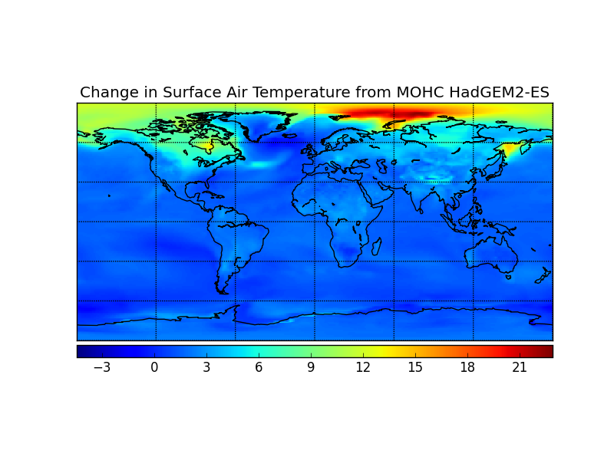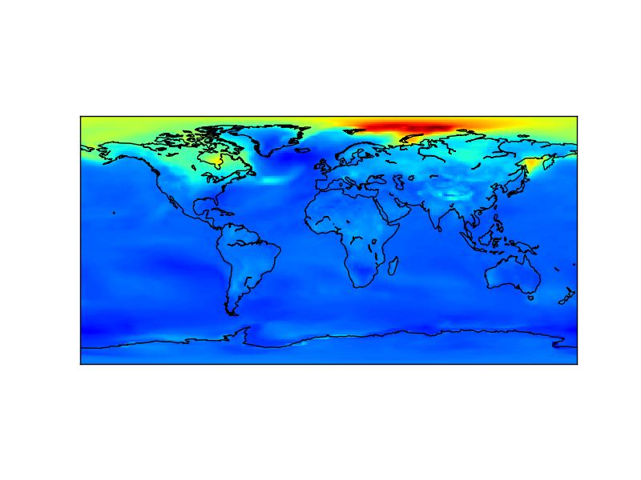The plots should look like this: