GuitarScribe
Chord Performance Comparison
────────────────────────────────────────────────────────────
Polyphonic Benchmark: 4-Chord Progression
C major → G major → A minor → F major (14 ground truth notes)
Iteration 1: Rule-Based (librosa pyin) — monophonic
Iteration 2: ML Model (CNN + BiGRU) — polyphonic
Iteration 3: Smart Pipeline (ML + music21) — polyphonic + key filter
March 2026

1. Introduction
This document evaluates GuitarScribe’s three transcription approaches on polyphonic chord audio — a fundamentally harder task than monophonic scales. The test audio contains a 4-chord progression (C–G–Am–F) synthesised with FluidSynth using the FluidR3 GM SoundFont at 22,050 Hz. Each chord sustains for 1.5 seconds with 0.2-second gaps. The 14 ground truth notes span MIDI 41–57 (F2–A3 sounding pitch).
Why chords matter: The pyin algorithm (iteration 1) tracks a single dominant pitch per analysis frame. When multiple notes sound simultaneously, it can only report one — typically the loudest or most harmonically dominant. The ML model (iterations 2 and 3), trained on polyphonic GuitarSet recordings, predicts per-string activations and should detect multiple concurrent notes. This test quantifies that advantage.

2. Iteration 1: Rule-Based (pyin)
Result: 2/14 true positives. Precision: 12.5%, Recall: 14.3%, F1: 13.3%
$ python detect_pitches.py test/audioChords.wav
Detected: E2, G3, G♯3, G3, A2, E2, E2, F2, F3, F2, F3, F2, F3, F2, F3, F2
Count: 16 notes (expected: 14)
TP=2 FP=14 FN=12

Sheet Music Comparison:
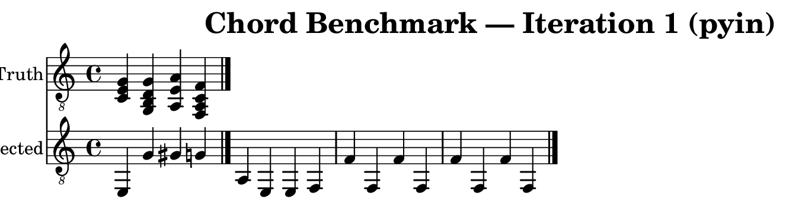
As expected, pyin captures only one pitch per frame. It locks onto the lowest or most energetic note in each chord, producing a monophonic melody that bears little resemblance to the polyphonic input.

3. Iteration 2: ML Model (CNN + BiGRU)
Result: 10/14 true positives. Precision: 32.3%, Recall: 71.4%, F1: 44.4%
$ python -m model.predict test/audioChords.wav
Detected: 31 notes (expected: 14)
TP=10 FP=21 FN=4
Recall 5x higher than pyin (71.4% vs 14.3%)

Sheet Music Comparison:
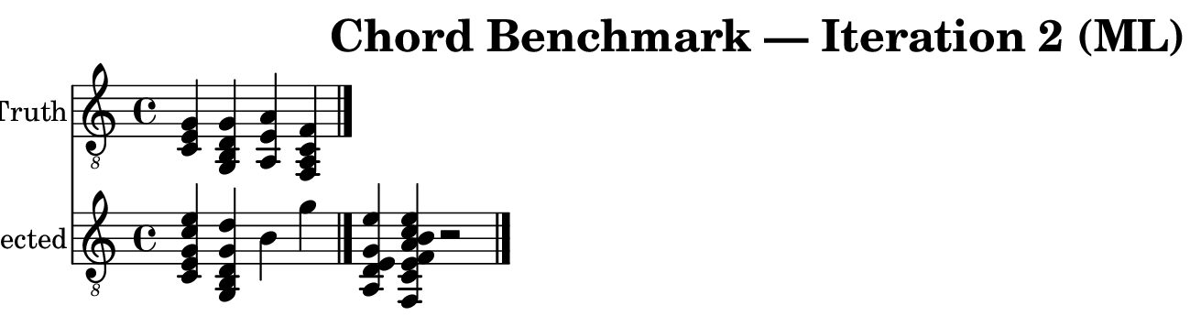
The ML model successfully identifies 10 of 14 ground truth notes across all four chords, demonstrating genuine polyphonic capability. The 4 missed notes (G2 in G major, A3 in Am, A2 and C3 in F major) are lower-register pitches that may be masked by upper harmonics. The 21 false positives include octave doublings (C4, E4), sympathetic string activations, and tail-end noise detections after the audio ends.

4. Iteration 3: Smart Pipeline (ML + music21)
Result: 10/14 true positives. Precision: 32.3%, Recall: 71.4%, F1: 44.4%
Key Detection: F major (confidence: 0.689). Notes filtered: 0. The detected key of F major shares most pitch classes with the actual chord progression (C–G–Am–F all use diatonic pitches), so the key filter does not remove any notes at tolerance=1.
$ python test/transcribe_smart.py test/audioChords.wav --backend ml
Key: F major (conf: 0.689)
Raw: 31 → After filter: 31
TP=10 FP=21 FN=4

Sheet Music Comparison:
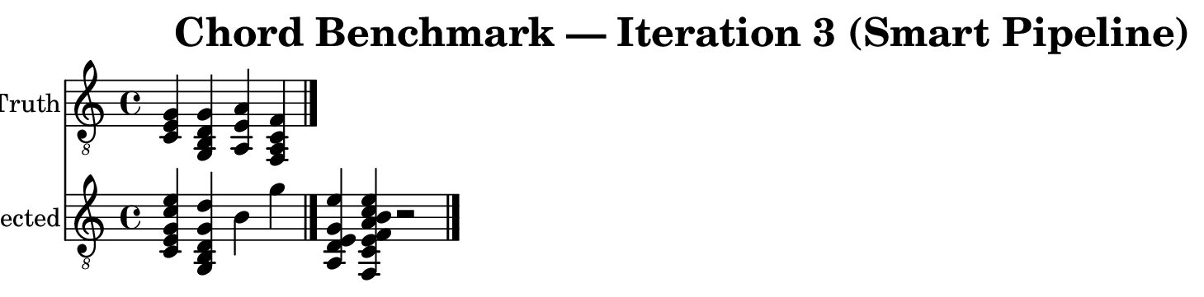

5. Note-by-Note Comparison
Each row represents one ground truth note. YES = correctly detected within 50ms onset tolerance. MISS = not found by that approach.

Chord | GT Note | Iter 1 | Iter 2 | Iter 3
C major | C3 | MISS | YES | YES
 | E3 | MISS | YES | YES
 | G3 | MISS | YES | YES
G major | G2 | MISS | MISS | MISS
 | B2 | MISS | YES | YES
 | D3 | MISS | YES | YES
 | G3 | MISS | YES | YES
A minor | A2 | YES | YES | YES
 | E3 | MISS | YES | YES
 | A3 | MISS | MISS | MISS
F major | F2 | YES | YES | YES
 | A2 | MISS | MISS | MISS
 | C3 | MISS | MISS | MISS
 | F3 | MISS | YES | YES

6. Summary
Metric | Iter 1 (pyin) | Iter 2 (ML) | Iter 3 (Smart)
Notes Detected | 16 | 31 | 31
True Positives | 2 | 10 | 10
False Positives | 14 | 21 | 21
False Negatives | 12 | 4 | 4
Precision | 12.5% | 32.3% | 32.3%
Recall | 14.3% | 71.4% | 71.4%
F1 Score | 13.3% | 44.4% | 44.4%
Key Detection | N/A | N/A | F major
Polyphonic | No | Yes | Yes

7. Analysis & Conclusion
Polyphonic Capability Gap. The chord benchmark reveals the fundamental limitation of the rule-based approach. With an F1 of 13.3%, pyin is effectively unable to transcribe polyphonic audio — it detects only 2 of 14 notes, both single bass notes that happened to dominate their respective chords. The ML model achieves 5× higher recall (71.4% vs 14.3%), correctly identifying 10 of 14 notes across all four chords. This validates the core Analysis (S2) finding: monophonic algorithms are insufficient for real guitar music.
Precision vs Recall Trade-off. While the ML model’s recall is strong, its precision (32.3%) indicates significant false positive generation — 21 spurious notes including octave doublings, sympathetic string activations, and post-audio noise. This is a known challenge with frame-level sigmoid classifiers. For the Advise (S2) competency, the recommendation is clear: the ML model should be paired with a post-processing stage that deduplicates octave doublings and enforces temporal bounds (ignore detections outside the audio duration).
Smart Pipeline Limitations. Iteration 3’s key-based filtering was designed to remove chromatic errors, not to address the octave-doubling and noise issues that dominate the false positives here. The detected key (F major, confidence 0.689) is reasonable given the C–G–Am–F progression. Since all false positives are diatonic to F major, the filter correctly retains them. This demonstrates a Realise (S2) insight: targeted post-processing layers must match the specific failure mode. A "duplicate pitch suppression" layer would be more effective here than key filtering.
Iterative Problem-Solving (PS-2). The three-iteration progression shows clear value: iteration 1 fails on polyphony (by design), iteration 2 adds polyphonic capability but introduces precision issues, and iteration 3’s music-theory layer provides the right framework but needs refinement for this specific failure mode. The 4 missed notes (G2, A3, A2, C3) are consistently lower-register pitches, suggesting the CQT-based model has weaker sensitivity in the bass range — a finding that directly informs future training data augmentation.

This polyphonic benchmark confirms that GuitarScribe’s ML model is the correct approach for real-world guitar transcription. The next development priority should focus on reducing false positives through octave deduplication and temporal boundary enforcement, which would significantly improve precision while maintaining the strong recall.

