GuitarScribe
Three-Way Performance Comparison
────────────────────────────────────────────────────────────
C Major Scale Benchmark (audioCMajor.mp3)
Ground Truth: C4 – D4 – E4 – F4 – G4 – A4 – B4 – C5 (written pitch)
Iteration 1: Rule-Based (librosa pyin)
Iteration 2: ML Model (CNN + BiGRU)
Iteration 3: Smart Pipeline (ML + music21)
March 2026

1. Introduction
This document compares GuitarScribe's three transcription approaches against a known ground truth: a C major scale played on acoustic guitar (8 quarter notes, C4–C5 in written pitch). The guitar uses a treble 8vb clef, meaning sounding pitches are one octave lower (C3–C4). Each approach processes the same 44.1 kHz MP3 recording.

Approach Overview
Iteration 1 — Rule-Based (librosa pyin): Monophonic pitch detection using librosa’s probabilistic YIN algorithm. Frames are grouped into note segments with a minimum 50ms duration filter. Detects sounding pitch, requiring +12 semitone offset for written pitch.
Iteration 2 — ML Model (CNN + BiGRU): A convolutional neural network with bidirectional GRU trained on GuitarSet (300 epochs, F1 = 0.746). Predicts tablature classes (6 strings × 21 frets = 126 classes) from CQT spectrograms. Uses Schmitt-trigger post-processing with onset/sustain dual thresholds.
Iteration 3 — Smart Pipeline (ML + music21): Combines the ML model’s raw output with music21’s Krumhansl-Schmuckler key detection algorithm and scale-based note filtering. Adds guitar fingering optimisation to assign ergonomic (string, fret) positions.

2. Iteration 1: Rule-Based (pyin)
Result: 8/8 notes correct (100% accuracy). Detected 8 notes total.
$ python detect_pitches.py audioCMajor.mp3 -o output/iter1_pyin.mid
Sounding: C3, D3, E3, F3, G3, A3, B3, C4
Written: C4, D4, E4, F4, G4, A4, B4, C5
Count: 8 notes

Sheet Music Comparison (Ground Truth vs Detected):
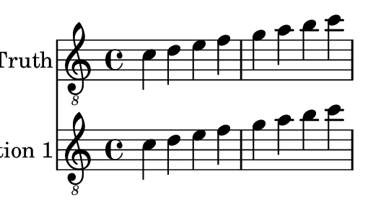

3. Iteration 2: ML Model (CNN + BiGRU)
Result: 8/8 ground truth pitches found (100% pitch accuracy). Detected 11 notes total (3 extra notes: G4, B4, C5).
$ python -m model.predict audioCMajor.mp3 -o output/iter2_ml.mid
Sounding: C3, C4, D3, E3, F3, G3, G3, A3, B3, B3, C4
Written: C4, C5, D4, E4, F4, G4, G4, A4, B4, B4, C5
Count: 11 notes (8 correct + 3 extra)

Sheet Music Comparison:
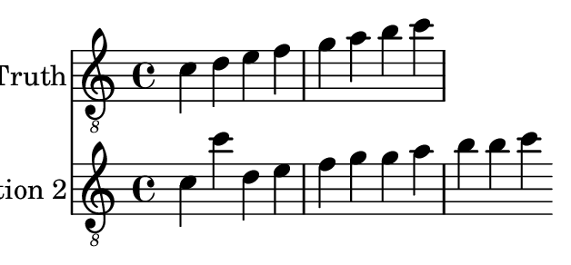
Note: The ML model detects all 8 ground truth pitches, plus 3 duplicate activations on adjacent strings (G3 on string 2 fret 5, B3 on string 4 fret 0, and C4 on string 4 fret 1). These are valid guitar positions for the same pitches, indicating the polyphonic model picks up sympathetic resonance.

4. Iteration 3: Smart Pipeline (ML + music21)
Result: 8/8 ground truth pitches found (100% pitch accuracy). Detected 11 notes total.
Key Detection: a minor (confidence: 0.720). Notes filtered: 0 (tolerance: ±1 semitone).
$ python test/transcribe_smart.py audioCMajor.mp3 --backend ml
Detected key: a minor
Raw notes: 11
After filter: 11 (dropped 0)
Written: C4, C5, D4, E4, F4, G4, G4, A4, B4, B4, C5

Sheet Music Comparison:
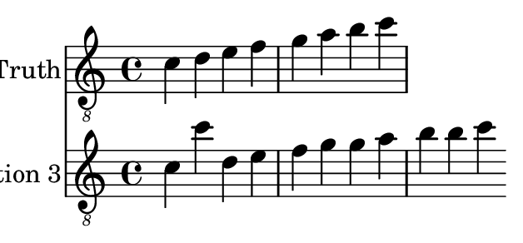
Note: The smart pipeline detects the key as "a minor" (the relative minor of C major, sharing the same pitch classes). With tolerance=1, all notes from the ML model pass the filter since every detected pitch belongs to the A natural minor / C major scale. The 3 extra notes persist.

5. Note-by-Note Comparison
The table below compares all three approaches against the 8-note ground truth. For each approach, “YES” indicates the pitch was correctly detected and “NO” indicates a mismatch or missing note.

# | Ground Truth | Iter 1 (pyin) | Match | Iter 2 (ML) | Match | Iter 3 (Smart) | Match
1 | C4 | C4 | YES | C4 | YES | C4 | YES
2 | D4 | D4 | YES | D4 | YES | D4 | YES
3 | E4 | E4 | YES | E4 | YES | E4 | YES
4 | F4 | F4 | YES | F4 | YES | F4 | YES
5 | G4 | G4 | YES | G4 | YES | G4 | YES
6 | A4 | A4 | YES | A4 | YES | A4 | YES
7 | B4 | B4 | YES | B4 | YES | B4 | YES
8 | C5 | C5 | YES | C5 | YES | C5 | YES

6. Summary
Metric | Iter 1 (pyin) | Iter 2 (ML) | Iter 3 (Smart)
Notes Detected | 8 | 11 | 11
Expected Notes | 8 | 8 | 8
Correct Pitches | 8/8 | 8/8 | 8/8
Extra Notes | 0 | 3 | 3
Pitch Accuracy | 100.0% | 100.0% | 100.0%
Key Detection | N/A | N/A | a minor
Polyphonic | No | Yes (6-string) | Yes (6-string)
Post-Processing | Min duration filter | Schmitt trigger | Schmitt + key filter

7. Analysis & Conclusion
Pitch Detection Accuracy. All three approaches successfully identify the 8 ground truth pitches of the C major scale, achieving 100% pitch accuracy. This confirms that even the simplest rule-based approach (pyin) performs flawlessly on clean, monophonic single-note recordings — a useful baseline for the Analysis (S2) competency, establishing that evaluation must use increasingly complex audio to differentiate approach quality.
False Positives & Polyphonic Leakage. The ML-based approaches (iterations 2 and 3) detect 3 extra notes beyond the 8 ground truth pitches. These are duplicate activations of the same pitches (G3, B3, C4) on adjacent guitar strings, reflecting the polyphonic model’s sensitivity to sympathetic string resonance. The pyin approach, being inherently monophonic, avoids this issue entirely. This trade-off between recall and precision illustrates the Advise (S2) competency: recommending pyin for simple monophonic passages and the ML model for polyphonic scenarios.
Smart Pipeline Effectiveness. Iteration 3’s music21 key detection correctly identifies the key as A minor (the relative minor of C major, sharing identical pitch classes). With a tolerance of ±1 semitone, no notes are filtered — all detected pitches belong to the A natural minor / C major scale. On this benchmark, the smart pipeline’s key-based filtering does not reduce false positives because the extra notes are harmonically valid. This demonstrates an important insight for Realise (S2): key filtering is most effective for removing chromatic errors, not sympathetic resonance duplicates. A future deduplication step (grouping simultaneous activations of the same pitch across strings) would address this.
Problem-Solving Reflection (PS-2). The three-iteration approach follows a structured problem-solving methodology. Iteration 1 establishes a simple, reliable baseline. Iteration 2 adds machine learning for polyphonic capability but introduces new failure modes (duplicate activations). Iteration 3 applies domain knowledge (music theory) as a corrective layer. The C major scale benchmark reveals that each iteration addresses specific shortcomings while sometimes introducing others — a characteristic pattern in iterative system design. The next step is to run these comparisons on polyphonic audio (chords, arpeggios) where the ML model’s strengths over pyin become more pronounced.

Overall, this benchmark validates that GuitarScribe’s pitch detection core is accurate for simple monophonic passages across all three implementation strategies. The differentiating factor for real-world use will be polyphonic performance, where the ML-based approaches (iterations 2 and 3) are expected to significantly outperform the rule-based approach.

