Benjamin Macalister
GUI Documentation
The GUI for My project consists of 2 bars, the first is the bar for the plain and the lighting variables and the second is to control the rain objects

the first bar looks similar to this
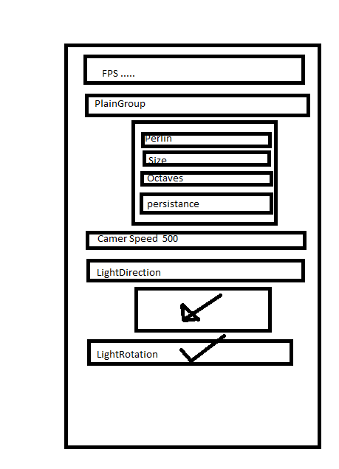
The FPS variable is there in order to show the user how many frames it is running at

the Plain group is a main section for the variables that change the variables of the plain
the Perlin determines how big the perlin texture is
the Size is to change the size of the map
the Octaves the octaves change how many times the perlin noise is run
the Persistence changes how close the octaves are grouped

the camera speed is used to change how fast you can move around the map

All of the above variables will only update when you Press R

and the light direction is there so you can change what way the light comes in and affects the map and characters

the light rotation is a boolean that will trigger the light spinning around the map

these will update as soon as you click back onto the screen

the second Bar looks like this
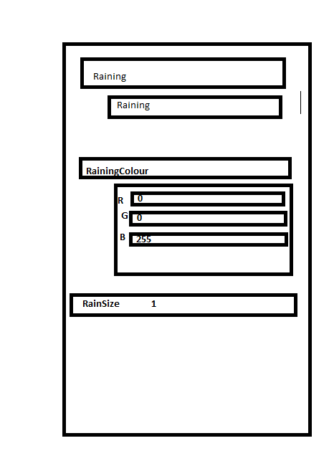
the Raining Variable is there to trigger if it is raining or not

the Raining Colour lets you change the colour of the rain real time

and the Rain Size variable changes how big each rain particle is

