5. Use-case model
The diagram below is a requirements-stage schematic. The fully dressed use cases are the normative description. Before submission, recreate/refine it in a UML tool so every association and include/extend arrow is unambiguous.
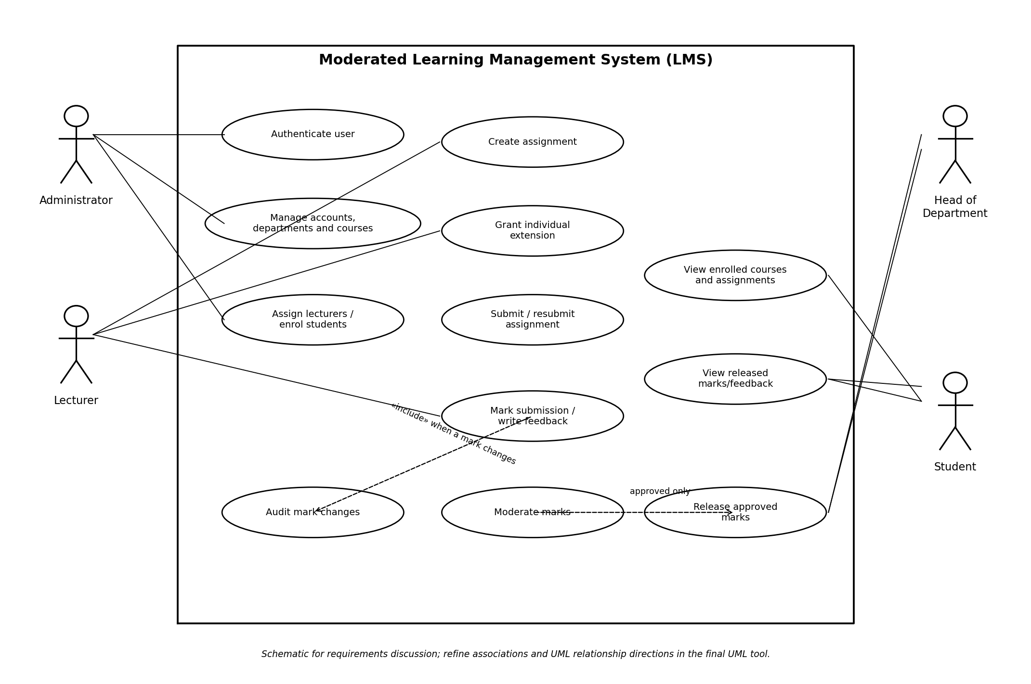

5.1 Actors and relationships
Actor | Principal goals
Administrator | Manage accounts, roles, departments and courses; assign lecturers; enrol students.
Lecturer | Create assignments; grant individual extensions; mark submissions; write feedback.
HoD | Moderate departmental marks and release approved results.
Student | View enrolled courses/assignments; submit and resubmit work; view released marks and feedback.

- Authentication can be shown as «include» for protected use cases, or documented as a system-wide precondition if login is modelled separately.
- Late submission and resubmission can be shown as «extend» paths from Submit assignment only if extension points and arrow direction are clearly labelled; they may also be documented as alternative flows.
- Mark-change auditing applies when an existing mark is changed. Do not imply that a first mark has an old value; model the audit behaviour precisely.
- Moderation and release are separate: approval is necessary but does not itself release the result.
- Actor generalisation is not needed unless a genuine shared actor relationship is identified. Do not add generalisation merely as decoration.

6. Fully dressed use cases

UC-01 — Submit assignment
Field | Specification
Scope / primary actor | Moderated LMS / Student
Supporting actors | LMS services and SQLite persistence
Goal / trigger | Record a submission. Trigger: student selects Submit or Resubmit for an assignment.
Preconditions | Student authenticated; enrolled in course; assignment exists and is available; student has submission permission.
Success postconditions | Submission is stored with student, assignment, timestamp and version; status is updated; confirmation is shown.
Failure postconditions | No partial record is committed; prior valid submission remains intact; clear error shown.
Business rules | BR-01, BR-04, BR-05, BR-09; timing assumptions must be approved.

Main flow
- 1. Student logs in and opens an enrolled course.
- 2. System lists assignments available to that student.
- 3. Student selects an assignment and chooses Submit or Resubmit.
- 4. System displays the applicable deadline, including any approved individual extension.
- 5. Student selects the work and confirms submission.
- 6. System validates enrolment, assignment availability, applicable deadline and resubmission eligibility.
- 7. System records the submission and timestamp in a database transaction.
- 8. System determines on-time/late status and records the basis needed to apply the late rule.
- 9. System commits and displays confirmation/receipt.

Alternative flows
- A1 Resubmission: if before the applicable deadline, system stores the new version as current and retains agreed submission metadata/history.
- A2 Late within window: system accepts it, records late status and applies the specified penalty during marking.
- A3 Approved extension: system displays the revised deadline and uses it for timeliness if the proposed rule is approved.
- A4 Exact deadline: proposed rule is that timestamp at or before deadline is on time; validate with stakeholders.

Exception flows
- E1 Not enrolled: reject attempt; create no submission.
- E2 Beyond three-day window: outcome must be zero. Decide during design whether the file is retained for audit/reference or submission is refused with a zero outcome.
- E3 Missing/invalid content: explain error; do not commit partial data.
- E4 Database failure: do not claim success unless the transaction committed; avoid duplicate/partial records.

UC-02 — Mark submission and provide feedback
Field | Specification
Scope / primary actor | Moderated LMS / Lecturer
Supporting actors | SQLite persistence and audit service
Goal / trigger | Record a mark and written feedback. Trigger: lecturer opens a submission awaiting marking.
Preconditions | Lecturer authenticated and assigned to course; submission exists; assignment maximum is defined.
Success postconditions | Mark and feedback saved; submission is pending HoD moderation; student cannot yet view result.
Failure postconditions | Invalid mark not saved; failed mark/audit operation leaves no inconsistent change.
Business rules | BR-01, BR-03, BR-06, BR-07; mark is within zero and maximum.

Main flow
- 1. Lecturer logs in and opens an assigned course.
- 2. Lecturer selects an assignment and submission awaiting marking.
- 3. System shows submission, maximum mark, timing/late status and penalty basis.
- 4. Lecturer enters a valid mark and written feedback.
- 5. System validates the mark and required fields.
- 6. System saves mark and feedback transactionally.
- 7. System changes status to Marked / Pending moderation.
- 8. System confirms save and makes clear the mark is not yet visible to the student.

Alternative flows
- A1 Existing mark correction: lecturer enters new mark and reason; system records actor, timestamp, old mark, new mark and reason in the same transaction.
- A2 Late submission: system presents the approved penalty basis; final mark cannot be negative.
- A3 Feedback revision before release: save revised feedback under the feedback-history policy approved in design.

Exception flows
- E1 Lecturer not assigned to course: deny access.
- E2 Mark below zero or above maximum: reject and display valid range.
- E3 Reason missing for a mark change: require the reason before saving.
- E4 Database/audit write failure: roll back the mark update so an unaudited change cannot remain.

UC-03 — Moderate and release marks
Field | Specification
Scope / primary actor | Moderated LMS / Head of Department
Supporting actors | Lecturer for returned corrections; Student as recipient after release
Goal / trigger | Review departmental marks, approve or return for correction, and release approved results.
Preconditions | HoD authenticated and responsible for department; submissions are marked and awaiting moderation.
Success postconditions | Moderation decisions are recorded; only approved results explicitly released become visible to students.
Failure postconditions | Unapproved marks remain hidden; failed release does not change visibility.
Business rules | BR-01, BR-06, BR-07; department scope and release control are mandatory.

Main flow
- 1. HoD logs in and opens the department moderation queue.
- 2. System lists marked submissions for courses in that department awaiting moderation.
- 3. HoD selects a submission and reviews mark, feedback and relevant submission context.
- 4. HoD chooses Approve or Return for correction.
- 5. If approved, system records the decision, HoD identity and timestamp; result becomes Approved / Awaiting release.
- 6. HoD selects approved result(s) and chooses Release.
- 7. System verifies each selected result is approved and within the HoD’s department.
- 8. System records release actor/time and changes status to Released.
- 9. Student can now view released mark and written feedback.

Alternative flows
- A1 Return for correction: record decision and reason, return submission to lecturer queue, keep mark hidden.
- A2 Approved but not released: result remains hidden until a separate Release action.
- A3 Batch release: validate each result individually; release only eligible approved results.

Exception flows
- E1 Result belongs to another department: deny access and prohibit moderation/release.
- E2 Unapproved result selected: reject release for that result and explain approval is required.
- E3 Release failure: do not expose result; preserve previous state.
- E4 Mark changes after review: require HoD to refresh and review the current mark before approval.

7. Traceability matrix (initial baseline)
The assignment requires functional requirements to link to use cases, design elements, database tables, source files and tests. The design, database, source filenames and test IDs below are provisional placeholders to be replaced with actual artefacts in Phases 3–5.
Requirements | Use case / feature | Provisional design/data mapping | Planned test IDs
FR-01 | Authenticate user | AuthenticationService; User | T-LOGIN-*
FR-02 | Role authorisation | AuthorizationPolicy; User/Role | T-AUTHZ-*
FR-03–05 | Administration/enrolment | Admin controller; User, Department, Course, Enrolment | T-ADMIN-*
FR-06–07, FR-21 | Assignment/extension | Assignment and Extension services/tables | T-ASG-*
FR-08–10 | UC-01 Submit assignment | Enrolment, Assignment, Submission | T-SUB-*
FR-11 | Late penalty | Penalty policy; Submission/Extension | T-PEN-*
FR-12–14 | UC-02 Mark submission | Submission, Mark/Feedback, MarkAudit | T-MARK-*
FR-15–17 | UC-03 Moderate/release | ModerationDecision, Mark/Release state | T-MOD-*
FR-18 | View released result | Submission, Mark/Feedback, Release state | T-REL-*
FR-19–20 | Persistence/validation | Data-access layer; persistent entities | T-DB-*
NFR-01–10 | Quality requirements | Architecture, security and QA artefacts | T-PERF/SEC/USE/BUILD-*

8. Open decisions and Gate 1 validation
ID | Decision required | Recommendation / status
OD-01 | Calendar day or rolling 24-hour late day? | Recommend school-local calendar days; open for HoD approval.
OD-02 | Exact deadline boundary? | Recommend at-or-before deadline is on time; proposed.
OD-03 | How does extension affect penalty calculation? | Use approved revised deadline; proposed.
OD-04 | Exact penalty arithmetic? | Clarify whether 10% means percentage points of maximum; proposed 10% of maximum per day, capped at three days.
OD-05 | After day three, is submission refused or retained with zero? | Outcome is zero; retention/audit handling open.
OD-06 | What constitutes quick response and 800 users? | Benchmark on named school hardware with 800 stored students; confirm concurrency expectation.
OD-07 | Show individual extensions where? | Recommend affected student sees revised deadline in assignment details; CR1 additionally requires class-wide extensions on assignment list.
OD-08 | How are marks changed after release? | Recommend authorised correction, audit record and fresh moderation/re-release; open for approval.

At Gate 1, stakeholders/supervisor should approve the open decisions, verify that each requirement is necessary and testable, and baseline the SRS and use-case model. Later changes must be assessed for their effect on design, database, source code and tests.

