MAHATANYA BENJAMIN MOERANE
202000733

Document contents
1. Introduction and design objectives
2. Architecture and design rationale
3. Detailed class design, patterns and SOLID
4. Behavioral design
5. Database design and normalization
6. Traceability, verification and project risks
7. CR1 impact analysis and version boundary
8. Gate 2 readiness and outstanding approvals

1. Introduction and design objectives
This Software Design Document (SDD) defines the technical design for the Moderated Learning Management System (LMS), continuing the project established in Phase 1 and Phase 2. It is intended to make the requirements implementable and verifiable before coding begins. The official CS4433 brief is the authority for mandatory deliverables and constraints; the Phase 1 plan controls the seven-week Waterfall schedule, V-Model verification approach and gate dependencies; Phase 2 controls the requirements, business rules, use cases and unresolved decisions.
The system supports four application roles only: Administrator, Lecturer, Head of Department (HoD) and Student. The Student representative and IT officer are stakeholders, not application roles. The application manages accounts, departments, courses, lecturer assignments, enrolments, assignments, individual extensions, submission versions, marks, written feedback, moderation, release and audit history. The first release is a C++17 local application with SQLite persistence and a console or simple desktop interface. It must work offline on a school computer or local network. Web/mobile interfaces, online payments, video conferencing, automated grading and plagiarism detection are outside v1.0 scope.
The main design objective is to make assessment transitions explicit and enforceable: a valid submission is recorded, the latest valid version is marked, the mark and feedback are persisted, the HoD moderates the current mark, and only an approved mark that has been explicitly released becomes visible to the student. Authentication, department/course scope, auditability and transactional integrity are cross-cutting controls rather than optional UI behavior.
The document is a proposed design baseline for Gate 2 review, not evidence that Gate 2 has already passed. Implementation remains scheduled for Weeks 4–5 and must not start until the design is approved at Gate 2 in Week 3. Assumptions in the Phase 2 open-decision register remain visibly provisional until the supervisor/HoD approves them.
The design boundary is intentionally limited to the responsibilities stated in the case study. It does not settle school policy that Phase 2 left open, and it does not add features merely because they are common in commercial learning platforms. In particular, v1.0 is not an online classroom: it records assignments, submissions, marks and feedback locally. A file reference is stored for each submission version, while the exact file storage convention and backup location must be agreed before implementation. The school computer or local network is the deployment environment, but this does not remove the need for authentication, authorization, validation and audit controls.
The intended users have different tasks and different exposure to sensitive information. A student needs a short path to enrolled courses, deadlines, submission receipts and released results. A lecturer needs assigned-course access to assignments, submissions, individual extensions and marking. An HoD needs a department-scoped moderation queue and a distinct release action. An administrator needs account and course administration without automatically gaining permission to change marks or release results merely because the account has an administrative role. These distinctions inform the authorisation policy, menu structure, repository queries and negative-test matrix.
The document uses stable terminology across its diagrams, schema and traceability artefacts. A Submission is the logical relationship between one student and one assignment; a SubmissionVersion is one submitted attempt; a Mark is the lecturer's assessment of a particular version; a ModerationDecision records the HoD's review; and a ReleaseRecord records the separate act that makes the result visible. This vocabulary should be retained in implementation names and viva explanations. Renaming these concepts inconsistently would make it harder to compare the code with the design and could conceal important distinctions such as approval versus release.

2. Architecture and design rationale
The selected style is a layered modular monolith. The Presentation layer contains simple role-specific menus and input/output formatting. The Application Services layer coordinates use cases and transaction boundaries. The Domain layer represents users, courses, assignments, submission versions, marks and moderation decisions and owns rules such as mark bounds, deadline evaluation and penalty calculation. The Persistence layer implements repository interfaces with SQLite and parameterised queries. A Password Hash Adapter isolates the recognised hashing library. All layers run in one local process; no web server or remote service is introduced.
Dependencies point inward: UI depends on application services; services depend on domain abstractions and repository interfaces; SQLite implementations depend on the SQLite library. Domain rules do not issue SQL. This structure allows unit tests to substitute in-memory repositories and penalty strategies, while integration tests exercise SQLite repositories. It also concentrates authorisation and workflow checks in services rather than trusting menu visibility alone.
A tightly coupled monolith with SQL embedded in menu handlers was rejected for this project, not because monoliths are inherently unsuitable, but because direct SQL/UI coupling would make business rules harder to test, would duplicate scope checks, and would increase the Phase 1 R3 risk of UML/database mismatch. A full MVC separation is compatible with a desktop GUI but is not required if the chosen console interface has limited view complexity. The layered design can still use a thin view/controller boundary without adding an unnecessary framework. Microservices and cloud deployment are rejected because they conflict with offline scope and would add deployment and schedule risk.
Transaction boundaries follow business invariants. Submission creation/version replacement occurs in one transaction, including updating the current-version pointer. A mark change and its audit event are written in the same transaction; if either write fails, both roll back. Moderation decision persistence is atomic. Release inserts a release record only after verifying HoD department scope, the current mark, and an approved moderation decision. The database enforces local row constraints and foreign keys; the application service enforces multi-table workflow conditions that SQLite CHECK constraints cannot reliably express.
The Presentation component should be deliberately thin. It reads commands, validates basic input shape for useful messages, calls a service and displays a result. It must not decide whether a student is enrolled, whether an extension is authorised, whether a mark is approved, or whether a result may be shown. Those decisions belong in application/domain services because hiding a menu item is not a security boundary. If the final implementation chooses a console interface, the menu can still be separated into role-specific view/controller functions. If a simple desktop GUI is selected instead, the same services and repositories remain reusable, so the interface choice does not change business rules.
Authentication and authorisation are separate responsibilities. AuthenticationService verifies the username and password against a stored salted hash and returns an authenticated user identity only after successful verification. AuthorizationService evaluates both role and resource scope. A Lecturer role alone does not authorise marking every course; the service must verify that the lecturer is assigned to the course. An HoD role alone does not authorise access to every department; the selected mark's department must match the HoD's scope. A Student role does not authorise access to another student's submission or result. The policy should fail closed when the actor, resource, role or ownership cannot be established.
The Application Services layer coordinates multi-step use cases and should return a structured success or failure result. Expected failures include invalid credentials, inactive accounts, missing enrolment, an expired submission window, invalid mark values, an unapproved release and a database constraint error. These should not be treated as unexpected crashes. The service should translate low-level database errors into safe user messages while retaining diagnostic context in a log that excludes passwords, password hashes, sensitive submission content and unnecessary learner details. Unexpected exceptions should be caught at the application boundary, the transaction rolled back, and the user told that the operation did not complete.
The local deployment context also affects fault handling and configuration. The database path, log location, backup location and any external hashing-library dependency should be documented rather than hard-coded to one developer's machine. Startup should fail with a clear diagnostic if the database cannot be opened or its schema version is unsupported. A schema migration or initialisation step must not silently replace existing learner records. The application should record its version and schema version in a way that helps a technician diagnose an installation issue without exposing sensitive assessment information. These are implementation tasks that follow from the selected architecture and the Phase 1 offline/deployment risk.
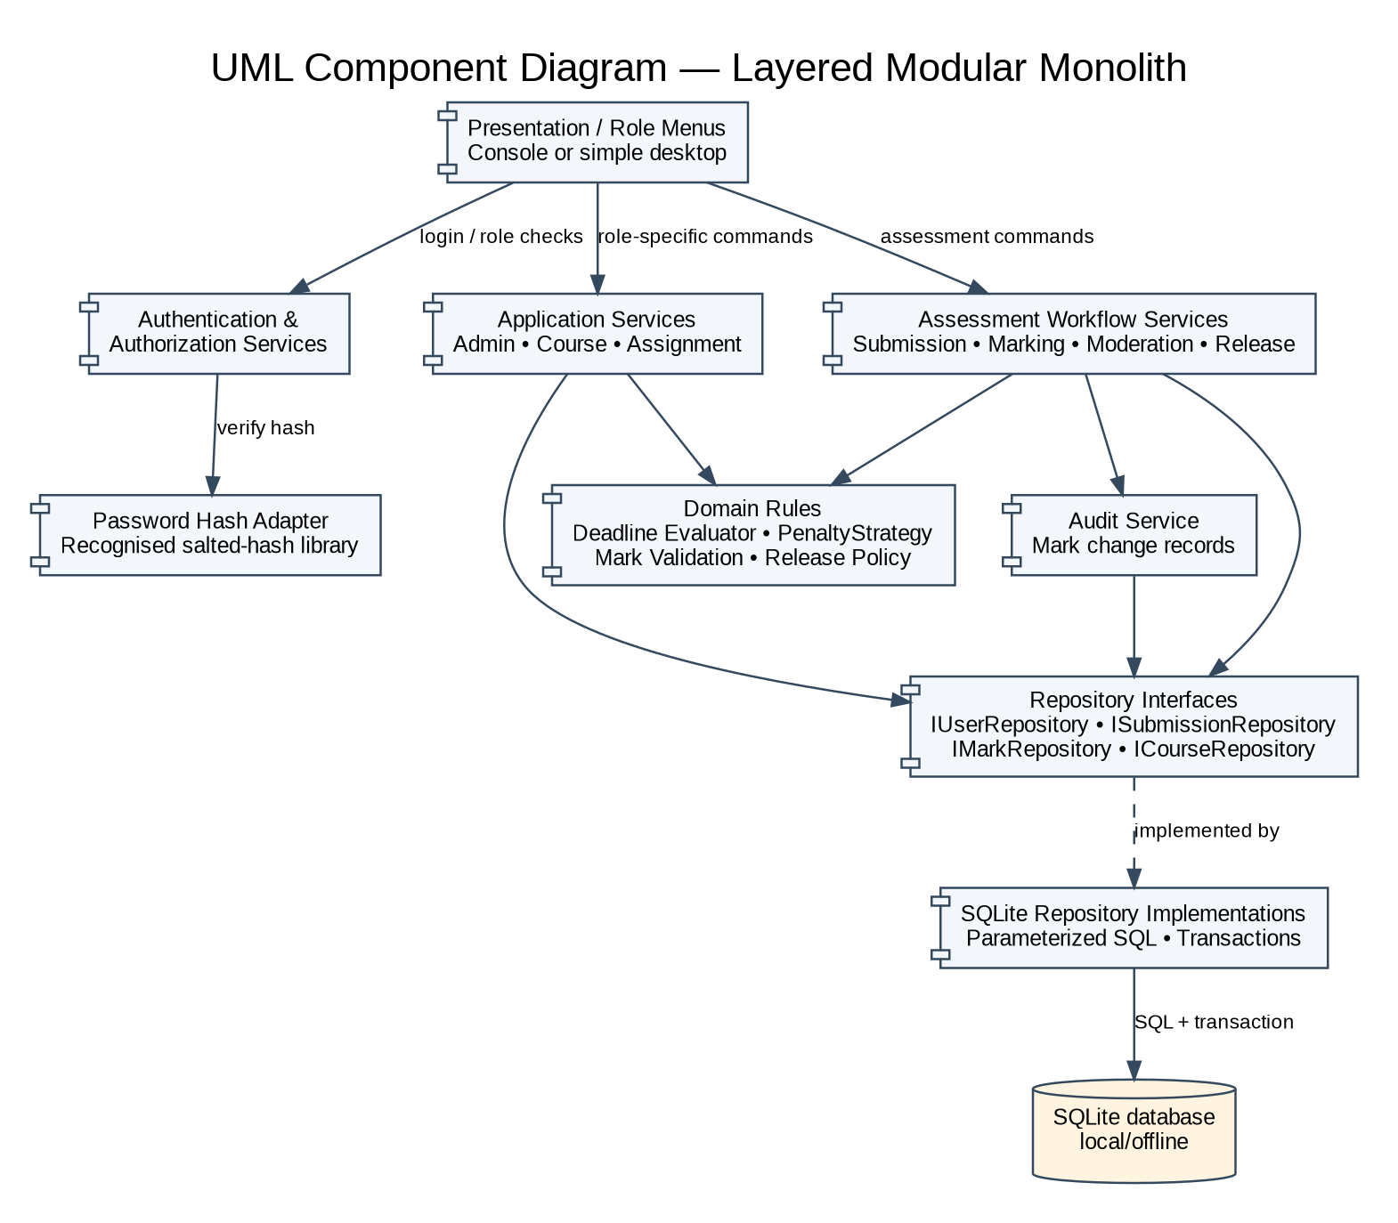
Figure 1. UML Component Diagram
The component diagram shows a local layered modular monolith. Services depend on repository interfaces; SQLite implementations own SQL and transaction details. The password hash adapter isolates the recognised hashing library. The arrows express dependencies rather than network calls.

2.1 Architecture decision summary
Criterion | Selected layered modular monolith | Rejected tightly coupled monolith
Offline deployment | One process and local SQLite; no network runtime dependency. | Can be offline, but UI, SQL and business rules become entangled.
Testability | Domain/services testable behind interfaces. | Tests depend on menus and live DB details.
Security | Central authorisation and scope checks. | Checks likely duplicated across handlers.
Transactions | Repository layer defines atomic write boundaries. | Transaction logic scattered across handlers.
Schedule | Small number of explicit layers; no distributed infrastructure. | Initially quick, but rework risk increases as rules interact.

3. Detailed class design, patterns and SOLID
User is abstract and exposes role() and can(action) as polymorphic operations. Administrator, Lecturer, HeadOfDepartment and Student are concrete subclasses. This preserves the brief requirement for inheritance and polymorphism without making the Student representative or IT officer application roles. Role-specific services still enforce policy centrally: polymorphism is not treated as a substitute for checking ownership, course assignment or department scope.
Domain classes include Department, Course, Enrolment, Assignment, Extension, Submission, SubmissionVersion, Mark, Feedback, ModerationDecision, ReleaseRecord and MarkAudit. Submission is the logical student/assignment aggregate; each SubmissionVersion is immutable after commit and receives a monotonically increasing version number. The current version is represented explicitly. Mark references the version that was marked, so later resubmission history does not silently change the meaning of a prior mark. Mark and feedback are separate concepts in the model, although a one-to-one feedback row is used for the current design. If the supervisor requires feedback history, that can be added without changing the moderation-before-release invariant.
Services include AuthenticationService, AuthorizationService, UserAdministrationService, CourseService, AssignmentService, ExtensionService, SubmissionService, DeadlineEvaluator, MarkingService, ModerationService, ResultQueryService and AuditService. Repository interfaces such as IUserRepository, ICourseRepository, ISubmissionRepository, IMarkRepository and IModerationRepository isolate persistence. SQLite implementations use prepared/parameterised statements and return explicit success/error results; exceptions are caught at application boundaries and reported without exposing credential or database details.
Pattern 1 — Strategy for late penalty. IPenaltyStrategy defines calculate(latenessDays, maximumMark). ProvisionalLinearPenaltyStrategy implements the Phase 2 recommendation of 10 percentage points of the assignment maximum per late day, capped at three days and with final mark floored at zero. SubmissionService records timing facts; MarkingService applies the chosen strategy once, preserving rawMark, penaltyAmount and finalMark separately. This supports FR-11 and BR-05 and lets tests replace the provisional strategy if Gate 1 approves a different interpretation. The cost is one extra interface and the need to avoid storing a penalty and then deducting it a second time.
Pattern 2 — Repository/DAO for persistence. Domain/application code calls repository interfaces instead of issuing SQL. SQLiteSubmissionRepository and SQLiteMarkRepository implement these interfaces. The pattern supports FR-19, NFR-03 and NFR-06, centralises parameterised queries and transactions, and permits isolated unit tests. Its cost is additional mapping code and a risk of over-abstraction; only persistence boundaries used by the use cases are abstracted.
SOLID application: (1) Single Responsibility — DeadlineEvaluator calculates timeliness; PenaltyStrategy calculates the penalty; AuditService appends audit events; repositories persist data. (2) Open/Closed — a different approved penalty strategy can be introduced by implementing IPenaltyStrategy rather than editing every marking branch. (3) Liskov Substitution — each concrete User subtype satisfies the User contract; services use the common account identity/role contract without assuming every user can submit or moderate. (4) Interface Segregation — separate focused repository interfaces prevent services from depending on unrelated CRUD operations. (5) Dependency Inversion — SubmissionService and MarkingService depend on interfaces and policies, not SQLite concrete classes.
Design invariants: marks must be between zero and the assignment maximum; only enrolled students may submit; lecturers may act only for assigned courses; HoDs may moderate/release only within their department; extensions must be authorised and belong to the student/assignment pair; every resubmission creates a new version; only the current valid version is eligible for marking; release requires approval and a separate explicit action; every mark change has actor, timestamp, old/new values and reason; password plaintext is never stored; multi-record updates use transactions. These invariants map to FR-02, FR-07–FR-18, BR-01–BR-08 and NFR-04–NFR-06.
Method contracts should make preconditions and postconditions visible to the implementation. SubmissionService::submit requires an authenticated Student, an active assignment, enrolment in the assignment's course, a valid content reference and a timestamp from the trusted application clock. On success it returns a receipt containing the submission identifier, version number, server timestamp and timing classification. It must not return success until the transaction commits. MarkingService::recordMark requires an authenticated Lecturer assigned to the relevant course, a current eligible submission version, a raw mark within the assignment range, written feedback and a reason when an existing mark is changed. It returns the persisted mark state, including raw mark, penalty amount and final mark, but not a student-facing release permission.
ModerationService::decide requires an authenticated HoD whose department matches the course's department, a current mark, and a decision of Approved or ReturnedForCorrection. A return decision must include a reason so the lecturer knows what must be corrected. A new mark or correction to a reviewed mark invalidates approval based on the earlier mark; implementation should either prevent editing while approval is active or require a fresh moderation decision. ModerationService::release requires a separate explicit command and rechecks approval at the time of release rather than relying on an earlier UI result. These contracts prevent time-of-check/time-of-use errors when the mark changes between moderation and release.
The Strategy pattern should not be used to hide an unresolved policy decision. ProvisionalLinearPenaltyStrategy is named provisional and its arithmetic is stated in the assumptions register. The strategy receives the number of late days and assignment maximum, returns a penalty amount and policy metadata, and does not update the database itself. MarkingService stores the raw mark separately, calculates the penalty once, then derives finalMark as the greater of zero and rawMark minus penaltyAmount. The strategy caps penalty days at three for late work within the window; beyond-window work receives zero according to BR-05. The implementation must not reapply the penalty when displaying, moderating or releasing a mark.
Repository interfaces should express operations in terms of domain outcomes rather than leak SQLite details. For example, saveVersion should return a result that distinguishes a validation rejection from a persistence failure, while findCurrent should return an optional submission rather than a raw SQLite row pointer. The SQLite implementation owns statement preparation, binding, row-to-object mapping and transaction mechanics. It should not silently convert a missing record into an empty but apparently valid domain object. A small, explicit repository API is easier to test than a generic repository with dozens of unused methods and helps maintain the single-responsibility and interface-segregation goals.
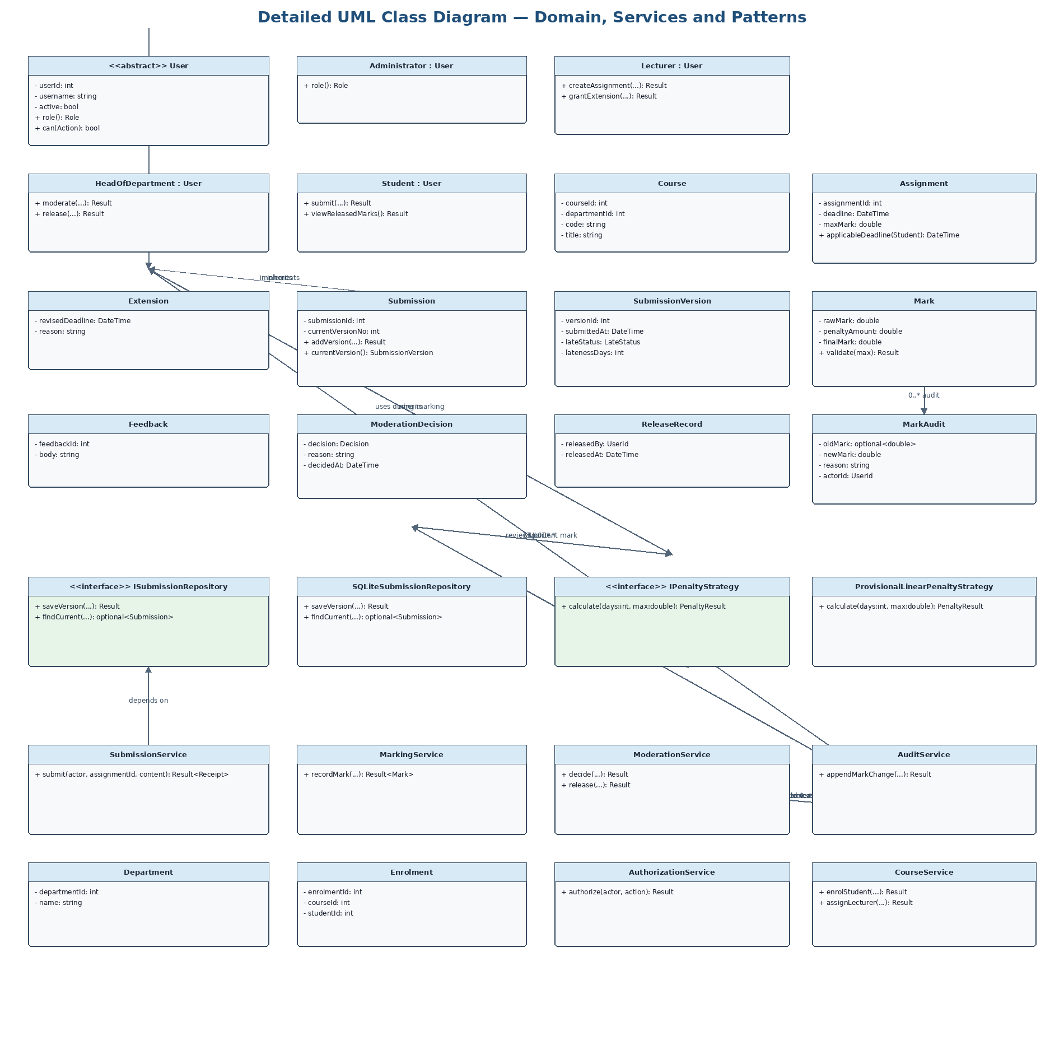
Figure 2. Detailed UML Class Design (domain/services overview)
The diagram shows abstract User inheritance, domain relationships, repository and penalty-strategy interfaces, and service dependencies. The SQL/data dictionary mapping later in the document gives the persistence detail. The class diagram is an overview-sized rendering; method contracts and multiplicities are elaborated in the accompanying class catalogue.

3.1 Class catalogue and principal contracts
Class / interface | Principal fields / operations | Responsibility
User (abstract) | userId:int; username:string; active:bool; role(); can(action) | Common identity contract; never stores plaintext password.
Administrator | role(); account/course administration service calls | Account lifecycle, departments, courses, assignments and enrolments.
Lecturer | createAssignment(...); grantExtension(...); recordMark(...) | Assigned-course work, individual extensions, marking and feedback.
HeadOfDepartment | moderate(...); release(...) | Department-scoped moderation and explicit release.
Student | submit(...); viewReleasedMarks() | Own enrolled courses, submissions and released results only.
Assignment / Extension | deadline, maxMark; revisedDeadline, reason | Assignment policy and one authorised individual extension per student/assignment.
Submission / SubmissionVersion | currentVersionNo; versionNo, submittedAt, lateStatus | Logical submission plus immutable version history.
Mark / Feedback | rawMark, penaltyAmount, finalMark; body | Mark references the version marked; feedback remains hidden before release.
ModerationDecision / ReleaseRecord | decision, reason, decidedAt; releasedBy, releasedAt | Separate approval decision and explicit release event.
MarkAudit / AuditService | oldMark, newMark, actor, changedAt, reason | Auditable changes; mark update and audit event share a transaction.
IPenaltyStrategy | calculate(days:int, max:double): PenaltyResult | Policy abstraction for the unresolved arithmetic rule.
ISubmissionRepository | saveVersion(...); findCurrent(...) | Persistence abstraction implemented by SQLite repository.
SubmissionService / MarkingService / ModerationService | submit(...); recordMark(...); decide(...); release(...) | Orchestrate use cases and enforce scope/state preconditions.

4. Behavioural design
The state machine deliberately distinguishes a submission’s timing classification from its assessment/release progression. OnTime, LateWithinWindow and BeyondWindow describe timing facts captured for a version; Marked/Pending moderation, Returned for correction, Approved/Awaiting release and Released describe workflow progression. Timing status is not itself a permission to release. A resubmission before the applicable deadline creates a new current version while retaining earlier versions; the latest valid version is the one marked. The handling of content submitted after the three-day window remains subject to OD-05: the outcome is zero, while whether the submitted file is retained or the attempt is refused must be approved.
The activity model crosses four swimlanes: Student, LMS/Application, Lecturer and HoD. The application authenticates and checks enrolment/availability, resolves an approved individual extension, records the timestamp, determines timeliness, and commits the version. The lecturer marks and supplies written feedback. Mark plus audit data commit atomically. The HoD reviews the current departmental mark, approves or returns it with a reason, and separately initiates release. Student result queries are guarded by ownership and release checks. The design does not equate moderation approval with release.
The Submit Assignment sequence uses the application service and repository boundary. Authentication/authorisation and course eligibility are checked before persistence. DeadlineEvaluator receives the server-recorded timestamp and applicable deadline; a successful commit creates a new immutable version and changes the current-version indicator in one transaction. A database failure yields no success receipt and leaves the previous current version intact. The penalty strategy is invoked during marking, not submission, to prevent deductions from being applied repeatedly during resubmission or display.
The Moderate and Release sequence first authorises the HoD, retrieves a department-scoped queue, records Approve or ReturnedForCorrection, and only then supports a distinct Release command. Before release, the service rechecks that the selected mark is current, belongs to the HoD’s department and has an approval decision. A student request before release returns no mark or feedback; after release it still verifies the requesting student owns the result. A mark changed after review invalidates the basis for approval and requires a fresh moderation decision; OD-08 asks stakeholders to approve the full post-release correction/re-release policy.
The submission lifecycle is represented by more than one conceptual dimension. A version has a timing classification based on the applicable deadline at the moment it was submitted. A logical Submission has a current version number. A mark refers to the version actually assessed. The moderation and release workflow belongs to that mark, not to a generic boolean on the student or assignment. This separation matters because a late submission may still be eligible for marking, a marked submission may be awaiting moderation, an approved mark may remain unreleased, and a released mark may later require an audited correction under the policy that stakeholders approve. A single status field attempting to represent all these facts would lose information or permit contradictory transitions.
Resubmission should be modelled as an event that creates a new immutable version, not as an overwrite of the original file reference. The previous version remains in history for traceability, but the current-version pointer changes only after the new version is successfully persisted. The service should reject a resubmission that violates the applicable deadline policy, and it should not modify the current version when validation or persistence fails. The exact treatment of attempts after the three-day window remains open: the design can record the attempt timestamp and zero outcome, but whether the submitted file is retained or the attempt is refused must be approved. This is recorded in OD-05 rather than hidden inside a diagram branch.
The moderation sequence intentionally includes two separate decision points. First, the HoD reviews the mark and records approval or return for correction. Second, the HoD explicitly chooses Release, after which the application checks that the current mark remains approved and within the HoD's department. If any selected item fails the eligibility check, the system must not expose it; a batch operation must validate each item and report its result rather than treating one eligible item as permission to release all selected marks. Student result queries must independently filter by the authenticated student and release record, so a direct request cannot bypass the menu workflow.
The diagrams are intentionally complementary. The state machine explains valid lifecycle transitions; the activity diagram assigns work to the Student, application, Lecturer and HoD; the Submit Assignment sequence explains service calls and persistence; and the Moderate and Release sequence explains authorisation, moderation decisions and result visibility. No single diagram is expected to show every detail. Their consistency is the important condition: all must preserve the latest-valid-version rule, the separate HoD release action, the prohibition on early result visibility and the unresolved status of the timing arithmetic.
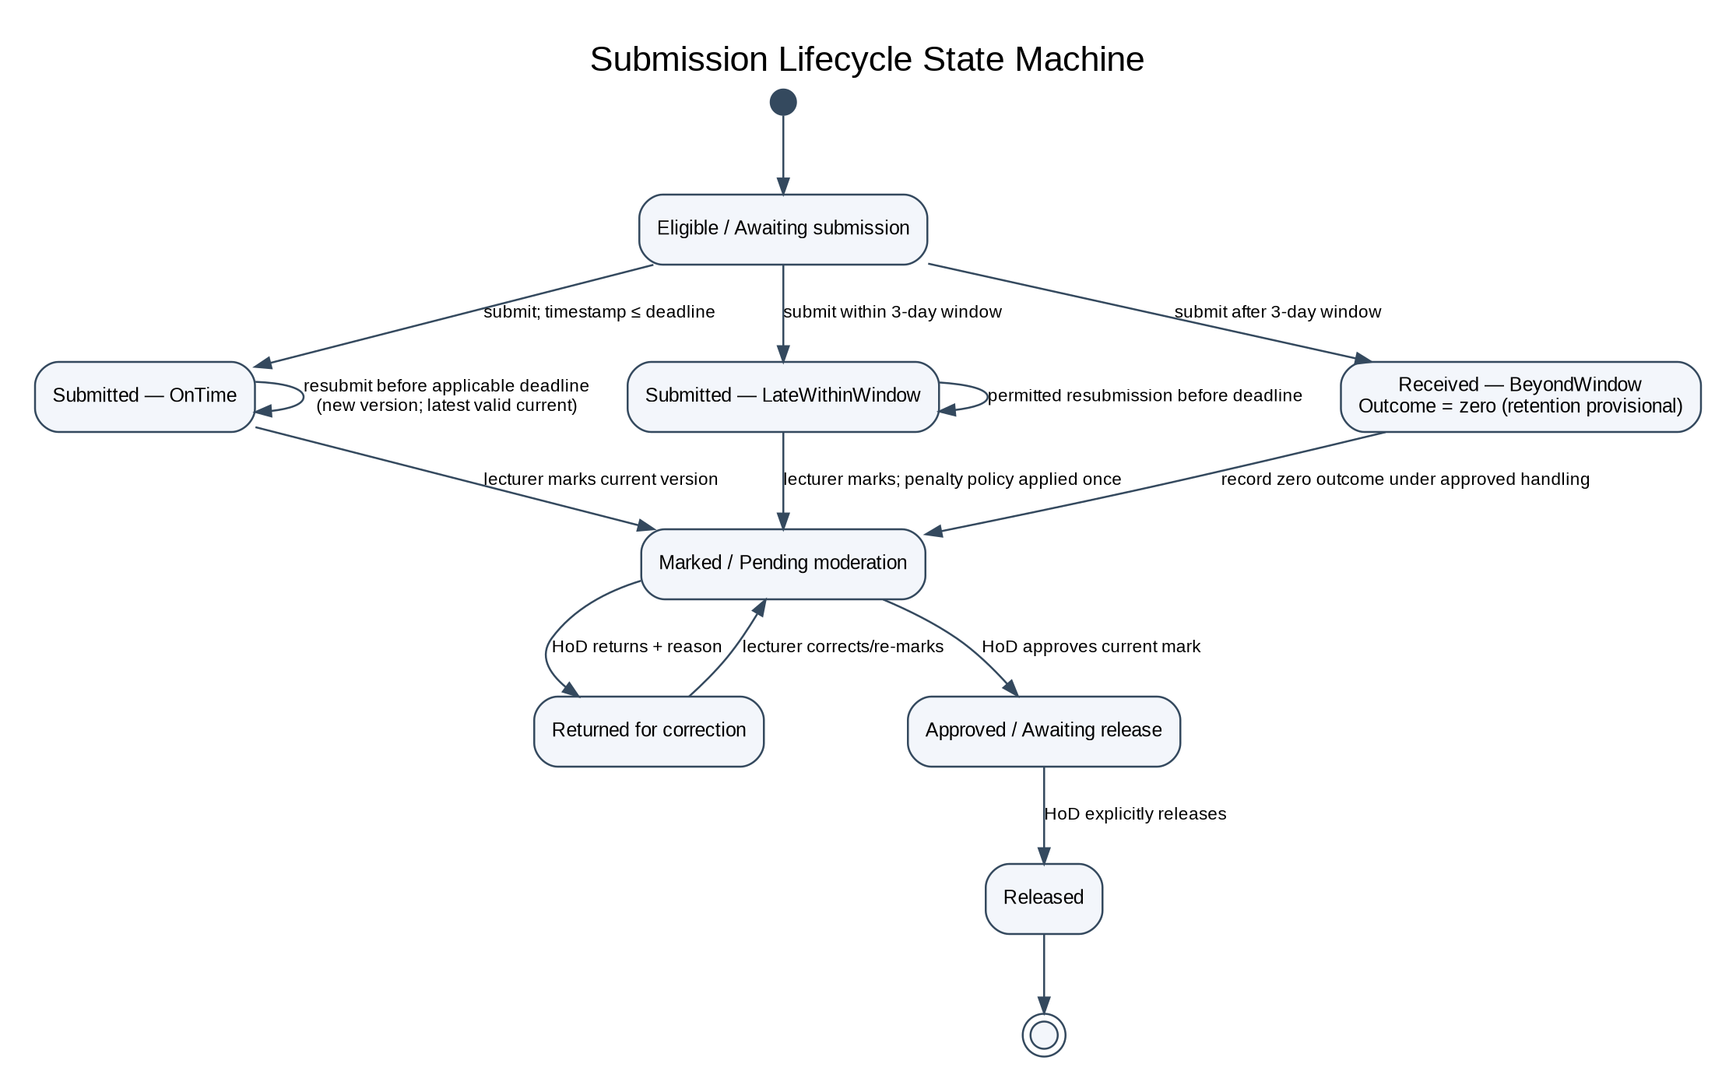
Figure 3. Submission Lifecycle State Machine
Timing labels are recorded per version, while marking/moderation/release are workflow states. A version is not released simply because it is marked or approved. The after-window content-retention choice remains provisional under OD-05.
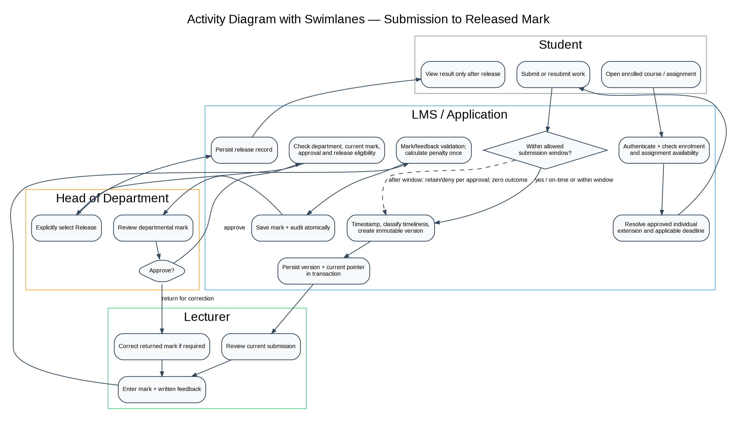
Figure 4. Activity Diagram with Swimlanes
The swimlanes allocate responsibility among Student, LMS/Application, Lecturer and HoD. The application owns timestamping, persistence and policy checks. HoD approval and explicit release are separate actions.
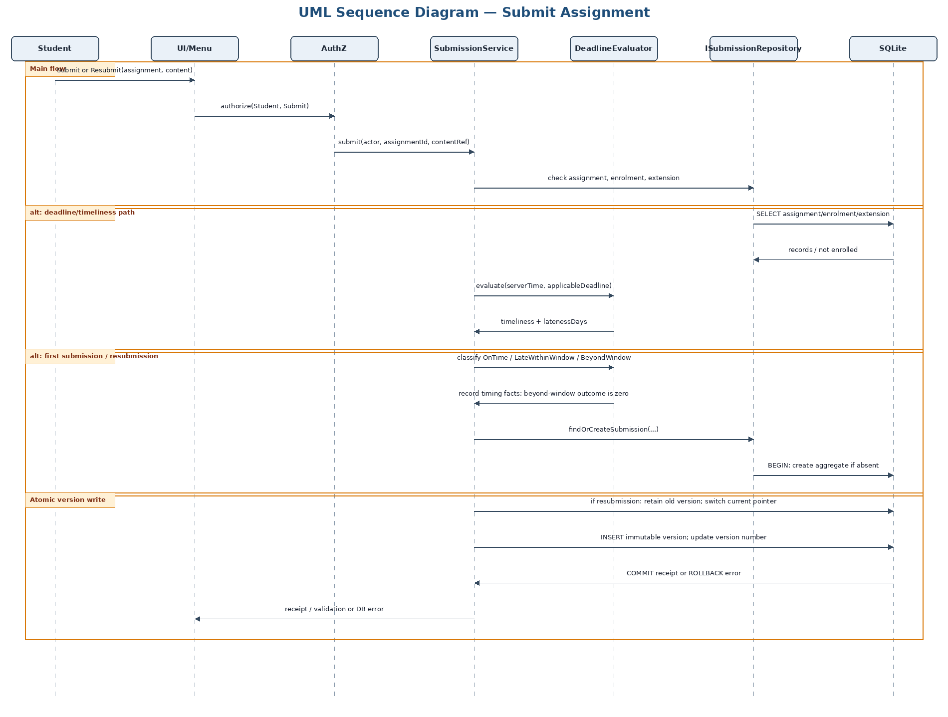
Figure 5. Sequence Diagram — Submit Assignment
Submission checks authorisation, enrolment and deadline before a transaction creates a new version. The penalty strategy is called during marking only; the submit path records facts needed for later calculation and avoids double deductions.
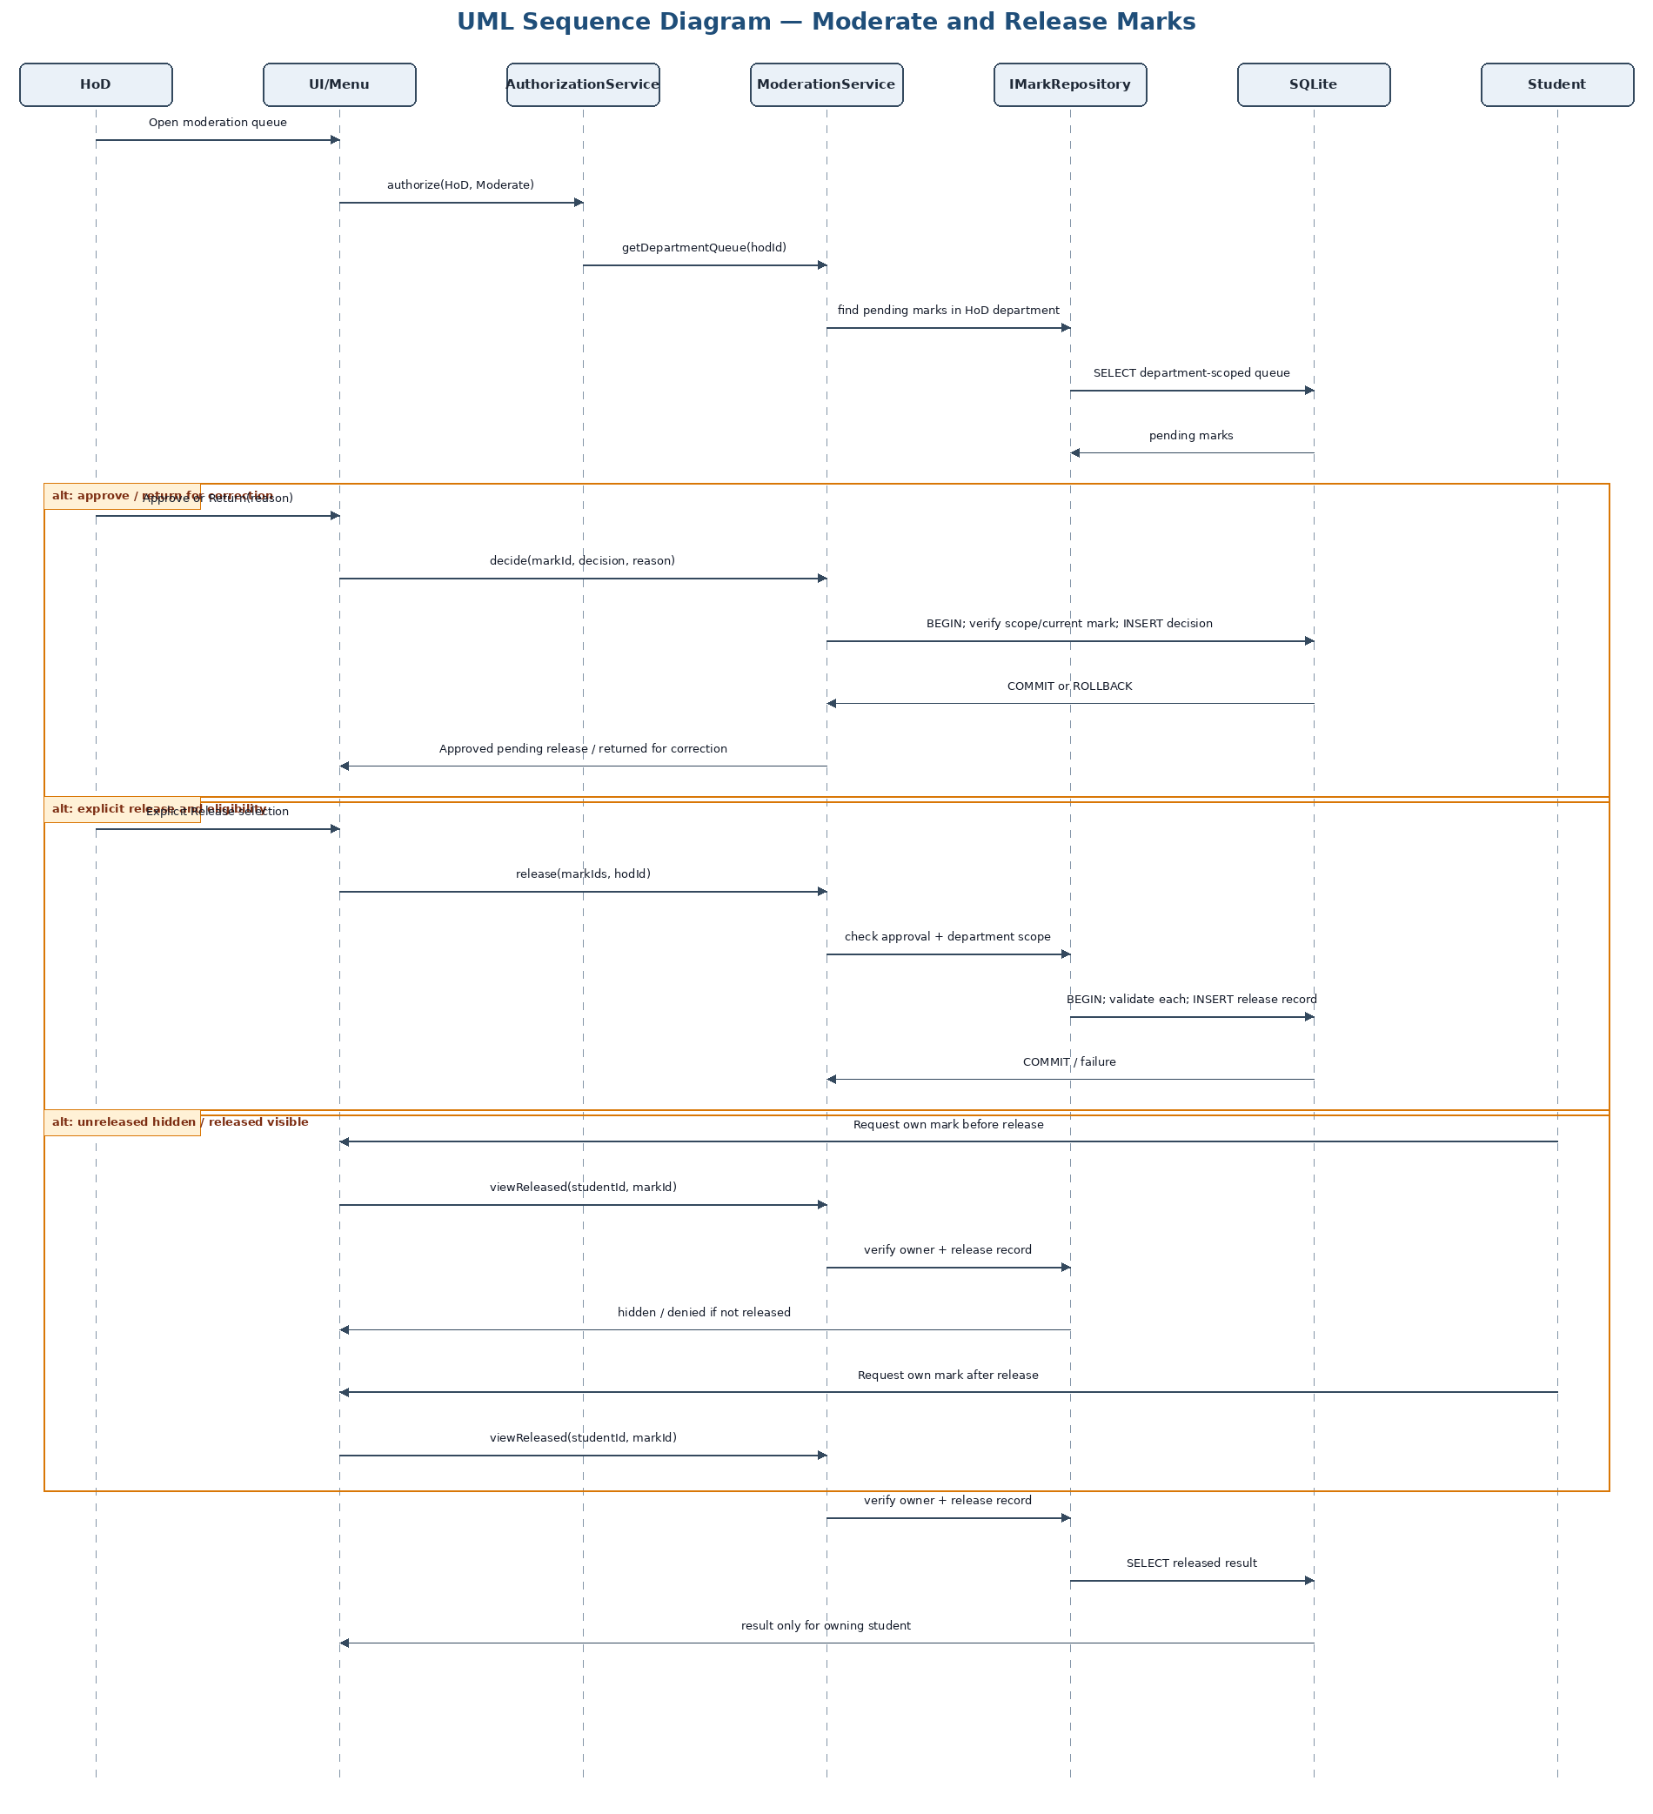
Figure 6. Sequence Diagram — Moderate and Release Marks
The service rechecks department scope and approval at release time. Student result retrieval is guarded by both ownership and an existing release record. The schema alone does not enforce all these multi-table conditions; services and transactions do.

5. Database design and normalisation
The SQLite schema separates accounts, organisational structure, teaching relationships, assessment definitions, submission history, marking, moderation, release and audit records. Surrogate integer primary keys are used for entities; natural identifiers such as username and course code have UNIQUE constraints. CourseLecturers and Enrolments are associative tables for many-to-many relationships. Extensions are individual in v1.0 and are unique per assignment/student pair under the current design. The schema does not add a class-wide extension table because BR-10 and C-10 place that feature in CR1/v1.1.
First Normal Form: every field is scalar; lecturer assignments and student enrolments are not stored as comma-separated lists, and each submission version is a separate row. Second Normal Form: in the junction table course_lecturers, assigned_at depends on the full composite key (course_id, lecturer_id); enrolments uses a surrogate key plus UNIQUE(course_id, student_id), so enrolment attributes depend on the enrolment. Third Normal Form: department names are stored only in departments rather than repeated in courses or users; course title/department data depend on course_id; submission-version facts depend on version_id; mark facts depend on mark_id; moderation/release/audit event facts depend on their own event keys. No non-key attribute is deliberately used to store a transitive department/course description.
The schema uses TEXT for ISO-8601 timestamps because SQLite has no dedicated datetime type. The application must define one timezone convention, preferably UTC for stored timestamps and an explicitly agreed school-local calendar rule for late-day calculations; it must not mix local timestamps and UTC silently. Boolean flags use INTEGER with CHECK values 0/1. Marks use REAL in the current design; the implementation should choose a documented precision/rounding rule and use the same rule in tests. The assignment maximum is positive, raw/final marks and penalty amounts are non-negative, but the cross-table rule final_mark <= assignment.max_mark is enforced in MarkingService because a row CHECK cannot safely inspect another table. Application validation must also check that the version belongs to the submission and assignment.
Foreign-key enforcement must be enabled on every SQLite connection using PRAGMA foreign_keys = ON. Foreign keys protect referential integrity but do not independently guarantee role scope, approved-before-release, or mark/audit atomicity. Those are enforced by service checks and transactions. The SQL schema was executed against a temporary SQLite database as part of this package validation; the validation report distinguishes schema execution from full workflow testing.
The database tables are organised around stable facts and event history. Users, departments, courses and assignments are relatively stable entities. CourseLecturers and Enrolments represent relationships that may change over time and should not be encoded as repeated names in a course row. Extensions record a specific authorisation for one student and assignment. Submissions identify the student/assignment pair, while SubmissionVersions preserve each accepted version's timestamp, content reference, applicable deadline snapshot and timing classification. Marks record the version assessed and the numeric components used to derive the final result. Moderation decisions, releases and audit events are separate rows because they describe distinct actions performed by identifiable actors at identifiable times.
Several important integrity rules cross table boundaries and therefore require application enforcement. SQLite can ensure that a mark references an existing submission and version, but a foreign key alone cannot prove that the version belongs to that submission. A CHECK constraint can ensure that final_mark is non-negative, but it cannot reliably compare final_mark with the maximum mark stored in another assignment row. A foreign key can prove that released_by refers to an existing user, but not that the user is an HoD for the owning department or that the current mark has an approval decision. These rules must be checked in the relevant service inside a transaction. Row-level constraints provide a defensive baseline, not a replacement for domain policy.
The schema is designed for offline operation and a single local database file. Foreign-key enforcement is connection-specific in SQLite, so database initialisation must execute PRAGMA foreign_keys = ON for every connection before operations. Repositories should use prepared statements and bind parameters rather than concatenate user input into SQL. The application should use short transactions, commit only after all related writes succeed, and avoid holding write locks while waiting for user interaction. Backups should be created using a documented SQLite-safe procedure and tested by restoration during deployment preparation; offline operation does not eliminate local data loss or corruption risks.
The choice of REAL for marks is a design simplification that requires a consistent numeric policy. The implementation should specify whether marks may contain fractional values, the permitted decimal precision, and how rounding is applied after a penalty. If exact decimal arithmetic is required, storing integer hundredths or another scaled integer may be safer than floating-point comparisons. That choice should be made before implementation and reflected in MarkingService validation, SQL constraints where possible, data dictionary descriptions and boundary tests. SQLite REAL by itself does not define an institutionally correct rounding rule.
Indexes are included for common lookup paths rather than every column. The course department index supports HoD-scoped course and moderation retrieval; the enrolment index supports student course access; the assignment course/deadline index supports assignment lists; the submission and version indexes support current-version lookup and history; and the audit index supports chronological inspection of mark changes. Indexes improve selected reads but increase write cost and storage use, so additional indexes should be justified by query plans or measured performance. NFR-02 should be tested using the specified assessment-record scale on agreed target hardware, not inferred from the existence of indexes alone.
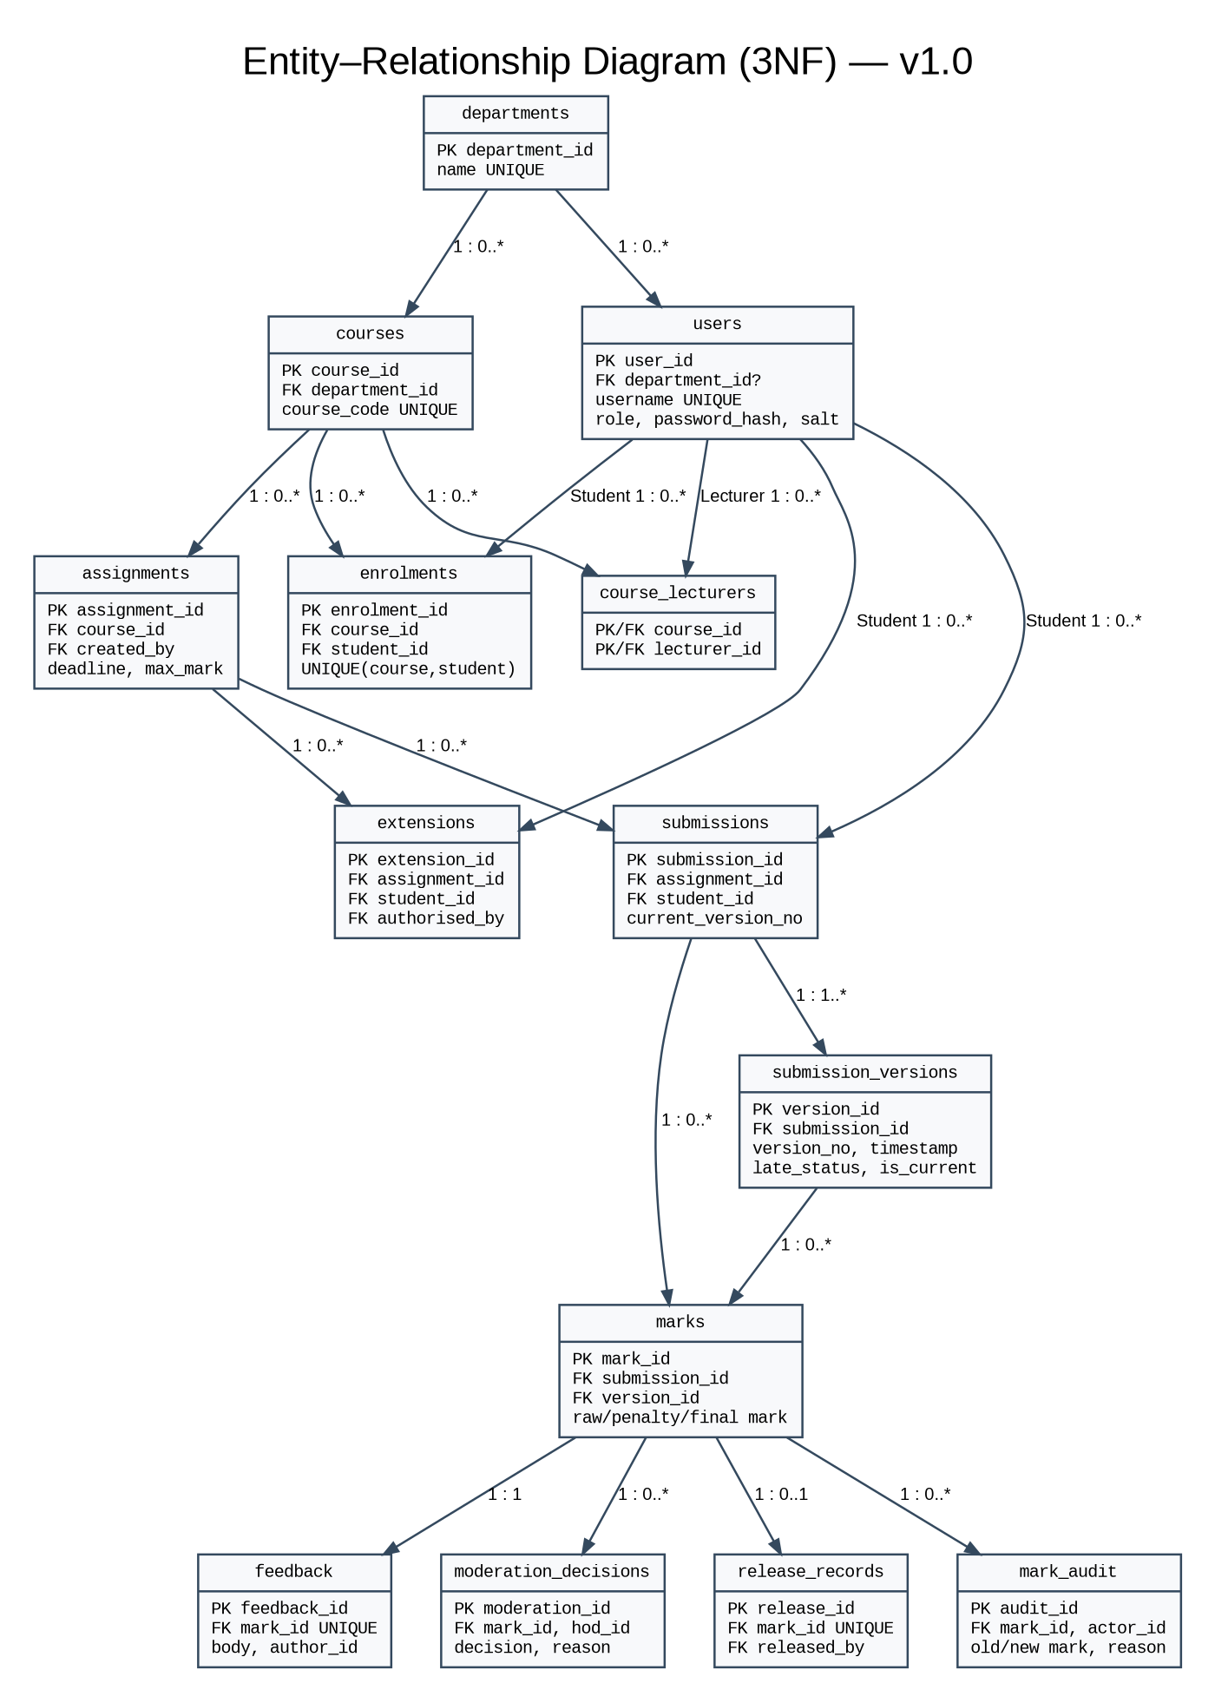
Figure 7. Entity–Relationship Diagram — 3NF v1.0
The ERD matches the SQLite schema tables and foreign-key relationships. CourseLecturers and Enrolments resolve many-to-many relationships; submission versions and event tables preserve history. Class-wide extensions are deliberately absent from v1.0.

5.1 Key relationships and cardinality
Relationship | Cardinality | Rationale
Department–Course | 1 to 0..* | Each course belongs to one department.
Course–Lecturer | many-to-many via course_lecturers | A course may have multiple assigned lecturers and a lecturer may teach multiple courses.
Course–Student | many-to-many via enrolments | Enrolment is an associative entity with uniqueness per student/course.
Assignment–Extension | 1 to 0..* | Each individual extension belongs to one assignment and student.
Assignment–Student Submission | 1 to 0..* | One logical submission per student/assignment, enforced by UNIQUE.
Submission–SubmissionVersion | 1 to 1..* | Each resubmission creates a distinct version.
Submission–Mark | 1 to 0..* | History may retain prior marks; one current mark per submission is indexed.
Mark–ModerationDecision | 1 to 0..* | Decision history retains return/approval records.
Mark–ReleaseRecord | 1 to 0..1 | A mark is not visible until a release event exists.
Mark–MarkAudit | 1 to 0..* | Mark changes append auditable events.

5.2 Class-to-database mapping
C++ class/interface | Table(s) | Mapping type / explanation
User and concrete subclasses | users | Single-table inheritance with role discriminator; CHECK restricts the four roles.
Department | departments | Entity table; users/courses reference it.
Course | courses | Entity table with department FK.
CourseLecturer association | course_lecturers | Junction table for many-to-many teaching assignment.
Enrolment | enrolments | Associative entity; unique course/student pair.
Assignment | assignments | Entity table; created_by references lecturer account (role checked in service).
Extension | extensions | Individual extension entity; class-wide extension excluded from v1.0.
Submission + SubmissionVersion | submissions; submission_versions | Aggregate root plus immutable child rows for history.
Mark + Feedback | marks; feedback | Separate rows to isolate mark lifecycle and feedback content.
ModerationDecision | moderation_decisions | Append-only decision history.
ReleaseRecord | release_records | Explicit release event; unique per mark in v1.0.
MarkAudit | mark_audit | Append-only audit event.
Services, Strategy, repository interfaces | No direct table | Application behaviour/abstraction, not persistent business entities.

6. Traceability, verification and project risks
Traceability is maintained from Phase 2 identifiers to use cases, components, classes/interfaces, diagrams, tables and planned tests. UC-01 is Submit assignment, UC-02 is Mark submission and provide feedback, and UC-03 is Moderate and release marks. Administration functions are traced to cross-cutting services and their own planned test groups. NFR tests are planned rather than reported as executed: the 2-second performance targets require agreed target hardware; NFR-02 additionally uses 100,000 assessment records; NFR-05 requires an approved negative-test matrix.
The design responds directly to Phase 1 risks. R1 (requirements ambiguity) is controlled by the open-decision table and explicit Gate 1 approval points. R2 (individual schedule pressure) is controlled by retaining the seven-week schedule and protecting Gate 2/Gate 3; no scope-expanding infrastructure is introduced. R3 (UML/database mismatch) is controlled by shared class/table names and a generated schema/data dictionary/traceability set. R4 (security) is controlled through salted hashing, central authorisation, scope checks and negative tests. R5 (assessment-rule complexity) is controlled by isolating DeadlineEvaluator and IPenaltyStrategy and enumerating boundary tests. R6 (SQLite defects) is controlled by repository interfaces, parameterised SQL and transactions. R7 (insufficient testing) is controlled by defining tests before implementation and preserving the Phase 1 goal of at least 70% business-logic line coverage. R8 (CI/static analysis) remains a Week 2–3 setup and Weeks 4–6 verification responsibility. R9 (offline deployment) is addressed by local SQLite and planned clean-machine installation testing. R10 (CR1 impact) is handled as a separate v1.1 change with regression tests.
The V-Model links detailed design to planned unit tests for deadline/penalty strategies and domain invariants; component/integration tests verify repository transactions, authentication and service orchestration; system tests verify UC-01/02/03 end-to-end; acceptance tests validate each role’s tasks, offline operation and usability. Tests depending on OD-01 through OD-08 remain pending the relevant approvals. No test execution, coverage figure, CI success or Gate 2 approval is claimed in this SDD.
The traceability matrix is a control artefact rather than a claim that implementation already exists. Each FR and NFR is linked to a use case or cross-cutting service, relevant classes/interfaces, diagrams, tables and a planned test identifier. During Phase 4, source files and implementation evidence should be added to the matrix. During Phase 5, planned tests should be supplemented with actual test names, execution results, defects and retest evidence. A row should not be marked verified merely because a design element is present. This distinction matters because the official brief penalises inconsistent artefacts and requires requirements to be traceable through design, source code and tests.
The V-Model influences the planned verification strategy. Unit tests should verify pure domain operations such as mark-range validation, deadline classification and the selected penalty strategy, including boundary values and negative cases. Integration tests should verify repository mapping, foreign-key enforcement, transaction rollback and coordinated service/repository behaviour. System tests should exercise the fully dressed use cases, especially a submission that is late or resubmitted, marking and audit, HoD return/approval, and the separate release action. Acceptance tests should observe each role completing real tasks, with offline operation and simple navigation included. Performance tests must state the actual target computer, database seed size, sample count and percentile calculation rather than reporting only an average.
Security and privacy tests should verify both allowed and denied behaviour. The role-permission matrix should include Student attempts to submit to a non-enrolled course, Lecturer attempts to mark a course they do not teach, HoD attempts to release a result from another department, and Student requests for another student's released result. Credential inspection should verify that plaintext passwords are absent from SQLite and logs and that a recognised salted password-hashing library is used. Error-path tests should force database failures where practical and check that the UI does not display a success receipt, the transaction rolls back and sensitive internal details are not exposed to the user.
The design also supports professional and ethical expectations in the brief. Learner data and marks should be visible only to users who need them for their defined responsibilities. The application should avoid unnecessary collection of personal information, avoid printing credentials or full submission content to logs, and provide clear error messages without exposing internal database details. Accessibility is not solved by architecture alone, but simple role-specific navigation, consistent prompts, readable contrast and avoiding colour-only status indicators reduce barriers. The late-penalty policy must be implemented transparently and consistently; until the arithmetic and day-count rules are approved, the system should not present the provisional interpretation as settled school policy.

6.1 Full requirements baseline
ID | Requirement summary | Priority | Design implication | Planned verification
FR-01 | Authenticate users by username and password before protected functions | Must | AuthenticationService; User; password-hash adapter | T-LOGIN
FR-02 | Enforce role-based permissions for all four roles | Must | AuthorizationService; role policies | T-AUTHZ
FR-03 | Administrator creates, updates, deactivates and assigns roles to accounts | Must | UserAdministrationService; UserRepository | T-ADMIN-ACCOUNT
FR-04 | Administrator creates and maintains departments and courses | Must | AdministrationService; Department; Course | T-ADMIN-COURSE
FR-05 | Administrator assigns lecturers and enrols students | Must | CourseService; Enrolment | T-ENROL
FR-06 | Lecturer creates assignment with title, deadline and maximum mark | Must | AssignmentService; Assignment | T-ASG-CREATE
FR-07 | Lecturer grants and records individual extension and authoriser | Must | ExtensionService; Extension | T-EXT
FR-08 | Student views only enrolled courses and their assignments | Must | CourseQueryService; AuthorizationService | T-COURSE-SCOPE
FR-09 | Record submission timestamp against applicable deadline | Must | SubmissionService; DeadlineEvaluator | T-SUB-DEADLINE
FR-10 | Permit resubmission before applicable deadline; mark latest valid version | Must | SubmissionService; SubmissionVersion | T-RESUB
FR-11 | Apply late penalty and zero after three-day window | Must | IPenaltyStrategy; DeadlineEvaluator | T-PENALTY
FR-12 | Lecturer views submissions only for assigned courses | Must | SubmissionQueryService; AuthorizationService | T-LECTURER-SCOPE
FR-13 | Lecturer records mark within zero and maximum and written feedback | Must | MarkingService; Mark; Feedback | T-MARK-RANGE
FR-14 | Every mark change records actor/time/old/new/reason | Must | AuditService; MarkAudit | T-AUDIT-ATOMIC
FR-15 | HoD moderates departmental marks and records decision | Must | ModerationService; ModerationDecision | T-MOD-SCOPE
FR-16 | Hide marks and feedback until HoD release | Must | ResultQueryService; ReleasePolicy | T-HIDDEN
FR-17 | Only approved marks can be explicitly released by HoD | Must | ModerationService; ReleaseRecord | T-RELEASE-GUARD
FR-18 | Student views only own released mark and feedback | Must | ResultQueryService; AuthorizationService | T-OWN-RELEASED
FR-19 | Persist assessment and administrative data in SQLite across restarts | Must | Repository interfaces + SQLite implementations | T-PERSIST
FR-20 | Validate input and handle DB errors without unexpected crash | Must | Validation; Result/error handling; transactions | T-ERROR-ROLLBACK
FR-21 | Display individual revised deadline in affected student assignment details | Should | AssignmentQueryService; Extension | T-EXT-DISPLAY
FR-22 | Provide simple role-specific menu/navigation flow | Must | Presentation/UI; role menu | T-UI-WALKTHROUGH
NFR-01 | 95% login attempts <2s with 800 stored student records | Must | Authentication/indexes; benchmark on agreed target hardware | T-PERF-LOGIN
NFR-02 | 95% assignment-list queries <2s with 800 students and 100,000 assessment records | Should | Indexes; query plan; bounded query results | T-PERF-LIST
NFR-03 | Core workflows operate offline with local DB available | Must | No network runtime dependency | T-OFFLINE
NFR-04 | Recognised salted password hash; no plaintext in DB/logs | Must | PasswordHashAdapter; credential logging prohibited | T-PASSWORD
NFR-05 | 100% prohibited actions denied in approved negative-test matrix | Must | Central AuthorizationService + scope checks | T-AUTHZ-MATRIX
NFR-06 | Every successful mark change has audit; failed change changes nothing | Must | Single DB transaction for mark + audit | T-AUDIT-TX
NFR-07 | 100 consecutive scripted core workflows without unhandled crash | Should | Exception boundaries; repeatable system test | T-RELIABILITY-100
NFR-08 | 4/5 representative users complete task after ≤10 min orientation | Should | Simple role menus; usability observation | T-USABILITY
NFR-09 | Clean checkout builds with CMake and runs automated tests | Must | CMake/CI pipeline; documented commands | T-CLEAN-BUILD
NFR-10 | Technician installs/launches within 30 min excluding OS setup | Should | Offline install guide; clean-machine check | T-INSTALL

6.2 Business rules BR-01 to BR-10
ID | Phase 2 rule | Design treatment
BR-01 | Username/password login and role-limited actions | AuthenticationService; AuthorizationService
BR-02 | Administrator manages accounts, departments, courses, assignments and enrolments | Administration/Course services
BR-03 | Lecturer creates assignments, grants individual extensions, marks and writes feedback | AssignmentService; ExtensionService; MarkingService
BR-04 | Students may resubmit before applicable deadline | SubmissionService + immutable versions
BR-05 | 10% available-mark penalty/day up to three days; after that zero | DeadlineEvaluator + provisional Strategy; approval required for arithmetic
BR-06 | HoD reviews departmental marks before release | ModerationService + ReleasePolicy
BR-07 | Every mark change records actor/time/old/new/reason | MarkAudit + atomic transaction
BR-08 | Plaintext passwords prohibited; salted hashes required | PasswordHashAdapter; NFR-04
BR-09 | C++17 + SQLite offline/local deployment | Layered local application
BR-10 | Class-wide extensions are CR1/v1.1 | No class-wide extension entity in v1.0

6.3 Phase 2 conflict register C-01 to C-10
Conflict ID | Phase 2 conflict | Design resolution/status
C-01 | Lecturer preference for immediate mark release conflicts with Principal/HoD moderation control. | HoD moderation and explicit release take precedence; marking alone never exposes results.
C-02 | Resubmission flexibility must coexist with enforceable deadlines. | Permit resubmission before applicable deadline; latest valid version is marked; history retained.
C-03 | Student objects to rejecting late work; HoD specifies penalty window. | Accept within the three-day window with penalty; after window outcome is zero; retention handling open.
C-04 | Individual extension interaction with late penalty is not fully defined. | Provisional: use recorded revised deadline; approval required.
C-05 | “Each day late” does not specify calendar day or rolling 24 hours. | Provisional school-local calendar days; approval required.
C-06 | Exact deadline boundary is unspecified. | Provisional: timestamp at or before deadline is on time.
C-07 | “10% of available mark” arithmetic is ambiguous. | Provisional: 10 percentage points of maximum per late day, capped at three days.
C-08 | “Quickly” and “all 800 students” lack hardware/concurrency definitions. | Use stated response-time targets and 800 stored records; confirm target hardware and concurrency.
C-09 | Simple interface must not weaken security and workflow controls. | Use simple role menus while retaining central authorisation, audit and moderation controls.
C-10 | Individual extensions are v1.0; class-wide extensions belong to CR1/v1.1. | No class-wide extension implementation/table in v1.0; analyse and regression-test in Week 7.

6.4 Open decisions and assumptions
ID / source | Provisional interpretation | Design impact | Consequence if changed | Approval status
OD-01 / C-05 / BR-05 / FR-11 | Use school-local calendar days for provisional lateness calculation. | DeadlineEvaluator and boundary tests use local calendar date boundaries. | Rolling 24-hour arithmetic would change latenessDays and penalty tests. | Awaiting HoD/supervisor approval
OD-02 / C-06 / FR-09 / UC-01 | Timestamp at or before applicable deadline is on time. | DeadlineEvaluator uses submittedAt <= applicableDeadline. | Strictly-before boundary would change equality test. | Provisional; validate at Gate 1
OD-03 / C-04 / BR-03 / FR-07 | Use recorded individual revised deadline as the applicable deadline. | Extension lookup precedes lateness calculation. | Alternative extension semantics affect timing/penalty tests. | Provisional; approval required
OD-04 / C-07 / BR-05 / FR-11 | Provisionally deduct 10 percentage points of assignment maximum per late day, capped at three days; final mark not below zero. | PenaltyStrategy calculates min(maxMark, days * 0.10 * maxMark); applied once to raw mark. | Percentage-of-earned-mark interpretation changes arithmetic and expected results. | Awaiting HoD approval
OD-05 / C-03 / FR-11 / UC-01 | A beyond-window submission receives zero; retain timestamp/attempt metadata; file retention versus refusal requires decision. | Design represents BeyondWindow; exact content retention/acceptance remains a policy toggle. | Could change whether version content_ref is persisted. | Outcome settled; retention detail open
OD-06 / C-08 / NFR-01 / NFR-02 | Use 800 stored students; separately seed 100,000 submission/assessment records; concurrency is not implied. | Indexed schema and benchmark plans capture hardware/configuration. | Concurrent-user requirement would change deployment/performance testing. | Hardware/concurrency confirmation required
OD-07 / C-09/C-10 / FR-21 | Show individual revised deadline in assignment details; class-wide extension list visibility is CR1 v1.1. | Extension service is isolated; no class-extension table in v1.0. | CR1 adds extension target scope and list query changes. | v1.0 interpretation; CR1 separate
OD-08 / C-01 / FR-14–FR-18 | After-release correction requires authorised change, audit, fresh moderation and explicit re-release. | Use mark history/audit and a new moderation decision; release policy prevents silent edits. | Could require mark versioning or revocation model refinement. | Open for supervisor/HoD approval

6.4 Phase 1 risk controls carried into design
Phase 1 risk | Design response
R1 Requirements ambiguity | Open-decision table; Gate 1 sign-off; pending tests remain labelled.
R2 Schedule pressure | Preserve Waterfall and seven-week schedule; no coding before Gate 2.
R3 UML/database inconsistency | Shared names, generated SQL/data dictionary, traceability and consistency audit.
R4 Security | Salted hash adapter; central authorisation; scope checks; negative tests.
R5 Assessment-rule complexity | DeadlineEvaluator and Strategy; explicit boundary cases.
R6 SQLite/data-access defects | Repository layer, parameterised SQL, transaction integration tests.
R7 Insufficient testing | Test IDs allocated in design; maintain ≥70% business-logic coverage target.
R8 CI/static analysis | CMake/CI and static analysis planned before implementation and verified at Gate 3.
R9 Offline deployment | No network dependency; clean local install test and installation documentation.
R10 CR1 change impact | Separate v1.1 change analysis and regression suite.

6.5 Design-level test scenarios (planned)
Test ID | Trace | Scenario | Status
T-LOGIN | FR-01/NFR-04 | Valid, invalid and inactive user login; inspect DB/logs for plaintext. | Pending implementation
T-AUTHZ | FR-02/NFR-05 | Run role × action negative matrix; all prohibited actions denied. | Role matrix approval
T-SUB-BOUNDARY | FR-09 / OD-02 | Submit exactly at deadline, immediately before and after. | Pending OD-02
T-RESUB | FR-10 | Two permitted versions; latest valid current version is marked; earlier version retained. | Planned
T-PEN-1..4 | FR-11 / OD-01/04 | On time, day 1, day 3, after day 3; verify one deduction and floor at zero. | Pending policy approval
T-EXT | FR-07/FR-21 / OD-03 | Authorised extension revises applicable deadline; unauthorised extension denied. | Pending OD-03
T-MARK-RANGE | FR-13 | Mark -0.01, 0, max, and above max; only in-range values accepted. | Planned
T-AUDIT-TX | FR-14/NFR-06 | Mark + audit success; force audit write failure and confirm mark rollback. | Planned integration test
T-MOD-RELEASE | FR-15–FR-18 | Unapproved release denied; approval alone hidden; explicit release visible to owner only. | Planned
T-SCOPE | FR-08/12/15/18 | Cross-course, cross-department and other-student access denied. | Planned
T-PERSIST | FR-19 | Restart application and verify users, submissions, marks and audit persisted. | Planned
T-DB-ERROR | FR-20 | Constraint/database failure returns error, no partial record, no crash. | Planned
T-OFFLINE | NFR-03 | Disconnect internet; complete core workflow with local DB available. | Planned
T-PERF | NFR-01/02 | Measure 95th percentile on agreed hardware using 800 users and 100,000 assessment rows. | Hardware confirmation required
T-RELIABILITY | NFR-07 | 100 scripted workflow runs; record crashes/exceptions. | Planned
T-CR1-REGRESSION | BR-10 / CR1 | v1.1 class extension visible; individual extension and current deadline behaviour unchanged. | Week 7 only

7. CR1 impact analysis and version boundary
CR1 requests a lecturer ability to extend a deadline for a whole class, rather than only an individual student, and requires those extensions to appear on the student assignment list. This is a maintenance change for v1.1, scheduled in Week 7 after v1.0 deployment and before regression testing. It is not a v1.0 feature.
The individual Extension class and ExtensionService should be kept behind an extension policy/query interface. For v1.1, the design can introduce a class-level extension entity or an extension scope/target model and define precedence between individual and class-wide deadlines. The class-wide extension must be visible in assignment-list queries. Affected artefacts include BR-10, FR-07/FR-21 and a new approved CR1 requirement, Extension/Assignment services, the ERD and schema, applicable sequence/activity diagrams, data dictionary, traceability matrix, and tests for class-wide visibility, deadline precedence and regression of individual extensions. Exact precedence if both class-wide and individual extensions exist is not defined in the current Phase 2 baseline and must be decided during CR1 impact analysis, not assumed in v1.0.
CR1 is a controlled maintenance change, not permission to quietly expand v1.0. The Week 7 plan requires analysis, design/code update, regression testing and a v1.1 release. The extension design should isolate deadline resolution behind an interface or service operation so a later policy can consider both individual and class-wide extensions without duplicating deadline arithmetic in submission and assignment-list code. A class-wide extension may affect many students at once, so its data model, authorisation, visibility and precedence rules require more careful treatment than inserting one extension row per student without a clear audit trail.
The most important CR1 decision is precedence when a student has both an individual extension and a class-wide extension. Phase 2 does not settle this. A v1.1 change proposal should define whether the later deadline wins, whether individual extensions override the class extension, or whether another explicit rule applies. The choice affects the applicable-deadline resolver, assignment-list display, submission timing classification, penalty calculation and regression tests. It should be documented in the change record and approved before implementation is changed. Migration must preserve existing individual extensions and the meaning of already submitted versions, which retain their recorded deadline snapshot.
The v1.1 change should be delivered with a migration plan and a regression checklist. Before the change, the developer should tag v1.0 and preserve a copy of the database schema and baseline tests. After implementing class-wide extensions, test new behaviour with a class where no individual extension exists, a student with an individual extension, and an assignment where a class-wide extension is changed. The test suite should confirm that existing submission versions retain the deadline snapshot used at submission, that individual extensions still work, and that students see the correct class-wide deadline on the assignment list. The final v1.1 release must be separately tagged as required by Phase 1.
Area | v1.0 design | CR1/v1.1 impact
Requirements | Individual extensions only (BR-03, FR-07, FR-21). | Add approved class-wide extension requirement; preserve BR-10 change boundary.
Classes/interfaces | Extension + ExtensionService; isolate applicable-deadline lookup. | Add class-extension entity/policy or extension scope model; define precedence.
Database | extensions unique per assignment/student. | Add class target/scope representation; migration and indexes.
Diagrams | Current UML models individual extension only. | Update class, activity, sequence and ERD diagrams.
UI/query | Individual revised deadline in assignment details. | Show class-wide extension in student assignment list.
Tests | Individual extension tests. | Class-wide visibility, precedence, migration and full regression tests.

8. Gate 2 readiness and outstanding approvals
This document is prepared for Gate 2 review. The architecture, seven required diagrams, class patterns, SOLID rationale, data dictionary, SQL schema, class-table mapping and traceability matrix are supplied. Gate 2 is not formally passed by document creation alone. Before approval, the supervisor/HoD should confirm the provisional timing and penalty decisions, late-after-window retention, post-release correction policy, timestamp/rounding conventions, target hardware and concurrency interpretation. The implementation dependency remains hard: coding starts only after approval.
The readiness checklist and validation report identify the artefacts created and the checks actually performed. A positive SQL execution check is not a substitute for workflow tests, a clean CMake build, static analysis, security review or Phase 5 system/acceptance evidence. Those remain future tasks in the Phase 1 plan.
The Gate 2 review should be conducted as a design decision, not a formality. The reviewer should follow a representative path across the artefacts: start from FR-10, locate the submission and version concepts in the class diagram, follow the Submit Assignment sequence, identify submissions and submission_versions in the ERD/schema, and locate the resubmission tests in the traceability matrix. Repeat this for FR-14 and NFR-06 through MarkingService, AuditService, marks and mark_audit, and for FR-16/FR-17 through ModerationService, moderation_decisions and release_records. A mismatch discovered in this review should be corrected in all affected artefacts before approval.
Gate 2 should remain blocked if a policy decision would materially alter the model and is still unresolved. OD-01 through OD-04 affect deadline and penalty calculations; OD-05 affects submission acceptance/retention; OD-06 affects performance acceptance criteria; OD-08 affects corrections after release. Some low-level design choices, such as internal helper names, can be finalised during implementation if they do not change observable behaviour. However, timing arithmetic, release permissions, audit guarantees and the v1.0/v1.1 boundary are externally observable and should be approved before code is written. The document's current status is therefore prepared for review, not approved.
The final review should confirm that each mandatory item is present as a real artefact, not merely mentioned in prose. The seven diagrams are rendered images embedded in the report; the SQL is executable; the data dictionary describes each schema column; and the traceability matrix includes functional requirements, non-functional requirements and business rules. The generated validation report records schema execution and document checks while explicitly identifying work not performed. This makes the design useful for the next phase without overstating its maturity: it is a reviewable design baseline, not an implemented or formally accepted system.
Gate 2 criterion | Evidence/status | Action
Architecture + rationale | Included; local layered modular monolith; alternative discussed | Review at Gate 2
Component diagram | Figure 1 rendered and embedded | Confirm labels/dependencies
Detailed class design + patterns | Figure 2 and class catalogue; Strategy + Repository | Review exact method signatures/multiplicities
SOLID rationale | All five mapped to actual classes | Review
State machine | Figure 3 | Approve OD-05 handling
Activity swimlanes | Figure 4 | Review role boundaries
Submit sequence | Figure 5 | Approve timing policy
Moderate/release sequence | Figure 6 | Approve post-release correction
3NF ERD | Figure 7 | Check against schema
Data dictionary | Supporting XLSX | Review timestamp/precision rules
Executable SQLite schema | Supporting SQL; execution check in report | Review app-level cross-table checks
Class/table mapping | Section 5.2 | Review mapping
Traceability | Supporting XLSX and SDD tables | Review all Must requirements
Security/transactions | Architecture and invariants | Review before implementation
Open assumptions | OD-01–OD-08 table | Resolve blockers
Gate status | Not formally passed | Supervisor approval required

Appendix A — Full data dictionary
The complete column-level data dictionary is also supplied as an editable spreadsheet. The following table is intentionally abbreviated for document readability; the XLSX contains every column in every schema table.
Table | Column | Type | Key | Nullable | Meaning
assignments | assignment_id | INTEGER | PK | No | Assignment identifier.
assignments | course_id | INTEGER | FK | No | Owning course.
assignments | created_by | INTEGER | FK | No | Lecturer creator.
assignments | title | TEXT | — | No | Assignment title.
assignments | description | TEXT | — | No | Optional instructions.
assignments | deadline | TEXT | — | No | Stored ISO-8601 timestamp with offset policy to be fixed.
assignments | max_mark | REAL | — | No | Positive maximum available mark.
assignments | created_at | TEXT | — | No | Creation timestamp.
assignments | active | INTEGER | — | No | Availability flag.
course_lecturers | course_id | INTEGER | PK + FK | No | Course taught by lecturer.
course_lecturers | lecturer_id | INTEGER | PK + FK | No | Assigned lecturer account.
course_lecturers | assigned_at | TEXT | — | No | Assignment timestamp.
courses | course_id | INTEGER | PK | No | Surrogate course identifier.
courses | department_id | INTEGER | FK | No | Owning department.
courses | course_code | TEXT | — | No | Unique course code.
courses | title | TEXT | — | No | Course title.
departments | department_id | INTEGER | PK | No | Surrogate identifier.
departments | name | TEXT | — | No | Unique department name.
enrolments | enrolment_id | INTEGER | PK | No | Enrolment identifier.
enrolments | course_id | INTEGER | FK | No | Enrolled course.
enrolments | student_id | INTEGER | FK | No | Student account.
enrolments | enrolled_at | TEXT | — | No | Enrolment timestamp.
extensions | extension_id | INTEGER | PK | No | Individual extension identifier.
extensions | assignment_id | INTEGER | FK | No | Assignment extended.
extensions | student_id | INTEGER | FK | No | Affected student.
extensions | authorised_by | INTEGER | FK | No | Lecturer who authorised extension.
extensions | revised_deadline | TEXT | — | No | Approved revised deadline.
extensions | reason | TEXT | — | No | Mandatory extension rationale.
extensions | created_at | TEXT | — | No | Creation timestamp.
feedback | feedback_id | INTEGER | PK | No | Feedback record identifier.
feedback | mark_id | INTEGER | FK | No | Associated mark.
feedback | body | TEXT | — | No | Written feedback.
feedback | author_id | INTEGER | FK | No | Feedback author.
feedback | created_at | TEXT | — | No | Feedback timestamp.
mark_audit | audit_id | INTEGER | PK | No | Audit event identifier.
mark_audit | mark_id | INTEGER | FK | No | Mark record changed.
mark_audit | actor_id | INTEGER | FK | No | Person making the change.
mark_audit | changed_at | TEXT | — | No | Change timestamp.
mark_audit | old_mark | REAL | — | Yes | Previous value; NULL for first entry if policy records it.
mark_audit | new_mark | REAL | — | No | New mark value.
mark_audit | reason | TEXT | — | No | Mandatory change reason.
marks | mark_id | INTEGER | PK | No | Mark record identifier.
marks | submission_id | INTEGER | FK | No | Logical submission.
marks | version_id | INTEGER | FK | No | Version being marked.
marks | raw_mark | REAL | — | No | Lecturer-entered mark before penalty.
marks | penalty_amount | REAL | — | No | Penalty amount applied once.
marks | final_mark | REAL | — | No | Non-negative mark after penalty.
marks | entered_by | INTEGER | FK | No | Lecturer who recorded mark.
marks | marked_at | TEXT | — | No | Mark timestamp.
marks | current | INTEGER | — | No | Current mark record flag.
moderation_decisions | moderation_id | INTEGER | PK | No | Decision history identifier.
moderation_decisions | mark_id | INTEGER | FK | No | Mark reviewed.
moderation_decisions | hod_id | INTEGER | FK | No | HoD who made decision.
moderation_decisions | decision | TEXT | — | No | Approved or ReturnedForCorrection.
moderation_decisions | reason | TEXT | — | No | Decision rationale or return reason.
moderation_decisions | decided_at | TEXT | — | No | Decision timestamp.
release_records | release_id | INTEGER | PK | No | Explicit release event identifier.
release_records | mark_id | INTEGER | FK | No | Approved mark released.
release_records | released_by | INTEGER | FK | No | HoD releasing the result.
release_records | released_at | TEXT | — | No | Release timestamp.
submission_versions | version_id | INTEGER | PK | No | Immutable submission version identifier.
submission_versions | submission_id | INTEGER | FK | No | Parent submission.
submission_versions | version_no | INTEGER | — | No | Monotonically increasing version number.
submission_versions | submitted_at | TEXT | — | No | Server-recorded submission timestamp.
submission_versions | content_ref | TEXT | — | No | Local file/path/content reference; storage policy must be secured.
submission_versions | deadline_used | TEXT | — | No | Applicable deadline snapshot used for this version.
submission_versions | lateness_days | INTEGER | — | No | Calculated lateness days under approved policy.
submission_versions | late_status | TEXT | — | No | OnTime, LateWithinWindow or BeyondWindow.
submission_versions | is_current | INTEGER | — | No | Current valid version flag.
submissions | submission_id | INTEGER | PK | No | Logical student-assignment submission aggregate.
submissions | assignment_id | INTEGER | FK | No | Target assignment.
submissions | student_id | INTEGER | FK | No | Submitting student.
submissions | current_version_no | INTEGER | — | No | Version number considered current.
submissions | created_at | TEXT | — | No | First submission aggregate timestamp.
users | user_id | INTEGER | PK | No | Surrogate account identifier.
users | username | TEXT | — | No | Unique login name.
users | password_hash | TEXT | — | No | Recognised password-hash output; never plaintext.
users | password_salt | TEXT | — | No | Salt for the password hash.
users | role | TEXT | — | No | One of the four application roles.
users | full_name | TEXT | — | No | Display name.
users | department_id | INTEGER | FK | Yes | Department association where applicable.
users | active | INTEGER | — | No | Whether account may authenticate.
users | created_at | TEXT | — | No | UTC creation timestamp.

