Timing Diagrams for Error Code (1, 2, 3, 4, 5, 6)

[Error Code 1] – File not found

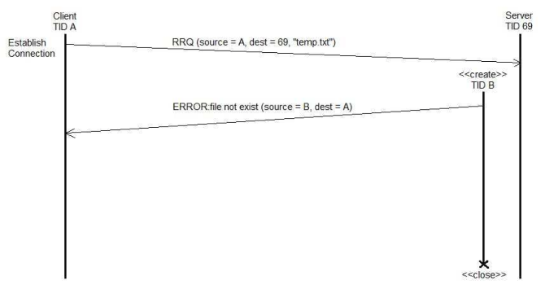

1. Client sends read request to destination 69 server
2. “temp.txt” file does not exist
3. Server sends an error (1) packet to client (“ file not exist”)
4. Server closes socket
5. Client prints out error (1) on server packet. Sent file “temp.txt” does not exist

[Error Code 2] – Access Violation

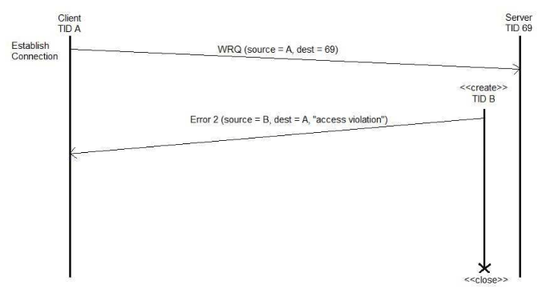

1. Client sends a write request to destination 69 server
2. Server traced client not having insufficient privileges to write.
3. Server sends an error (2) packet to client (“access violation”)
4. Server closes packet
5. Client prints out error (2) on server packet. Write was not successful, access violation

[Error Code 3] - Disk full or allocation exceeded

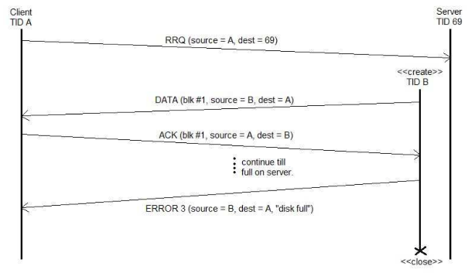

1. Client sends a read request to destination 69 server
2. Server successfully received the request and sends DATA packet (blk #1)
3. Client successfully received the DATA and sends an ACK (blk #1)
4. Step 2 and 3 occurs till the disk is full on server
5. Server sends an error (3) packet to client (“disk full”)
6. Server closes packet
7. Client deletes the file that was not successful in completion
8. Client prints out error (3) on server packet. Server disk full or allocation exceeded

[ERROR Code 4] – Illegal TFTP operation

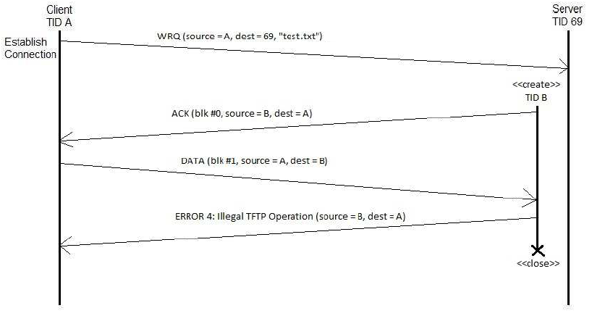

1. Client sends a write request to destination 69 server
2. Server receives the write request from Client
3. Server creates a new thread and send an ACK packet to client
4. Client receives the ACK packet
5. Client sends DATA packet but is incorrect
6. Server handled the incorrect DATA and sends an **ERROR(4)** to client. (“Illegal TFTP operation”)
7. Client prints out **ERROR(4)**. Illegal TFTP operation

[ERROR Code 5] – Unknown transfer ID.

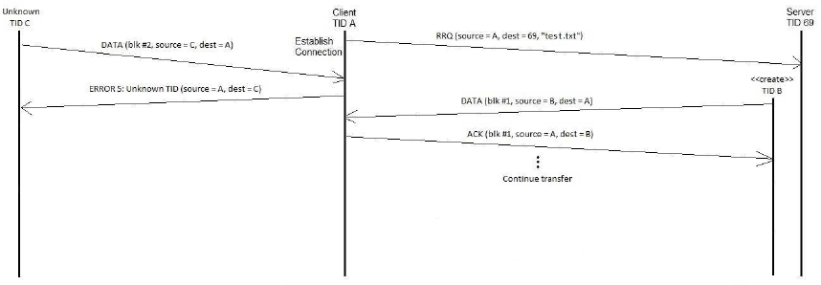

1. Client sends a read request to destination 69 server
2. Server receives the read request from Client
3. An Unknown Thread sends a DATA packet to client
4. Client detects the unknown thread and send an **ERROR(5)** to unknown thread. (“Unknown transfer ID”)
5. Unknown prints out **ERROR(5)**. Unknown transfer ID
6. Server creates a new thread and send DATA packet to client
7. Client receives the DATA packet
8. Client sends ACK packet to server
9. Process continues the transfer

[Error Code 6] – File already exists

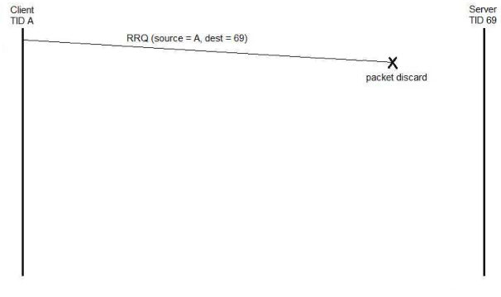

1. Client sends a read request to destination 69 server
2. Client finds existent DATA file
3. Client discards the packet transmission
4. Client prints out error (6). File already exist