Ben Parenteau Asiah Taylor
3/22/2026
Professor Citro
CST-315
Project 4
https://github.com/BenjaminParenteau/CST-315/tree/main/pager

Project 4: Pager – Virtual Memory Manager

1. Project Description
This project implements a simplified virtual memory manager (VMM) using paging. The system simulates how an operating system manages memory using virtual addresses, page tables, and physical frames. It translates virtual addresses into physical addresses, supports demand paging, and handles page faults and segmentation faults.
The implementation demonstrates how processes can use more memory than physically available by leveraging virtual memory and swapping mechanisms. The system also models page replacement, dirty page handling, and resource cleanup upon process termination.

2. Methodology / Approach
The system is designed using a simplified paging model:
- Each process is assigned a virtual address space
- Memory is divided into fixed-size pages
- Physical memory is divided into frames of the same size
- Each process maintains its own page table
- A global frame table tracks physical memory usage
When a process accesses memory:
- The virtual address is translated into a page number and offset
- The page table is checked
- If the page is in memory → direct translation
- If not → a page fault occurs and the page is loaded
If physical memory is full, a FIFO (First-In-First-Out) replacement algorithm selects a page to evict.

3. Assumptions
- Page size = 4096 bytes
- FIFO replacement
- No TLB
- Swap simulated
- Single-level page table

4. Design Requirements
1. Physical memory uses fixed frames.
2. Virtual memory defined per process.
3. Processes declare memory size.
4. Page size is 4096 bytes.
5. Pages calculated dynamically.
6. Each process has a page table.
7. Global frame table tracks memory.
8. FIFO replacement algorithm used.
9. Dirty pages written to swap.
10. Page and segmentation faults handled.
11. Resources freed on termination.

5. Paging Algorithm
Virtual address → page table lookup → page fault if invalid → load page → resume execution.

6. Page Fault Flow

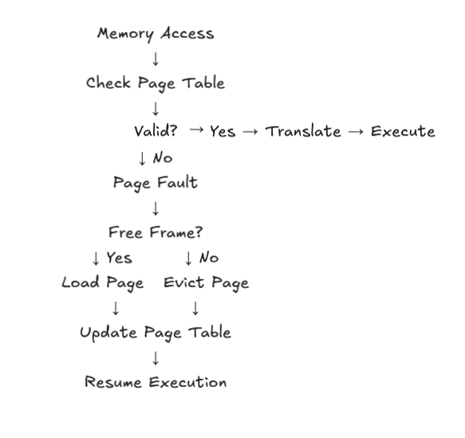

7. Segmentation Fault Flow
Invalid address or write to read-only → Segmentation Fault

8. Code Overview
Implemented in C using structs for processes, pages, and frames. Includes functions for paging and memory access.

9. Question answers

1. Size of Physical Memory (Frames)
Physical memory is modeled as a fixed number of frames (for example, 4 frames), where each frame is the same size as a page (4096 bytes). This keeps the system simple and forces page replacement to happen when memory fills up. It helps demonstrate how real systems deal with limited RAM.
2. Size of Virtual Memory
Each process gets its own virtual memory space based on how much memory it needs. This virtual space is divided into pages and is larger than physical memory. This allows processes to act like they have more memory than actually exists.
3. Memory Required per Process
When a process is created, it is given a memory size in bytes. This value is stored and used to figure out how many pages the process needs. It also helps check if a memory access is valid or not.
4. Page Size
The system uses a fixed page size of 4096 bytes. This makes address translation easier since both virtual pages and physical frames are the same size. It also matches how real systems usually work.
5. Pages per Process and Allocation
The number of pages is calculated using a simple formula based on the process size. Pages are set up in the page table when the process is created, but they are only loaded into memory when needed. This keeps memory usage efficient.
6. Page Table Management
Each process has its own page table stored as an array. Each entry keeps track of things like whether the page is in memory, what frame it’s in, and whether it’s been modified. The page table is created when the process starts and deleted when it ends.
7. Frame Table Management
There is one global frame table that keeps track of all physical memory frames. Each frame stores which process and page it belongs to. This makes it easy to find free frames or decide which one to replace.
8. Memory Allocation Algorithm
The system first looks for a free frame when loading a page. If none are available, it uses a FIFO (first-in-first-out) method to evict a page. This is simple and works well enough for this project.
9. Swapping Between Memory and Disk
When a page is removed from memory, the system checks if it was modified. If it was dirty, it is written to swap space. If it was clean or read-only, it is just discarded and can be reloaded later.
10. Page Faults and Segmentation Faults
A page fault happens when a page isn’t in memory, so the system loads it when needed (demand paging). Programs are not fully loaded at once, only the pages that are accessed are loaded. If a page was modified, it is written to swap when removed, while clean or read-only pages are not. A segmentation fault happens when a process accesses invalid memory or tries to write to a read-only page. In a real system, other processes would continue running during page faults, and this behavior is assumed in the design.
11. Freeing Resources on Termination
When a process ends, all of its memory is cleaned up. Any frames it was using are freed, and its page table is cleared. This makes sure memory can be reused by other processes and nothing is left behind.

10. References
Operating System Concepts (Silberschatz)
Modern Operating Systems (Tanenbaum)

