Shows the runtime behavior of the virtual memory system, including process creation, page faults, demand paging, and address translation. As memory fills, pages are evicted using FIFO, with dirty pages written to swap and clean/read-only pages discarded.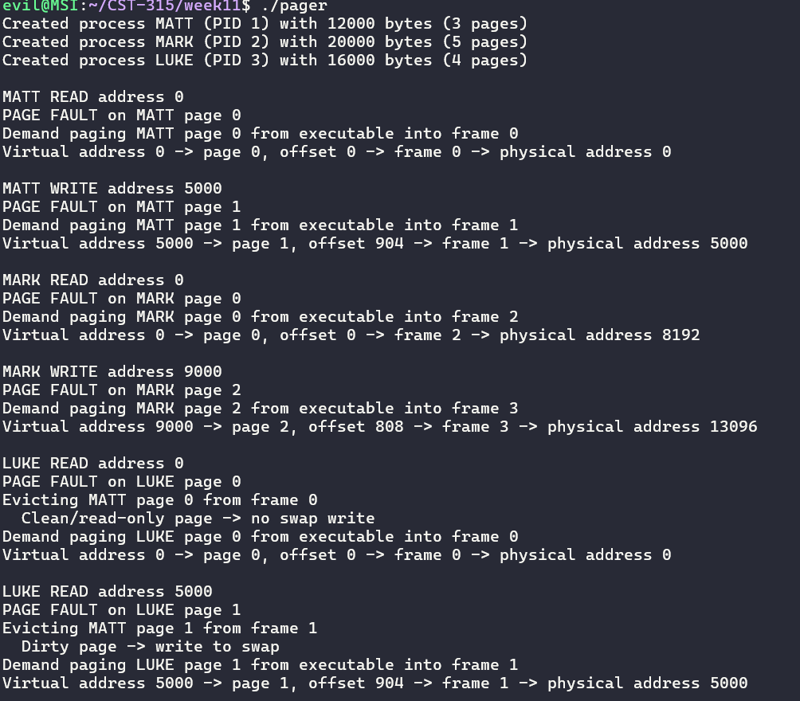

Displays the frame table and page tables for each process, showing which pages are in memory, swapped out, or invalid. After process termination, all frames are freed, confirming proper memory cleanup.
