Testing

1. Open Gui.java, and hit the green button show in this picture:
2. 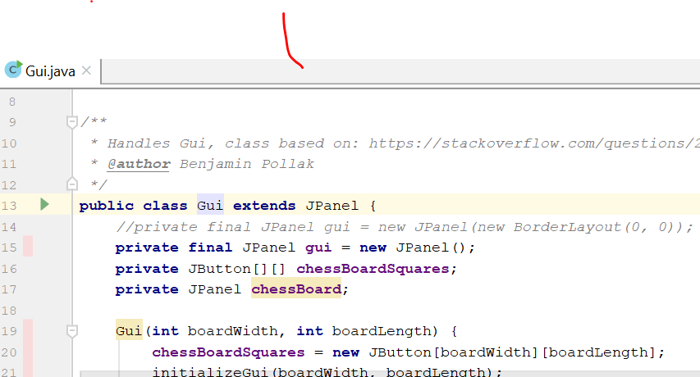When this is done, the following should appear:

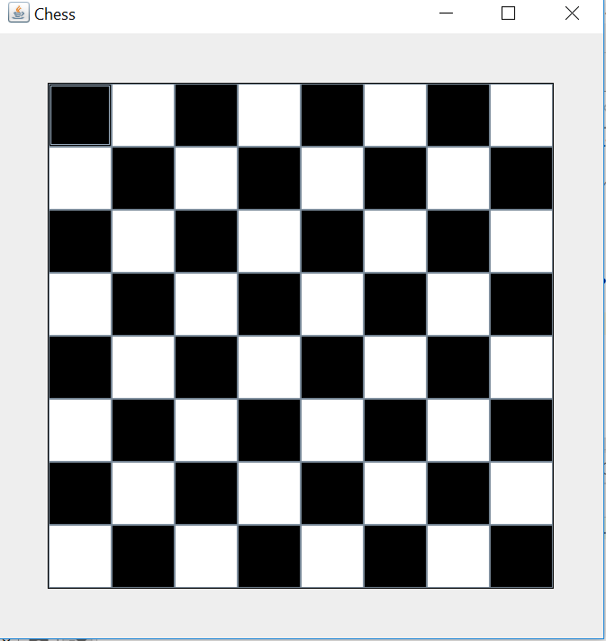

1. To get a different size board, change the line of code on line 62, instantiating the gui. It cannot currently handle width and length of unequal values