Final Report
Group members: Manuel Bustos, Benjamin Prowse, Artem Zinets
GitHub Link: https://github.com/BenjaminProwse/DatabaseProject
Application of Database:
For the project, the group has decided to create a database for commercial use of an ice cream shop. This database would help the store to keep track of information about the stores, like inventory, and of the sales that are being made.
Findings:
During this project, the group learned to apply consistency and breakdown entities in its various components for better organization and improving queries processing.
First, consistency presented a challenge to the application of the database since any entry to one table would need to verify that it is present and consistent across the relational tables and the entities related to it. Such is the case in Invoices. Each invoice would require an entity in Invoices table but also require one entry in the inCharge table and one or more entries in the Contain table. This also presented a challenge since every entry in each relational table would require checking in the other table that it relates to confirm that the entity being mentioned exists in the Staff table and the IceCreamFlavour one. In the end it was possible to maintain consistency across the database by putting various insert and delete commands to either delete or add the matching data to the corresponding table.
Then, the next issue was deciding whether some attributes relate exclusively to the entity or relate to other elements, such was the case with Shipment and Order. Originally it was thought that each shipment would contain an array of flavors indicating the contents of the delivery and another one indicating the amounts. However, during implementation it was decided that the Orders table was to be created as a relation between the Shipments and IceCreamFlavors tables since a shipment can carry multiple deliveries of various flavors. This allowed for easier queries and better access to data.
Lastly, there is identifying whether an element corresponds to the specific database. In the initial project proposal, table Sales was proposed. However, during the application, it was discussed that it did not belong since Sales would be related to the transaction rather than keeping the data related to the shop. In conclusion, table Sales and any relational table with a connection to it were removed for both security, consistency of transactions and to keep only relevant information in the database.

ER Diagram

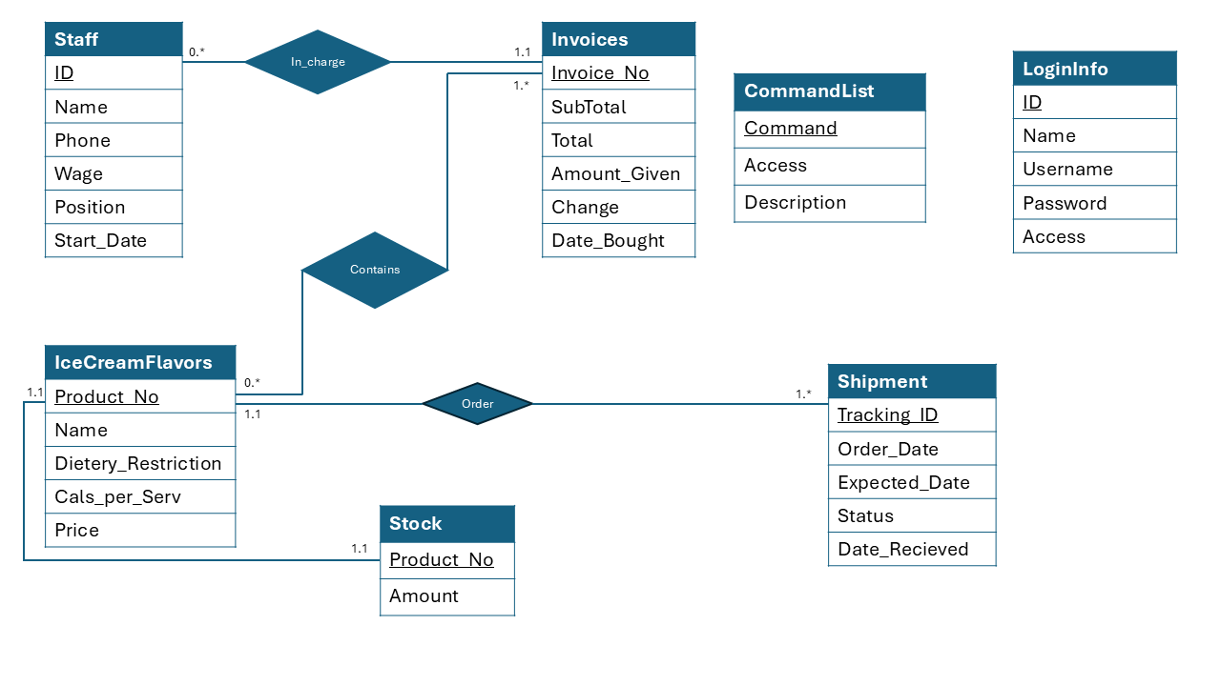
ER Diagram
Requirements met:
- All of minimal requirements.

- All of moderate requirements adjusted to the application. It was provided an example database in the GitHub with many values inserted into the tables. In the case of the application, it is shown how an invoice applies a sales tax of 15% without needing to input the total as it automatically calculates the subtotal plus tax. It was also provided an image showing how Invoices can be shown but also using a specific parameter the search can be narrowed down to a more specific value, like the ID of the employee that processed the purchase.

- All the challenging requirements are met. An interface using java was created. In this interface the user can login and perform various actions, such as seeing the stock or adding an order.

Table | DDL Statement | Relation in ER Diagram
Staff | Create table Staff(  ID int NOT NULL,  Name varchar(64) NOT NULL,  Phone varchar(16),  Wage int,  Position varchar(32),  Start_Date varchar(16),  PRIMARY KEY(ID)  ); | Every entity in Staff has an automatically assigned ID to be used as primary.  Staff is mainly used to keep track of employes which is why it has only one relation in the database.  It is only related to Invoices through inCharge in a many to many relations. Since any employees can process any number of purchases but does not require to have at least one the relation has no enforced minimum nor limit.
IceCreamFlavor | Create table IceCreamFlavor(  Product_NO int not null,  Flavor varchar(16),  Dietery_Restrictions varchar(255),  Cals_per_Serv int,  Price numerical (16,2),  PRIMARY KEY(Product_NO)  ); | Each ice cream flavor has an integer used as primary key; it is assigned to it automatically for easier differentiation.  Each ice cream flavor also has a one-to-one relation with Stock since there can only be one amount of one flavor in inventory for consistency.  Then there is the many to many relations with Invoices since one purchase can contain multiple flavors, this is done using Contains relation where each entry in the table is a flavor related to a specific purchase.  Finally, there is the relation of many to many with Shipment using the table Order.
Stock | Create table Stock(  Amount varchar (16),  Product_NO int ,  FOREIGN KEY (product_no) REFERENCES IceCreamFlavor  ); | The Stock table is used to keep track of inventory for each flavor and as such is related to IceCreamFlavor. It is not an attribute in the other table since the amount in inventory of a flavor is not a characteristic of the flavor itself but rather of the inventory of the shop.  Stock is also related to Shipments since every order received affects the amount in inventory.
Shipment | Create table Shipment(  Tracking_ID int not null,  Order_Date varchar (8),  Expected_Date varchar(8),  Status varchar(15),  Date_Recieved varchar(8),  Primary Key (Tracking_ID)  ); | Each shipment contains a tracking id automatically assigned which is used as primary key for easier identification of the multiple orders related to the deliveries.  The Shipment table represents the delivery service itself. Since a delivery can have multiple orders or packages Order was created as a separate relational table.
Invoices | Create table Invoices(  Invoice_No int NOT NULL,  SubTotal decimal (16,2),  Total decimal (16,2),  Amount_Given decimal (16,2),  Change decimal (16,2),  Date_bought varchar(8),  Primary key (Invoice_No)  ); | Each entity in Invoices represents a purchase, as such it contains the data related to the transaction, like the amounts and the date, and the automatically assigned id to the sale to avoid multiple invoices with the same id.  Each invoice is related to at least one employee in Staff since someone has to process the purchase.  It is also related to flavors since every purchase can have at least one flavor in its contents.
inCharge | Create table inCharge(  id,  invoice_no,  foreign key (id) REFERENCES Staff,  foreign key (invoice_no) REFERENCES Invoices  ); | inCharge is used to reference which invoices have been processed by which employees. As such it uses the primary keys from Staff and Invoices since someone without an ID should not be able to process a purchase or a nonexistent purchase.
Contain | Create table Contain(  product_no,  invoice_no,  scopes int,  foreign key (product_no) REFERENCES IceCreamFlavor,  foreign key (invoice_no) REFERENCES Invoices  ); | Contains indicates what flavors were bought in a purchase. It uses as keys both the product number and the invoice number since one invoice can have multiple contents and the same flavor can be present across many purchases. However, a purchase can does not have multiple instances of buying the same flavor in separate entries.
Orders | Create table Orders(  product_no,  tracking_id,  amount numerical (16,2),  status varchar (32),  foreign key (product_no) REFERENCES IceCreamFlavor,  foreign key (tracking_id) REFERENCES Shipments  ); | Each order represents a package in a delivery, as such it references a flavor, the content, and the delivery, the shipment it is in. It also contains an integer to represent how much is being ordered which would later affect Stock.  It also contains a string to indicate the status, whether it is on route, received or cancelled.
CommandList | Create table commandlist(  command varchar(20),  access int,  Description varchar(20),  Primary Key (command)  ); | A table used to contain information useful for the user of the interface.
LoginInfo | Create table logininfo(  ID int,  Name varchar(20),  Username varchar(20),  password varchar(20),  access int,  Primary Key (ID)  ); | A table to contain the information of the users of the program. Any user that is not in the database does not gain access to the program and database.
Table 1 list of DDL statements used to create tables and a short explanation of each table
Table | Insert Statement
Staff | INSERT INTO Staff (id, name, phone, wage, position, start_date) VALUES (1, 'Benjamin Prowse', '555-5555', 28, 'Manager', '14/04/1980');
IceCreamFlavor | insert into IceCreamFlavor(product_no, flavor, dietery_restrictions, cals_per_serv, price) VALUES (1, 'Vanilla', 'None', 240, 2.5);
Stock | INSERT INTO Stock(amount, product_no) VALUES (20, 1);
Shipment | INSERT INTO Shipment(tracking_id, order_date, expected_date, status) VALUES (1001, '01/01/25', '08/01/25', 'On Way');  Date received is initially left as null and later updated to a date when the shipment is received
Invoices | INSERT INTO Invoices (invoice_no, subtotal, total, amount_given, change, date_bought) VALUES (1, 24.75, 24.75*1.10, 30.00, 30.00-24.75*1.10, ‘12/05/21’);
LogingInfo | INSERT INTO logininfo (id, name, username, password, access) VALUES (1, 'Benjamin Prowse', 'BenPro', 'BenPass100', 1);
CommandList | INSERT INTO commandlist (command, access, description) VALUES ('!HELP', 3, 'Shows all commands')
Contain | INSERT into Contain (product_no, invoice_no, scopes) VALUES (1,1, 2);
inCharge | INSERT into inCharge (id, invoice_no) VALUES (2,1);
 | INSERT into Orders (product_no, tracking_id, amount, status) VALUES (1,1001, 10.5, ‘On Way’);
Table 2 Examples of DML statements used to insert values into the tables

Example of insert used in interface

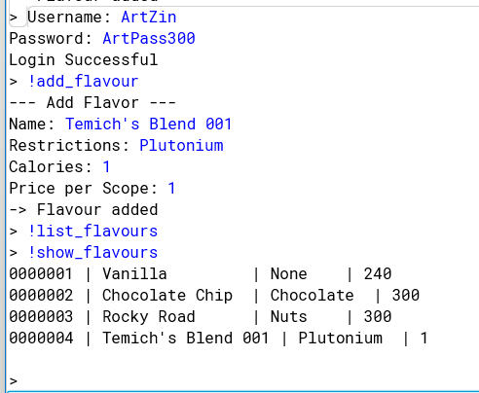

Example of showing data according to one specific parameter, in this case Staff ID in the invoice

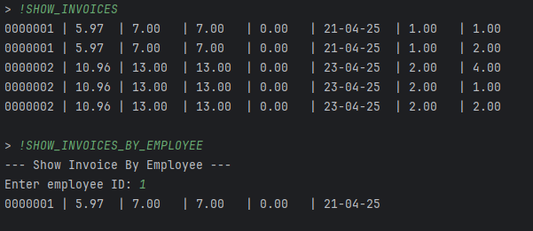

Example of a transaction where a 15% tax is applied on the total

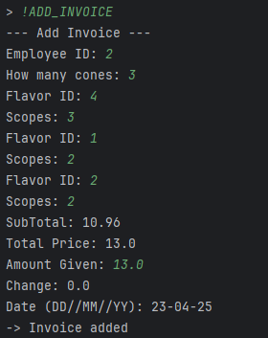
Interface example

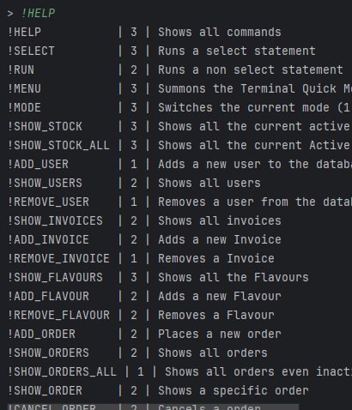

The image is the starting screen for the interface after using the command !help or !HELP. This command provides a list of all possible actions that can be performed in the interface. The add, delete and some of the show commands will require user input handled in the driver to perform the query. For example, in the previous image it is shown how the !ADD_FLAVOUR command is used, where the driver has a series of prompts for inputs and then using the data provided and some automatically set, like product number, is used to insert values in the IceCreamFlavour table in the database.
DML used in java code to perform modifications to the database. In this case this method creates a new entity in the IceCreamFlavors table using parameter passed.
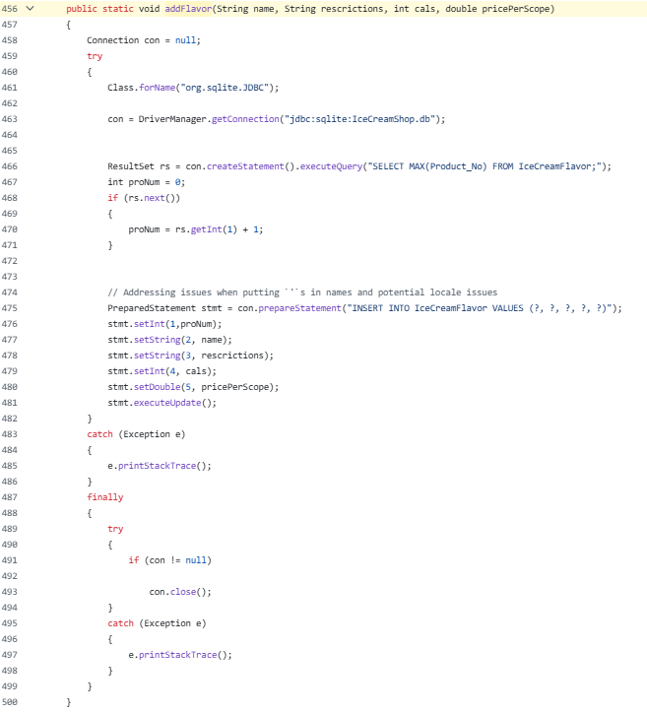

Java code is provided in GitHub page:
https://github.com/BenjaminProwse/DatabaseProject
Conclusion
In conclusion, the project the group learned to organize and create a database as well as implementing the use and application of it into java code for easier user interaction.

Bibliography

IntelliJ IDE help, I used this link to make changing the database easier

https://www.jetbrains.com/help/idea/sqlite.html#official_information_links

Date Help, these links were used for getting dates and formatting dates

https://www.w3schools.com/java/ref_string_format.asp

https://www.w3schools.com/java/java_date.asp

https://docs.oracle.com/javase/8/docs/api/java/time/LocalDate.html

