Donald Trump’s News Coverage in North America
Hadia Safa, Yuna Ruel, Benjamin Roderick
McGill University
hadia.safa@mail.mcgill.ca, yuna.ruel@mail.mcgill.ca, benjamin.roderick@mail.mcgill.ca

Introduction
We study how Donald Trump is covered in North American news published within the past month. We investigate two different aspects of his coverage: the topics of the articles he is mentioned in, and the biases of the article in the form of the sentiment. This enables us to get a general overview of the types of discussions happening about him, but also his reception by the media.
We chose Trump as our subject as he is a polarising figure, which has led to a vast spectrum of topics and sentiments in news outlets. It was also interesting to see the more local views of the politician, as it is the opinion of people that are going to be affected by his presidency.
Having served the 2017-2020 presidential term, Donald Trump was re-elected in 2024 as the 47th president of the United States. The 2024 elections having taken place within a month of this study has created a significant influx of articles about him. This enables us to see not only whether news outlets are aligned with Trump’s party but also if they focused on discussing his politics or his personal life and image.
Overall, the polarising nature and the period in the electoral cycle made it ideal to study Donald Trump’s coverage in North American media.
Data
To best answer the question “What is the sentiment and how is Trump being covered in North American media within the last month?”, we collected news articles using NewsAPI.org filtering by publishing date to be within the last month. Each article of the final dataset was collected including this information: source, date published, title, content, URL.
Firstly, to ensure that the articles we were using covered Trump, we filtered by the presence of “Trump” in the article title. Otherwise, we noticed the article would not necessarily be about Trump, leading to it not being an accurate representation of how he is covered. We chose sources by researching each news organization individually, then categorizing them. We decided to consider “North American” any source that was legally based in a North American country. This allowed us to keep many sources that are less mainstream than the other major news organizations. These sources are important to coverage of Trump specifically, however, because they are often representative of more far-left or far-right viewpoints.
We also had to do several passes to refine the dataset we got from the API. The original data files contained many duplicate articles, and some blurbs contained html code. Also, certain characters in the text stream from the API used a strange encoding that produced groups of special characters that needed to be translated to the intended original characters. An example of this being that the apostrophe character would be displayed as “Äò” in certain articles.
Handling Biases
To minimize bias, we used random sampling from our raw dataset to ensure the data was not concentrated around the same dates or sources, thereby avoiding snowball sampling. Additionally, we took steps to prevent our personal opinions and emotions from influencing the annotation process. Articles lacking explicit positive or negative language were labeled as neutral to maintain objectivity. For example, articles describing Trump’s cabinet appointments were categorized as neutral, even if we personally viewed some appointees negatively. Since such articles did not explicitly portray them in a positive or negative light, we adhered strictly to our established criteria.
Methods
After our initial discussion, we mutually decided to focus our project on Jagmeet Singh, the leader of the New Democratic Party of Canada. However, our first attempt to collect data on Singh using NewsAPI.org yielded fewer than 100 articles. Since obtaining at least 500 articles on Singh through NewsAPI.org required a paid subscription, we decided to switch our focus. Our second choice was Justin Trudeau, as we believed his prominence would result in a larger dataset within the date range of October 2024 to November 2024. However, even after cleaning the data for Justin Trudeau, we were left with less than 500 articles. Finally, we chose Donald Trump, as this provided us with the required amount of data, even after prepping it for analysis
In the sections that follow, we will outline the key methodologies and steps we followed to complete the data science project: open-coding, typology development, annotation and analysis (TF-IDF).
Open-Coding
We began the open-coding process with 200 articles. Each of us independently labeled the articles using our own terms and assessed whether the sentiment was positive or negative. Initially, we decided that if an article didn't contain any negative terms, it would be considered neutral, and we assumed neutral would default to positive. However, after further reflection and discussion, we concluded that it was important to differentiate between neutral and positive articles. Neutral articles were more factual and declarative, often focused on events like Trump's cabinet appointments, while positive articles used more favorable language. Once our individual coding was complete, we came together to discuss the topics we had identified. We had to carefully choose the right semantics and terminology to describe each topic. In the first round, we had 15 topics, which we later merged into 12, and finally reduced to 8.
Typology Development
After completing the open coding, we used the final eight topics to develop our typology. Our goal was to create a consistent and comprehensive typology without ambiguous terms, ensuring consistent understanding among annotators and minimizing any potential confusion during data annotation. To achieve this, we made decisions regarding semantics. For instance, we removed the word "policy" from topics like "climate policy" or "economic policy" to ensure the topics could encompass broader discussions on climate and economics, not just policies. We also ensured that none of our topics were so broad that they resembled another category. We began our typology by providing a one-sentence explanation of its purpose and significance. Next, we listed the eight topics, each accompanied by a brief description, rules for inclusion and exclusion, and examples from the data. To address ambiguous cases, we included guidelines on handling unclear sentiments and data, ensuring consistent labeling.
Annotation
After determining the topics and creating a typology, we based ourselves on those results to annotate the 500 articles we had collected. Each annotation was done based on the title and the first lines of the article, and following the reasons for exclusion and edge cases defined in the typology. We also categorised the article into a sentiment, which we did taking into consideration both the content and the way certain news articles use a certain framing in their titles to express their bias.
There were certain issues regarding the content section as it sometimes contained html code, in those cases we based ourselves on the title alone paying more attention to the phrasing which might reveal a certain bias.
Using the carefully designed typology, we did not have much issue determining the topic and sentiment as most of the edge cases were covered.
Analysis (TF-IDF)
Once we finished annotation, we conducted a word frequency analysis using the term frequency-inverse document frequency (TF-IDF) algorithm. After separating the dataset into the categories we assigned them during annotation, we removed special characters and punctuation, as well as casting all the strings to lowercase. This homogenized the words such that capitalized words at the beginning of sentences or punctuation following a word would not have it count as a unique term for the purposes of our analysis.

Results

In this section we will present the results from our typology and TF-IDF scores.
Typology Results
The following are the final topics in our typology:

- Election (ELEC): Articles focused on Trump’s campaigns, election results, endorsements, polls, and post-election reactions. Topics include the Biden vs. Trump or Harris vs. Trump campaigns and supporters' endorsements. Excludes Trump’s legal issues impacting the election, family-focused articles, and policy discussions unrelated to the election. Example: "Trump wins a second term."
- Personal (PERS): Articles centered on Trump’s personal life, image, and public behavior. This includes his criminal charges, court cases, public conduct, and personal details such as family and hobbies. Excludes articles about appointments, policies, or other politicians. Example: "Trump, using violent language, attacks 'war hawk' Liz Cheney."
- Internal Politics (INT-POLI): Articles addressing Trump’s government structure, cabinet appointments, and relationships with other American politicians. Topics include cooperation or opposition in Congress and high-profile appointments like Elon Musk’s inclusion in government roles. Excludes articles about international relations, personal information, or non-political topics. Example: "Trump announces Elon Musk to lead 'Department of Government Efficiency.'"
- Social (SOCIO): Articles discussing Trump’s views and policies on social issues, including LGBTQ rights, racism, sexism, and immigration. Topics include deportations, border policies, and racial controversies. Excludes other politicians’ views on these topics or unrelated issues like Trump’s legal troubles. Example: "Latino political strategist responds to Puerto Rico jokes at Trump MSG rally."
- International (INTER): Articles covering Trump’s relationships with international leaders, foreign policies, and global events such as the Ukraine-Russia war and Israel-Palestine conflict. Topics include relations with leaders like Putin, Xi Jinping and Volodymyr Zelenskyy. Excludes internal politics, domestic policies, or personal topics. Example: "Putin praises Trump, says he's ready to talk to him."
- Climate (CLIM): Articles focusing on Trump’s stance on climate-related issues, including international climate agreements and environmental policies. Excludes articles that don’t explicitly mention climate or involve health-related discussions. Example: "Trump likely to target climate measures that are making the most difference."
- Economy (ECON): Articles related to Trump’s impact on economic policies, inflation, finance, technology, and industries driving the U.S. economy. Topics include stock markets, debt, and trade policies. Excludes non-economic content or vague mentions of economic trends. Example: "Young Black and Latino men say they chose Trump because of the economy and jobs."
- Health (HEAL): Articles discussing public health issues, abortion, healthcare policies, and the pharmaceutical industry during Trump’s term. Topics include his stance on pro-life topics and public health measures. Excludes content unrelated to health or focused on other politicians’ healthcare policies. Example: "‘We’re Not Single-Issue Voters.’ Trump Bets Abortion Isn’t Key to Suburban Women Vote."
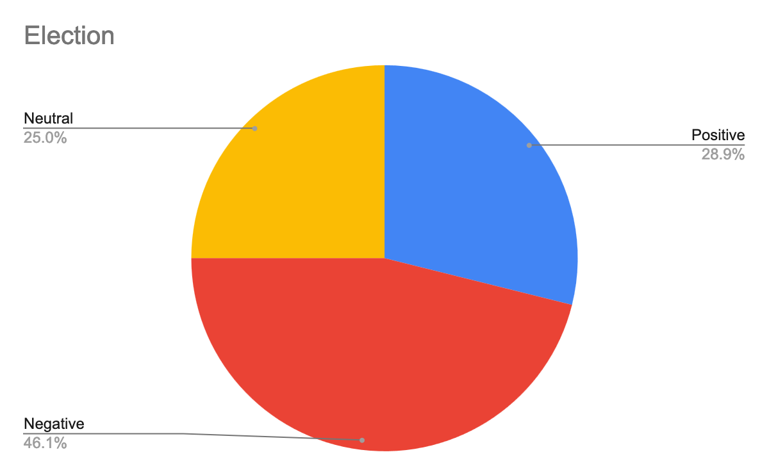
Each topic includes rules for inclusion and exclusion, ensuring clarity and consistency. Additionally, examples from the data provide concrete guidance for annotators, minimizing ambiguity during annotation.
Preliminary Data Analysis Results
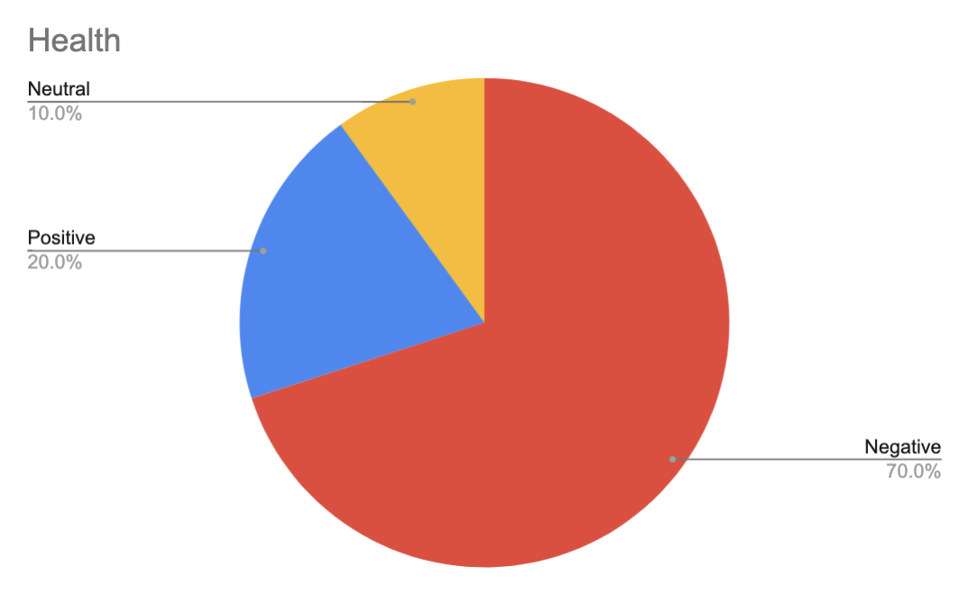
To get a general overview of the data, we’ve graphed the topics and sentiments into pie charts to visually understand what the most common topics and the most prevalent sentiments are.
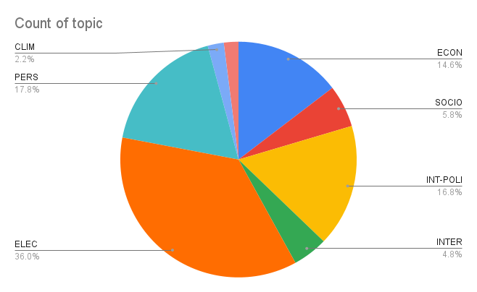
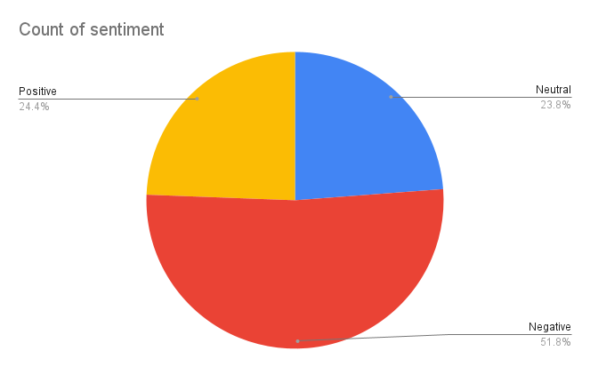
Then to get a better idea of the sentiments based on each topic, we isolated the count of sentiments to each topic and graphed in into a pie chart again.

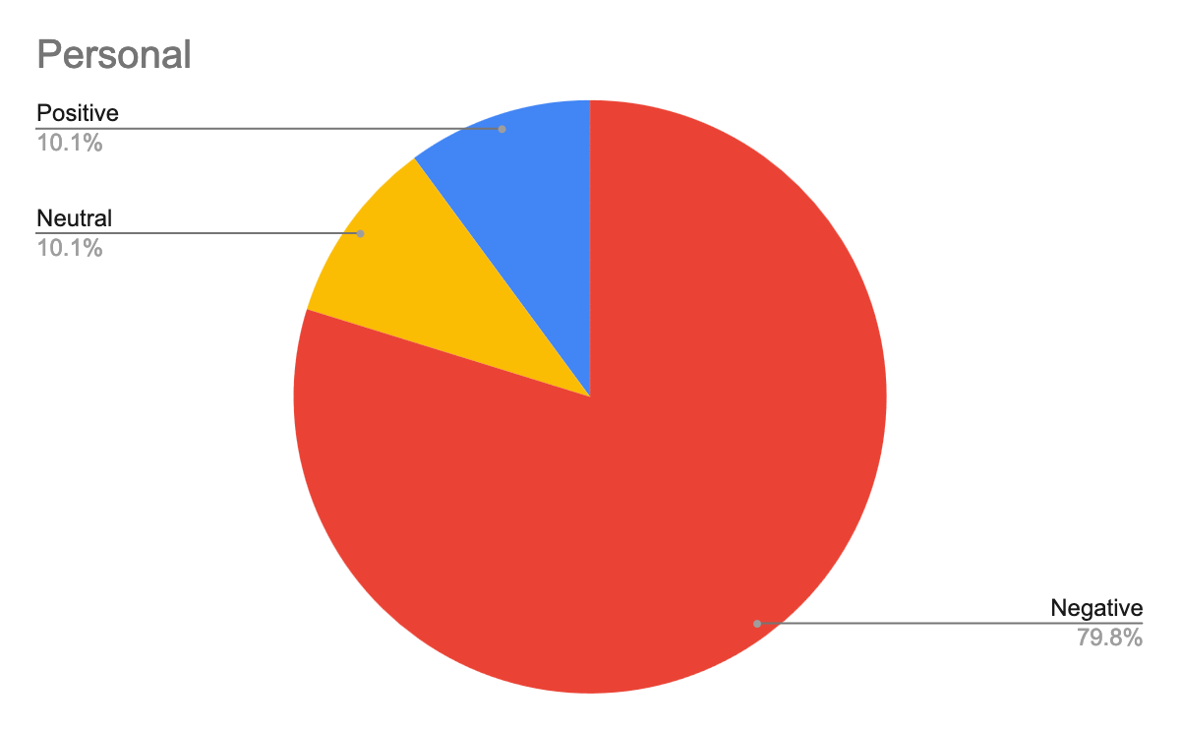
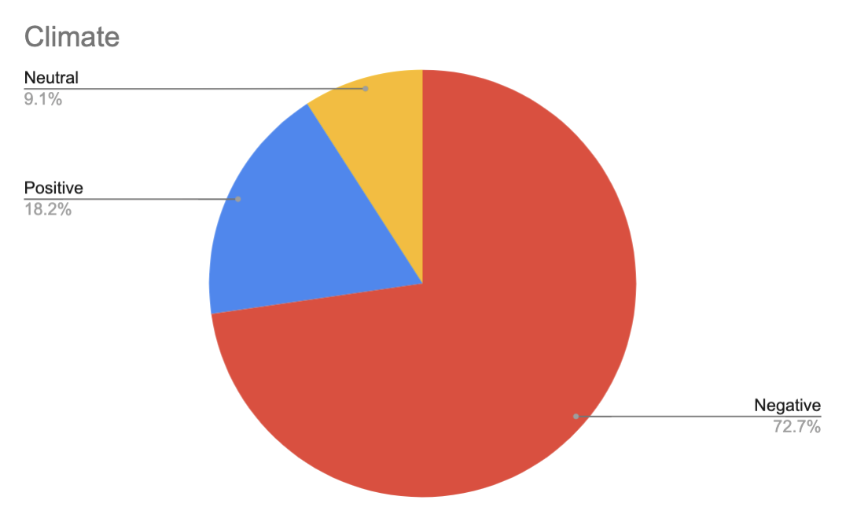
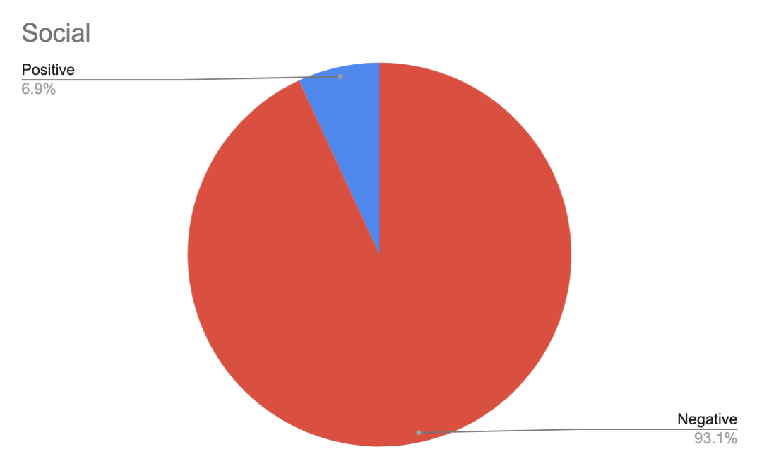
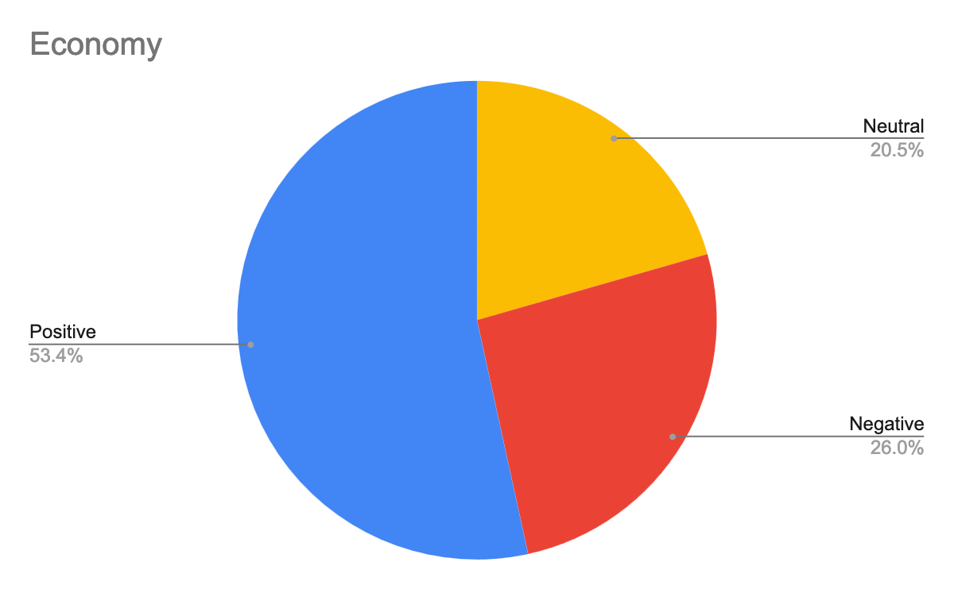

TF-IDF Results
We have carried out a TF-IDF analysis of our articles, which determined the most used words within each category. We have then plotted bar graphs to illustrate the subcategories that emerged and their frequency of appearance in each topic:

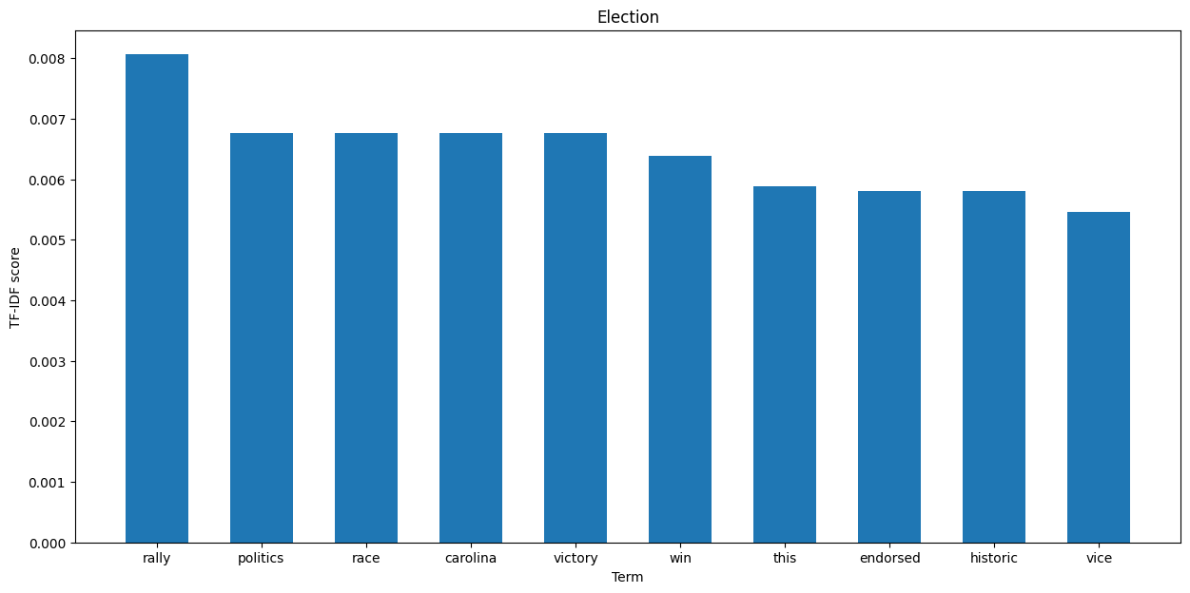

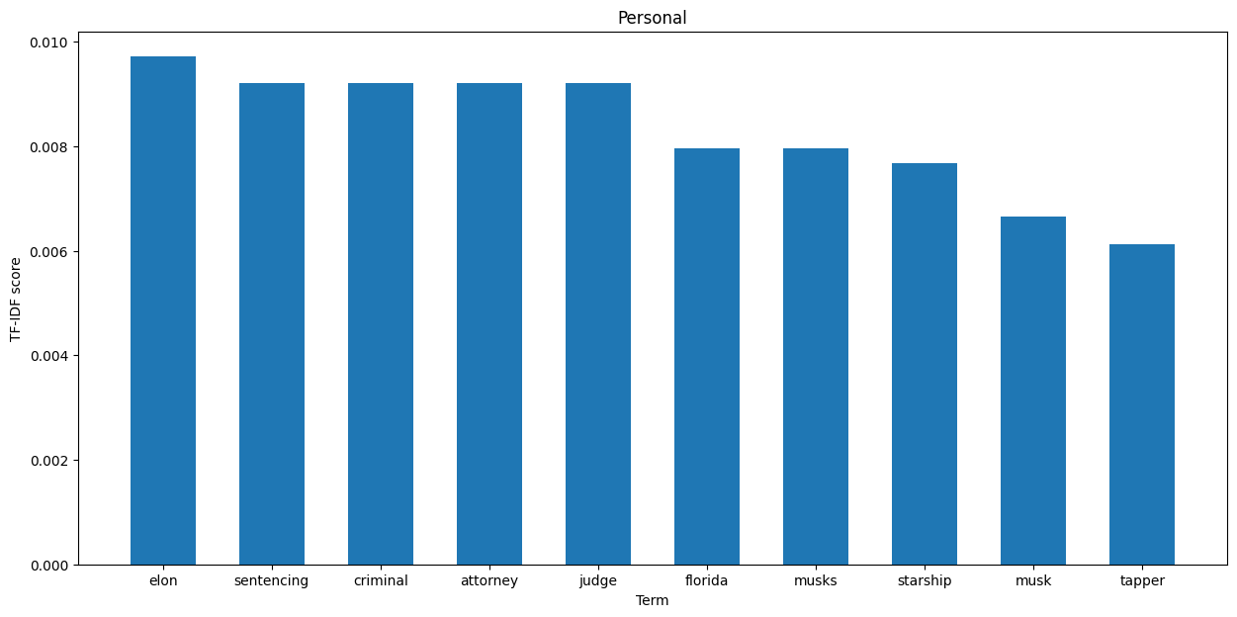

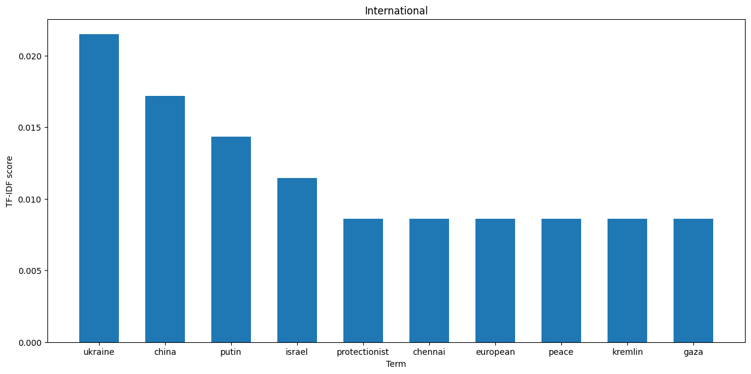

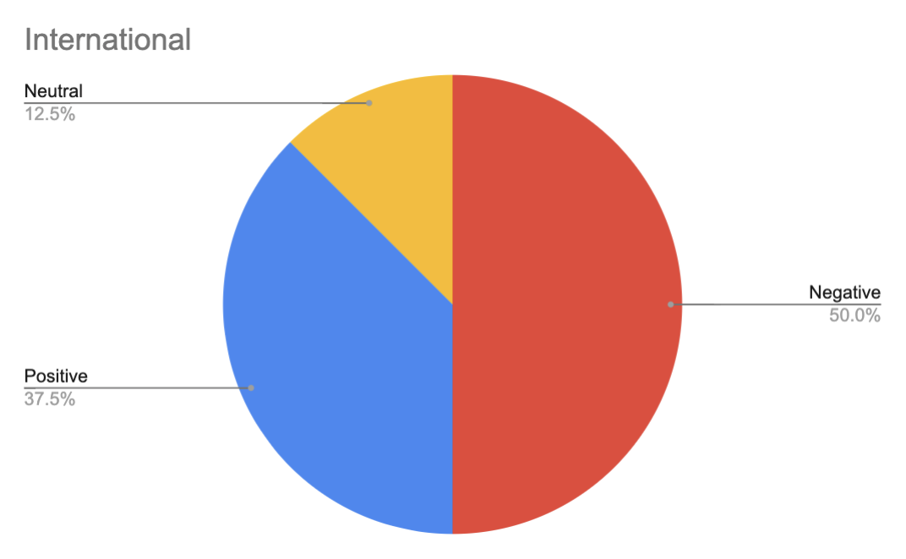

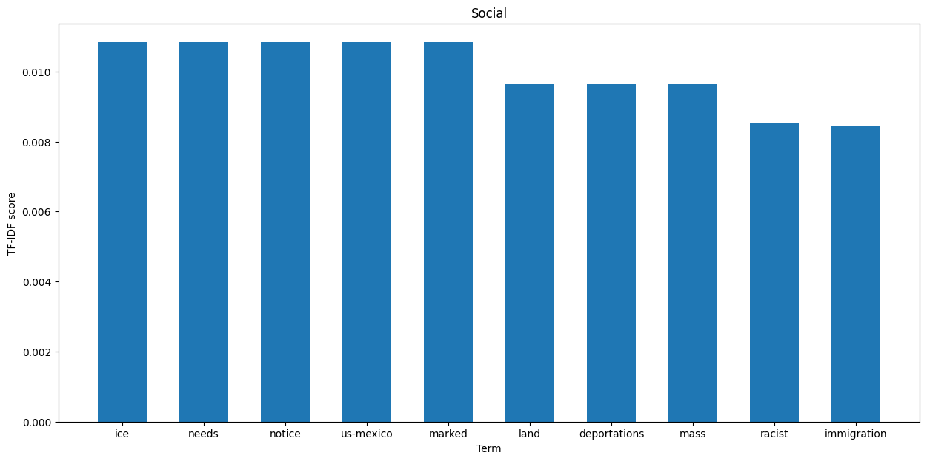

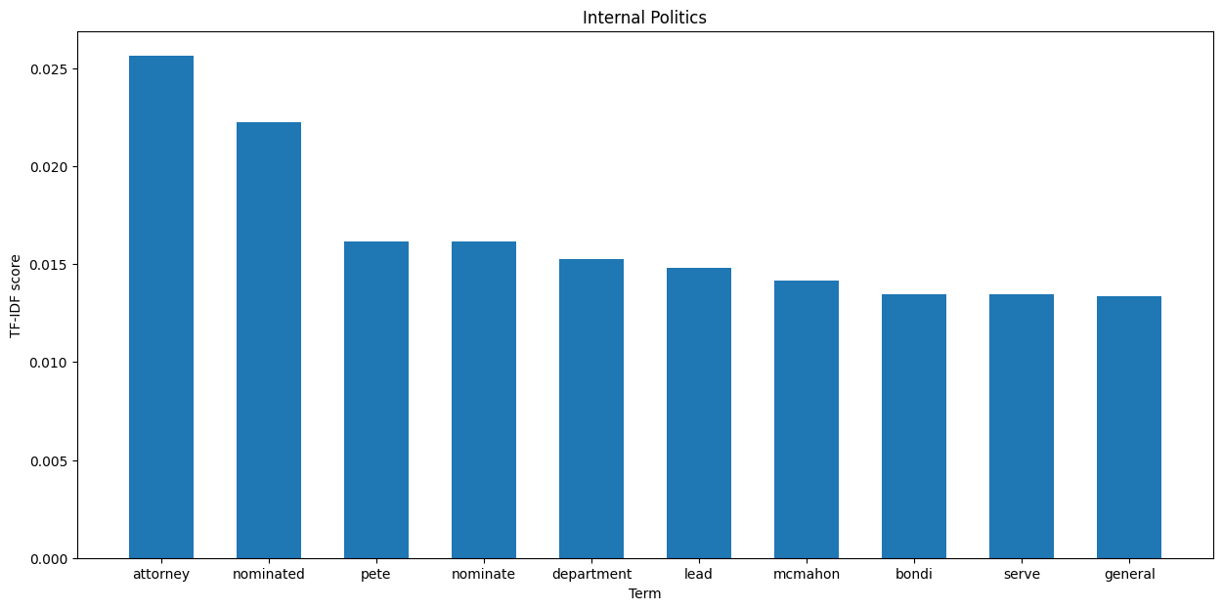

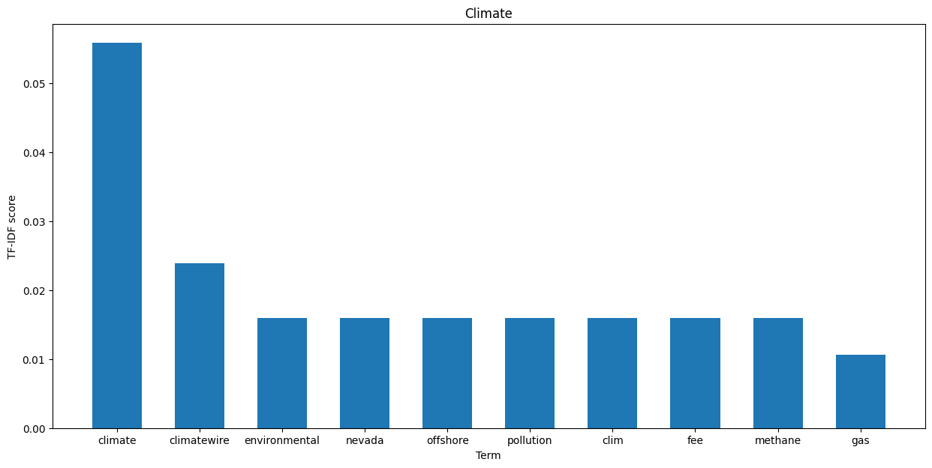

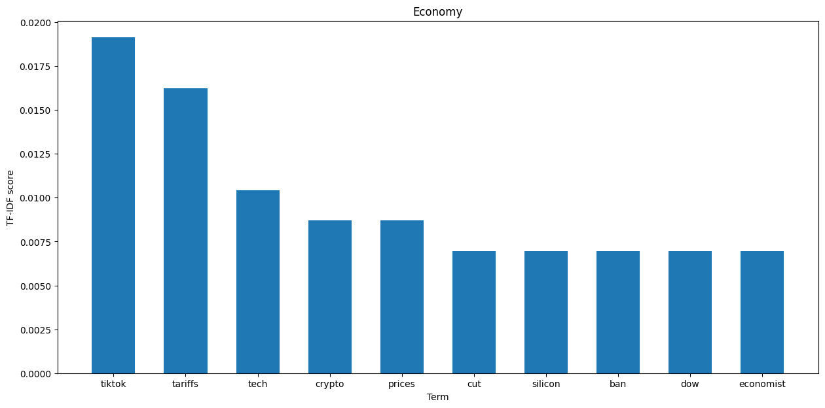

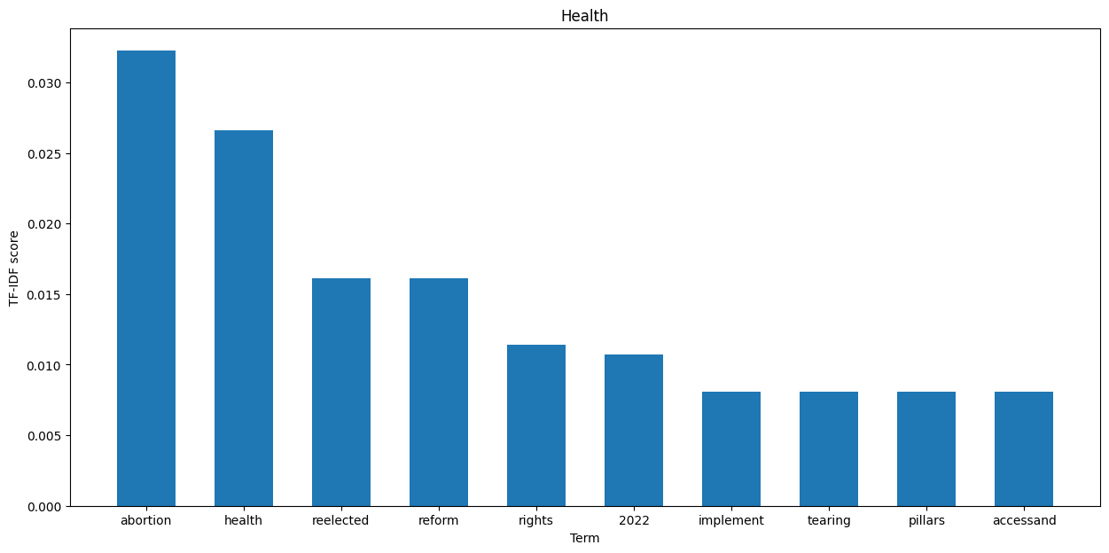

Discussion

The aim for this project was to study the coverage of Donald Trump in North American news, more specifically the topics and the sentiment of his image in the media.
Regarding the topics, the most discussed topics in the media are Election, Personal, and Internal Politics. Through our TF-IDF we have also seen that for each topic these are the most discussed subtopics:
- Election: rally, politics, race
- Personal: Elon, sentencing, criminal
- Internal politics: attorney, nominated
- Social: ice, us-Mexico
- International: Ukraine, China, Putin, Israel
- Climate: climate, climate wire, environmental
- Economy: TikTok, tariffs, tech
- Health: abortion, health
Which gives us an overview of the aspects that are being discussed when it comes to Trump.
Regarding the sentiment, the articles covering Trump have:
- Positive: 24.4%
- Neutral: 23.8%
- Negative: 51.8%
Furthermore, the topic with the most positive coverage was Economy and the one with the least was Social. For the case of the most discussed topics, the graphs indicate that Election has a 46.1% negative coverage, Personal a 79.8% negative coverage, and Internal Politics a 53.6% neutral coverage.
The media coverage for Trump revolves around two main aspects, his political presence and his personal life. In this past month his coverage was about the election as it was the most current event, and with his election this leads into the third most popular topic which covers the cabinet nominations. But Trump does not seem to be covered only as a political figure as we can see by the second most popular topic being Personal. With the elections, the attention of North American news seems to have gravitated towards him, which led to criticism of his person as seen by the overwhelming majority negative bias. This criticism seems to be directed at his relationship to Elon and his criminal cases.
Being a politician, it is a given that most of the Trump’s media coverage is bound to discuss his policies. Based on the sentiment and the TF-IDF scores we derived from our dataset, North American media projects the coming Trump presidency will have a positive impact on the economy, this can be deduced due to the fact that 53.4% of articles on the topic reflected positively on Trump. On the flip side, however, we have observed that Trump’s stances on abortion are not at all well-received, due to it being the top-scoring term, and the abysmal 70% negative coverage he has on this topic. Additionally, for Trump’s most negative coverage-dominated topic of all, social issues, the top terms according to TF-IDF suggest that his general attitude towards US-Mexico relations is incredibly not well received by the press.
Group member Contributions
All group members worked on open-coding and the report. Hadia wrote the typology. Hadia and Yuna did annotations. Benjamin did article collection, TF-IDF and charts.
References

The White House. (2022, December 23). Donald J. Trump | The White House. https://www.whitehouse.gov/about-the-white-house/presidents/donald-j-trump/

