[](http://www.stuart.iit.edu/)

VPM (MSF 504)

Homework 3: Due Wed, 4/17 midnight

**I want a *hard copy*! You can work in groups of up to 4 people. Each group turns in only one solution set with all members’ names listed on the front.**

**Background:** We know the CAPM has week support empirically. That’s why we extend it with Fama-French SMB and HML factors. Yet, these extensions still cannot explain the “momentum effect”. Let’s try something. Let us do a study that tries to find out if time-varying betas are the key to the momentum anomaly. Let us see if betas are functions of the relative volatility of the market. The hypothesis is that “winner” portfolios command high returns as risk compensation because these assets are hyper sensitive to market risk *when market risk is higher-than-average.* The “loser” portfolio commands low returns because their asset betas are relatively low *when market risk is higher-than-average*. This may not be the case empirically. But that’s what we are going to try and find out.

**Data:** I downloaded the following portfolios from Ken French’s website:[1]

25 Portfolios formed on Size and Book-to-Market (*SB11* through *SB55*)

5 Portfolios formed on market Betas (*Beta1* through *Beta5*)

10 Portfolios formed on Cashflow-to-Price ratios (*CFtoP1* through *CFtoP10*)

10 momentum portfolios (*Mom1* through *Mom10*)

Fama-French 3 factors and Risk free rate

An Employment Index, *EmpInd* (I made this one up myself; let’s see if it works)

All monthly data from July, 1963 through February, 2017

**Project:** Conduct a Fama-Macbeth style analysis on this data set.

**Step 1:** Regress Monthly excess returns for each portfolio



where  is a rolling z-score,



Note that , so the  can be interpreted as the time-varying market beta, conditional upon last month’s .

The chart below shows how the Employment Index changes over time.

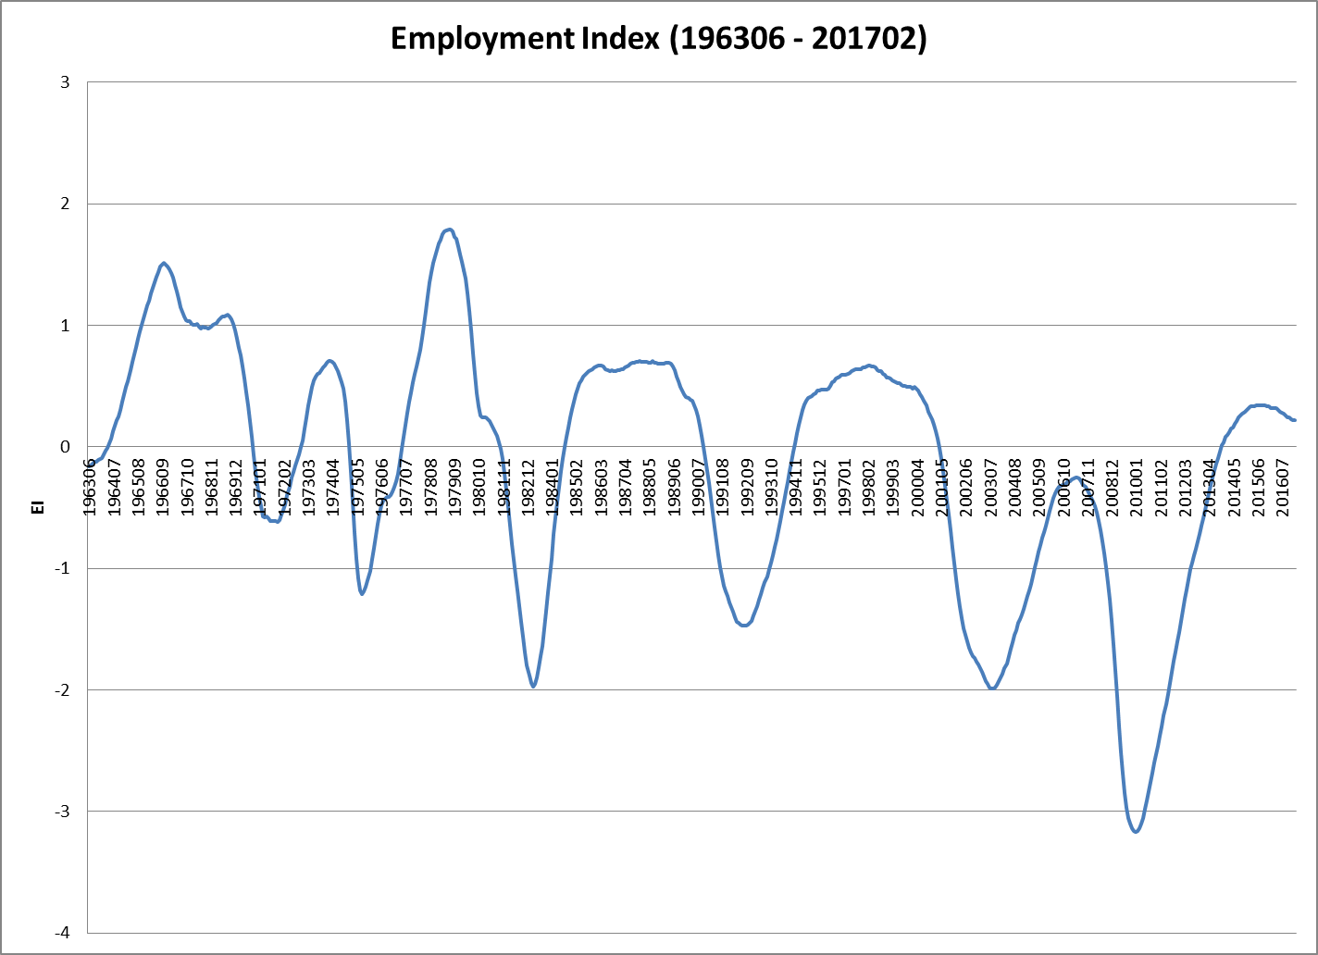

**Step 2:** Each Period (from 196307, on) regress the cross-sectional returns of the 50 portfolios against the following portfolio variables to get that period’s beta returns as the “x-variables”:, , , ,  and.

That is, for each month, regress the 72 portfolio returns, against the “first-pass” factor exposures ( through ).



**Step 3:** Find the average factor returns and standard errors for all seven of these variables. For example,

 and , with 

**Analysis:** Answer the follow equations based upon your findings.

1. Are any of the factor returns from Step 3 significantly different from zero?

2. Do the signs of the coefficients (plus or minus) make economic sense? Explain. (This is an open-ended question. I just want to know your thoughts.)

3. Estimate the quasi-R2 of the model, , for[2]

1. All 50 portfolios
2. The 25 size/bm sorted portfolios
3. The group of 15 portfolios sorted by, betas and cashflow/price.
4. The 10 momentum portfolios

4. How well does this model fit the data? Explain.

1. <http://mba.tuck.dartmouth.edu/pages/faculty/ken.french/data_library.html>
2. Fitted Average Returnp = 