- Clear the Temporary Internet Files and close all the instances of Edge opened.
- Open a fresh instance of Edge.
- On Edge, reach to the point from where we can start the leak cycle.
- Press F12 key and F12 developer tools would appear on the screen.
- Alternatively, we can also go to Settings> More Tools> Developer Tools to open F12 Developer Tools.
- Once opened, go to the Memory tab, and make sure Heap snapshot is selected. As we open the Memory tab, it already starts recording.
- Carry out the leak cycle.
- Click on the Take snapshot button to capture first snapshot.

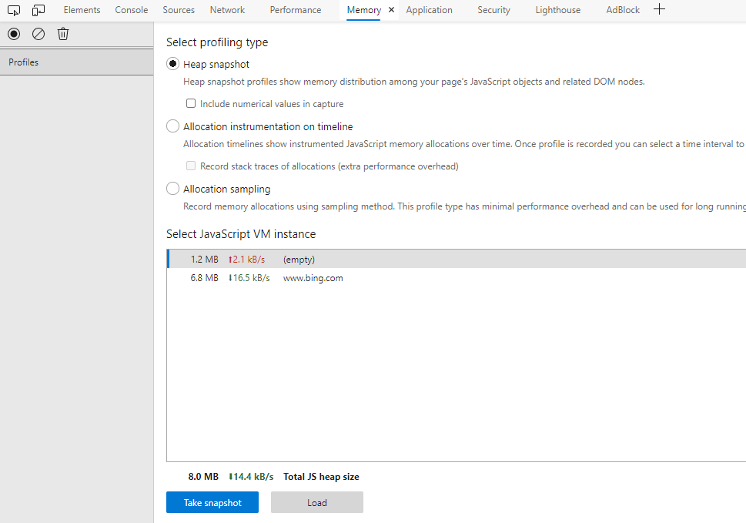

- Repeat the leak cycle again and after completing the leak cycle, click on Take snapshot option present at the left top corner of F12.
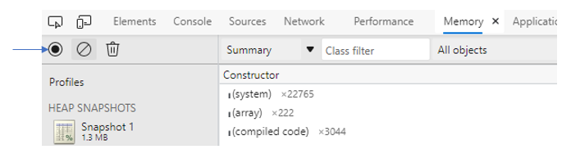

- We would need to repeat the leak cycle one more time and click on Take snapshot once more.
- After completing three leak cycles, it shoud look something like this:
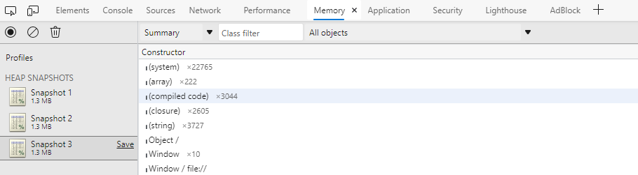
- If we have captured three Snapshots, then we are good to save the log. We need to click on Save option present next to each snapshot. Every snapshot should be saved individually.
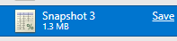
- The file would be saved in .heapsnapshot extension.

<Note for Engineer>
This log is a very useful one when it comes to memory leak. However, it should only be used when the memory leak does not involve any navigation. The steps of the leak cycle are all carried out on the same page.

