- Clear the Temporary Internet Files and close all the instances of Internet Explorer opened.
- Open a fresh instance of Internet Explorer.
- Press F12 key and F12 developer tools would appear on the screen.
- Alternatively, we can also go to Settings> F12 Developer Tools to open F12 Developer Tools.
- Once opened, go to the Memory tab.
- On Internet Explorer, reach to the point from where we can start the leak cycle.
- Click on the Play button to start recording. Or we can also click on Start profiling to begin a performance session as well to start the recording

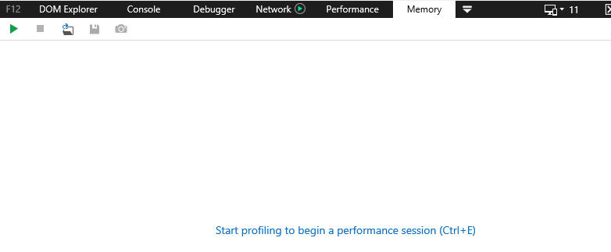

- After completing the leak cycle, click on Take a heap snapshot option.
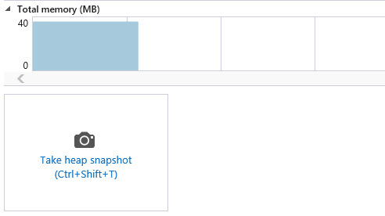

- Repeat the leak cycle again and then click on Take a heap snapshot again.
- We would need to repeat the leak cycle one more time and click on Take a heap snapshot one more time.
- After completing three leak cycles, it shoud look something like this:
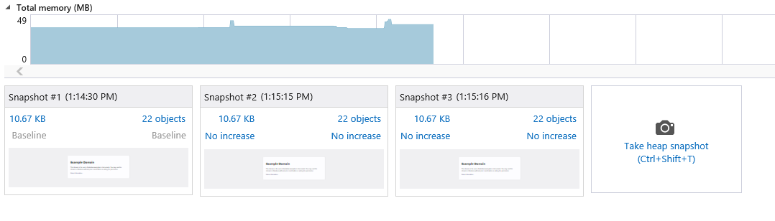
- If we have captured three Snapshots, then we are good to save the log by clicking on the Save button on the tool itself.
- The file would be saved in .diagsession extension.

<Note for Engineer>
This log is a very useful one when it comes to memory leak. However, it should only be used when the memory leak does not involve any navigation. The steps of the leak cycle are all carried out on the same page.

