- Clear the Temporary Internet Files and close all the instances of Internet Explorer opened.
- Open a fresh instance of Internet Explorer.
- Press F12 key and F12 developer tools would appear on the screen.
- Alternatively, we can also go to Settings> F12 Developer Tools to open F12 Developer Tools.
- Once opened, go to the Network tab.
- By default, it would be in Capturing mode. If it is Stop button would be enabled and the toolbar would look like this:
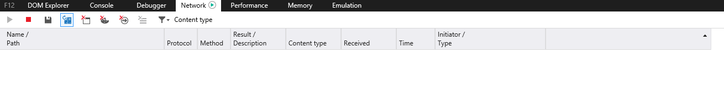
- If it does not load in this mode, click on the green Play button and it would start capturing.
- Carry out the steps to reproduce the issue.
- Once the issue is reproduced, click on the Stop button on the F12 Network tool.
- Click on Save button to save the capture.
- File should be saved in .har extension.

<Note for Engineer>
There is an option on F12 Network tool called Clear entries on navigate and it stays enabled by default. If we are capturing a log from a scenario where multiple redirections would happen, then we should always disable this option before capturing the log. Else, Network tool would clear the entries as soon as navigation happens.

