- Clear the Temporary Internet Files and close all the instances of Edge opened.
- Open a fresh instance of Edge.
- Press F12 key and F12 developer tools would appear on the screen.
- Alternatively, we can also go to Settings> More Tools> Developer Tools to open F12 Developer Tools.
- Once opened, go to the Performance tab.
- If Performance tab is not visible on the tab menu, then click on the icon and then select the Performance option. This will enable the Performance tab on the Developer tools.
- On Edge, reach to the point from where we can start the steps to reproduce the issue.
- Click on the Record button to start recording.
- Reproduce the problem and click on the Stop button.
- Once stopped, it should look something like this:
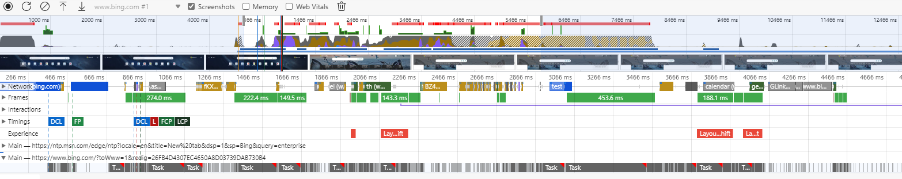

- Save the log by clicking on the Save Profile button.
- The log should be saved with file extension .json.

