- Clear the Temporary Internet Files and close all the instances of Internet Explorer opened.
- Open a fresh instance of Internet Explorer.
- Press F12 key and F12 developer tools would appear on the screen.
- Alternatively, we can also go to Settings> F12 Developer Tools to open F12 Developer Tools.
- Once opened, go to the Performance tab.
- On Internet Explorer, reach to the point from where we can start the steps to reproduce the issue.
- Click on the Play button to start recording. Or we can also click on Start profiling to begin a performance session as well to start the recording
- Reproduce the problem and click on the Stop button or click on Stop profiling to generate a report.
- Once stopped, it should look something like this:
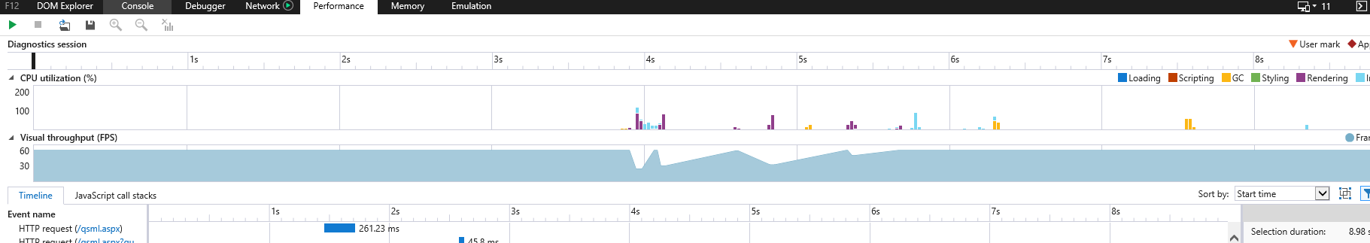

- Save the log by clicking on the Save button.
- The log should be saved with file extension .diagsession.

