- Download and install fiddler from http://www.telerik.com/download/fiddler
- Close all the browser windows opened
- Launch fiddler and go to Tools>Fiddler options, select the HTTPS tab and check Decrypt HTTPS traffic. You should now get some warnings related to the certificate installations, please click on OK and install the certificates.
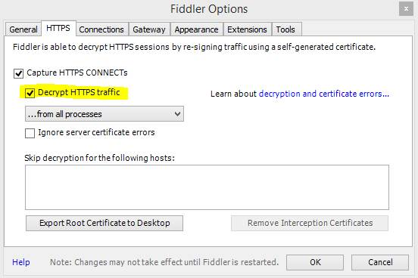

- Once this is done, please clear the Temporary Internet Files from the browser for which we are collecting the Fiddler trace.
- Open a fresh browser window and access the application and once the issue is reproduced, note down the time so that we can narrow it down to that location.
- Save the log file. File>save>All sessions.

