Fiddler Set Up
- Download Fiddler from http://www.telerik.com/download/fiddler
- Install Fiddler on a machine which is on the same domain and network as that of the mobile device.
- Click Tools > Fiddler Options > Connections.
- Click the checkbox by Allow remote computers to connect.
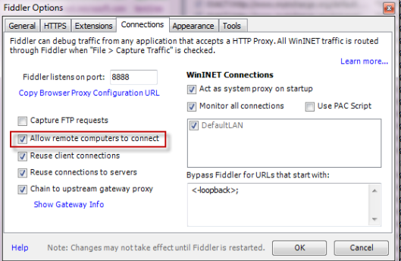

- Now, go to the HTTPS tab and enable Decrypt HTTPS Traffic option
- Restart Fiddler.
- Ensure your firewall allows incoming connections to the Fiddler process.
- Find the IP for the network that both devices are connected on (for ease make sure it's the same network)
  - One way to do this Hover over the Online indicator at the far right of the Fiddler toolbar to display the IP addresses assigned to Fiddler's machine.
  - Another is to go to wifi find the connection that both devices are connected on:
    - Click "properties"
    - Scroll to the bottom where the network properties are listed
    - Find the listing for "IPv4 address"


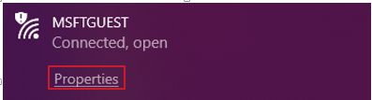

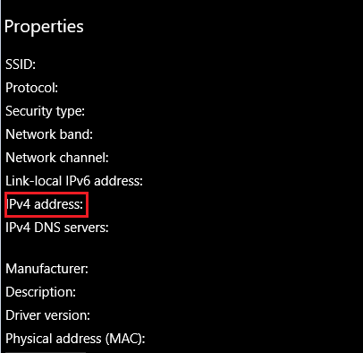
- Verify client iOS device can reach Fiddler by navigating in the browser to http://FiddlerMachineIP:8888. This address should return the Fiddler Echo Service page.
  - Fiddler needs to be capturing for this to work.
    - If Fiddle is not already capturing traffic, enable it by selecting File menu -> Capture Traffic and ensuring it's checked (alternatively you can also enable by hitting F12 or clicking on the lower left corner).
  - Replace the "FiddlerMachineIP" with the IP you located above. (for example http://123.45.67.89:8888)
- For iPhone: Disable the 3g/4g connection.

iOS set up
- Before proceeding with these steps please confirm that you are getting the splash page when performing step 7 above
- To allow for HTTPS decryption we need to install Fiddler's certificate on the device this can be downloaded from the splash page when clicking the "FiddlerRoot certificate" link
  - This step will need to be performed from Safari. From our testing and research, it seems that Apple only allows installation of certificates from Safari.
  - For more information on Fiddler's certificate please see their documentation https://docs.telerik.com/fiddler/Configure-Fiddler/Tasks/ConfigureForiOS
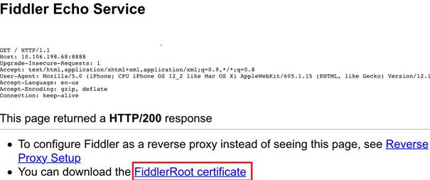
- After clicking you will get a prompt on whether you would like to allow the installation of the "Profile". Select allow. Once installed you will get a second prompt notifying that the profile has been downloaded. This however does not mean that we have finished setting up the certificate
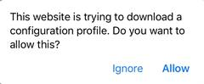

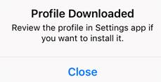
- Next go to Settings -> General -> Profile Management
  - Here you should see in the list an option under Downloaded Profile section "DO_NOT_TRUST_FiddlerRoot". Select this to navigate to the install pane.
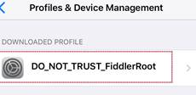
- After opening the profile click the Install button located in the top right.
  - Once it's installed you should see the Not verified section below turn to a green "Verified" with a check mark and the title of the section should change from "Install Profile" to just "Profile"
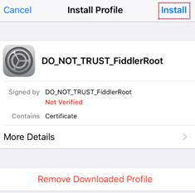

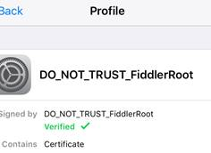
- The final step to allow for https decryption, go to settings -> general -> about -> Certificate Trust -> settings and enable "DO_NOT_TRUST_FiddlerRoot" option
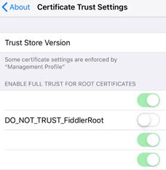
- Now that we have HTTPS decryption set up change the wifi to use Fiddler as a proxy
  - Go to settings -> wifi and select the information option next to the wifi that we are using
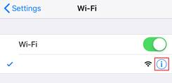
- At the bottom select to configure proxy. Once the page for Configure Proxy comes up choose Manual and enter :
  - In Server enter -> <IP that we used in first section step 7>
  - In port enter -> 8888
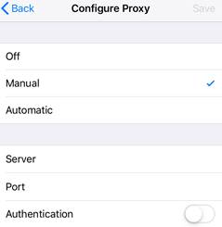

Data Collection
- Before starting prep both the mobile device and the "proxy" machine for collection.
  - To try and minimize the data we capture please try to close out of all applications on both the proxy machine and mobile device that are not needed for the repro.
  - If there are any other tabs that are open, please close out of these
- Clear the browser cache
  - Go to Settings -> Privacy -> Clear browsing data and make sure the following are checked:
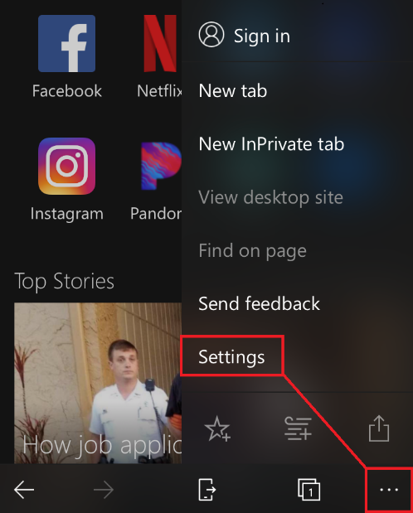
- Cookies and site data
- Cache
- Form Data
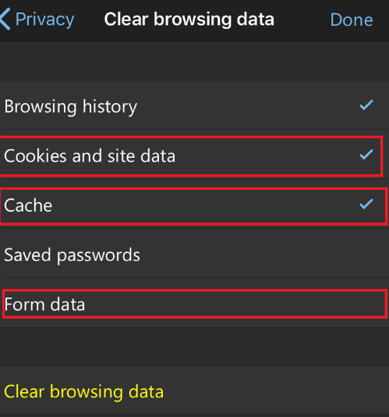
- Once checked click the button to clear browsing data
- Now that we have the environments set for collection, start capturing traffic in fiddler
  - If you had Fiddler capturing traffic during the set-up phase, please clear out any traffic not related to the issue at this time.
  - If Fiddle is not already capturing traffic, enable it by selecting File menu -> Capture Traffic and ensuring it's checked (alternatively you can also enable by hitting F12 or clicking on the lower left corner).
- Perform the steps necessary to reproduce the issue
- Once finished, stop capturing traffic by repeating the above step
- Save all sessions by selecting File menu -> Save -> All sessions...

How to Uninstall Fiddler Certificate once finished
- Go back to where we installed the Fiddler profile/certificate (Settings -> General -> Profile Management )
  - Select "DO_NOT_TRUST_FiddlerRoot"
- Once inside the detail view for the profile press the Remove Profile button at the bottom

