To collect gpresult:

- Open command prompt as Administrator.
- Run the following command:

gpresult /h <file_name>.html

- An html file with the list of policies would be generated under the location of the command prompt.

To collect RSOP:

- Open command prompt as Administrator.
- Run the following command:

rsop.msc

- It would present a window like this:
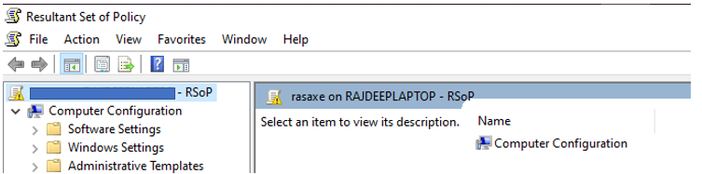

- Save the file by click on File> Save As. File would be saved in .msc extension.

