- Determining the Process ID using Process Explorer (If hanging process is iexplore.exe):
- Download and run Process Explorer from https://live.sysinternals.com/procexp.exe
- Once it is up and running open Internet Explorer and try to replicate the issue
- As soon as the issue happens, come back to Process Explorer
- Click and hold the target icon and drop it over Internet Explorer window which is in hung state. This would highlight the iexplore.exe process relating to the tab in which we have distorted graphics. Make a note of the PID of iexplore.exe highlighted. We would use it while collecting hang dumps.

- Now, click on View menu> Lower pane view> DLLs
- It would show all the hooked DLLs at the bottom of the window
- Now, click on File> Save as. Save the File by the name Hooked DLLs.
- Once saved, click on View menu> Lower pane view> Handles
- Again, click on File> Save as. Save the File by the name Handles.

- Determining the Process ID using Browser Task Manager (If hanging process is msedge.exe):
- Keep a separate Edge process opened which we would use to open Browser Task Manager
- Click on the three dots menu and select More Tools> Browser Task Manager. A window like this would appear. Keep it opened.
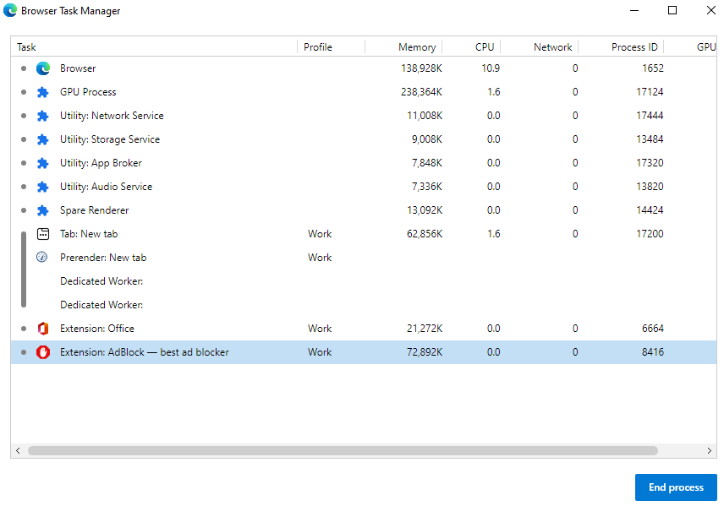
- Open another Edge window and then reproduce the issue there. Once the issue has happened, take a note of the Process ID where the hung page is loading.

- Collecting Hang Dumps:
- Download and Extract ProcDump utility from https://live.sysinternals.com/procdump.exe and save it under C:\Temp folder
- Open command prompt as Administrator
- Cd to C:\Temp where you have extracted ProcDump
- Once done, run the following command once browser window goes into hung state, to gather the hang dump:

Procdump -h -ma pid

- Replace pid with the Process ID determined in Part 1.
- Hit Enter and it will automatically collect a dump.
- In case, you do see any message saying dump is generated then run the following command

Procdump -ma pid

- Collect three such dumps in an interval of 30 seconds each.

<Note for Engineer>
- These logs should be collected very carefully. If we miss on following these steps, we might end up having incorrect data, which would lead to collect the data again. So, always go through the steps and if possible, always collect hang dumps in our presence unless the issue is intermittent. If we cannot be on the call, make sure we educate the customer through the complete process of collecting the dumps so that we get the right data.
- Also, the interval specified in the steps is 30 seconds. However, if the hang does not last fore more than a minute than the just divide the length of hang by 3 and decide the interval the dumps should be collected. For example, if the hang lasts for 30 seconds, then 10 seconds should be chosen as the interval to collect the dumps.
- In the hang scenario, we should always collect at least three dumps. Collecting just one or two dumps would not be useful, as they would not give us the correct information around the hung threads.

