- Download and install HttpWatch from https://www.httpwatch.com/download/ .The basic edition should be sufficient for log collection.
- Clear the Temporary Internet Files and close all instances of Internet Explorer.
- Open a fresh instance of Internet Explorer.
- Launch httpwatch in Internet Explorer by going to Tools> Httpwatch.
- Start the capturing by clicking on the Record and make sure that you note down the site and time when the issue happens.

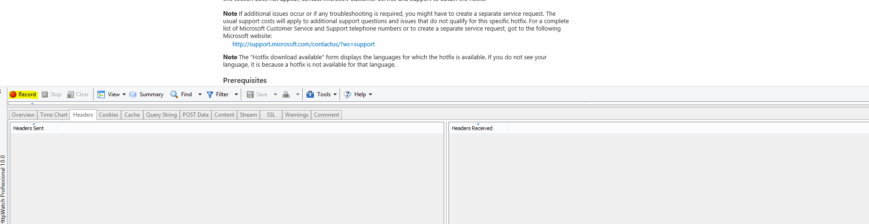

- Reproduce the issue by accessing the site.
- Click on Stop button and then click on Save button.
- The file should be saved in .hwl extension.

