- Clear Temporary Internet Files from Edge and then close all the open instances of Edge.
- Open a fresh instance of Edge and type edge://net-export in the address bar and hit Enter.

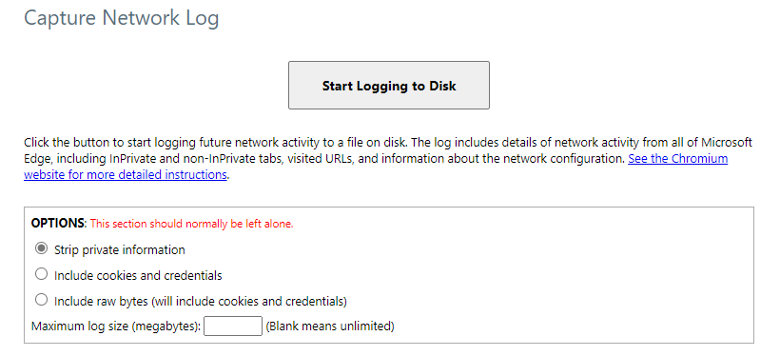

- Select Strip private information option.
- Click on Start Logging to Disk and it would present a dialog to save the file in which the trace would be captured.
- Select the location where we want to save the file, name the file, and save it.
- Open a new tab in the same window and reproduce the issue.
- Once the issue has been reproduced, come back to the tab where net-export was running and click on Stop Logging button.

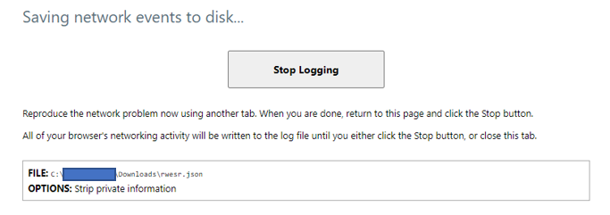

- File would be saved at the location chosen in Step 5.

<Note for Engineer>
Generally, we should collect with Strip private information enabled on edge://net-export. However, it might change depending on the scenario. So, it is always advised to check with Escalations or Technical Advisors on which option should be chose unless we are very sure on which option should be used.

