- Download and install Network Monitor, taking all the installation defaults: https://www.microsoft.com/en-in/download/details.aspx?id=4865
- Open command prompt and run the following command: ipconfig /flushdns
- Start the Network Monitor tool, by default there should be a Microsoft Network Monitor 3.4 icon on the desktop.
- From the Select Networks pane, please click to select the network adapter we are using from the list (if it is not already checked).
- Click the New Capture button available right below the File menu.

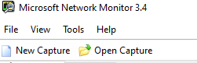

- When you are ready to reproduce the problem, start the trace by clicking on the Play button in the toolbar, or by clicking Capture > Start.

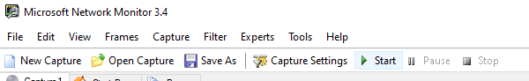

- Once the issue is captured, stop the network trace by clicking on the Stop button on the Network Monitor's window.
- Save the trace by clicking on File> Save As, and save the file as <name_of_the_file>.cap.

