- Download the process monitor tool from the following link and extract the zip file to the desktop: http://technet.microsoft.com/en-us/sysinternals/bb896645.aspx
- Copy the procmon.exe to the desktop
- Right click on the procmon.exe file and select Run As, run the file using any Administrator account (if you are administrator then this step is not needed). Once process monitor is launched the capturing is started immediately.
- Please ignore the process monitor filter window (as shown below) and click on the reset button, Apply and OK.

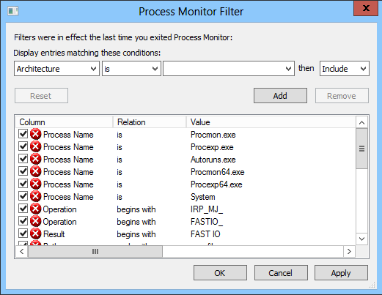

- Launch the browser and replicate the issue
- In the ProcMon window and press Ctrl+E (or click on the magnifier button) to stop the capture.

- Click on File menu and then select Save option. Make sure that we select All Events before saving the file.
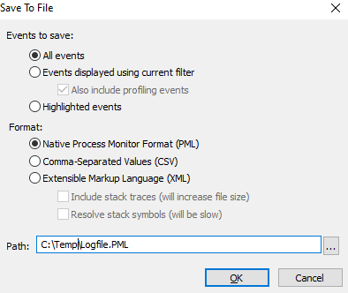

- Click on Ok to save the file.

