- Open Edge
- Type edge://sync-internals in the address bar and press Enter
- Click on the Dump Status button and it would provide the data in text format on a text box right below the button like this:
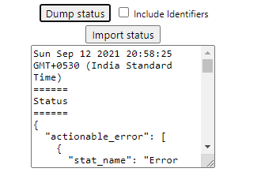
- Copy the text from this text box and put it on a notepad file and save the text file.

