- Download the Windows ADK version matching the Windows version where the problem occurs at https://aka.ms/adk (for Windows 7 use the Windows 8.1 ADK package)
- Select the Windows Performance toolkit only for installation.
- Gathering performance traces instructions
  - To collect the traces, use Windows Performance Recorder (type wpr in the start menu search and then select Windows Performance Recorder)
  - Enable the following options:
    - First Level Triage
    - CPU Usage
    - Heap Usage
    - VirtualAlloc Usage
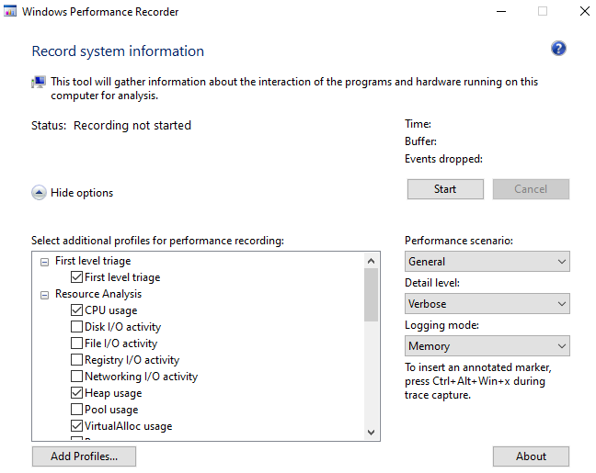
- Click start in WPR. Navigate to the repro the issue on the browser.
- Repeat the leak cycle three times without closing the browser.
- Once you can repro the issue, stop, and save the trace.

<Note for Engineer>
Before we start collecting the logs, make sure we have closed all the applications other than the required ones because WPR would collect data from all the running processes, making it a heavier log. This could result in upload issues, problems while analyzing etc.

