Benjamin Smith

Anna Therkelsen

CS 420 Project

***Train***

PrimaryKey – TrainID

Highest NF – BCNF (Multivariable dependencies)

Functional Dependencies

TrainID TrainName

TrainID TrainModel

TrainID NumOfCars

|  |  |  |  |
| --- | --- | --- | --- |
| TrainID | TrainName | TrainModel | NumOfCars |

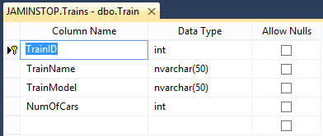

***Passenger***

PrimaryKey – PassengerID

Highest NF – 2NF (Transitive dependency)

Functional Dependencies

PassengerID FirstName + LastName

FirstName + LastName Baggage

PassengerID Baggage

|  |  |  |  |
| --- | --- | --- | --- |
| PassengerID | FirstName | LastName | Baggage |

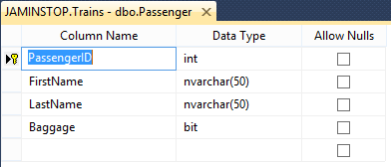

***Station***

PrimaryKey – StationID

Highest NF – 2NF (transitive dependency)

Functional Dependencies

StationID StationName

StationID City

City StationName

|  |  |  |
| --- | --- | --- |
| StationID | StationName | City |

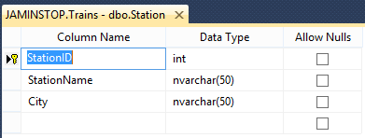

***Ticket***

PrimaryKey – TicketID

Highest NF – 3NF (Not all determinates are candidate keys)

Functional Dependencies

RouteID + RouteDate + PassengerID SeatAssignment

|  |  |  |  |  |
| --- | --- | --- | --- | --- |
| TicketID | RouteID | RouteDate | PassengerID | SeatAssignment |

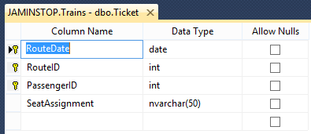

***Route***

PrimaryKey – RouteID

CanidateKey – StationID

Highest NF – 3NF (All determinates are not candidate keys)

Functional Dependencies

RouteID + StationID ArrivalTime

RouteID + StationID DepartTime

ArrivalTime + DepartTime TrainID

|  |  |  |  |  |
| --- | --- | --- | --- | --- |
| RouteID | StationID | ArrivalTime | DepartTime | TrainID |

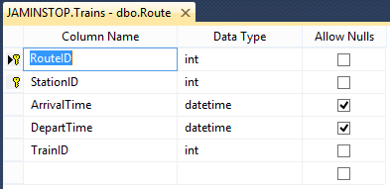

**Route_Station**

Primary Key – RouteID

Canidate Key – StationID

Highest NF – 4NF

|  |  |
| --- | --- |
| RouteID | StationID |