|  |  |  |  |  |
| --- | --- | --- | --- | --- |
|  |  | | | |
|  | |  | | |
| Project: | | <Fishing Trip> | | |
| Team No.: | | Team 3 | | |
| Class: | | CSE 3310.003 - Fall 2020 | | |
| Module: | | System Requirements Analysis (SRA) | | |
| Deliverable: | | SRA Document | | |
| **Version:** | | **[1.3]** | **Date:** | **[10/22/2020]** |

Contributors:

Jeremy Jones

Uyen Do

Tia Deloach Benson

Alexander Cole

Benjamin Stanelle

**Revision History**

|  |  |  |  |  |
| --- | --- | --- | --- | --- |
| ***Version number*** | ***Date*** | ***Originator*** | ***Reason for change*** | ***High level description of changes*** |
| 1.0 | 10/06/2020 | Jeremy Jones  Uyen Do  Tia Deloach Benson  Alexander Cole  Benjamin Stanelle | Initial draft |  |
| 1.1 | 10/19/2020 | Uyen Do | Revise system requirements | Remove winning and losing screen, add Game Over screen |
| 1.2 | 10/20/2020 | Jeremy Jones  Alexander Cole  Benjamin Stanelle | Revise context diagram  Revise UML diagram | Change user to player, scoreboard screen to “Game Over “screen  Take out “coins” |
| 1.3 | 10/22/2020 | Uyen Do | Final version | Spell check and correct some formatting issues |

**TABLE OF CONTENTS**

**1. INTRODUCTION AND PROJECT OVERVIEW**3

**2. OBJECTIVES**4

2.1 Business Objectives 4

2.2 System Objectives 4

**3. PROJECT CONTEXT DIAGRAM**5

**4. SYSTEMS REQUIREMENTS**6

4.1 “Home Screen” Requirements 6

4.2 “Play Game” Requirements 7

4.3 “Game Over” Requirements 17

4.4 “Quit Game” Requirements 19

4.5 “Change Settings” Requirements 20

4.6 “High Scores” Requirements 21

**5. SOFTWARE PROCESSES AND INFRASTRUCTURE**24

5.1 Hardware and Infrastructure 24

5.2 UML Class Diagram 25

5.3 Change Settings UML 26

5.4 High Scores UML 26

5.5 Play Game UML 27

5.6 Obstacles UML 27

5.7 Power-Ups and Debuffs UML 28

5.8 Game Over UML 29

5.9 Saving Highscores 29

5.10 Screen Shots 29

5.11 Test Plan 30

**6. ASSUMPTIONS AND CONSTRAINTS**31

6.1 ASSUMPTIONS 31

6.2 CONSTRAINTS 31

6.3 Out of Scope material 31

**7. DELIVERY AND SCHEDULE**32

**8. STAKEHOLDER APPROVAL FORM**33

**APPENDIX:**34

# **1. Introduction and Project Overview**

Group 3 has decided to design and release an android game app. This game will be two-dimensional, and the character will constantly be running to the right of the screen. The objective will be to get as far as possible without touching an obstacle. There will be power-ups and sound effects. The player will also be able to choose from five-character appearances. There will be many obstacles, randomly spawned into the game. The app will also keep track of the 10 highest scores on the device. The app will be ready by November 24th, 2020

# **2. Objectives**

## 2.1 BUSINESS OBJECTIVES

The following is a list of business objectives:

**Objective 1**: Track High Scores: The Player will enter a short name when they complete a game and their score is higher than the current 10th High Score.

**Objective 2**: Character Skins: The Player will be able to switch between 5-character appearances referred to as “skins.”

**Objective 3**: Dynamic Background: The background of the game will change as you reach certain distances, and new obstacles will appear.

## 2.2 SYSTEM OBJECTIVES

The following is a list of system objectives:

**Objective 1**: System will be an Android application.

**Objective 2**: High Scores will be saved locally.

**Objective 3**: App will be developed with unity to simplify the development process.

**Objective 4**: App will be developed for horizontally held phones.

# **3. Project Context Diagram**

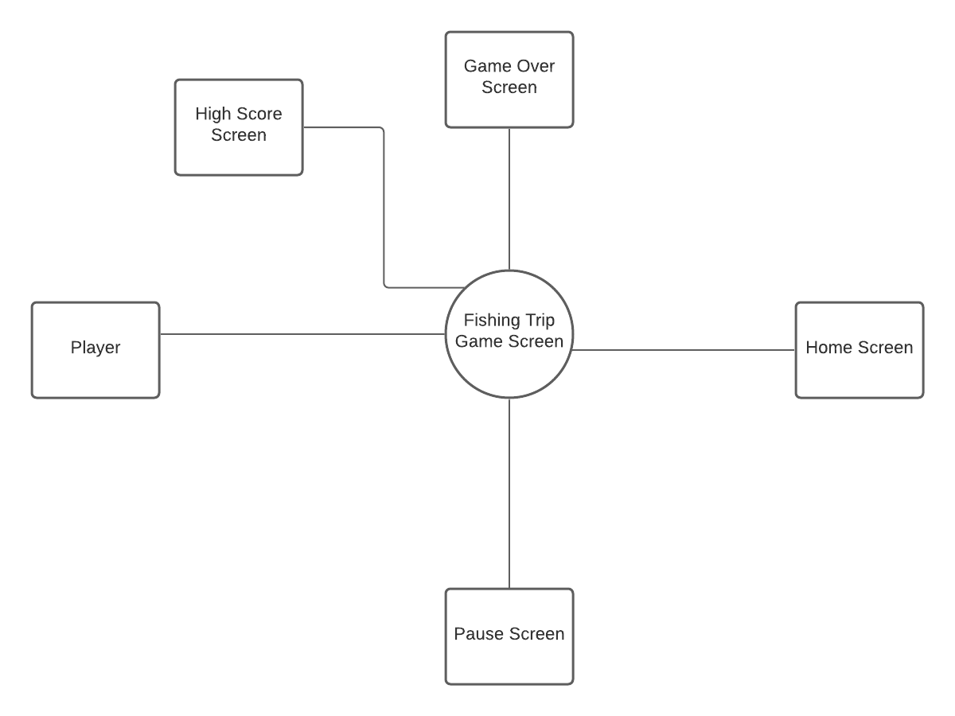

# **4. Systems Requirements**

The following sections provide details of the system requirements we will implement in accordance with the game specifications published in the project description. The requirements are grouped into six main categories: Home screen, Play game, Game over, Quit game, Change Settings and High Scores

## 4.1 “HOME SCREEN” REQUIREMENTS

|  |  |
| --- | --- |
| **Requirement Title:** | Home Screen |
| **Sequence No:** | 1 |
| **Short description:** | Display welcome screen with buttons to redirect to other screens |
| **Description:** | The “Home” screen shall have a welcome background and 4 buttons: “Start”, “Setting”, “High scores”, and “Quit”. The player will be redirected to other screens according to the clicked buttons.   * Start: go to play game screen * High Scores: go to high score screen * Settings: go to setting screen * Quit: exit game |
| **Pre-Conditions**: | The player has downloaded and installed the game on Android mobile device |
| **Post Conditions:** | Successfully opening the game will display welcome background and options to start game, change settings, see high scores and exit game |
| **Other attributes:** | There is background music while staying at “Home” screen |

## 4.2 “PLAY GAME” REQUIREMENTS

## 

|  |  |
| --- | --- |
| **Requirement Title:** | Play Game |
| **Sequence No:** | 1 |
| **Short description:** | Start a new game |
| **Description:** | The system will start a new game and allows players to play endlessly until they hit any obstacles.   * Hitting any obstacle will end the game and redirect to the “Game over” screen. * Hitting power-ups will allow the player to speed up, invisible (be immune to one obstacle) or add bonus points to the total score. * Hitting debuffs will slow the player down or negate any currently used power-ups. * While playing, the player has options to pause and resume the game. |
| **Pre-Conditions**: | The player successfully opens the game by clicking the “Start” button. |
| **Post Conditions:** | Successfully loading the game will redirect the player to the game screen |
| **Other attributes:** | There is background music while playing game |

## 

|  |  |
| --- | --- |
| **Requirement Title:** | Play Game |
| **Sequence No:** | 2 |
| **Short description:** | Change background scenes |
| **Description:** | The background scene will change for the player; this is based on how far of a distance the player has run. The background will change between 3 different scenes in order and loop back with more obstacles.   * Field (default) * Forest * Beach   These background changes will also increase the difficulty of the game. |
| **Pre-Conditions**: | The player is still alive and running in the game, and the distance requirements have been met. |
| **Post Conditions:** | The background will change to a different scenery depends on the achieved distance |
| **Other attributes:** | There is background music while playing the game. Same background music for all scenes. |

## 

|  |  |
| --- | --- |
| **Requirement Title:** | Play Game |
| **Sequence No:** | 3 |
| **Short description:** | Control character’s movements |
| **Description:** | The system will allow the player to move their chosen character. The character will be able to move left and right and will also be able to jump to avoid obstacles. |
| **Pre-Conditions**: | The player is still alive and continues to run in the game |
| **Post Conditions:** | The player will see these responses on the game screen in real time when the system successfully implements the player’s movement commands. |
| **Other attributes:** | N/A |

|  |  |
| --- | --- |
| **Requirement Title:** | Play Game |
| **Sequence No:** | 4 |
| **Short description:** | Display current running distance |
| **Description:** | The system will update the running distance based on the achieved distance. Buffs that are applied will increase the distance score faster than debuffs that are applied. The current distance will be displayed on the game screen in real time. |
| **Pre-Conditions**: | The player is still alive and running in the game |
| **Post Conditions:** | Successfully updating the running distance will display the correct running distance in real time for the player. |
| **Other attributes:** | N/A |

## 

|  |  |
| --- | --- |
| **Requirement Title:** | Play Game |
| **Sequence No:** | 5 |
| **Short description:** | Ability to keep track of and collect baits (bonuses) |
| **Description:** | The system will track the number of baits collected by the player and will be displayed as bonus points on the gaming screen in real time. The collected baits will add points to the total score at the end of the game. Not collecting baits will not negatively affect the player. |
| **Pre-Conditions**: | The player is still alive and collects baits along the way |
| **Post Conditions:** | Successfully updating the baits will display the correct bonus points on the gaming screen in real time |
| **Other attributes:** | N/A |

|  |  |
| --- | --- |
| **Requirement Title:** | Play Game |
| **Sequence No:** | 6 |
| **Short description:** | Collect and use power-ups |
| **Description:** | The system will apply the correct power-up ability based on what the player collects  There are three power-ups with different functionalities:   1. Coffee - Makes the player run faster; rapidly increases the distance ran 2. Fishing Hook - Gives temporary invincibility by allowing the player to hit one obstacle without penalty 3. Fishing Bait - Adds an extra point to the total score at the end of the game. There are three different bait colors. Different colors will apply different bonuses. |
| **Pre-Conditions**: | The player is still alive in the game and collects power-ups |
| **Post Conditions:** | The power-up will be applied immediately. The player will speed up or be invisible for a short period of time. |
| **Other attributes:** | N/A |

## 

|  |  |
| --- | --- |
| **Requirement Title:** | Play Game |
| **Sequence No:** | 7 |
| **Short description:** | Debuff the player |
| **Description:** | The mud obstacle will debuff the player, which will decrease the player’s speed. If the player is currently using power-ups. This debuff will also negate any power-ups that have been applied to the player. |
| **Pre-Conditions**: | The player is still alive and running in the game, and the player runs into the mud obstacle without having the fishing hook invincibility power-up |
| **Post Conditions:** | The debuff will be applied to the player for a short period of time. The distance travelled will accumulate slower than normal during this period. |
| **Other attributes:** | N/A |

## 

|  |  |
| --- | --- |
| **Requirement Title:** | Play Game |
| **Sequence No:** | 8 |
| **Short description:** | Spawning obstacles |
| **Description:** | The system will randomly place obstacles throughout the game to make the player lose the game. Hitting any obstacles will cause “Game over” and redirect the player to “Game over” screen.  There are multiple obstacles:   1. Cows, Chickens, Bushes, Rocks - will stand still, won’t run at the player 2. Bulls - will run at the player 3. Dogs - will chase behind the player |
| **Pre-Conditions**: | The player is still alive and running in the game |
| **Post Conditions:** | Obstacles will be randomly spawned into the game screen as long as the player is still alive or the player will be redirected to “Game over” screen. |
| **Other attributes:** | N/A |

|  |  |
| --- | --- |
| **Requirement Title:** | Play Game |
| **Sequence No:** | 9 |
| **Short description:** | Allow player to pause current game |
| **Description:** | The system shall allow the player to pause the game by clicking the “Pause” button on the game screen. The system will freeze the game and save all current states to be resumed if the player does not close the game window or turn off the device. Closing the game or turning off the device while pausing will terminate the current game and all settings will be resettled to default. |
| **Pre-Conditions**: | The player is playing the game and clicks the “Pause” button |
| **Post Conditions:** | “Pause” the game will freeze current game and display “Resume” button |
| **Other attributes:** | There is “Resume” button to resume current game |

## 

|  |  |
| --- | --- |
| **Requirement Title:** | Play game |
| **Sequence No:** | 10 |
| **Short description:** | Allow player to resume current game |
| **Description:** | The system shall allow the player to resume the current game by clicking the “Resume” button. The system will resume the current game with existing settings and states. |
| **Pre-Conditions**: | The game is in the pausing state and the player clicks the “Resume” button. |
| **Post Conditions:** | Resuming the game will successfully return to the current game window with existing settings and states. The “Resume” button will become “Pause” button |
| **Other attributes:** | There is “Pause” button to pause current game |

## 4.3 “GAME OVER” REQUIREMENTS

|  |  |
| --- | --- |
| **Requirement Title:** | Game Over |
| **Sequence No:** | 1 |
| **Short description:** | Game Over only when the player hits an obstacle |
| **Description:** | The player will run endlessly to the right and earn points based on achieved distance and collected baits until hitting any obstacle. Hitting any obstacle will cause Game over. The system will display a “Game Over” screen.  If the player’s total score is higher than the 10th highest score in the high score board, the player will be allowed to enter name to the high score board and redirect to the high score screen. |
| **Pre-Conditions**: | The player hits any obstacle without having invisible power-up |
| **Post Conditions:** | The player will be redirected to the “Enter name” screen for high score board or “Game Over” screen. |
| **Other attributes:** | There are “Game Over” screen and “Enter name” screen |

## 

## 

|  |  |
| --- | --- |
| **Requirement Title:** | Game Over |
| **Sequence No:** | 2 |
| **Short description:** | “Game over” screen |
| **Description:** | Hitting any obstacle will cause Game over. The “Game Over” screen will display:   * Achieved distance * Collected baits (bonus) * Total score = distance + baits   and 3 buttons:   * “Restart” button to start new game with existing setting * “Home” button to return to home screen * “Exit” button to exit game |
| **Pre-Conditions**: | The player hits any obstacle without having invisible power-up |
| **Post Conditions:** | The player will be redirected to the screen that the player choses |
| **Other attributes:** | N/A |

## 

## 4.4 “QUIT GAME” REQUIREMENTS

## 

|  |  |
| --- | --- |
| **Requirement Title:** | Quit Game |
| **Sequence No:** | 1 |
| **Short description:** | Allow the player to exit game |
| **Description:** | The system shall allow the player to exit the game by clicking the “Quit” button on any screen. The system will terminate the game, reset all settings to default settings, and close the game window. |
| **Pre-Conditions**: | The player successfully opens the game and click “Quit” button on any screen |
| **Post Conditions:** | Successfully quitting the game will close the game window immediately. All settings will be reset to default. |
| **Other attributes:** | N/A |

## 

## 4.5 “CHANGE SETTINGS” REQUIREMENTS

## 

|  |  |
| --- | --- |
| **Requirement Title:** | Change Settings |
| **Sequence No:** | 1 |
| **Short description:** | Allow player to change game settings |
| **Description:** | The system allows the player to change:   * Player’s name or use default name as “Player” * Character’s skin: there are 5 different skins to choose or use the first one as default. * Music: turn on and off music.   There is a “Save” button to save settings. Without clicking the “Save” button the setting will not be saved, and the system will use the default setting. |
| **Pre-Conditions**: | The player successfully change setting and click save |
| **Post Conditions:** | Successfully changing and saving the settings, the system will apply new settings to new game |
| **Other attributes:** | There is “Home” button to return to home screen |

## 4.6 “HIGH SCORES” REQUIREMENTS

## 

|  |  |
| --- | --- |
| **Requirement Title:** | High Scores |
| **Sequence No:** | 1 |
| **Short description:** | Display the top 10 high scores |
| **Description:** | The system will have a nice background for high scores screen and display the top ten player’s names with their scores in descending order. |
| **Pre-Conditions**: | The player successfully opens the game and clicks the “High Score” button or is redirected from the “Enter name” screen after playing and the total score is in the top 10 highest scores. |
| **Post Conditions:** | Successfully see high score will display top 10 highest scores |
| **Other attributes:** | There is “Home” button on “High scores” screen to return to home screen |

## 

|  |  |
| --- | --- |
| **Requirement Title:** | High Scores |
| **Sequence No:** | 2 |
| **Short description:** | Ability to update new high scores |
| **Description:** | The player’s total score will be automatically compared to the top ten high scores in the system. If the player’s total score is higher than the 10th highest score. The system will update the high score board and display the new high score board. |
| **Pre-Conditions**: | The player cause “Game over” and total score is higher than the 10th highest score in the system |
| **Post Conditions:** | Successfully update high score board will display high score screen with updated scores |
| **Other attributes:** | N/A |

## 

|  |  |
| --- | --- |
| **Requirement Title:** | High Scores |
| **Sequence No:** | 3 |
| **Short description:** | Ability to enter player’s name for high score board |
| **Description:** | If the player’s total score is higher than the 10th highest score in the system, the player will be redirected to the “Enter name” screen to enter the name for the high score board.  The player’s current name (default name or changed name) will be prefilled in the name entry. The player has options to enter a new name or use the prefilled name.  There is a “Save” button to save the name and a “Next” button to go to the next screen. Without clicking the “Save” button the entered name will not be saved, and the current name will be used for the high score board. |
| **Pre-Conditions**: | The player’s total score is higher than the 10th highest score in the system |
| **Post Conditions:** | Successfully enter the player’s name to the high score board will display high score screen with updated name and scores |
| **Other attributes:** | N/A |

# **5. Software Processes and Infrastructure**

## 5.1 HARDWARE AND INFRASTRUCTURE

We will be designing the game using the Unity Game Engine (<https://unity.com/>) and Testing game using Unity Android Emulator and Android mobile phone.

## 5.2 UML CLASS DIAGRAM

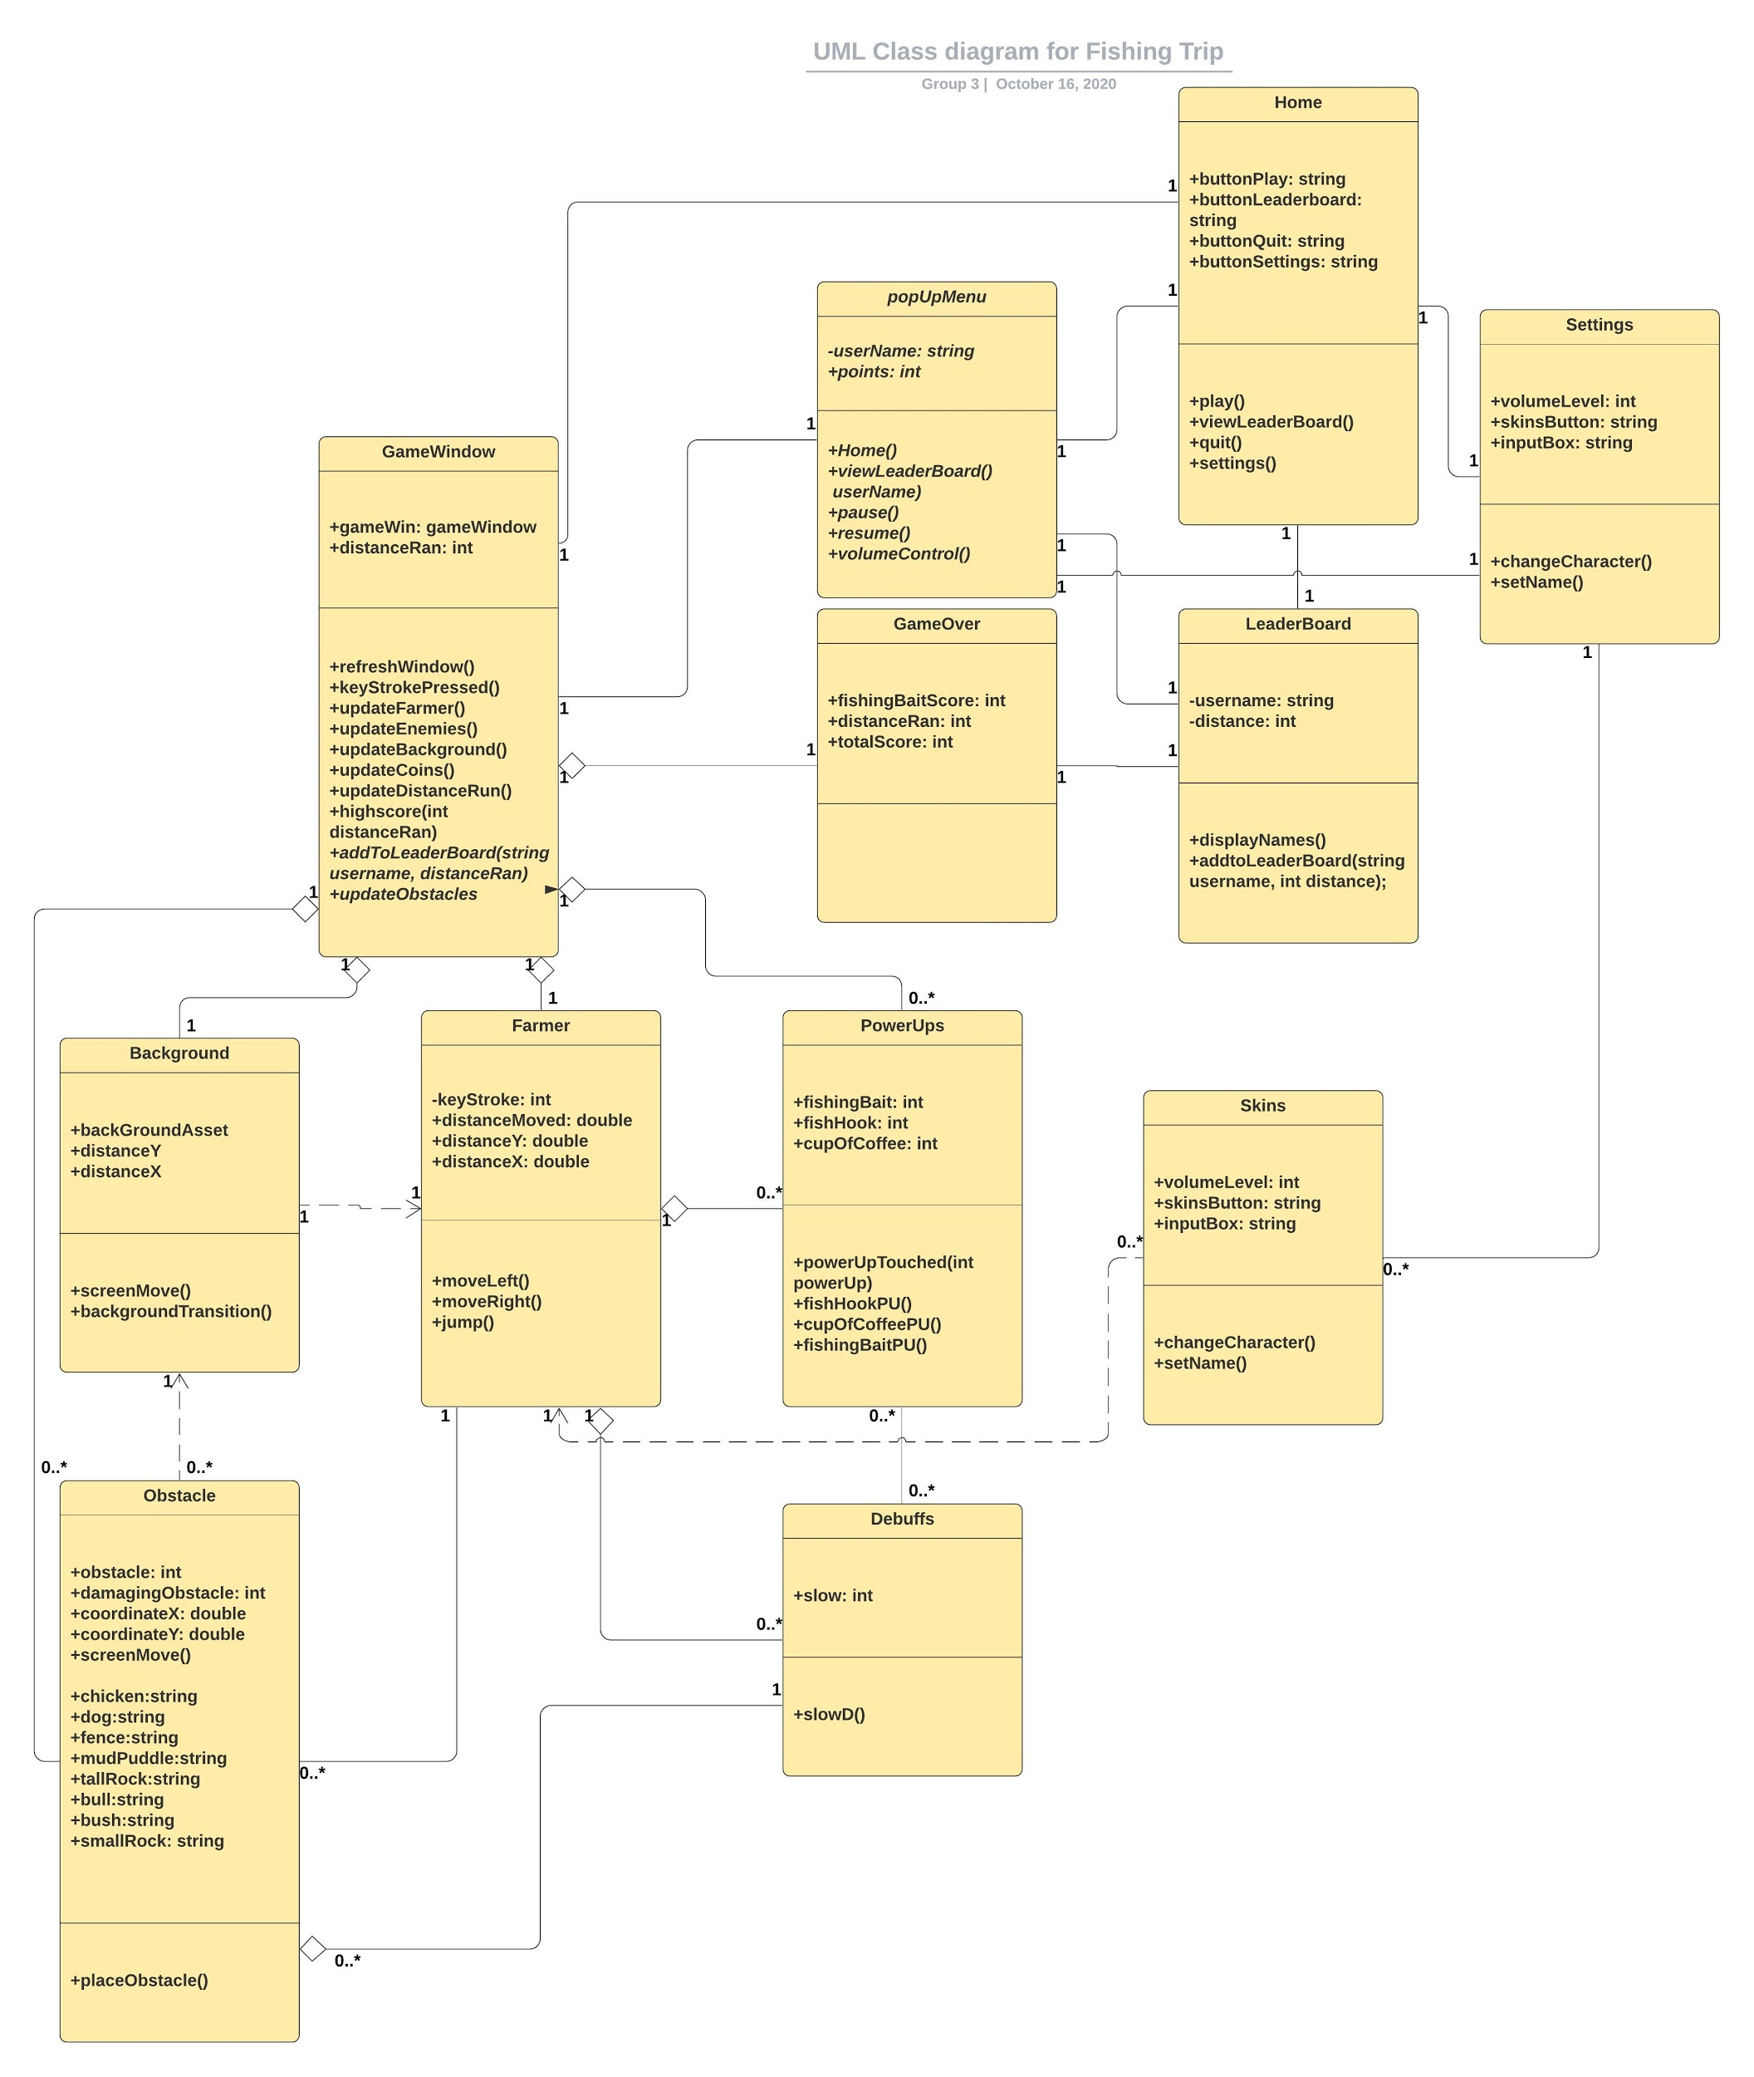

## 5.3 CHANGE SETTINGS UML

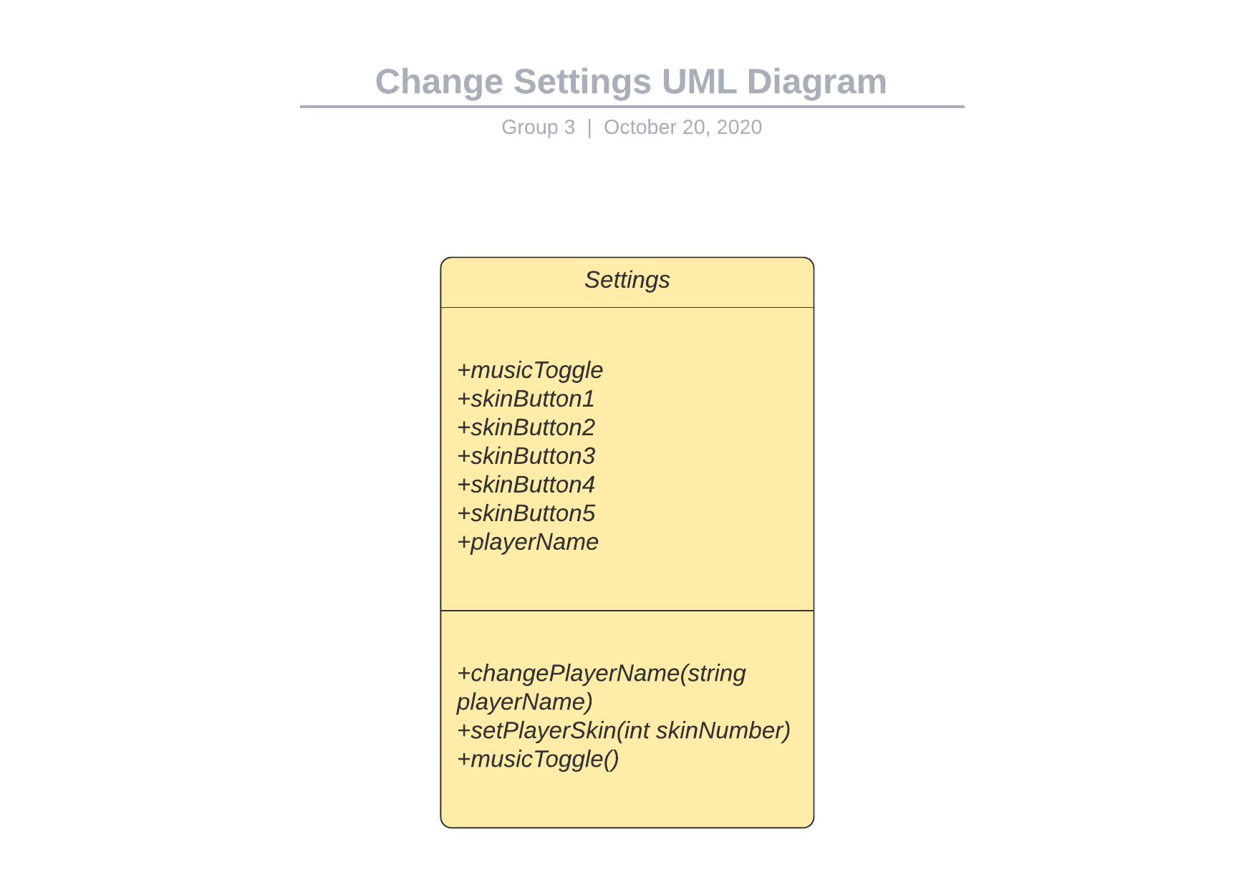

## 5.4 HIGH SCORES UML

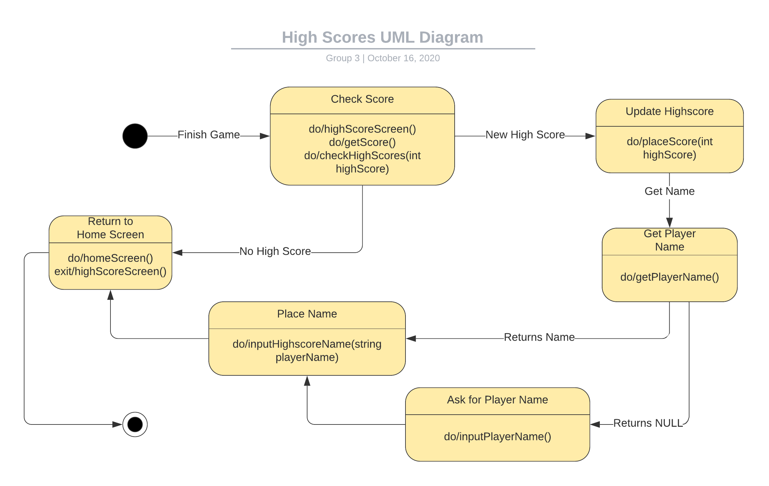

## 5.5 PLAY GAME UML

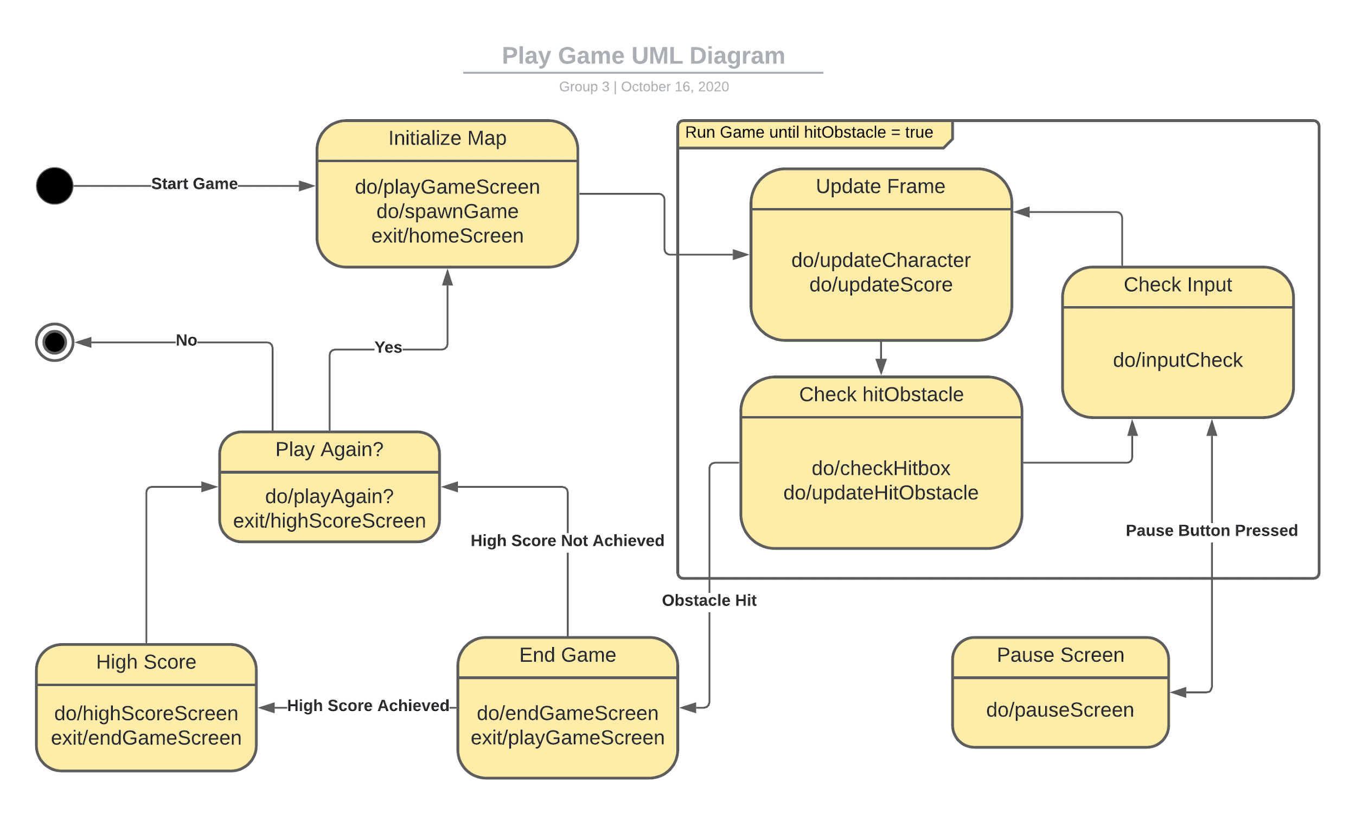

## 5.6 OBSTACLES UML

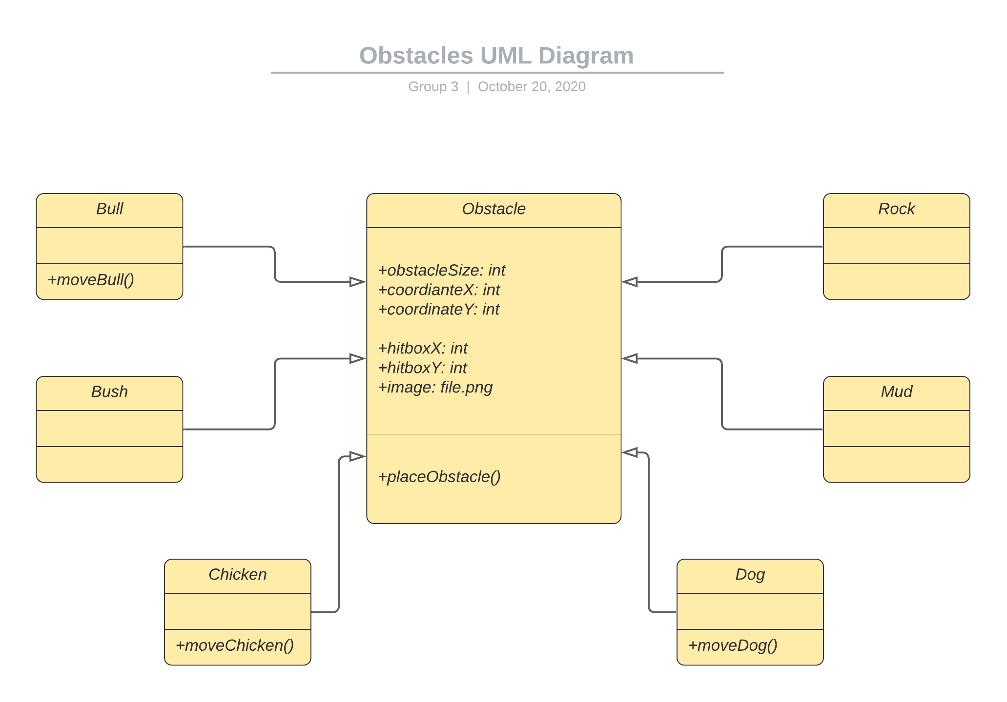

## 5.7 POWER-UPS AND DEBUFFS UML

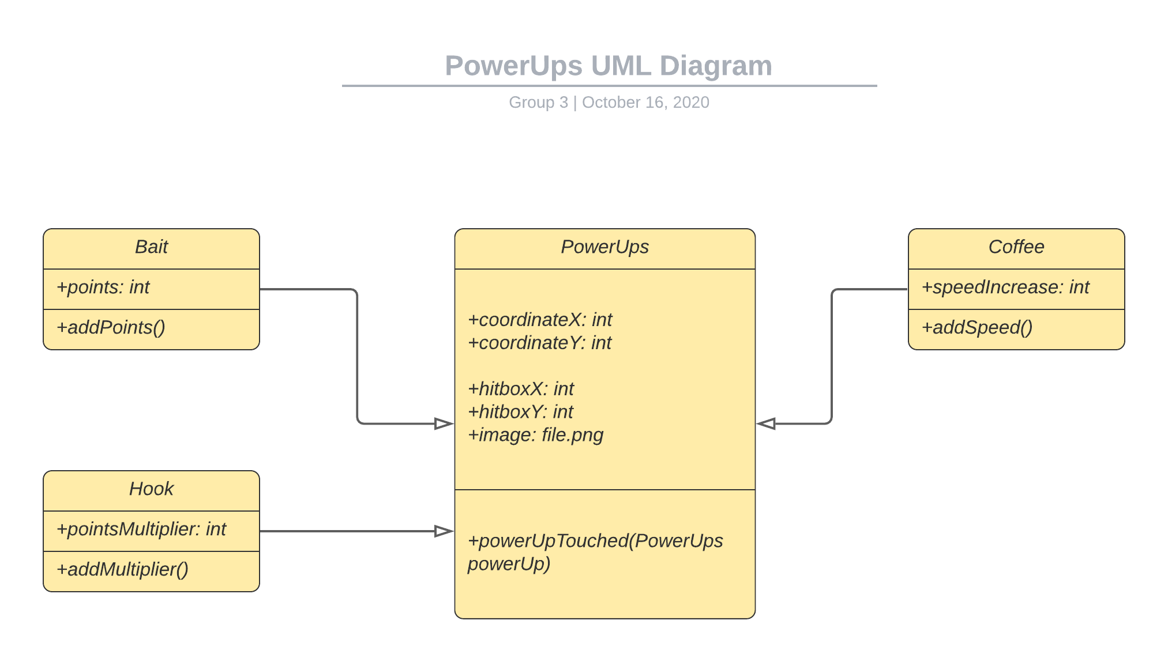

## 5.8 GAME OVER UML

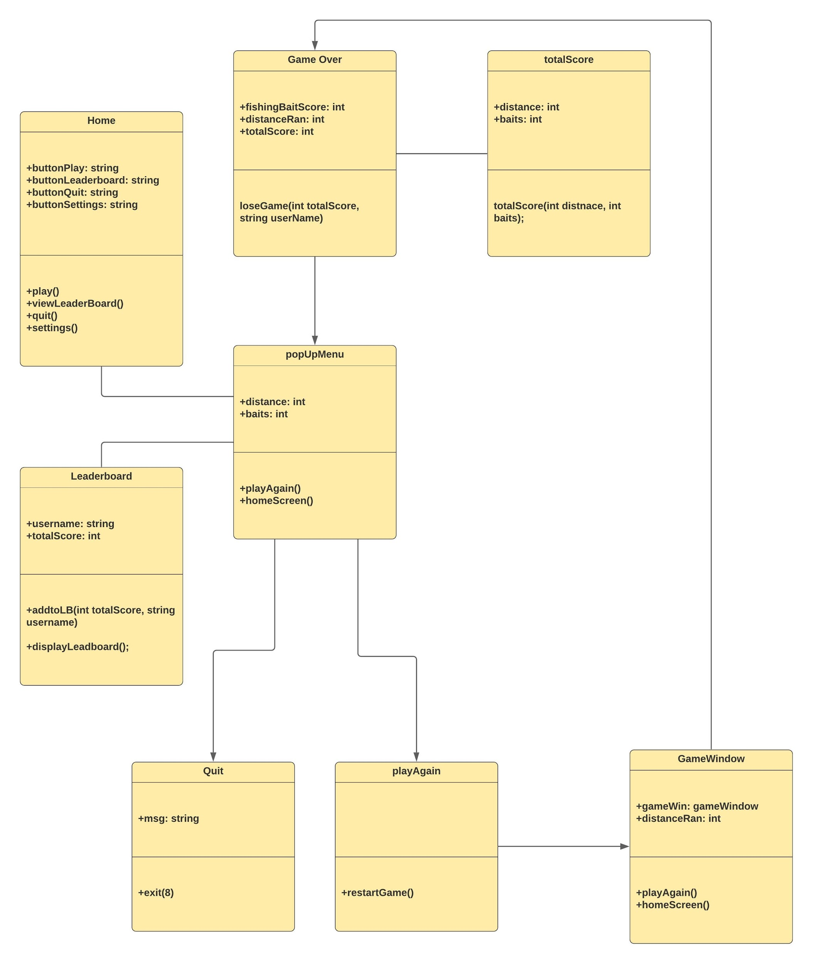

## 5.9 SAVING HIGHSCORES

Currently we have all our high scores saved locally on the machine.

## 5.10 SCREEN SHOTS

Not available currently

## 5.11 TEST PLAN

Testing happens through every step of the creation process, since the game as a whole will either crash or not play properly when done wrong. Everyone will play test the different iterations and provide feedback over the course of development.

# 6. **Assumptions and Constraints**

## 6.1 ASSUMPTIONS

The following is a list of assumptions:

* This is a non-profit app
* The whole team will be available for the entire project
* This app will not be released to the public

## 6.2 CONSTRAINTS

The following is a list of constraints:

* Team lacks Android experience
* Team lacks Unity experience
* Art assets that have a coordinated style exceed the project’s budget.
* Budget of zero dollars.

## 6.3 OUT OF SCOPE MATERIAL

The following is a list of “out of scope” material:

* Post Project maintenance is not covered
* Online Score Management System will not be developed/supported

# 7. **Delivery and Schedule**

|  |  |  |  |  |
| --- | --- | --- | --- | --- |
| Task/Milestone Description | Anticipated Start Date | Anticipated End Date | Status | Comments |
| Prepare Requirements and UML diagram | 9/17/2020 | 10/1/2020 | Complete | Deliverable will be a UML Zip folder.  Increment 1 Deliverable |
| SRA document (Includes project objectives, Requirements and UML diagrams) | 10/6/2020 | 10/22/2020 | In Progress | Deliverable will be the SRA document. All stakeholders agree on the content of the SRA by signing in section 8.  Increment 2 Deliverable |
| Home screen design and implementation | 10/22/2020 | 11/1/2020 | To Be Completed (TBC) |  |
| Settings Screen design and implementation | 11/1/2020 | 11/10/2020 | TBC |  |
| High Score Screen design and implementation | 11/1/2020 | 11/10/2020 | TBC |  |
| Game Screen Screen design and implementation | 11/1/2020 | 11/19/2020 | TBC |  |
| Score Screen design and implementation | 11/5/2020 | 11/10/2020 | TBC |  |
| Character Skin design and implementation | 11/5/2020 | 11/10/2020 | TBC |  |
| Test case design | 11/5/2020 | 11/12/202020 | TBC | Increment 3 Deliverable |
| External Documentation (i.e. User Manual) | 11/12/2018 | 11/24/2020 | TBC |  |
| Project presentation | 11/24/2020 | 11/24/2020 | TBC |  |
| Final Milestone: project delivery | 11/24/2020 | 11/24/2020 | TBC | Increment 4 Deliverable |

# 8. Stakeholder Approval Form

|  |  |  |  |
| --- | --- | --- | --- |
| Stakeholder Name | Stakeholder Role | Stakeholder Comments | Stakeholder Approval Signature and Date |
| Rodrigo Augusto | Development Mgr |  |  |
| Prajwal Gautam | Project Assistant |  |  |
| Jeremy Jones | Developer |  | Jeremy Jones  10/18/2020 |
| Uyen Do | Developer |  | Uyen Do  10/20/2020 |
| Tia Deloach Benson | Developer |  | Tia Deloach Benson  10/18/2020 |
| Alexander Cole | Developer |  | Alexander Cole 10/18/2020 |
| Benjamin Stanelle | Developer |  | Benjamin Stanelle  10/21/2020 |

# Appendix:

None