Project: |  | Stock Trading System (STS)
Team No.: |  | Team Two
Class: |  | CSE 3310; Fall 2019
Module: |  | System Requirements Analysis (SRA)
Deliverable: |  | SRA Document
Version: |  | [1.2] | Date: | [12/03/2019]

Contributors:
Oreoluwa Adebambo
Shazad Brohi
James Lunsford
Jeffrey Strickland

Revision History
Version number | Date | Originator | Reason for change | High level description of changes
1.0 | 10/16/2012 | Oreoluwa Adebambo  Shazad Brohi  James Lunsford  Jeffrey Strickland | Initial draft
1.1 | 10/31/2012 | Shazad Brohi | Updated Requirements and UML for News component of STS | The News component of the STS now uses Yahoo! Finance API to retrieve RSS feeds for stocks.
1.2 | 12/03/2012 | James Lunsford | Final Version | Corrected minor formatting issues within text and UMLs

TABLE OF CONTENTS
1. Introduction and Project Overview 6
2. Objectives 7
2.1 BUSINESS Objectives 7
2.2 SYSTEM Objectives 9
3. System Context Diagram 10
4. Systems Requirements 11
4.1 Requirements Overview 11
4.2 “Logon” Requirements 11
4.3 “Account Set up” Requirements 15
4.4 “Account Maintenance” Requirements 18
4.5 “Cash mangement” Requirements 20
4.6 “Transaction” Requirements 26
4.7 “Transaction History” Requirements 29
4.8 “Stock Management” Requirements 33
4.9 “News” Requirements 35
4.10 “Communications” Requirements 36
5. Software Processes and Infrastructure 40
5.1 Hardware and Infrastructure 40
5.2 System Class Diagram 40
5.3 Account Maintenance UML 41
5.4 Account Setup UML 42
5.6 Login UML 44
5.7 Transaction History UML 45
5.8 News UML 46
5.9 Cash Management UML 47
5.10 Quotes UML 48
5.11 Transactions UML 49
5.12 Conceptual Data Model - Database 50
5.13 Screen Shot 50
5.14Test Plan 50
6. Assumptions and Constraints 51
6.1 ASSUMPTIONS 51
6.2 CONSTRAINTS 51
6.3 Out of Scope material 51
7. Delivery and Schedule 52
8. Stakeholder Approval Form 53
Appendix: 54

1. Introduction and Project Overview

Group 2 has been employed to design and implement a software application for a small brokerage company with multiple locations across the United States. This web-based application should allow their customers to perform various stock related activities such as checking stock prices and news, buying and selling stocks. The system will be up and operational during the first week in December of 2012 just in time for the 2013 trading year. In addition to the minimum set of requirements listed below, the brokerage company is open to any recommendations in functionality as well as look & feel of the application.

2. Objectives

2.1 BUSINESS Objectives
The following is a list of business objectives:

Objective 1: System will require registration and will be password protected.

Objective 2: “Account setup” functionality must be supported that includes the following customer data:
- First Name, Middle Name {Optional}, Last Name
- Date of Birth
- Home and Mailing Addresses
- Email Address
- Social Security Number
- One Phone Number
- Marital Status
- Beneficiary Name, Beneficiary SSN, and Beneficiary Relationship

Objective 3: “Account Maintenance” functionality must be supported that allows user to close
account and edit personal information and includes the following customer data:
- First Name, Middle Name {Optional}, Last Name
- Home and Mailing Addresses
- Email Address
- One Phone Number
- Marital Status
- Beneficiary Name, Beneficiary SSN, and Beneficiary Relationship

Objective 4: “Cash Management” functionality must be supported that allows user to
withdraw and deposit money and includes the following customer data:
- Transaction type(Check or Wire Transfer)
- Amount
- Account Number
Objective 5: “Quotes” functionality must be supported that displays the following quotes:
- Current
- Owned Stocks
- Watch-List

Objective 6: “Transaction” functionality must be supported that includes the following types:
- Buying stock
    - Market Price
    - Good-till-Cancel
- Selling Stock
    - Market Price
    - Stop Loss
    - Good-till-Cancel

Objective 7: "News" functionality must be supported that displays an RSS feed of news links retrieved from Yahoo! Finance API based on the users query.

Objective 8: "Communications" functionality must be supported that includes the following types:
- Automated Receipt generation
- Popup Confirmations
- Monthly account summaries

2.2 SYSTEM Objectives
The following is a list of system objectives:

Objective 1: System will be Web-based.
Objective 2: MySQL will be used as the database.
Objective 3: Host Gator will be used for webhosting.
Objective 4: System will use PHP.
Objective 5: System will support Internet Explorer.
Objective 6: User interface will be intuitive.

3. System Context Diagram

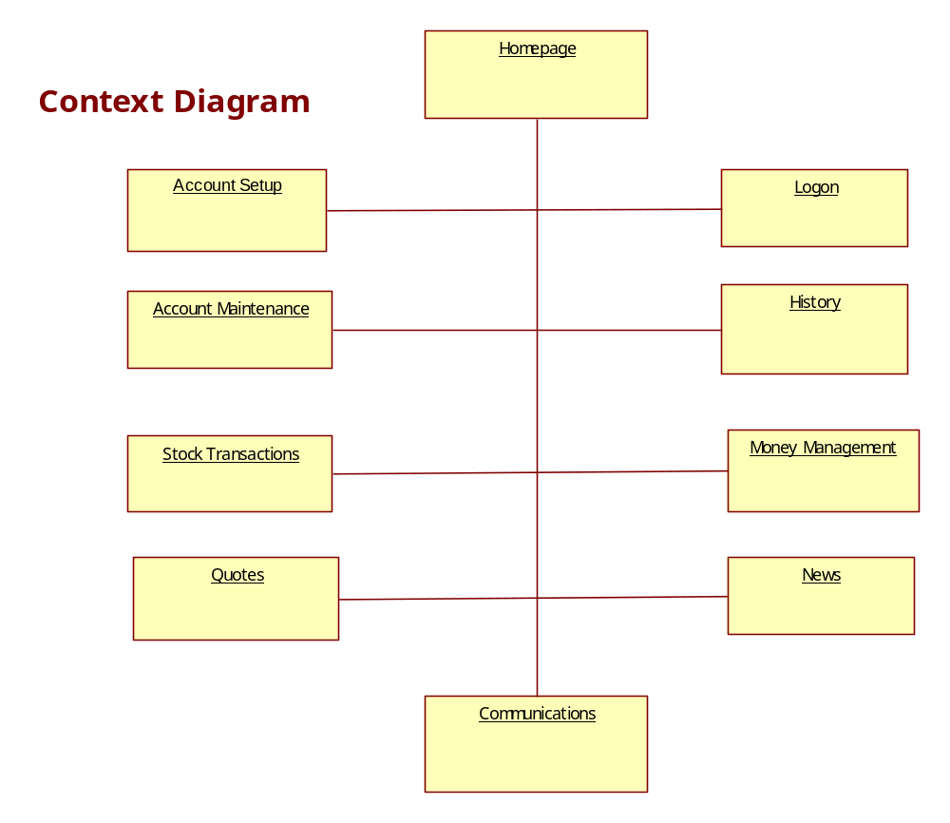

4. Systems Requirements

4.1 Requirements Overview
The following sections detail the system requirements we devised to ensure the website we develop meets the specifications published in the project description. The requirements are grouped by subsystem. The categories include Logon, Account Setup, Account Maintenance, Cash Management, Transaction, Transaction History, Stock Management, and News

4.2 “Logon” Requirements
Requirement Title: | Logon
Sequence No: | 1
Short description: | Accept Login Information
Description: | The system shall have two text entry boxes on the splash page where the user will input their user name and password. The text boxes should be individually labeled with "User Name" and "Password". Each input area should allow 25 characters to be input. The text boxes will accept character input up to 25 characters in length.
Pre-Conditions: | The user will have navigated to the website hosting the stock trading program.
Post Conditions: | Successful entry of user name and password will trigger entry to the main webpage for the site.
Other attributes: | There must be a button labeled "Login" that will attempt to login the user when pressed.

Requirement Title: | Logon
Sequence No: | 2
Short description: | Ability to create new user
Description: | The system shall provide functionality such that when an unregistered user clicks on the "Create Account" button they are redirected to an account setup page that allows them to enter all required information and register their account.
Pre-Conditions: | There must not be a user account already associated with the entered email address.
Post Conditions: | Logs in user and navigates to homepage.  Sends confirmation email to user
Other attributes: | System should error check data when possible (SSN length, etc.). New customer must be at least 18 years old.

Requirement Title: | Logon
Sequence No: | 3
Short description: | Password retrieval functionality
Description: | The system shall provide functionality such there will be a "Forgot Password" button on the logon screen that will prompt users for their registered email address when they click on it.  Input: Valid email address associated with a registered user.  Output: email sent to address with a link for password recovery.
Pre-Conditions: | The provided email address must be linked to a registered user bin order to generate the email.
Post Conditions: | Email sent with password recovery link generated.
Other attributes: | The user must change their password after recovery.

Requirement Title: | Logon
Sequence No: | 4
Short description: | Company Logo on Logon page
Description: | The system shall include a logon screen that displays the company logo as a watermark.
Pre-Conditions: | Company must provide a logo to be used.
Post Conditions: | N/A
Other attributes: | N/A

4.3 “Account Set up” Requirements
Requirement Title: | Account Setup
Sequence No: | 1
Short description: | Method to create new user.
Description: | The system shall provide functionality such that the account setup function will guide the prospective user through the process of creating an account.
Pre-Conditions: | User must have an email address, and be over 18.
Post Conditions: | User will be registered on the website.
Other attributes: | N/A

Requirement Title: | Account Setup
Sequence No: | 2
Short description: | Minimum required information to create an account
Description: | The system shall not register a user unless they provide the following information.  - Home address  - Mailing address  - Email  - First and last name  - Preferred phone #  - SSN  - DOB  - Marital Status  - Beneficiary  - Password  - User ID will be email address  - System will generate account number
Pre-Conditions: | N/A
Post Conditions: | User account is created.
Other attributes: | N/A

Requirement Title: | Account Setup
Sequence No: | 3
Short description: | Send a confirmation email
Description: | The system shall send a confirmation email to the users registered account upon successfully creating an account.
Pre-Conditions: | Account was successfully created.
Post Conditions: | N/A
Other attributes: | N/A

Requirement Title: | Account Setup
Sequence No: | 4
Short description: | Close account creation process.
Description: | The system shall generate a pop up notification to confirm the success or failure of the account creation process and navigate to the logon page so the new user can logon.
Pre-Conditions: | Account creation process terminated
Post Conditions: | Pop up communication window  Navigate to logon page
Other attributes: | N/A

4.4 “Account Maintenance” Requirements
Requirement Title: | Account Maintenance
Sequence No: | 1
Short description: | Edit Personal Information
Description: | The system shall offer the user the option to edit personal information. They will have the opportunity to change the following fields: Home address, Mailing address, Email address, First and last name, Preferred phone number, Marital Status, Beneficiary and Password.  Once the user has finished updating their information the user can choose to confirm or cancel the updates.  If they confirm, the changes would be saved to the database, a confirmation email would be sent to them and the user will be directed back to the homepage.  If they choose to cancel, no updates would be made and the user would be taken back to the home page.
Pre-Conditions: | - User must be logged on before performing this function.  - User must select the "Edit Personal Information" button.
Post Conditions: | - User must fill out the appropriate field in which they chose to edit.  - User must confirm changes and afterwards, the changes would be saved to the database and the user would be returned to the main user page.
Other attributes: | - The system will check that every input filled has valid data if being changed.  - Error messages will be displayed if changes are invalid or not completed.  - Confirmation message would be emailed if changes were successful.

Requirement Title: | Account Maintenance
Sequence No: | 2
Short description: | Close Existing Account
Description: | The system shall offer the option to close an account. The system would ask the user if they wish to sell all stocks.  If the user agrees to, the system would sell all stocks at the market price.  If the user cancels, the system will display the message “all stocks must be sold before the account can be closed."  The system would then refund all the money to the user's bank account and email a confirmation.  The user would then be returned to the user main page after confirmation.
Pre-Conditions: | User must be logged on in order to perform this function. User must select the "close account" button.
Post Conditions: | - The system will sell all the stocks.  - System will refund accounts.  - User must confirm changes and then be deleted from the database and logged out.
Other attributes: | - Error message will be displayed if function cannot be completed.  - Confirmation message will be emailed if the functions were completed.  - System will not reuse previously used account numbers.

4.5 “Cash mangement” Requirements

Requirement Title: | Cash Management
Sequence No: | 001
Short description: | Account Deposit
Description: | The system shall allow the user to deposit currency into their Stock Trading System account.  The user can choose to deposit a check wire transfer to their stock trading system account. The user will be required to choose a bank account before making a deposit transaction. If the user desires to deposit an amount listed on a check they will need to provide the check routing number, deposit amount.  Else, if the user desires to do a wire transfer, they will need to provide the wire transfer number deposit amount.  After the user enters the information above in either case, they will need to click on the “Submit” button, which will send the information to the server. After pressing submit, a random 10 – digit transaction id will be generated and stored in a transaction history table.  A confirmation email will also be sent out to the user detailing their current transaction.
Pre-Conditions: | The user must be logged into the stock trading system
Post Conditions: | - A random 10 – digit transaction id will be generated and stored along with the transaction information in a transaction history table in the MySQL database.  - A confirmation email will be sent to the user to detail the current transaction.
Other attributes: | The user will have the option of selecting their deposit type: “Check” or “Wire Transfer”

Requirement Title: | Cash Management
Sequence No: | 002
Short description: | Account Withdrawal
Description: | The system shall provide functionality to withdraw funds from the user’s account. The user can choose to be paid via check or wire transfer.  The system will not pay out more than the total balance in an account.  After the user enters the amount to withdraw, they will need to click on the “Submit” button, which will send the information to the server. The withdrawal amount will be then deducted from their account balance.  A random ten digit transaction id will be generated and a confirmation email will also be sent out to the user detailing their completed transaction.  If the user just specified a withdrawal amount, a check will be mailed to their address 1 week from the transaction date.
Pre-Conditions: | The user must be logged into the stock trading system
Post Conditions: | - A random 10 – digit transaction id will be generated and stored along with the transaction information in a transaction history table in the MySQL database.  - A confirmation email will be sent to the user to detail the current transaction.  - A check will be mailed to the user’s home address two weeks from the transaction date if the user simply specified a withdrawal amount.
Other attributes: | The user will have the option of selecting their deposit type: “Withdrawal via Check – in - Mail” or “Wire Transfer”

Requirement Title: | Cash Management
Sequence No: | 003
Short description: | Email Receipt
Description: | The system shall send an email receipt to the registered user upon completing an account deposit or withdrawal transaction.  A confirmation email or email receipt will be generated and sent to the user’s email address upon clicking “Submit” for account deposit and withdrawal transactions.  The email message will include the following elements:  - User’s First and Last name  - User’s Stock Trading System Account Number  - Transaction Type (Deposit or Withdrawal)  - Transaction Amount  - Last 4 digits of the bank account that was debited or credited  - Account Balance after transaction  - Thank You message  For particular withdrawal transactions, the email message will also indicate that a check with the withdrawal amount has been mailed to the user’s home address.  The email that will be used will be the email that the user listed through Account Setup.
Pre-Conditions: | - The user must be logged into the stock trading system  - The user must press “Submit” for an account deposit or withdrawal transaction.
Post Conditions: | A confirmation email will be sent to the user to detail the current transaction.
Other attributes: | N/A

Requirement Title: | Cash Management
Sequence No: | 004
Short description: | Pop – Up Order Confirmation
Description: | The system shall open up a pop - up order confirmation dialog after a user either deposits an amount to their account or withdraws an amount.  The order confirmation dialog will contain a message that will display the following information:  - User’s transaction type (deposit or withdrawal)  - Transaction amount  - An indication that an email receipt has been sent to the user’s email address that will provide further details of their current transaction.
Pre-Conditions: | - The user must be logged into the stock trading system  - The user must press “Submit” for an account deposit or withdrawal transaction.
Post Conditions: | N/A
Other attributes: | N/A

Requirement Title: | Cash Management
Sequence No: | 005
Short description: | Auto-generation of the transaction id
Description: | The system shall auto-generate a randomized 10 digit transaction id for an account deposit or withdrawal transaction.  After the user submits a deposit or withdrawal transaction request to the server, a ten digit transaction id will be automatically generated and stored along with the transaction’s information in a transaction history table in MySQL.  A custom implementation of a random number generator will be used to generate the ten digit transaction id.  Each digit need not be unique.  Each generated transaction id will be unique.
Pre-Conditions: | - The user must be logged into the stock trading system  - The user must press “Submit” for an account deposit or withdrawal transaction.
Post Conditions: | The transaction id along with the transaction information will be added as a record to the transaction history table stored in our database.
Other attributes: | N/A

Requirement Title: | Cash Management
Sequence No: | 006
Short description: | View Account Balance
Description: | The system shall provide functionality so users can click the “View Account Balance” button to display their balance to date.  When the user clicks the “View Account Balance” button their current balance will be displayed.  The option to view the account balance will be available in the “Account” section of the website along with “Account Maintenance”, separate from the trading section.
Pre-Conditions: | The user must be logged in.
Post Conditions: | N/A
Other attributes: | N/A

4.6 “Transaction” Requirements
Requirement Title: | Transactions
Sequence No: | 1
Short description: | Buy Stocks
Description: | The system shall allow a registered user to purchase stocks by providing the Stock Symbol and the number of shares to be purchased. The user will be able to choose whether to buy their selected stock either by market or limit type.  Inputs:  - Symbol and the number of shares to be purchased.  - The user will be able to choose whether to buy their selected stock either by market or limit type.  - Buy type(Market, limit).  - If limit, price for share must be provided.  Outputs:  - Unique transaction ID will be generated.  - User will be provided with a pop-up confirmation or deny screen. User will be emailed a receipt and confirmation for their order.
Pre-Conditions: | User must be logged in.  Inputs must be valid and all inputs must be filled in.
Post Conditions: | User will remain logged in and on the Purchase screen.  A confirmation email will be sent.
Other attributes: | User must have a cash balance in account sufficient enough to purchase stock. Stock symbol, amount of stocks to be purchased and limit order dollar value will be included in text.

Requirement Title: | Transactions
Sequence No: | 2
Short description: | Selling Stocks
Description: | The system shall allow a registered user to sell stocks by providing the Stock Symbol and the number of shares to be sold. The user will be able to choose whether to sell their selected stock either by market, limit, or Stop loss type.  Inputs:  - Stock symbol.  - Number of shares to be purchased.  - Sale type(Market, limit, stop loss). If limit or stop loss price for share must be provided.  Outputs:  - Unique transaction ID will be generated.  - User will be provided with a pop-up confirmation or deny screen. User will be emailed a receipt and confirmation for their order.
Pre-Conditions: | User must be logged in.  Inputs must be valid and all inputs must be filled in.
Post Conditions: | User will remain logged in and on the Purchase screen.  A confirmation email will be sent.
Other attributes: | User must own the stock selected to be sold and have sufficient number of stocks.

Requirement Title: | Transactions
Sequence No: | 3
Short description: | Cancel Order
Description: | The system shall allow a user to cancel an order if the user currently has limit (buy or sell) and/or stop loss (sell) orders open.  Inputs:  - Orders will be cancelled by clicking a cancel button that correspond to a specific open order..  Outputs:  - Unique transaction ID will be generated.  - User will be provided with a pop-up confirmation or deny screen. User will be emailed a receipt and confirmation for their order.
Pre-Conditions: | User must be logged in.  User must own stock to cancel.
Post Conditions: | User will remain logged in and on the cancel screen. A confirmation/deny email will be sent.
Other attributes: | User must own stock to cancel. User can only cancel a full order, may not choose partial stock numbers or change price. These must be done by rebuying or reselling.

4.7 “Transaction History” Requirements
Requirement Title: | Transaction History
Sequence No: | 001
Short description: | Chronological Transaction History
Description: | The system shall save transactions in chronological order and display this history upon request.  Upon clicking to view the transaction history, the system will display both stock and account transactions in chronological order via the transaction date.
Pre-Conditions: | N/A
Post Conditions: | N/A
Other attributes: | N/A

Requirement Title: | Transaction History
Sequence No: | 002
Short description: | Transaction Id as unique identifier
Description: | The system shall generate a unique ten digit transaction id for each transaction completed by the user.
Pre-Conditions: | N/A
Post Conditions: | N/A
Other attributes: | N/A

Requirement Title: | Transaction History
Sequence No: | 003
Short description: | The system will group transactions into two categories: “Account” and “Trade”.
Description: | The system shall use two categories for transactions, Account and Trade.  The Account transaction type is used for account deposits or account withdrawals.  The Trade transaction type is one that is either a purchase or sale of stock shares.
Pre-Conditions: | The user must be registered with the Stock Trading System
Post Conditions: | N/A
Other attributes: | N/A

Requirement Title: | Transaction History
Sequence No: | 004
Short description: | Filter transactions by type
Description: | The system shall allow users to filter for either Account transactions or Trade transactions or both.  Upon selecting the “View Transaction History” button, the user will be directed to a new page that will list the users transactions, of both types, in chronological order.  There will be three radio buttons above the users transaction history table. The default button upon load will list all transactions processed by the user since registration. A second button will allow the user to filter for only account related transactions. And a third radio button will allow the user to filter for trade only transactions.
Pre-Conditions: | The user must be registered with the Stock Trading System
Post Conditions: | N/A
Other attributes: | N/A

4.8 “Stock Management” Requirements
Requirement Title: | Stock Management
Sequence No: | 1
Short description: | Display owned stocks
Description: | The system shall display all of the users currently owned stock upon request. Each stock will display relevant information via Yahoo! Finance API. Page will also provide a button for instant selling shares.
Pre-Conditions: | User must be logged in.
Post Conditions: | If user clicks to sell a specific stock, will be taken to Sell Stock webpage with relevant values entered for user.
Other attributes: | User must own stock in order to sell the stock.

Requirement Title: | Stock Management
Sequence No: | 2
Short description: | Display Watch-list
Description: | The system shall store the five most recently searched stocks for each user.  The watch list page will display the five stocks on the Watch-list.
Pre-Conditions: | User must be logged in.
Post Conditions: | .  N/A
Other attributes: | The list will contain buy buttons for each stock, the buttons will navigate the user to the Purchase Stock webpage with relative values entered automatically.

4.9 “News” Requirements

Requirement Title: | News
Sequence No: | 1
Short description: | Availability of market news
Description: | The system shall contain a "News" page that consists of a list of RSS links of related news links provided for a given input stock symbol.
Pre-Conditions: | N/A
Post Conditions: | System will open the clicked link in a new window.
Other attributes: | N/A

4.10 “Communications” Requirements
Requirement Title: | Communications
Sequence No: | 1
Short description: | Receipts
Description: | The system shall email the user a receipt after every transaction. Once the user performs a transaction on their account, a receipt containing the following information will be sent to user via email:  - timestamp,  - transaction ID,  - transaction type  - and description of the transaction
Pre-Conditions: | Customer must be registered  User must have completed a transaction
Post Conditions: | Receipt generated and sent via email.
Other attributes: | N/A

Requirement Title: | Communications
Sequence No: | 2
Short description: | Popup Confirmation
Description: | The system shall have a popup confirmation after changes are made or a task has been completed.  Whenever the user performs a task from editing their information to performing a transaction, a popup box would appear for them to confirm the action has been performed.  Thank you messages and goodbye messages would also appear based on the action made.
Pre-Conditions: | User must be logged on and perform an action before a pop-up message can appear.
Post Conditions: | The user must click "ok" after each pop up message appears to dismiss the message.
Other attributes: | N/A

Requirement Title: | Communications
Sequence No: | 3
Short description: | Monthly account summary
Description: | The system shall email the user a monthly account summary.  At the end of each month, the user would receive an email containing their account summary which would include their end of month balance and transaction summary of all the transactions of the month reported.
Pre-Conditions: | User must be registered.
Post Conditions: | N/A
Other attributes: | N/A

Requirement Title: | Communications
Sequence No: | 4
Short description: | Confirmation Email For Create/Delete Account
Description: | The system shall email the user a confirmation email whenever they create or delete an account.  After a new user creates an account, they will receive a confirmation email with their account username (email), password and account number.  After a current user de-activates their account, they will receive a confirmation email as well.
Pre-Conditions: | User must have successfully sold all their stocks and clicked the delete account button to receive a confirmation email for deleting their account.
Post Conditions: | The account number of a new or deleted user cannot be reused.
Other attributes: | N/A

5. Software Processes and Infrastructure

5.1 Hardware and Infrastructure
Host Gator would be used for web hosting. For all Hardware and Infrastructure issues, please contact Host Gator.

5.2 System Class Diagram
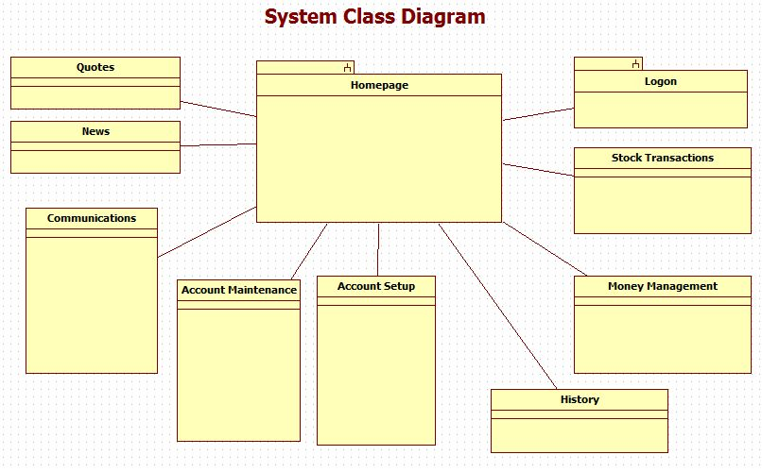

5.3 Account Maintenance UML

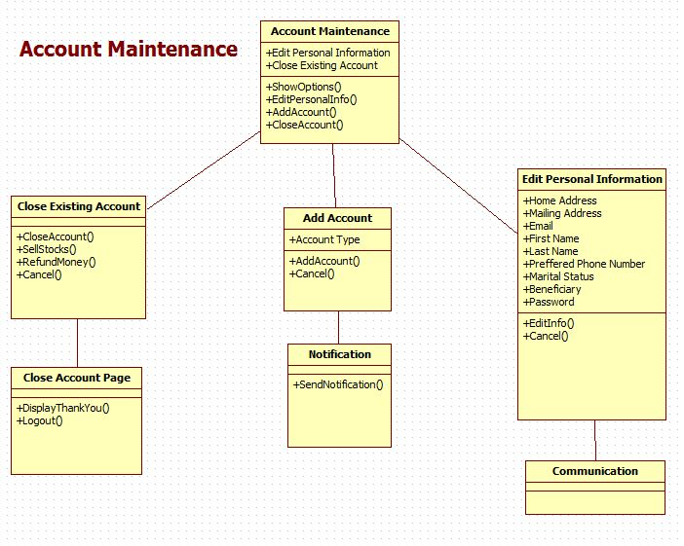

5.4 Account Setup UML

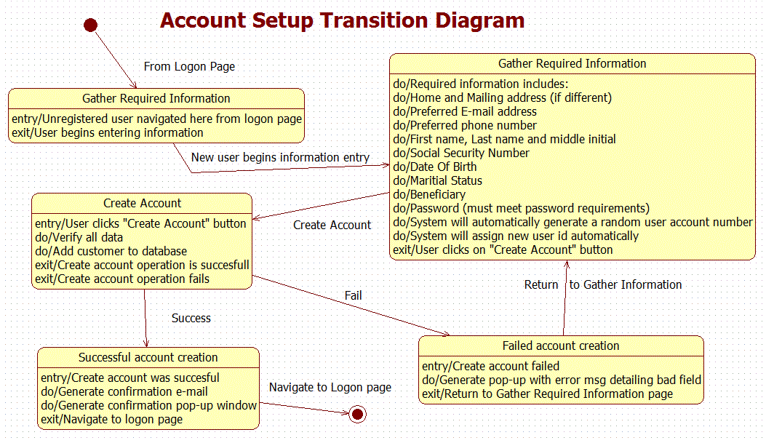

5.5 Communications UML

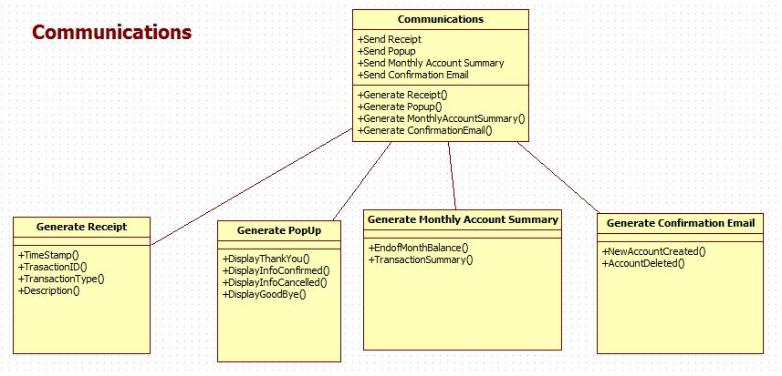

5.6 Login UML

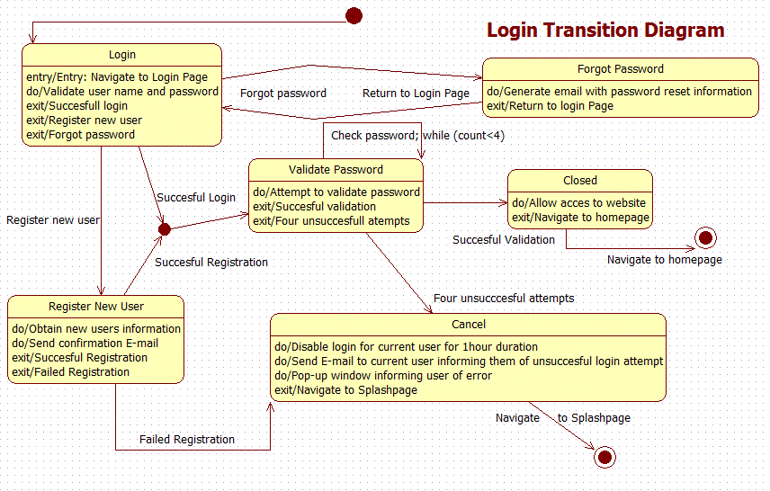

5.7 Transaction History UML

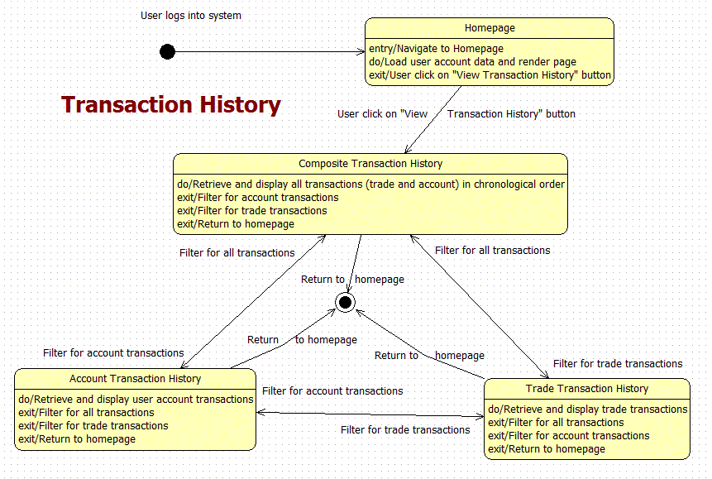

5.8 News UML

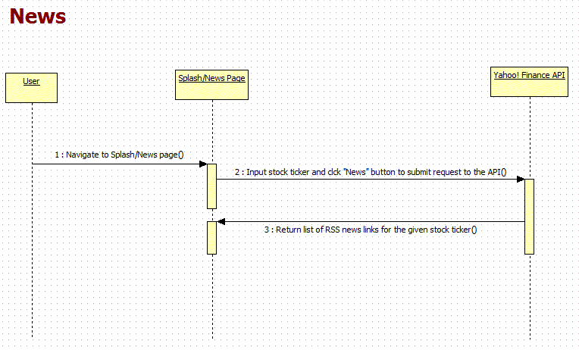

5.9 Cash Management UML

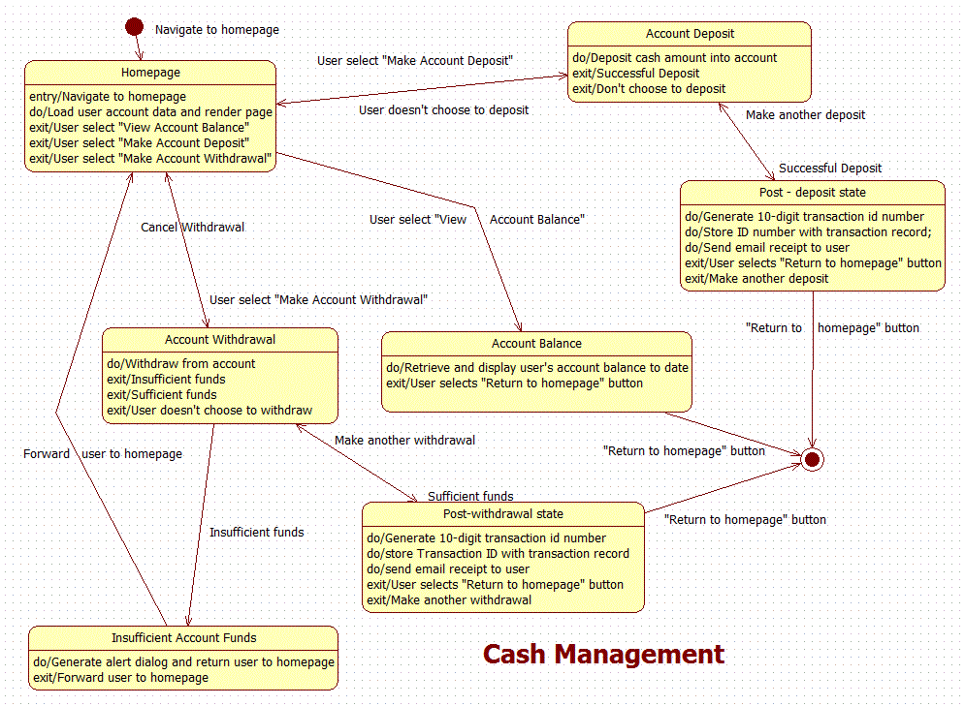

5.10 Quotes UML

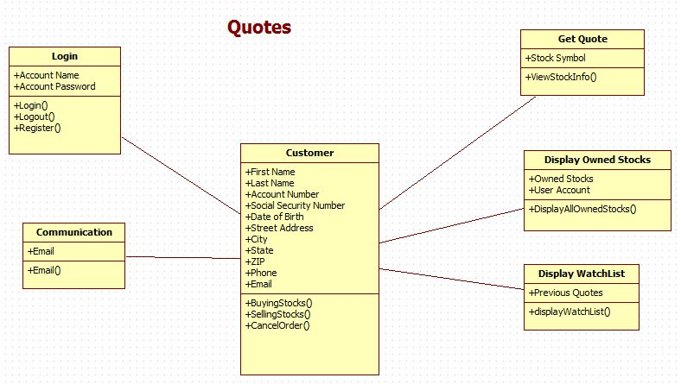

5.11 Transactions UML

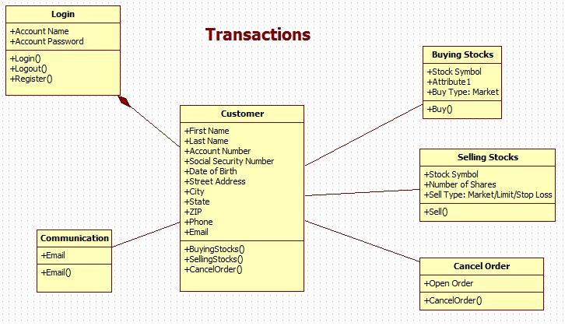

5.12 Conceptual Data Model - Database
We will use MySQL as the database and the code will be written in PHP. More information will be available as we develop the back end.

5.13 Screen Shots
None Available at this time

5.14Test Plan
We will develop our testing plan concurrently with the website so that we will be able to have thorough testing.

6. Assumptions and Constraints

6.1 ASSUMPTIONS
The following is a list of assumptions:
- US stock markets are considered only
- Only people older than 18 can order
- Network issues will be ignored
- Contract negotiations and legal terms will not required
- No post – project maintenance after initial release
- Ignore tax reporting to IRS
- Advanced brokerage functionality (mutual funds, futures, commodities, options (call/put), hedging, selling shorts and currency trading) will not be included with initial release

6.2 CONSTRAINTS
The following is a list of constraints:
- Team lacks web development skills
- Team lacks database management and programming (SQL) skills

6.3 Out of Scope material
The following is a list of “out of scope” material:
- Post Project maintenance is not covered

7. Delivery and Schedule

Task/Milestone Description | Anticipated Start Date | Anticipated End Date | Status | Comments
Prepare Requirements and UML diagram | 9-20-2012 | 10-16-2012 | Completed
SRA document (Includes project objectives, Requirements and UML diagrams) | 9-27-2012 | 10-16-2012 | Completed | Deliverable will be the SRA document. All stakeholders agree on the content of the SRA by signing in section 8.
Milestone: Presentation of SRA |  | 10-16-2012 | Completed
Database Design | 10-22-2012 | 10-25-2012 | Completed
Web page design and Navigation | 10-22-2012 | 11-07-2012 | Completed
Test Data Entry | 11-01-2012 | 11-15-2012 | Completed
Milestone:  Website Demonstration |  | 11-29-2012 | Completed
Test Plan Delivery | 11-01-2012 | 12-03-2012 | Completed | Deliverable will be Test Plan. Test plan is to be utilized for requirements verification.
External Documentation (i.e. User Manual) | 11-15-2012 | 12-03-2012 | Completed
Final Milestone: Project delivery |  | 12-06-2012 | Completed

8. Stakeholder Approval Form

Stakeholder Name | Stakeholder Role | Stakeholder Comments | Stakeholder Approval Signature and Date
Bahram Khalili | Development Mgr
Mr. hafiz Sheikh | Project Assistant
James Lunsford | Developer
Oreoluwa Adebambo | Developer
Shazad Brohi | Developer
Jeffrey Strickland | Developer

Appendix:

None

