Bembidion Movement Model
Documentation of movement-model implementations M1–M4
Repository: BenjaminSteffen/Bembidion
Purpose
This document summarizes the movement-model implementations developed for the Bembidion modelling work, explains what was changed in each model variant, and provides notes for subsequent researchers or developers who continue the modelling work.

1. About the project
This repository contains different implementations and extensions of a spatial movement model for Bembidion ground beetles. The starting implementation is based on the movement behaviour of the former ALMaSS Bembidion model. In contrast to an individual-object representation, the implementations in this repository operate on the population using Polars DataFrames.
The purpose of the repository is to test and compare several modifications of the original movement assumptions. Four modifications were developed separately (M1–M4) before being combined into one implementation. The separate files make it possible to isolate the effect of individual assumptions, whereas the combined file represents the integrated movement model.

2. Repository structure
The modelling work discussed in this README is organized around the following Python scripts:
Bembidion/
├── Bombidion_Movment(7).py
├── Bombidion_Movement_M1_fix.py
├── Bombidion_Movement_M2_only.py
├── Bombidion_Movement_M3_only.py
├── Bombidion_Movement_M4_only.py
└── Bombidion_Movement_M1_M4_fix.py

File | Purpose
Bombidion_Movment(7).py | M0 – original/reference movement implementation (without M1–M4 modifications)
Bombidion_Movement_M1_fix.py | M1 – turning decision at every movement step
Bombidion_Movement_M2_only.py | M2 – independent daily starting direction
Bombidion_Movement_M3_only.py | M3 – daily activity range / home-range restriction
Bombidion_Movement_M4_only.py | M4 – landscape boundary conditions
Bombidion_Movement_M1_M4_fix.py | Combined implementation of M1–M4
The *_only.py files were created to isolate one modification from the other changes. They are particularly useful for model comparison, debugging and sensitivity testing.

3. Basic movement implementation

3.1 Landscape representation
Movement takes place on a raster-like landscape. The landscape is read from:
data/lulc.parquet

The input table must contain at least:
x
y
accessibility

The accessibility classification is interpreted as follows:
- full – the cell can always be entered
- partial – the cell can be entered with a probability of 0.4
- none – the cell cannot be entered
The scripts sample beetles from cells that are at least partially accessible. Each individual is represented by its coordinates and its current movement direction. Eight movement directions are possible:
0°, 45°, 90°, 135°, 180°, 225°, 270°, 315°

A movement step transfers an individual to one of the eight neighbouring cells.

3.2 Daily movement
The central movement function in the implementations is move_to(...). For every simulated day, each individual receives a randomly selected movement distance between one step and a specified maximum distance.
The example simulations use the following parameter values:
max_distance = 14
turning_probability = 0.8

For each movement step, the beetle first attempts to enter the cell in its current movement direction. If this cell cannot be entered, the remaining directions are evaluated as alternatives. Accessible alternatives are identified and a successful direction is selected randomly. If no neighbouring cell can be entered, the individual remains at its current position for that movement step.

4. Model modifications

4.1 M1 – Turning during movement
File: Bombidion_Movement_M1_fix.py
Problem addressed. In the starting implementation, the probabilistic decision to change direction was made only once before the movement of an entire day. An individual could therefore perform many movement steps while retaining essentially the same heading unless an obstacle forced a change.
Implementation. M1 moves the turning decision inside the movement loop. A new random turning decision is made before every individual movement step:
turn left by 45° probability = turning_probability / 2
turn right by 45° probability = turning_probability / 2
continue straight probability = 1 - turning_probability

With turning_probability = 0.8, an individual can change direction repeatedly within a single day. This produces more locally variable, less persistently straight movement paths. The previous day’s final direction is still available at the beginning of the next day; the independent daily reset is introduced separately in M2.

4.2 M2 – Independent daily starting direction
File: Bombidion_Movement_M2_only.py
Problem addressed. In the starting implementation, the direction at the end of one day influences the direction used at the beginning of the following day, creating directional persistence between days.
Implementation. At the beginning of every call to move_to(), every individual receives a new direction drawn uniformly from the eight possible headings:
0°, 45°, 90°, 135°, 180°, 225°, 270°, 315°

The direction at the end of the previous day is therefore ignored when determining the new day’s starting direction. In the M2-only implementation, this direction is drawn once at the beginning of the day; the M1 per-step turning modification is deliberately not included.
Consequence. Successive simulation days no longer inherit a preferred movement direction from the previous day, so the daily starting orientation is independent between days.

4.3 M3 – Daily activity range
File: Bombidion_Movement_M3_only.py
Problem addressed. Without an additional spatial restriction, repeated movement steps can result in individuals moving progressively away from their starting location. M3 introduces a spatial constraint representing a limited daily activity range.
Implementation. At the beginning of every simulated day, the current position of each beetle is stored as center_x and center_y. This position acts as the centre of the individual’s activity range for that day. Candidate movement steps are weighted using a Gaussian function according to their distance from this centre:
P = exp(-d² / (2 × sigma²))
d = distance from the daily starting position
sigma = HOME_RANGE_SIGMA

The current default is:
HOME_RANGE_SIGMA = 5.0

Movement close to the daily centre therefore has a high probability of being accepted, while movement farther away becomes progressively less likely. The restriction is applied to the preferred movement direction and to alternative directions considered when the preferred cell cannot be entered.
Important interpretation. The activity centre is reset every day. M3 does not represent one permanent home-range centre for the whole simulation; it restricts movement relative to the position at which the individual started the current day. HOME_RANGE_SIGMA should be treated as a model parameter and calibrated or tested in sensitivity analyses where appropriate.

4.4 M4 – Landscape boundary conditions
File: Bombidion_Movement_M4_only.py
Problem addressed. Treating cells outside the simulated landscape as inaccessible can create artificial behaviour near the model boundary. M4 introduces explicit boundary conditions controlled by BOUNDARY_CONDITION.

none
BOUNDARY_CONDITION = "none"

This reproduces the previous behaviour. A movement step outside the landscape is treated as inaccessible. The beetle searches for another direction and remains at its current position if no alternative is available. This option is useful as a reference for comparison with the newly implemented boundary conditions.

torus
BOUNDARY_CONDITION = "torus"

The landscape is wrapped around. An individual leaving the landscape on one side re-enters it on the opposite side (for example, right edge → left edge and top edge → bottom edge). This removes a hard outer boundary and allows movement to continue across the model domain.
Runtime note: When using the torus boundary condition, simulations can take noticeably longer, especially for long simulation periods, larger populations or larger landscapes. This should be taken into account when planning multi-year runs, repeated simulations or batch experiments.

reflecting
BOUNDARY_CONDITION = "reflecting"

The landscape boundary behaves like a reflecting wall. A movement step crossing the boundary is mirrored back into the landscape and the corresponding component of the movement direction is reversed. The individual therefore effectively “bounces” off the model boundary.

absorbing
BOUNDARY_CONDITION = "absorbing"

Individuals attempting to cross the landscape boundary are removed from the simulation. This can be interpreted as emigration from the represented landscape. Unlike the other boundary conditions, this option can reduce the simulated population size over time.
The isolated M4 implementation can be run with the desired boundary option. The combined implementation discussed below currently uses torus for the integrated example.

5. Combined implementation – M1 to M4
File: Bombidion_Movement_M1_M4_fix.py
This file integrates all four modifications into one movement function. The daily sequence is approximately:
Start of day
↓
Random movement distance
↓
M2: draw a new independent starting direction
↓
Store current position as daily activity centre
↓
For every movement step:
↓
M1: probabilistic turning decision
↓
Calculate candidate cell
↓
M4: apply landscape boundary condition
↓
Check habitat accessibility
↓
M3: apply distance-dependent activity-range probability
↓
Move if successful
↓
Otherwise evaluate alternative directions
↓
Next step

The combined implementation currently uses:
HOME_RANGE_SIGMA = 5.0
BOUNDARY_CONDITION = "torus"

The combined model therefore represents the following assumptions:
- M1 – movement direction can change at every step
- M2 – the initial direction is redrawn independently every day
- M3 – movement is restricted around the daily starting position
- M4 – the selected landscape boundary rule is applied explicitly

6. What does this mean for emergent movement patterns?
The modifications change individual movement decisions, but their main modelling relevance lies in the population- and trajectory-level patterns that emerge from repeated application of these rules. The following effects are expected from the implemented mechanisms:
M1 – per-step turning: More frequent turning reduces strongly directional trajectories. Paths become more tortuous and locally variable, which can reduce long straight displacements.
M2 – independent daily direction: Resetting the starting direction removes directional persistence between days. Over longer periods, this reduces systematic displacement caused by repeatedly continuing in approximately the same direction.
M3 – daily activity range: The Gaussian acceptance function increases the probability that an individual remains near its position at the beginning of the day. This can produce stronger local clustering and slower spatial expansion. The strength of this effect depends strongly on HOME_RANGE_SIGMA. Importantly, the activity centre is reset to the beetle’s current position at the start of every day; M3 therefore creates local daily movement restriction, not an attraction toward the geographic centre of the landscape.
M4 – boundary conditions: The selected boundary rule can substantially alter patterns close to the landscape edges. Hard boundaries can create edge effects, reflecting boundaries redirect movement back into the domain, absorbing boundaries remove emigrating individuals, and torus boundaries connect opposite sides of the landscape and therefore remove a hard outer edge.
In the combined model these mechanisms interact. M1 and M2 reduce directional persistence, while M3 limits daily displacement. The resulting trajectories are therefore expected to be relatively local and irregular rather than dominated by long, consistently directed paths. With a torus boundary, these patterns can develop without individuals encountering a hard outer landscape edge.
These statements describe expected consequences of the implemented rules. Emergent patterns should ultimately be evaluated from repeated simulation outputs rather than inferred from a single trajectory alone.

7. Example: one beetle over one year on the small landscape
The following figures show example movements of a single beetle over one simulated year on the small landscape. In both the M0 and M1–M4 scripts, one individual is sampled and move_to() is called once for each of 365 simulated days. After the complete daily movement sequence, the beetle’s current position is stored. Each triangular point therefore represents the end-of-day position of the same beetle for one simulated day (365 recorded daily positions in total). The points are not individual within-day movement steps and they do not represent different beetles. The initial position before the first simulated day is not stored as an additional point.
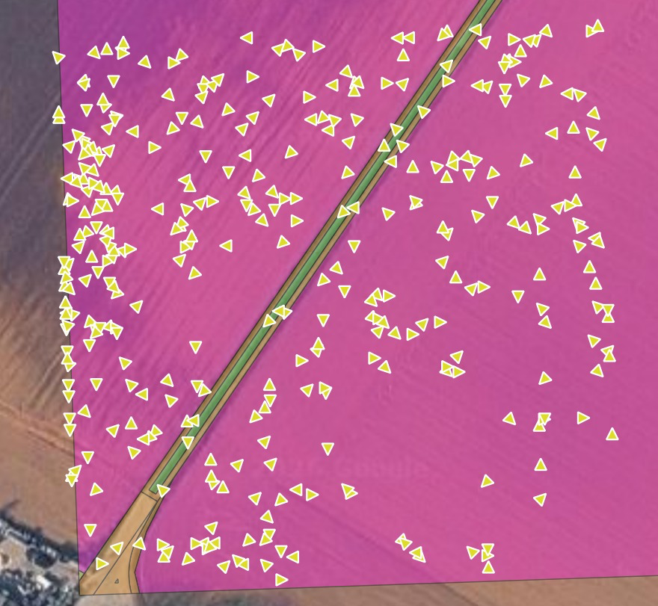
Figure 1. Movement_one_year_small_Movement(7) (M0). Original/reference run without the M1–M4 implementations; one beetle over one simulated year, with one end-of-day position shown for each day.
Figure 1 shows M0, i.e. the original/reference movement implementation before M1–M4 were added. In this example, the daily positions are spread broadly across the small landscape, with a conspicuous concentration along the left outer boundary. In M0, a step outside the defined landscape is inaccessible and the model searches for an alternative heading. The visible boundary accumulation is therefore consistent with the artificial edge effect that motivated the implementation of explicit boundary conditions in M4. Because this is one stochastic run, the figure illustrates the behavior but does not quantify how often or how strongly the effect occurs.
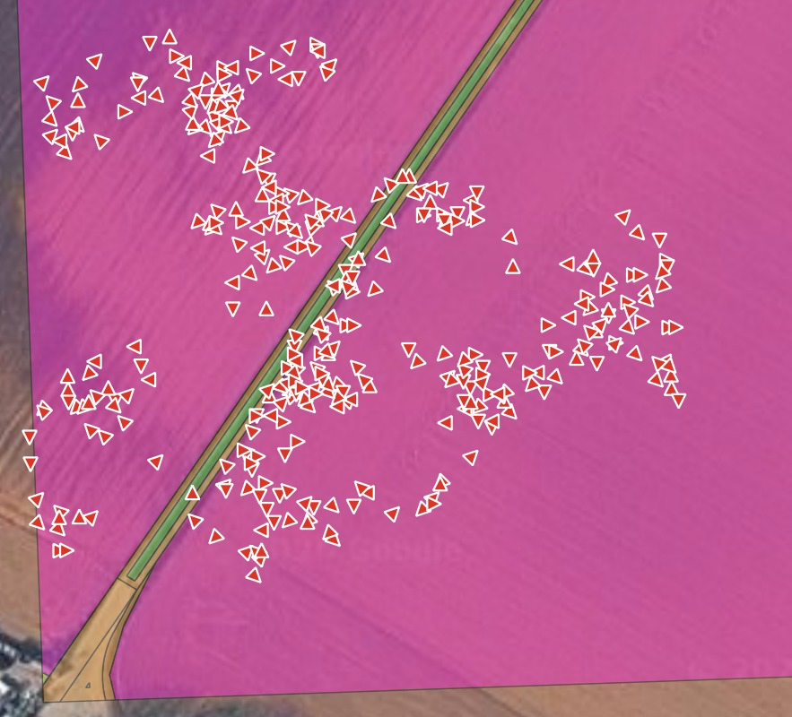
Figure 2. Movement_small_one_year_M1-M4 (reflecting). Combined M1–M4 implementation with a reflecting boundary condition; one beetle over one simulated year, with one end-of-day position shown for each day.
Figure 2 shows the combined M1–M4 model with a reflecting boundary condition. When a proposed step crosses the landscape extent, the coordinate is mirrored back into the domain and the relevant component of the heading is reversed. In the shown realization, no comparable accumulation at the outer boundary is visible; the artificial hard-edge pattern seen in M0 is therefore no longer apparent. This is consistent with the intended effect of the reflecting boundary condition. The checked repository version currently sets BOUNDARY_CONDITION = "torus" in Bembidion_Movement_M1_M4_fix.py, so this figure corresponds to a run in which that setting was changed to "reflecting" before execution. Repeated runs and a quantitative distance-to-boundary analysis would still be needed to demonstrate the absence of edge effects systematically.
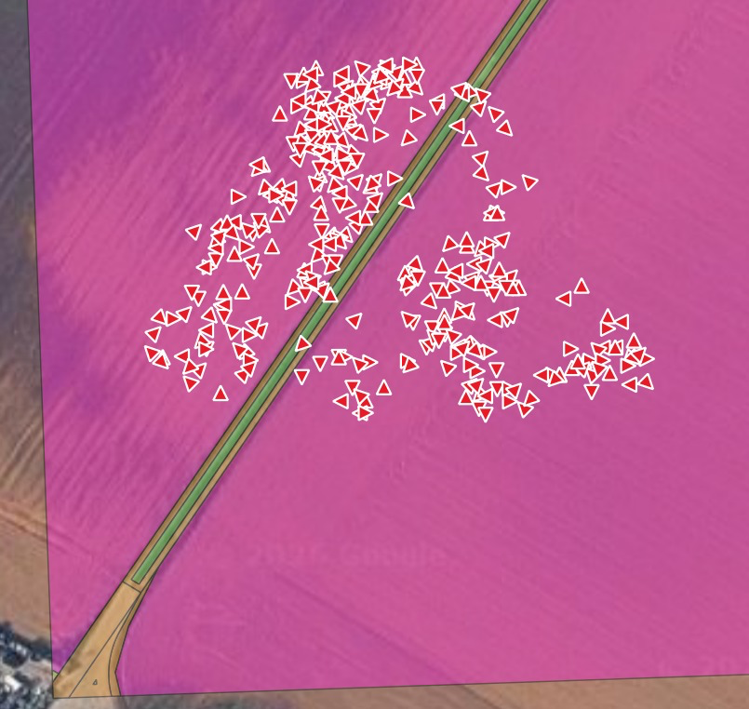
Figure 3. Movement_one_year_M1-M4 (torus). Combined M1–M4 implementation with a torus boundary condition; one beetle over one simulated year, with one end-of-day position shown for each day.
Figure 3 shows the combined M1–M4 model with a torus boundary condition. The daily positions form several local clusters and, in this realization, occur mainly in the interior of the small landscape. The local clustering is consistent with the M3 home-range mechanism, because candidate steps farther from the beetle’s daily starting position are increasingly likely to be rejected. However, M3 does not pull the beetle toward the centre of the map: its activity centre is reset to the individual’s current position at the start of each day. Because this particular trajectory contains relatively few observations at the outer boundary, it is not well suited to assessing how the beetle behaves when it actually encounters a torus edge. A targeted additional simulation starting an individual close to the boundary, or explicitly recording boundary crossings, would provide a more informative test of torus behavior.

7.1 Short comparison of the three example patterns
The three example trajectories highlight different aspects of the movement model. Figure 1 (M0) shows the original run and a visible concentration of daily positions at the left outer boundary, illustrating the edge behavior that motivated M4. Figure 2 (M1–M4, reflecting) does not show a comparable boundary accumulation in this realization, which is consistent with the reflecting rule removing the hard-edge effect by redirecting attempted outward movement back into the domain. Figure 3 (M1–M4, torus) shows stronger local clustering, which is consistent with the daily home-range restriction in M3. However, the torus example contains too few clear boundary interactions to draw a strong conclusion about edge behavior from this trajectory alone. A dedicated boundary-focused simulation would therefore be useful for comparing torus and reflecting behavior directly.
Important: The three figures represent individual stochastic simulation runs. They should therefore be treated as illustrative examples, not as statistical proof that one implementation always creates a specific spatial pattern. Robust comparison should use several replicate runs with controlled random seeds and summary measures such as displacement, occupied area, distance to boundaries, cluster size or spatial density.

8. Simulation experiments included in the scripts
The scripts contain several development and comparison simulations, including:
- 1 day
- 365 days on the complete landscape
- 365 days on a smaller sub-landscape
- 3650 days on the smaller sub-landscape
- 365 days following a single individual
The small test landscape is generated by filtering the original landscape using coordinate limits. These simulations are primarily intended as development, diagnostic and comparison runs rather than as a fixed experimental design.

9. Output
Simulation results are written as CSV files into subdirectories of data/. The output directory is controlled by the run_name variable and can be changed before execution.
Typical output files include:
example_start_locations.csv
example_start_locations_with_directions.csv
locations_with_directions_after_one_year.csv
locations_with_directions_after_one_year_small.csv
locations_with_directions_after_ten_years_small.csv
movement_one_year_small.csv

movement_one_year_small.csv records the position of one individual over time and is particularly useful for visual inspection of movement trajectories such as the examples shown above.

10. Requirements
The scripts are written in Python and use the following packages:
polars
polars_random

pathlib is additionally used for output-path handling and is part of the Python standard library. For reproducible future work, an explicit environment specification such as requirements.txt, pyproject.toml or a Conda environment file is recommended.

11. Required input data
Before running the movement scripts, the following landscape file must be available:
data/lulc.parquet

The file is not generated by the movement scripts themselves. It represents the movement landscape and must contain at least x, y and accessibility, with accessibility classified as full, partial or none. The landscape is prepared in a separate GIS/preprocessing workflow.

12. Notes for further development
The implementations should primarily be understood as experimental movement-model variants. For subsequent modelling work, the isolated M1–M4 versions should preferably be kept unchanged whenever possible because they provide useful reference implementations for identifying the effect of individual model assumptions. Further development can then take place in the combined implementation or in a clearly named successor.
Parameters and assumptions that are particularly suitable for calibration or sensitivity analysis include:
- maximum daily movement distance
- turning probability
- HOME_RANGE_SIGMA
- probability of entering partially accessible habitat
- boundary condition
The model is stochastic. For reproducible experiments, future simulations should use explicit random-seed handling and record the full parameter configuration of each run. This is especially important when comparing emergent patterns between boundary conditions or movement variants.

13. Development history
M0 – original/reference implementation
↓
M1 – per-step turning
↓
M2 – independent daily direction
↓
M3 – daily activity-range restriction
↓
M4 – explicit boundary conditions
↓
Combined M1–M4 implementation

The separate implementations allow each modelling assumption to be tested independently, while Bombidion_Movement_M1_M4_fix.py represents the integrated model used for combined tests.

14. Reference documentation
The structure of this README was informed by the documentation style used in the related xLandscape repositories:
- Scenario-NRW2 README
- LandscapeModel-Core README
- Bembidion repository

