**第一部分：询盘判断**

1. **首次接洽**

**四类客户**

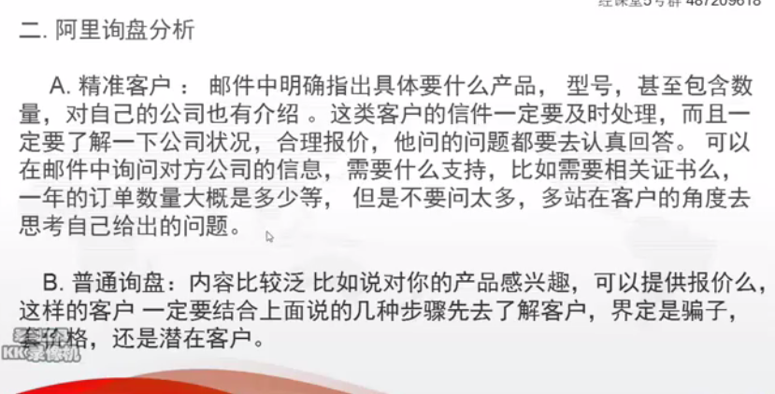

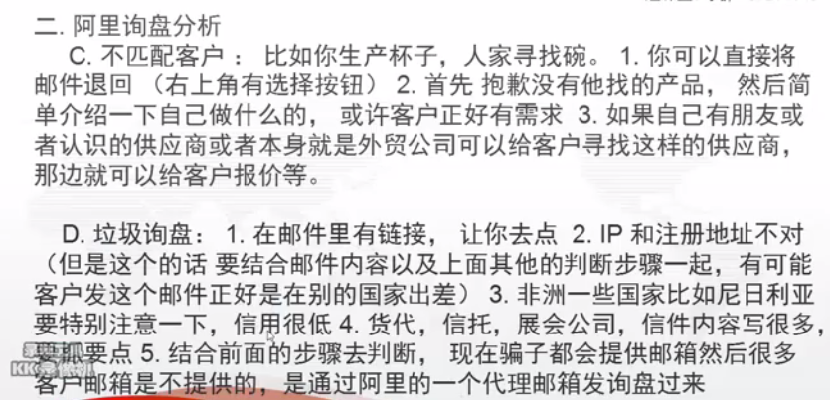

判断步骤：

通过站内信息

1询盘内容（判断是否匹配，有没有垃圾链接）

2查看客户发件IP地址和客户注册地（可以询问客户情况）

3查看客户是否是会员，是否是蓝标客户

4查看客户产品浏览数

5查看客户有效询盘发出数量

6垃圾询盘数量：可以告诉你客户的诚信度

7最近搜索词（从去年到现在，有所调整，大部分是看不到的）

8点击客户名字（喜好的行业，浏览的产品 判断客户是行业内的还是相关行业的，从而更深入的判定）

9访客详情查看客户浏览量，页面停留时长，总浏览量，浏览了几个供应商等

**第二部分：客户常见问题及回复**

参考模版如下。

**询盘相关问题**

**针对程式化询盘**

**首次回复**

Dear Deja

This is Brand,Thanks for your inquiry.

May I know the length and the quantity of each length you want?

Regards,

Brand Wang

Oversea Business Department

Xuchang Jinye Hair Products Co.,LTD，CHINA

Email：brand@jinyehair.com

Whatsapp NO.：+8618237417824

针对客户问题解答回复

建议：首次收到询盘，如果没有具体要求，除固定格式外，直接回复询问长度。

简洁明了。因为邮件普遍回复比较慢，这样可以提高交流效率。

如果有具体询问，针对问题回答。这类客户要尽快回复。

**2通讯方式：whatsapp/skype/iMessage(苹果内置软件)/Wechat**

**3公司相关方面**

Q:Can you send a link of your company ?

A:OK.The following is our link.

Q:Does your company manufacture the hair, or do you just supply the hair ?

A:We are manufacture.Our factory have experience more than 20 years..

Q:Could you show some information about your factory?

A:Our company information are as below:

1.established in 1994 with 23 years hair producing experience.

2.Large-scale &High Cost-Effective production line.

3.True direct factory price

4.Supplier of the top 3 hair companies in US.

5.Large stock,Ship in 48 hours

6.Accept OEM & ODM

Q: Can you explain the OEM services and do they cost?

A:No cost nothing.OEM means we provide it what you design.How many do you want to order?

Q:Will you sign a contract for a partnership with an American company?

A:We can do that if you wish.

**4样品**

Q:do you guys offer samples？

A：Yes,we could offer your sample.

Q:Can you give me free sample?

A:Yes,We will refund the sample money you paid in your next order.

Q:Do you send out sample products and I'm looking for Curly patterns and straight

A:Yes.

Q:Since I am planning on buying in bulk do you all offer samples?

A:Yes

**5产品方面**

Q:Can you send me your product catalog？

A:The following is our catalog.

Q:what is the origin of the hair you offer?/Where is the hair from?

A:Our hair is Indian hair acturally.

Q:Do you carry cuticle aligned hair ?

A:Yes,Our hair is cuticle aligned hair.

Q:Is There more than one pattern of hair?

A:Yes,What kinds of style are you interested?

Q:May I ask what lengths you have?

A:8″-30″

Q:Does hair come from one donor?

A:Yes.

Q:What hair textures do you offer?

A:straight, body wave ,loose wave ,deep wave ,kinky wave and closure ,360 lace closure

Q:Will you private label each bundle?

A:We are redesigning our Logo and label now,it will be amazing if it have be done.but for now,we can only provide label on Grade 10A bundles.besides,we can do OEM according to your need.

**5质量方面**

Q:How do you ensure the quality of your hair?

A:Yes.Our factory began from 1994

Q:Can you guarantee hair is Virgin?

A; Yes,This is virgin Indian hair actually.

Q:Could you tell me different between 10A and 8A?

A:The 10A grade hair is that the cuticle aligned of root and top is the same direction，but the 8A grade hair that hair root and top is not same direction..

Q:Do you have a sampling program?

A:We promise every product will be double checked befor delivery.

**6价格方面**

Q:Do you have a price list about...？

A:OK,This is the price list.附件

Q:give me your best price about ....

A:The price of ...is USD##.The total price is USD##

Q:Are there any discounts for bulk orders or bundle deals?

A;There are discounts for bulk orders.Bundle deals have not discounts.

**7发货 售后保养，**

Q:When could you send the goods?

A:We will ship within 48 hours after payment.The goods can be arrived in 7 days.

Q:Can hair be washed, conditioned, dyed, bleached and straightened?

A: Yes,no problem.

Q:Will hair return to natural wave pattern after washing and straightening?

A:It can hold the curl very well after washing.But It will change the texture if you use the flat Iron straightener.

Q:How long does it last?

A :In general,it is a year and a half.Take very good care of it in order to use longer.

Q:How can I take care of the hair ?

A:Treat it like your own hair.

Q:Does the products need to pay customs fees?

A:根据具体国家，价值大小决定

Q:Will you please send the regular PayPal link?

A:PayPal Account:amanda@jinyewigs.com

Paypal 付款链接https://www.paypal.me/jinye1994/##usd