Question

Below I have plotted graphs with elite sizes of: 0, 5, 10, 20, 30, 40, 60, 80, 100.

Elite size 0:
- Convergence is very erratic.
- Variability between generations is very high.
- No high-quality solutions are created.
- Leans too hard into exploration.

Elite size 5, 10, 20, 30, 40:
- An increased level of elitism increases the stability of the convergence.
- Tents to find and keep high quality solutions.
- These settings seem to hit the balance of exploration and exploitation.

Elite size 60, 80, 100:
- As the elite size increases, the results become less stable, and do not tend to produce high-quality solutions.
- Solutions tend to stop progressing sooner, potentially leading to the program getting stuck in a local optima.

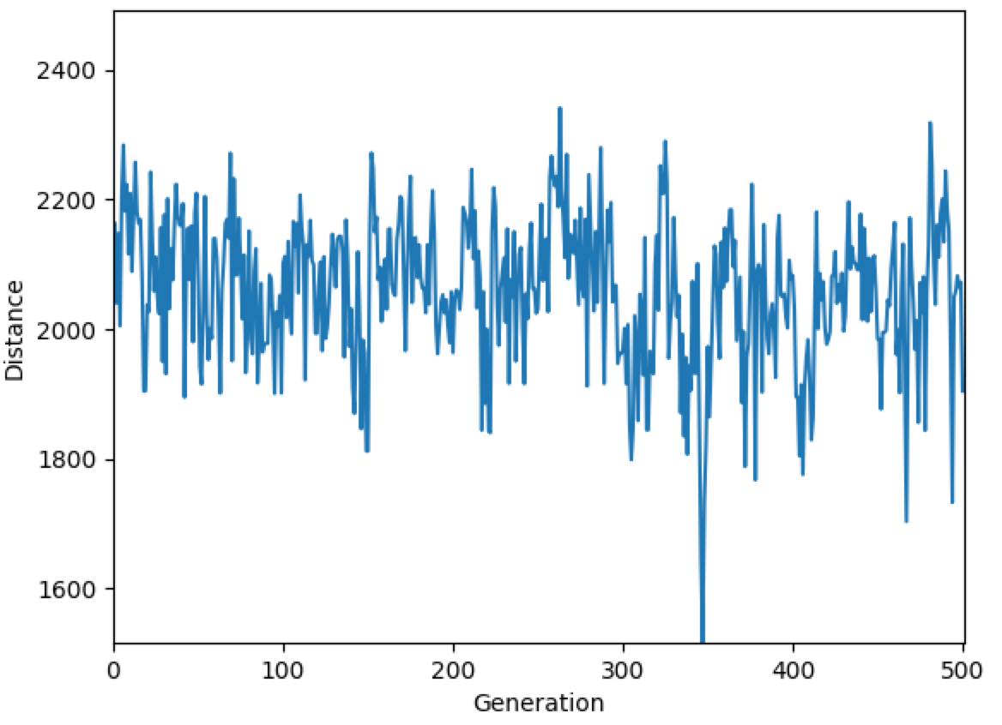
Figure 1 Elite size = 0
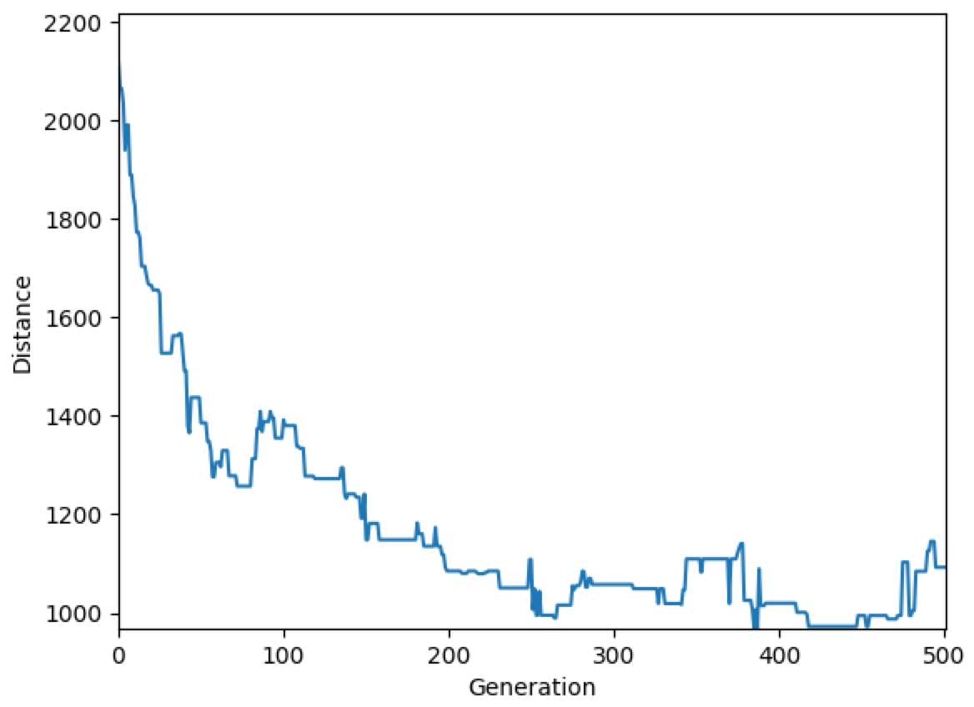
Figure 2 Elite size = 5
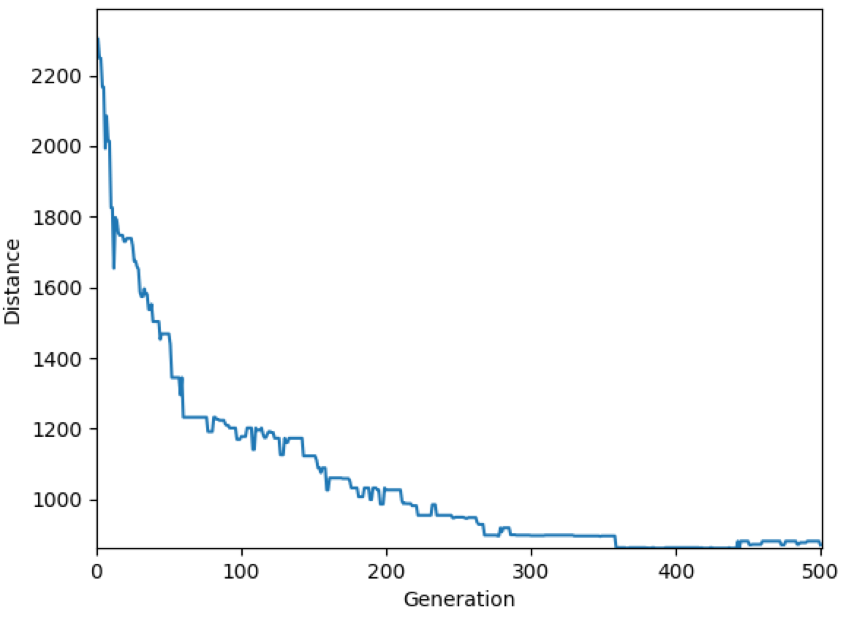
Figure 3 Elite size = 10
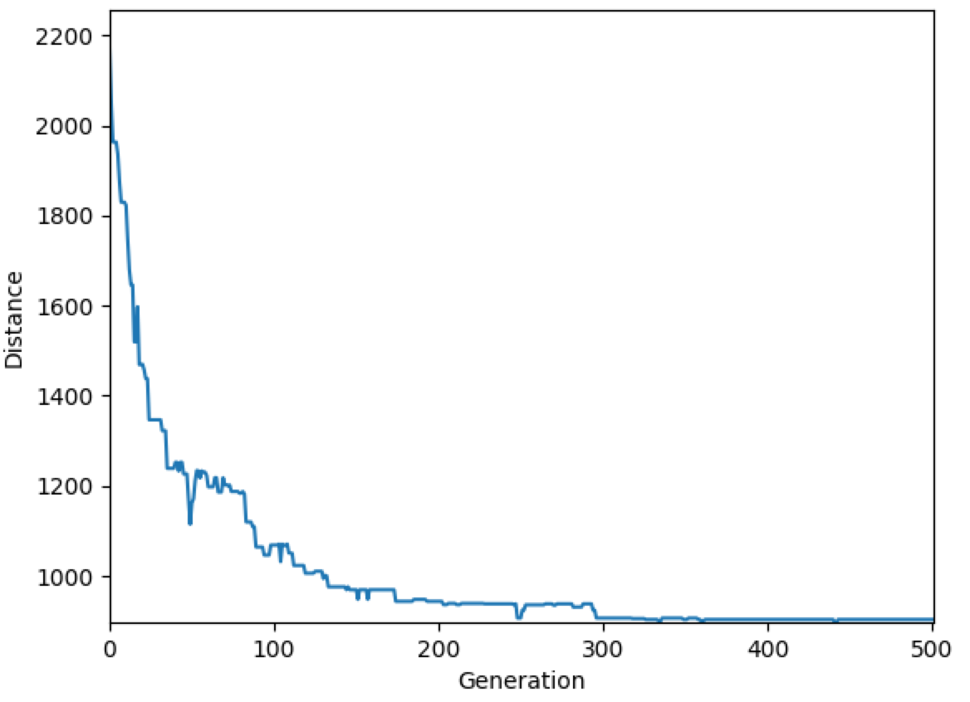
Figure 4 Elite size = 20
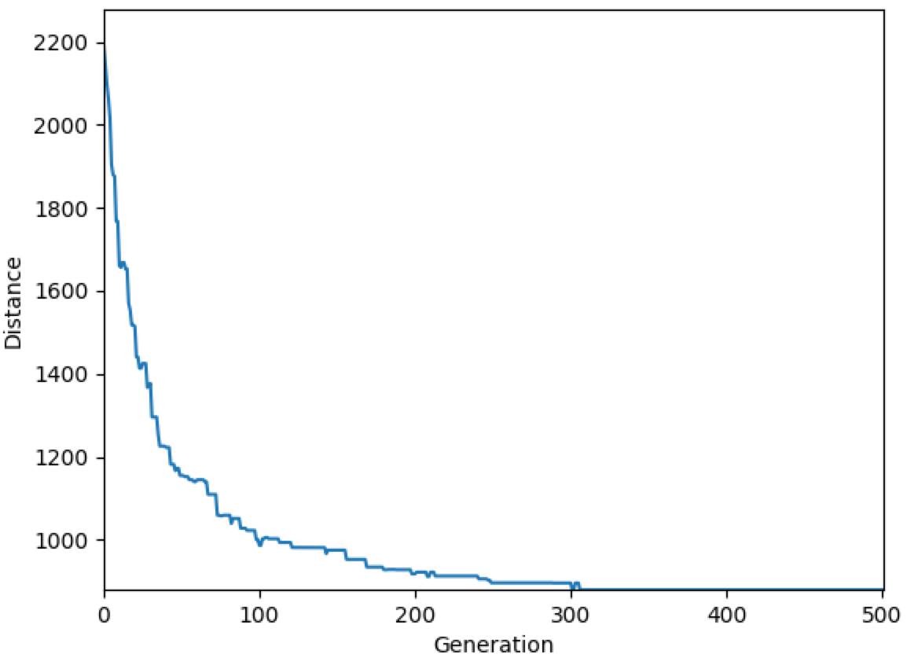
Figure 5 Elite size = 30
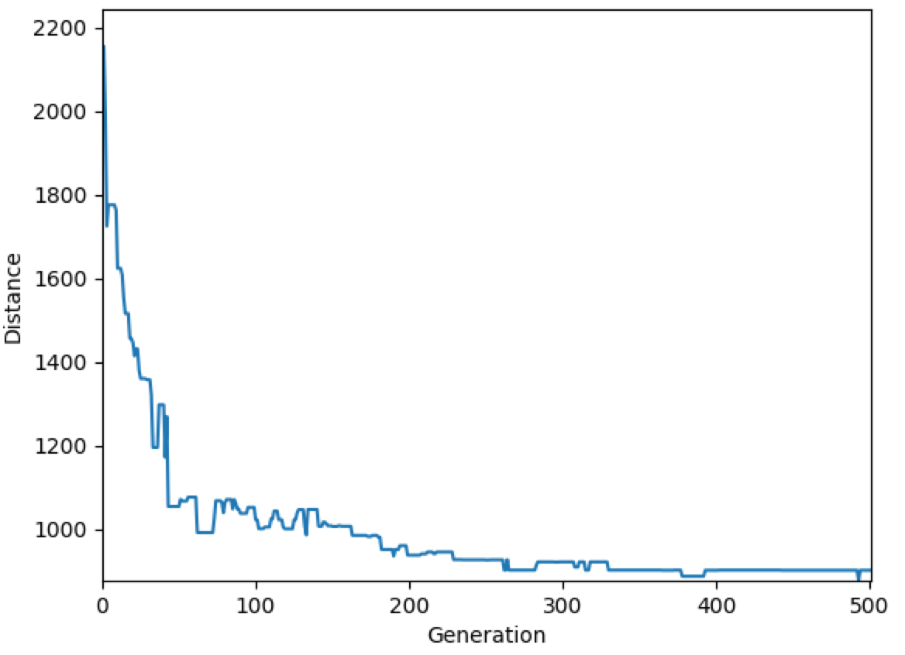
Figure 6 Elite size = 40
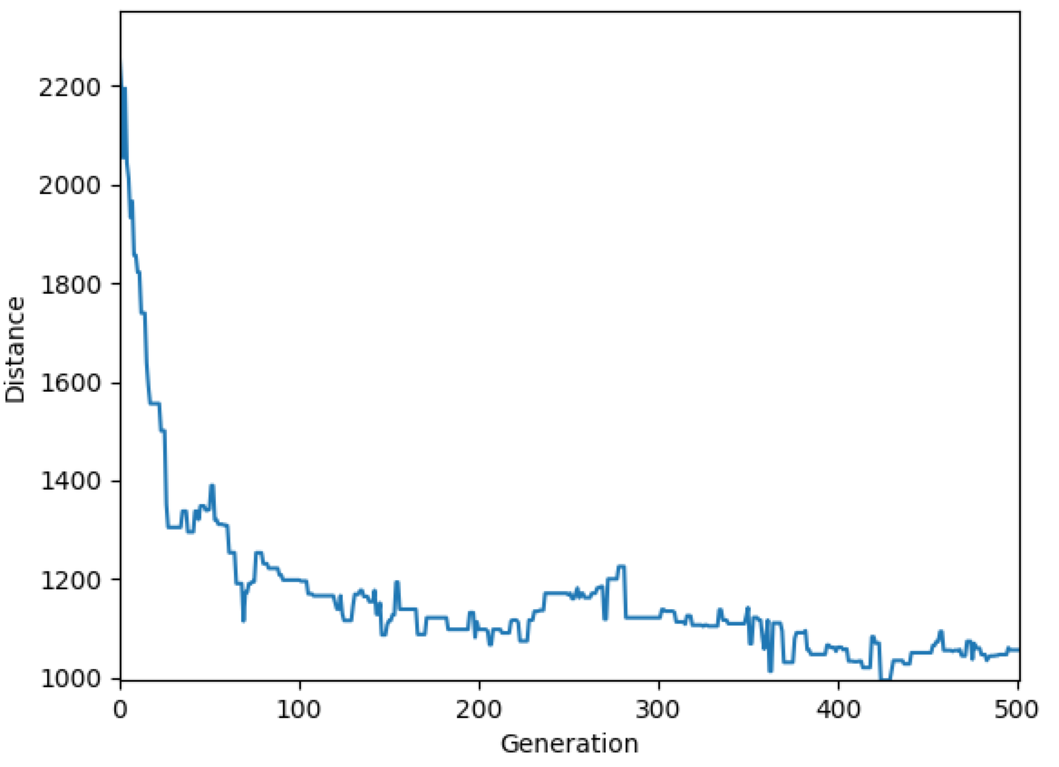
Figure 7 Elite size = 60
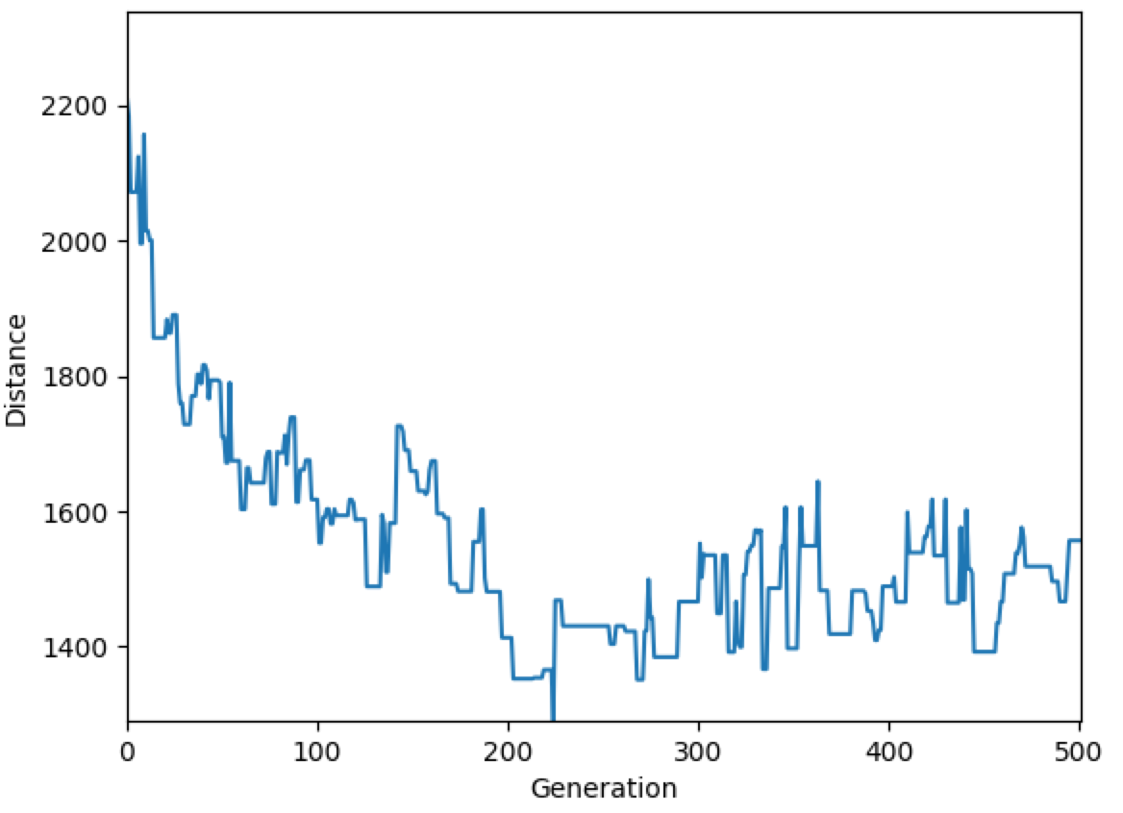
Figure 8 Elite size = 80
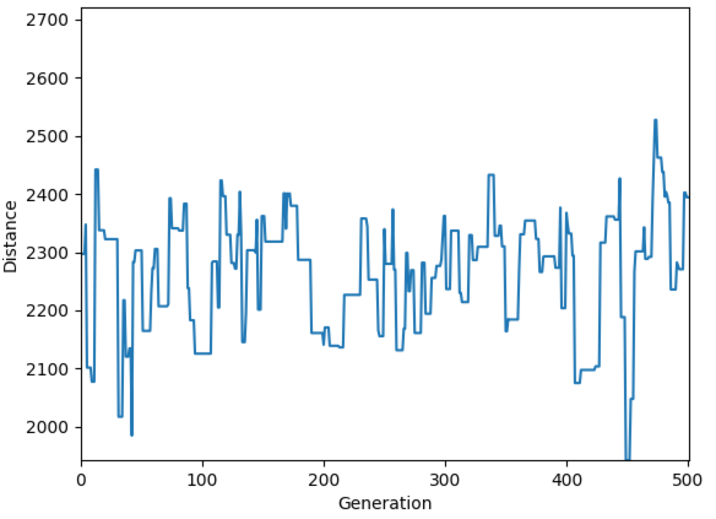
Figure 9 Elite size = 100

