Comparison
Please note that for this lab I used a SoftMax output activation function.

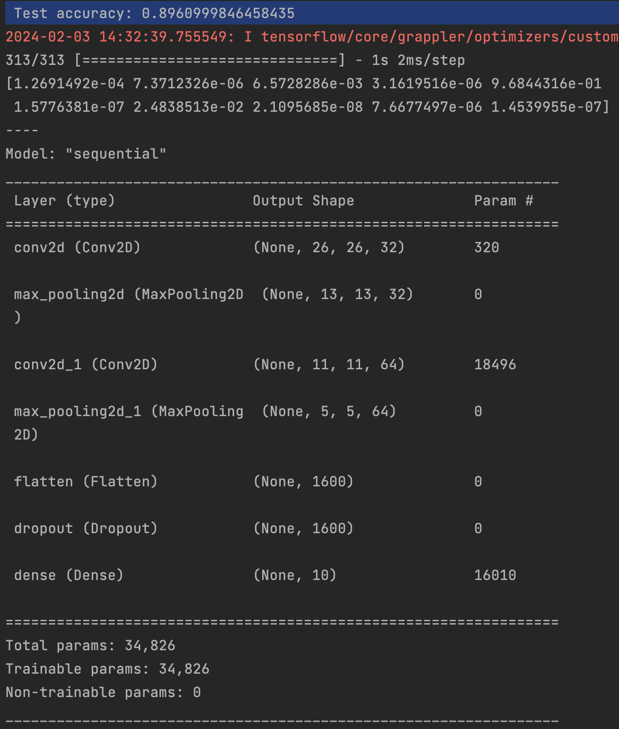
Figure 1 Original with no new layer.
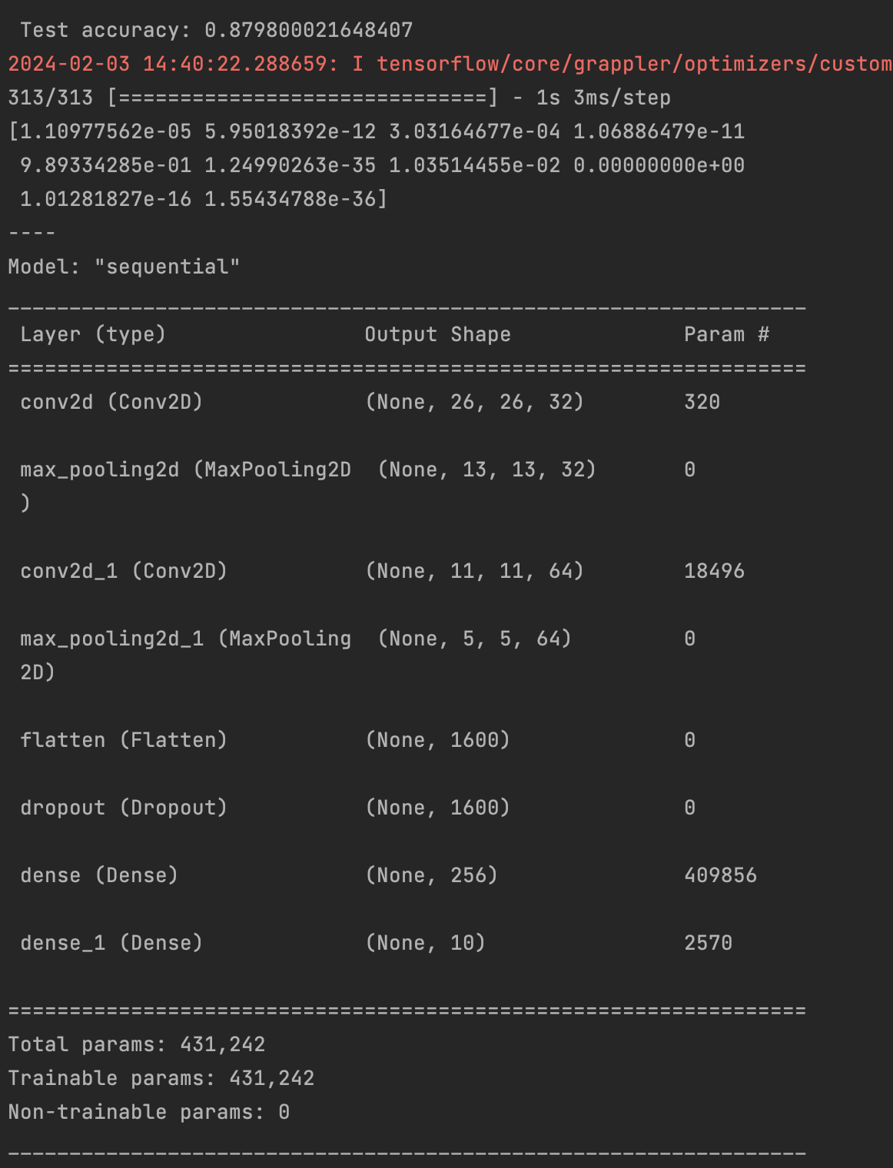
Figure 2 Summary with new layer.
Originally, I hypothesized that there would be an increase in performance due to the new layer. Since there would be an increase in the model’s capacity to identify more complex structures. However, the actual result shows a decrease in performance by 2%; it seems likely that the decrease in performance is due to overfitting, because the accuracy increases initially and then decreases.
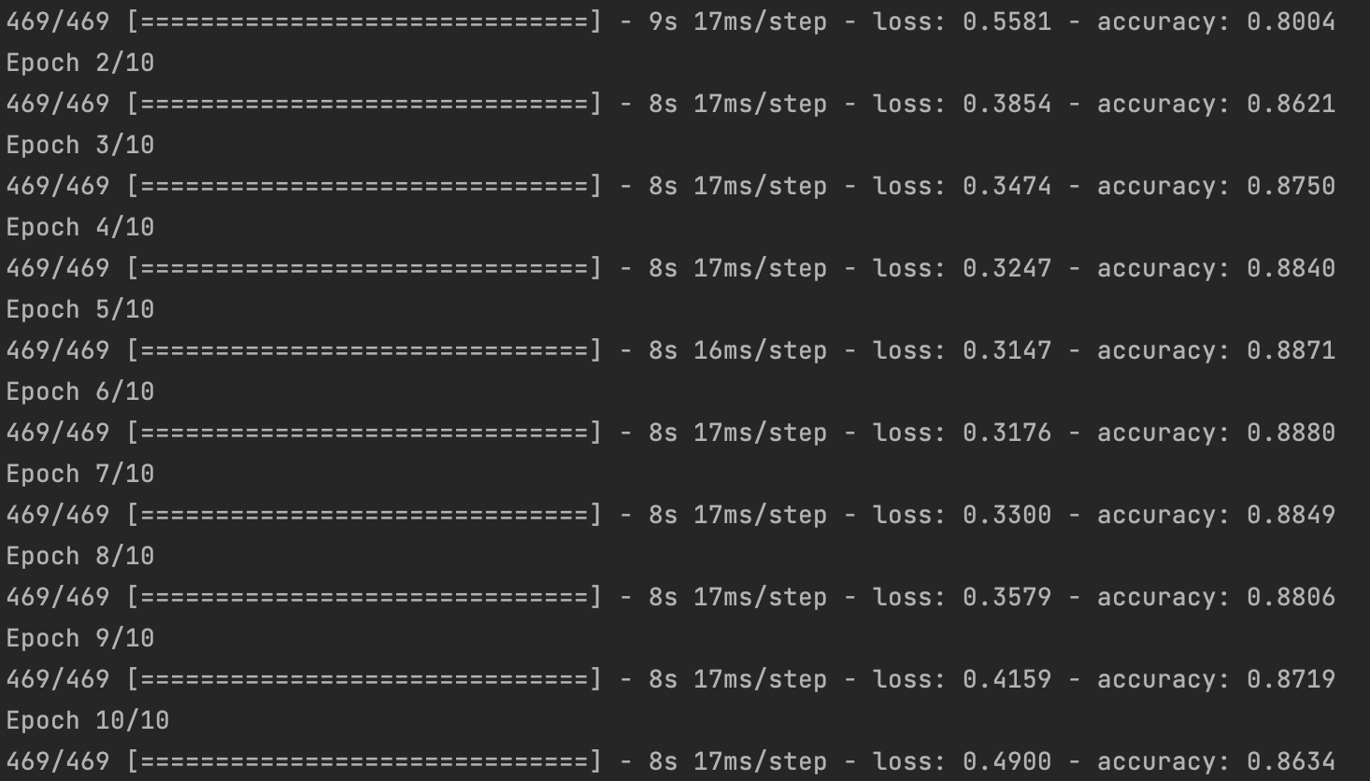

This did not occur with the earlier model.

