Weight matrix
The size of the weight matrix is due to the number of neurons in each layer, with x and y representing the number of neurons for each layer.

Example of the weight matrix for 100 neurons to 100 neurons.
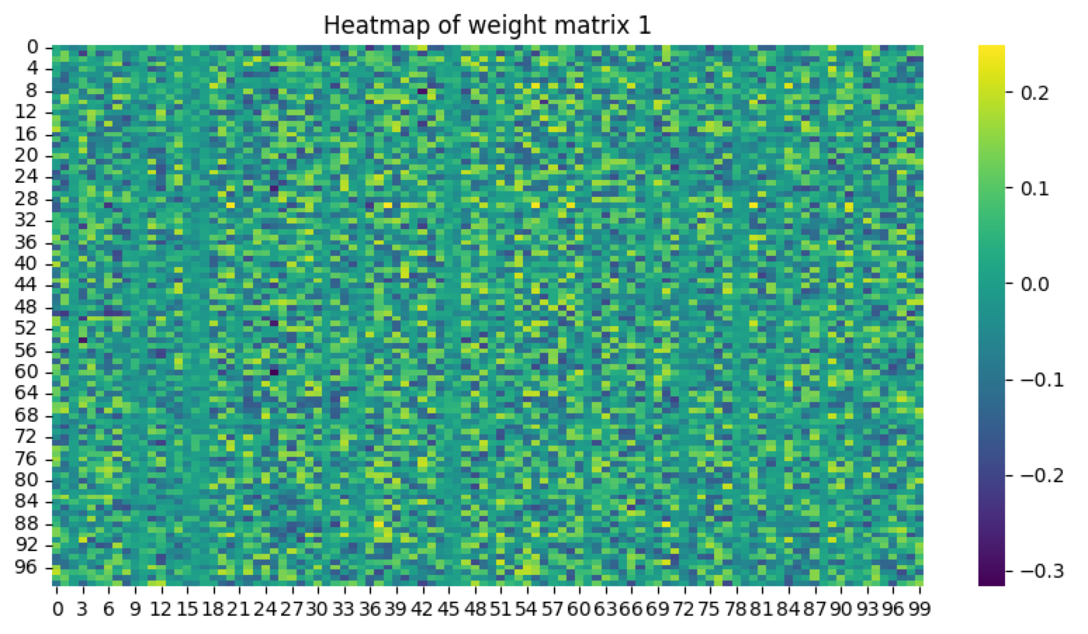

What activation function is used for the output layer?
The activation function for the output layer is determined by the type of classification the model is attempting to solve. In the case of binary classification like with the lab work the ‘logistic sigmoid function’.

Why is the activation functions of hidden layers and output layers different?
The output activation function is different because it needs to match the requirements for the output of the model. Hidden layers have a different activation function typically to introduce non-linearity, which can improve the model’s performance and operational complexity.

