**Homework Assignment 2**

**Introduction to Network Engineering**

**Benjamín Ragnarsson**

**Tölvusamskipti**

**Hugbúnaðarverkfræði**

**Teachers: Fatima Zahra Errounda / Stephan Schiffel**

**Haustönn, 2025**

1. **Network Transport Times**

**(a)**

**New York**

As seen here above the average round trip time is around 165ms.

**Tokyo**

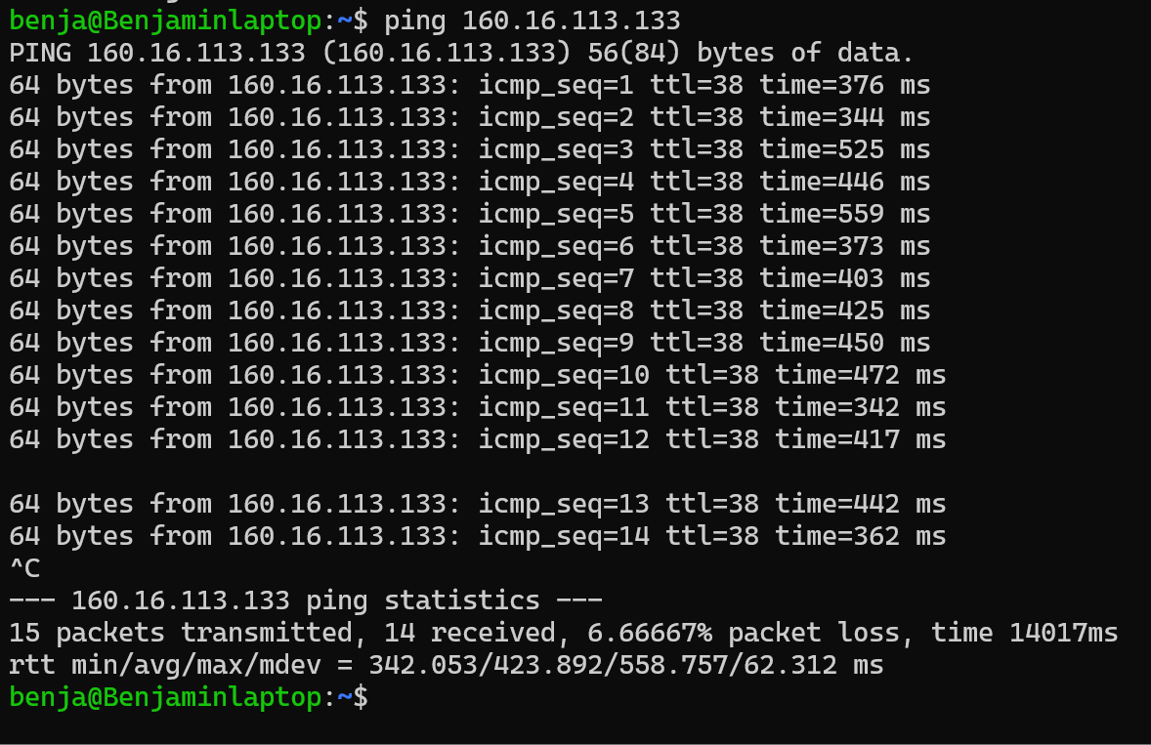

Here we have more time, it is 424ms on average per round trip, this is because it takes more time to go to Tokyo than to New York.

**(b)**

Moves made from the person in New York will take:  
t + 165ms, where t is the time to make a move.  
Moves made from the person in Tokyo will take:  
t + 424ms.

(t+424) – (t+165) = 259ms

For every move made, the Tokyo player uses 259ms more of their time than the New York player.   
Conclusion is that the New York player will win and will have approximately 259ms * (number of moves).  
So he might win in 10 seconds if the number of moves are 40, 259 * 40 = 10360ms = 10s.

**(c)**

**1. mel1.speedtest.telstra.net**

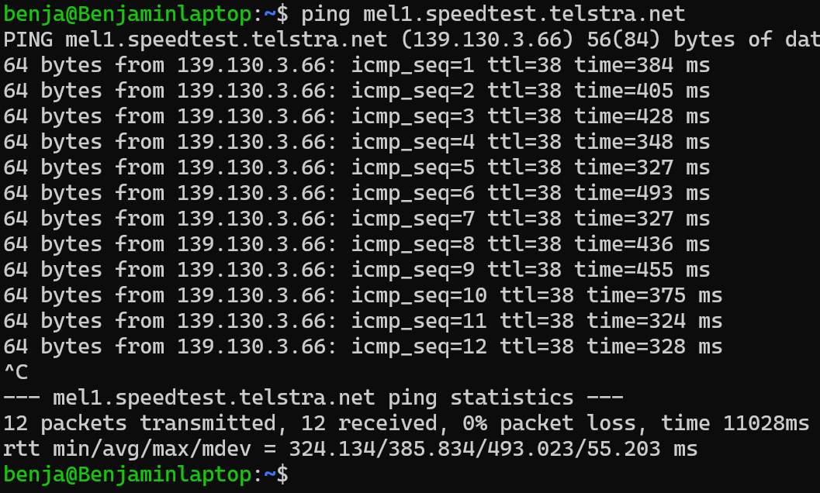

The average time here is 386ms.

2. per1.speedtest.telstra.net

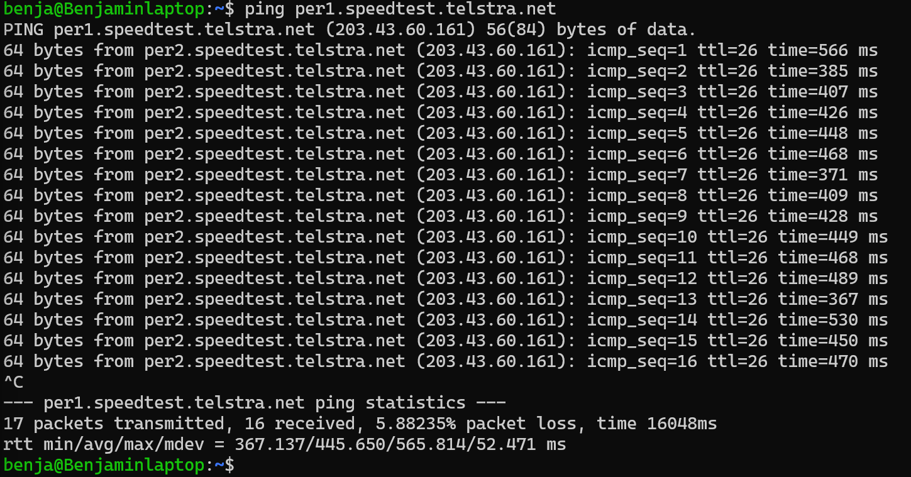

As seen here, we have an average time of 446ms per round trip.

(d)

300.000.000 m/s / 1,5 = 200.000.000 m/s

Difference from the two locations is 60ms = 0,06s, so the total meters are 0,06 * 200.000.000 = 12.000.000 m, so the length between the locations is 12.000 km according to our ping above. This would be for the round trip so we can divide this by 2 and get the distance between the two places as 12.000 / 2 = 6.000 km.

1. **Network Throughput**

**(a)**

Size of the dataset: 100TB = 10^14 bytes = 8 * 10^14 bits

Connection speed: 1 Gbps = 10^9 bps (10^9 bits)

Protocol overhead: 15%, so effective speed is = 85% of 1 Gbps = 0,85 * 10^9 bps

Transfer time = (8 * 10^14 bits) / (0,85 * 10^9 bps) 941.176,47 seconds.

941176,5 / 60 / 60 / 24 = 10,89 days = 10 days and 21 hours.

**(b)**

The total time to send the data by tape is total of 7 hours (3+1+3)

**(c)**

ddd

**(d)**

ddd

1. **Network Engineering**
2. **Error Detection / Correction**
3. **Protocol Overhead**