MySQL Installation Guide (Windows)

**Step1- Install MySQL**

The following description is based on MySQL 8.0.17 for Windows.

Go to MySQL download page (<http://dev.mysql.com/downloads/mysql/>). Click the **Windows MySQL Installer MSI** “Download” button.

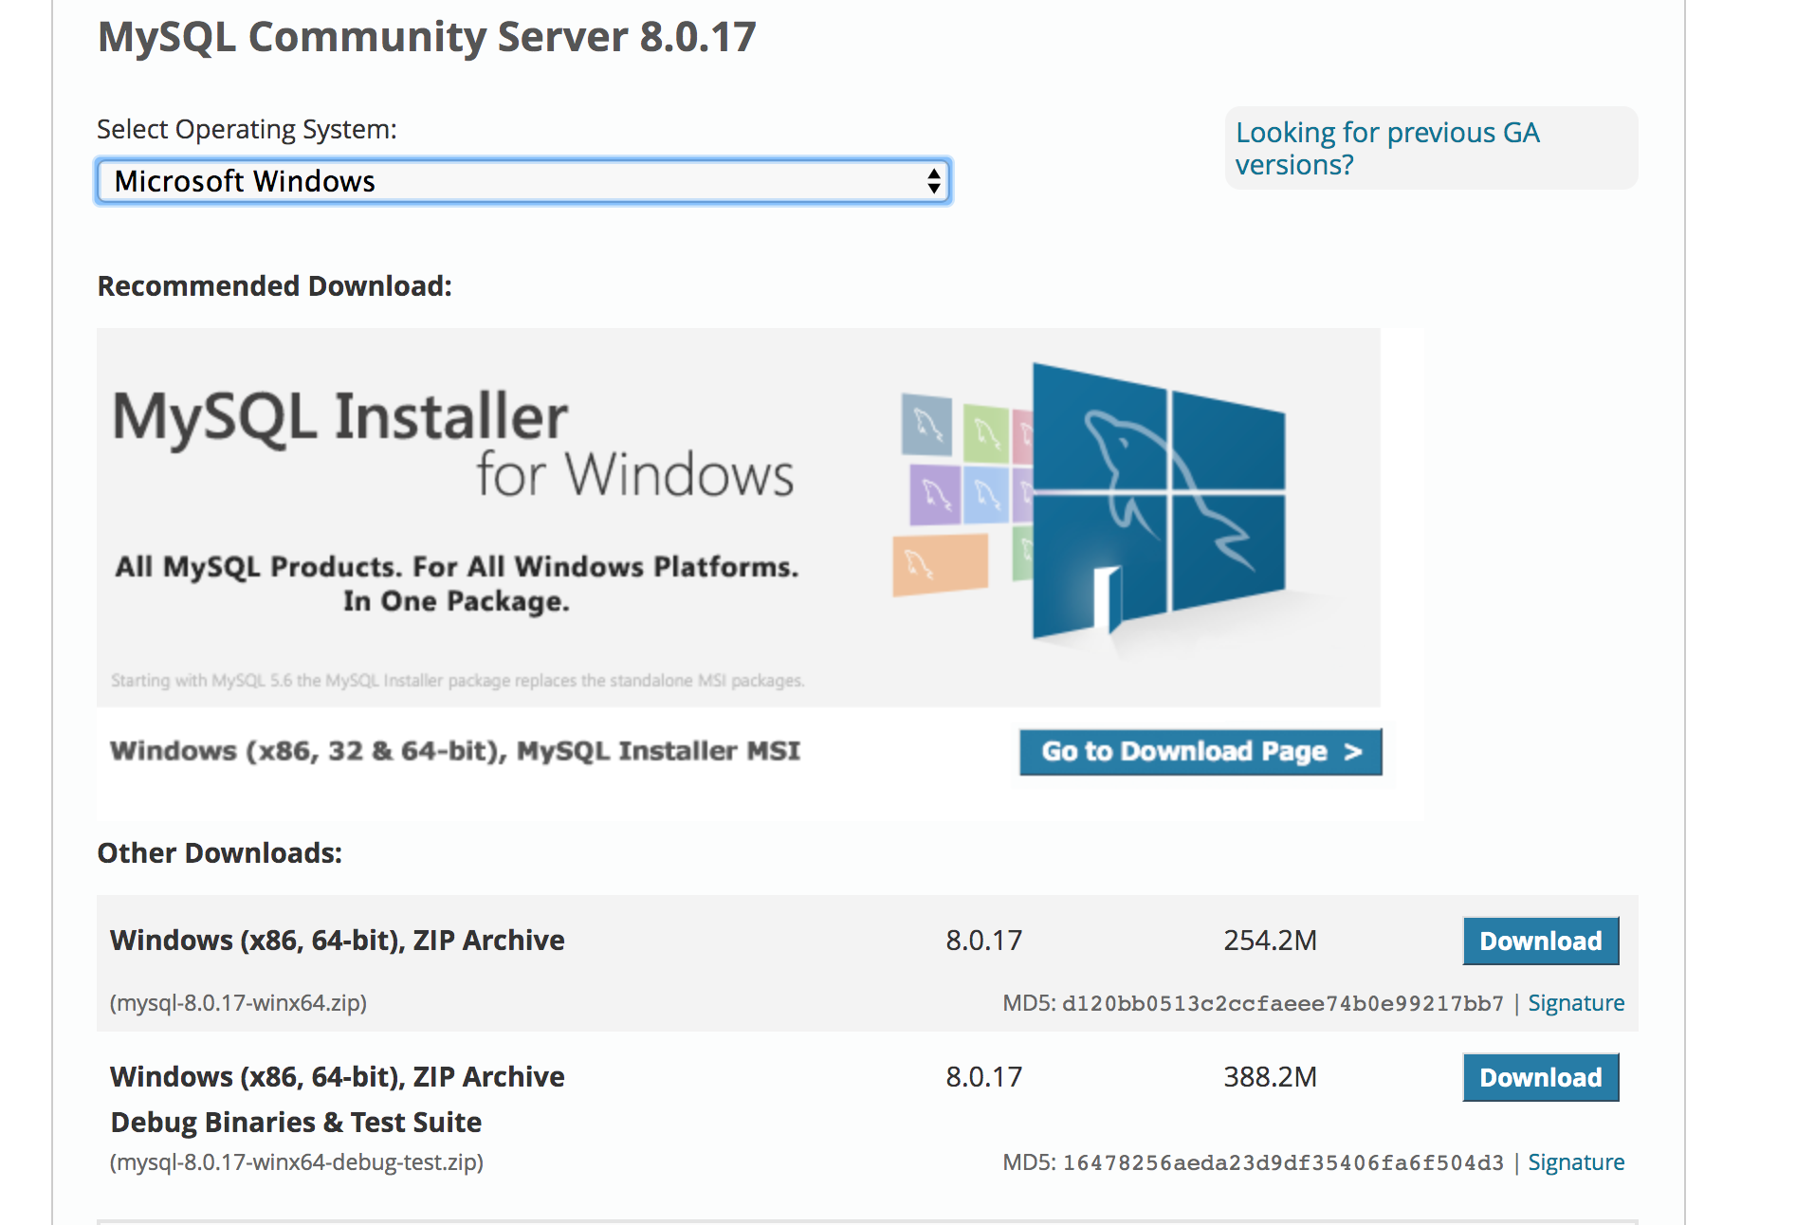

Click on Go to Download Page >

You will see the following window. Download the Installer whose size is 393.4M.

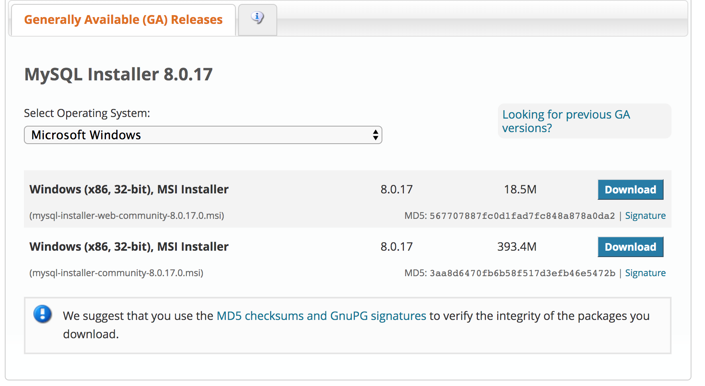

1. Execute the installer. Check “I accept the license terms.” And click “Next”.

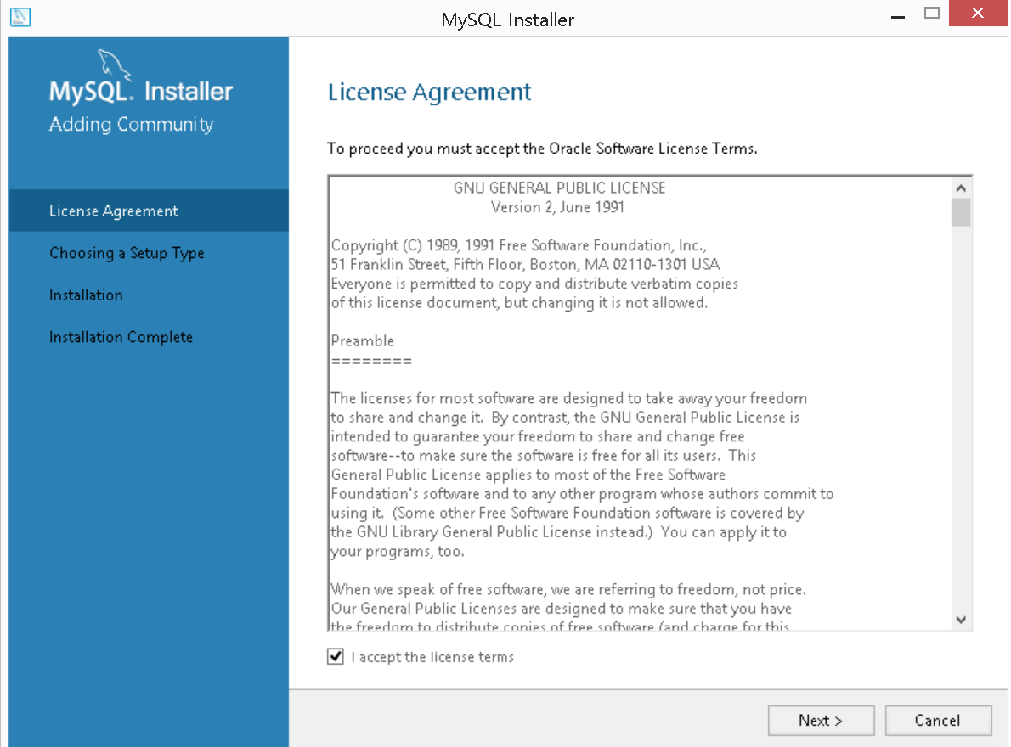

2. When asked, choose “Developer Default” and click “Next”.

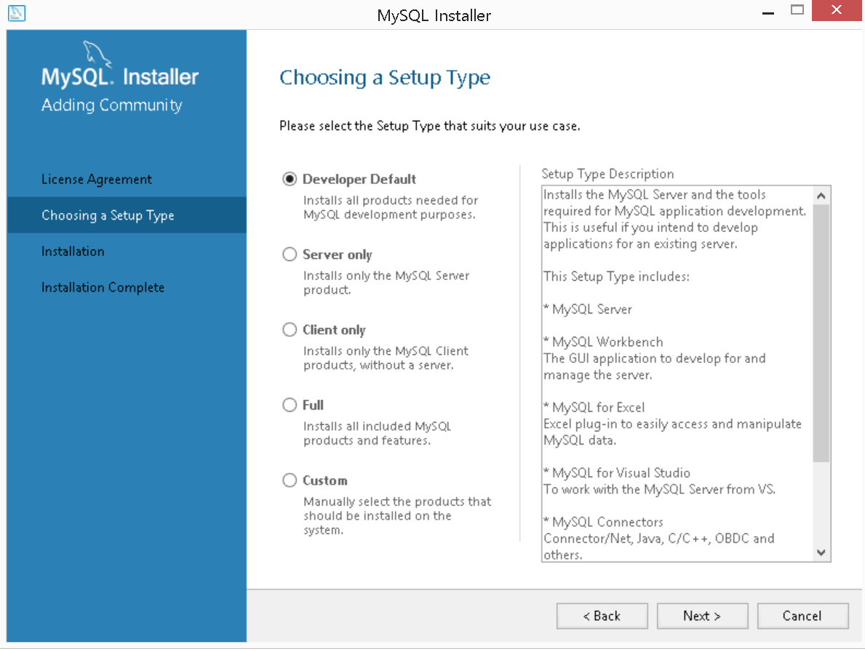

3. It may ask to resolve the certain requirements. Click “Execute” to resolve these requirements. After finished, click “Next” to continue.

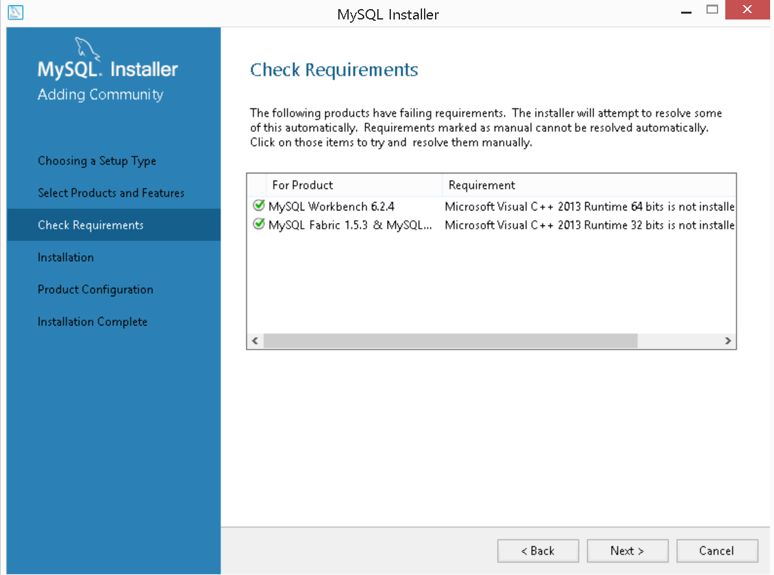

4. A list that contains the products that are going to be installed will appear. Click “Execute”. The installer is going to install these products.

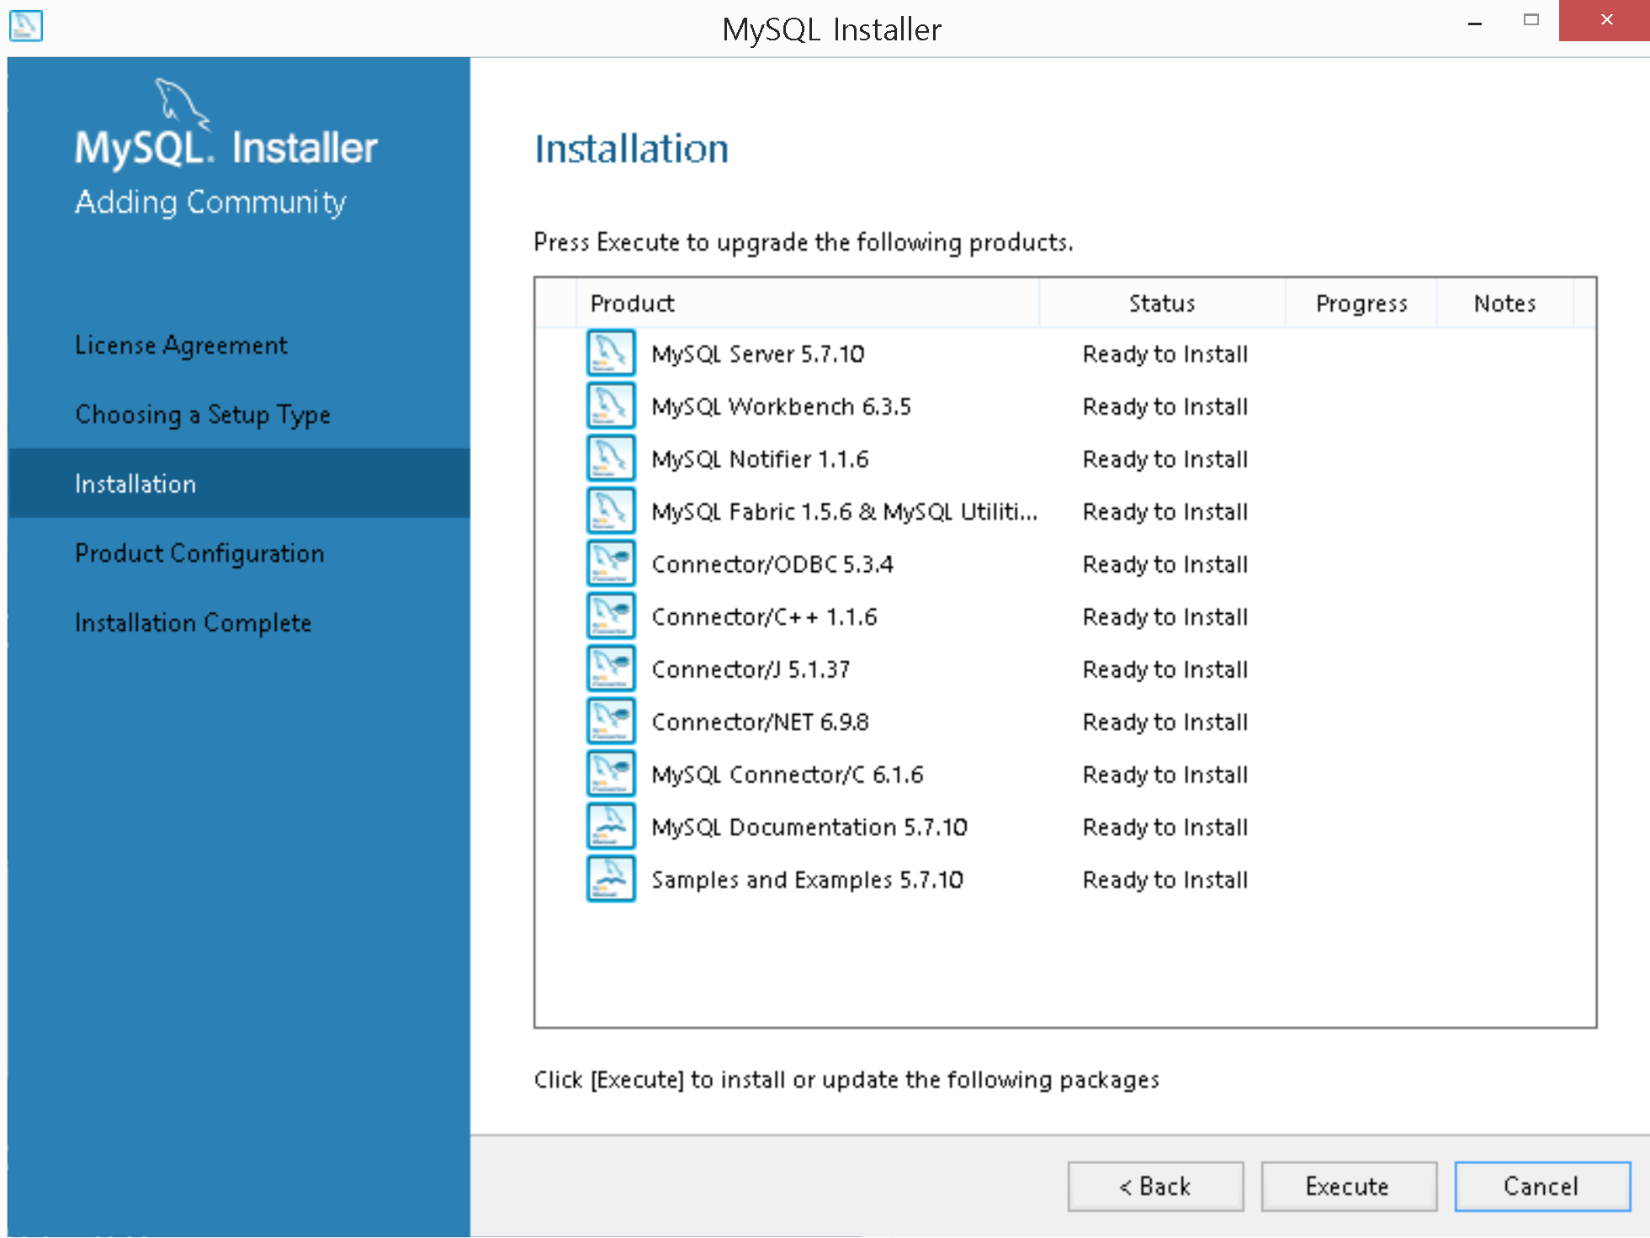

5. After done, it will ask you to configure the MySQL Server. Click “Next”.

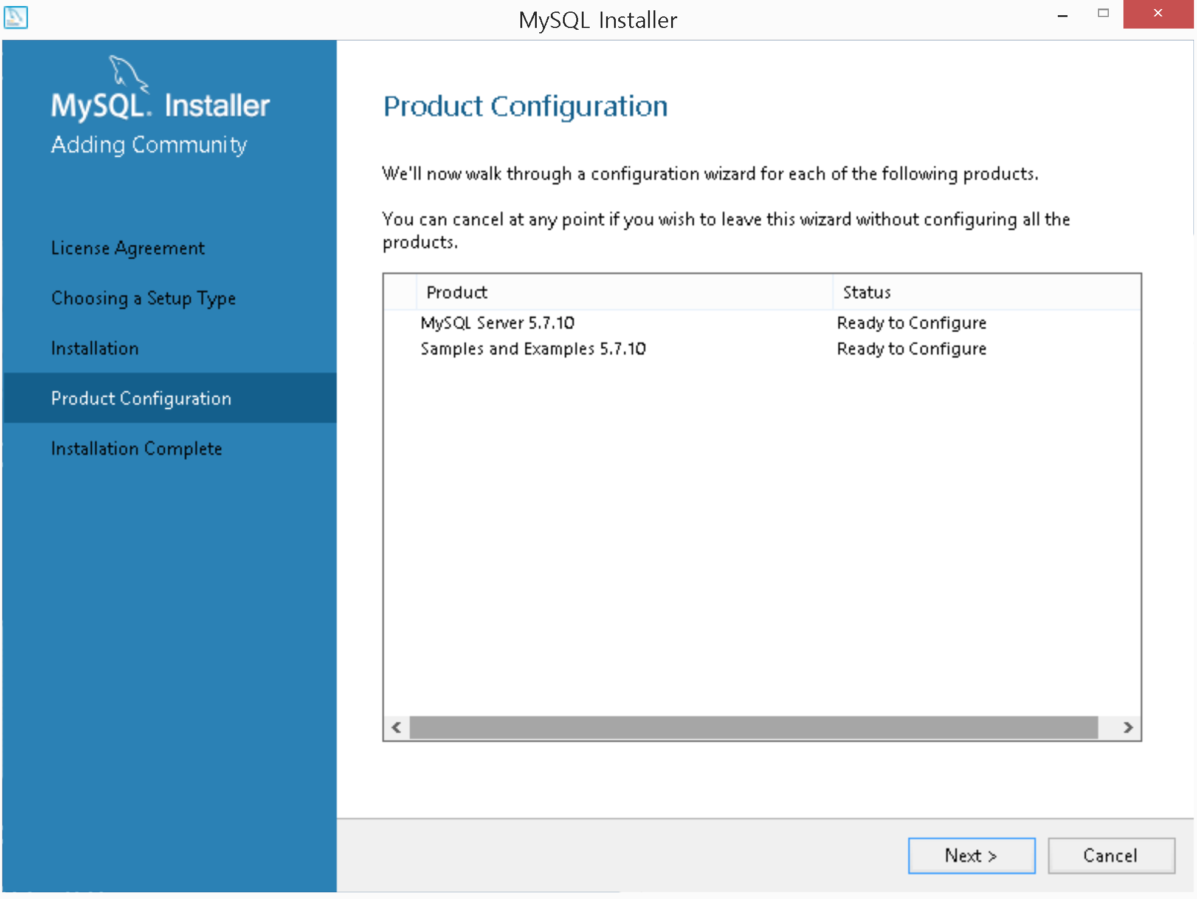

6. For the Config Type, choose “Development Machine”. For Connectivity, choose “TCP/IP” and enter 3306 as the port number. Also click “Show Advanced Options” then click “Next”.

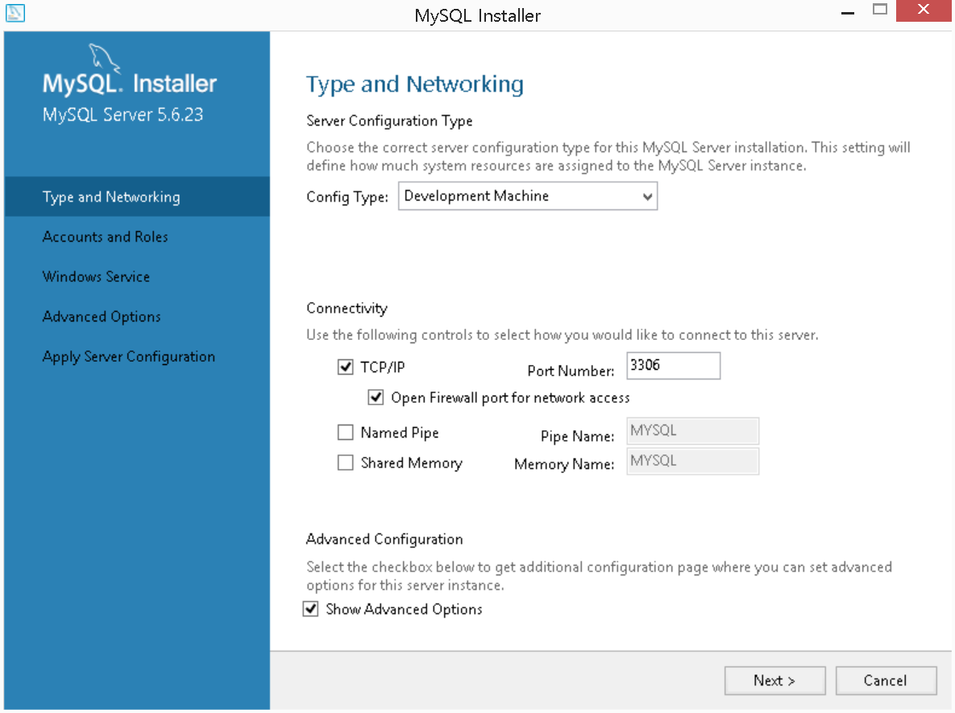

7. Set the root password. The length should be at least 4. Also, you can create a user account.

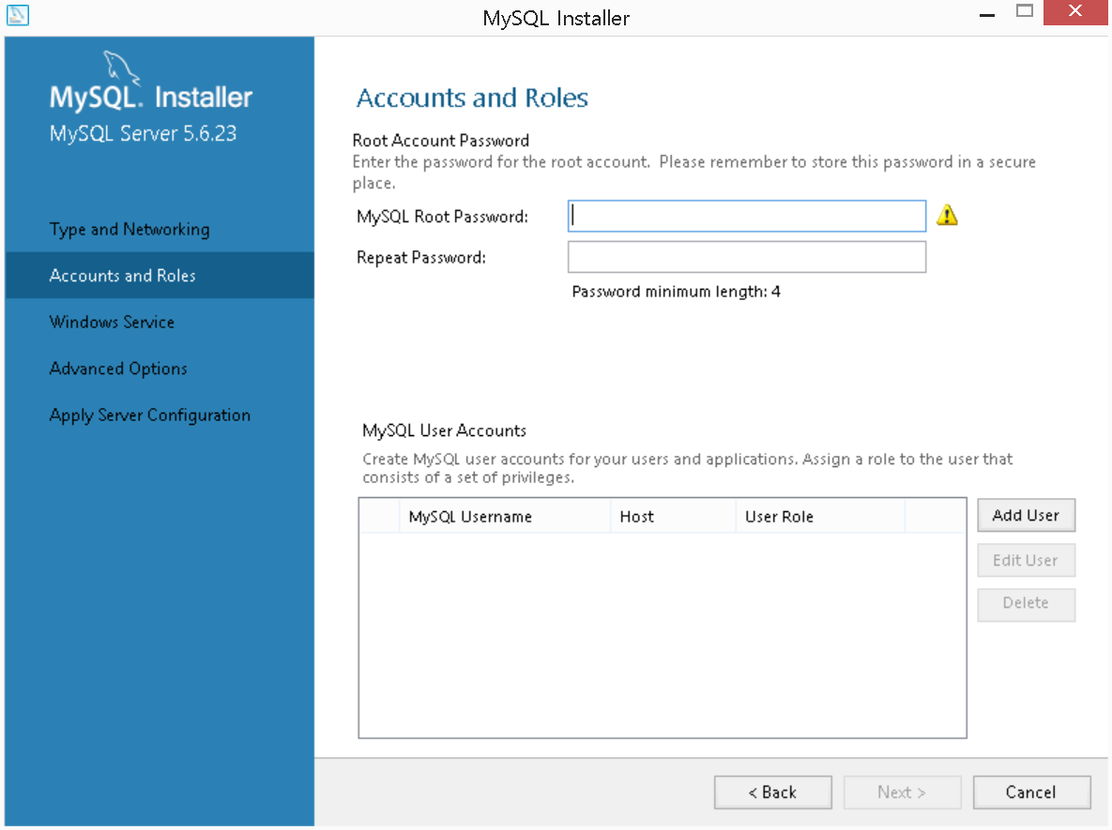

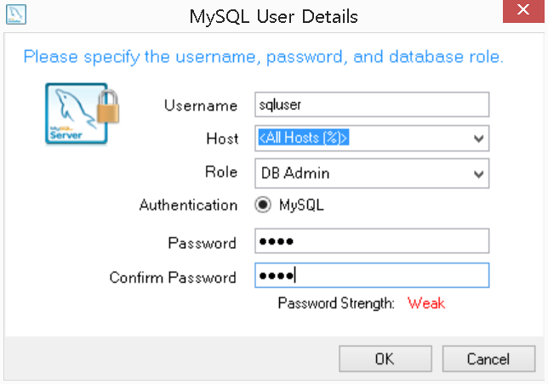

8. Select “Configure MySQL Server as a Windows Service” and select “Standard System Account”.

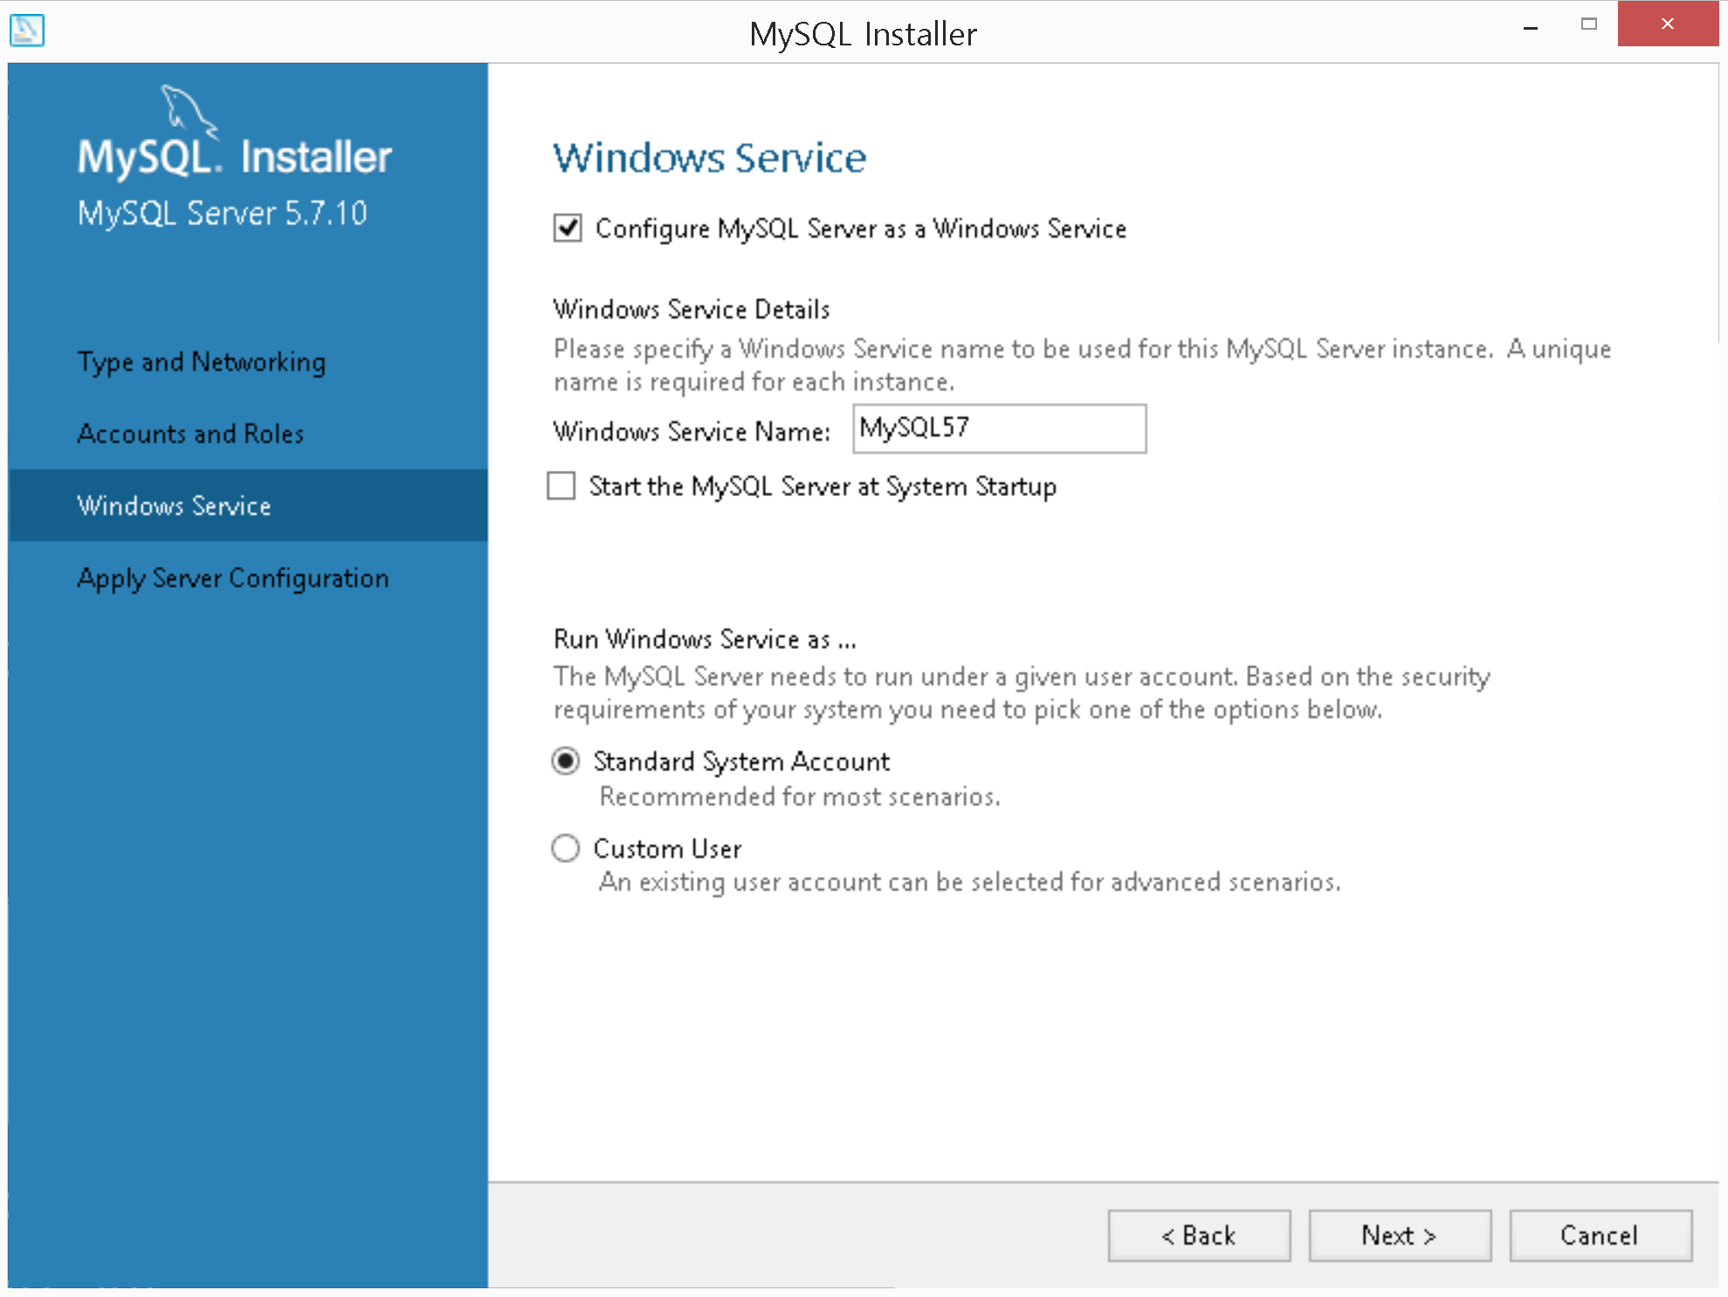

9. Click “Execute” to continue. After this step is done, click “Finish”.

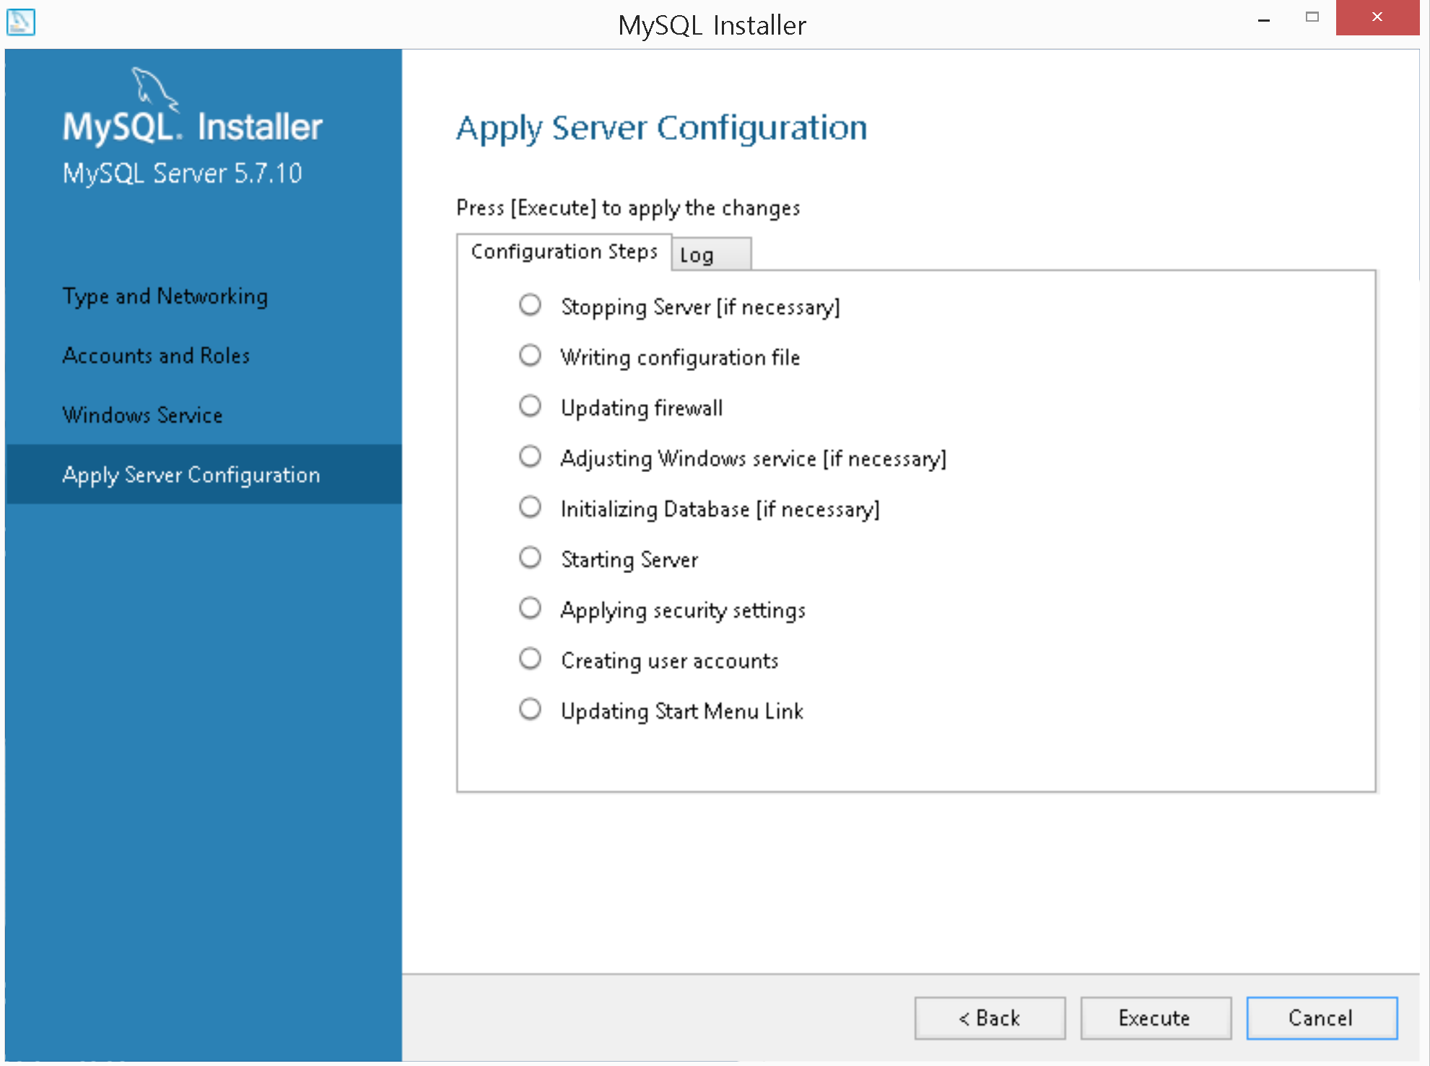

10. Click “Next”.

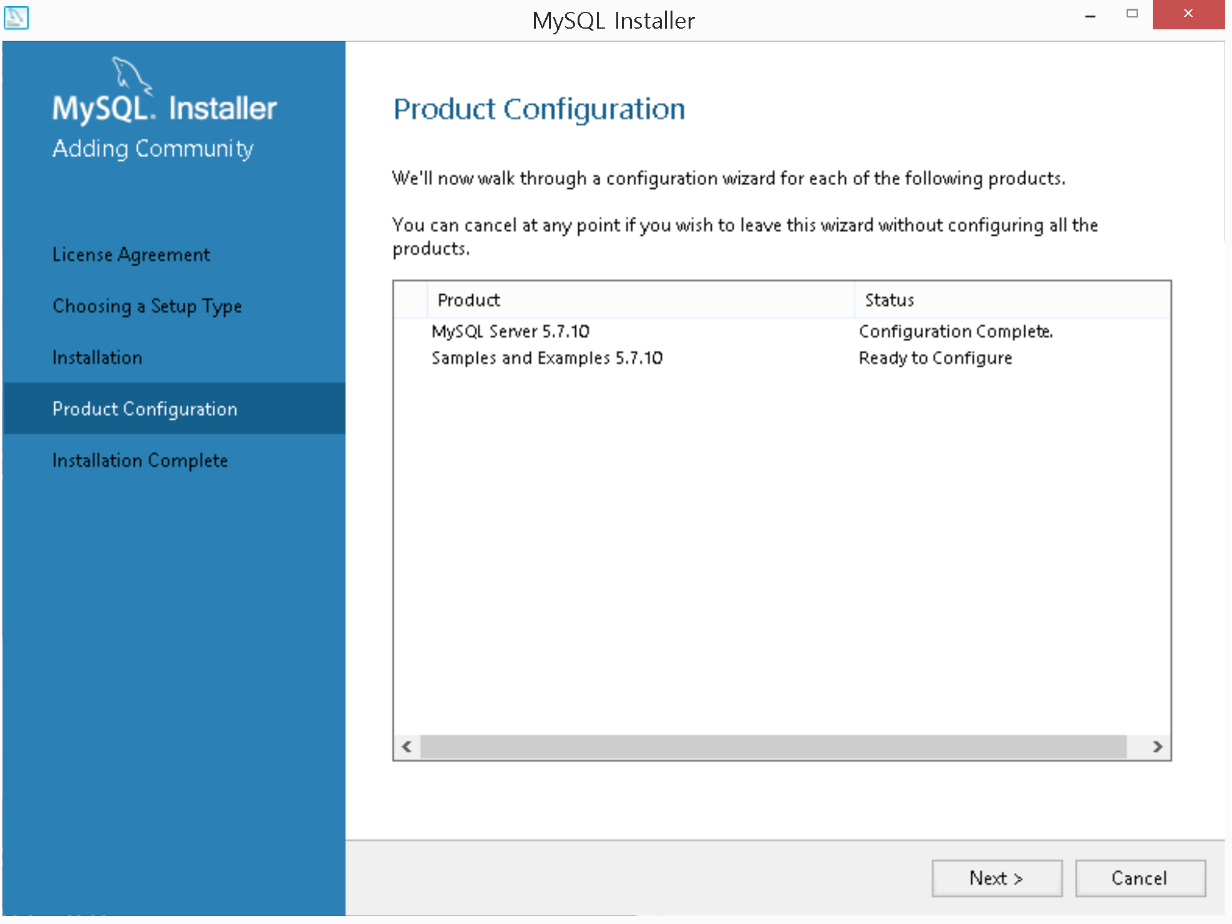

11. Click “Check” to check the connection. If it works well, click “Next” and then click “Execute” in the next screen.

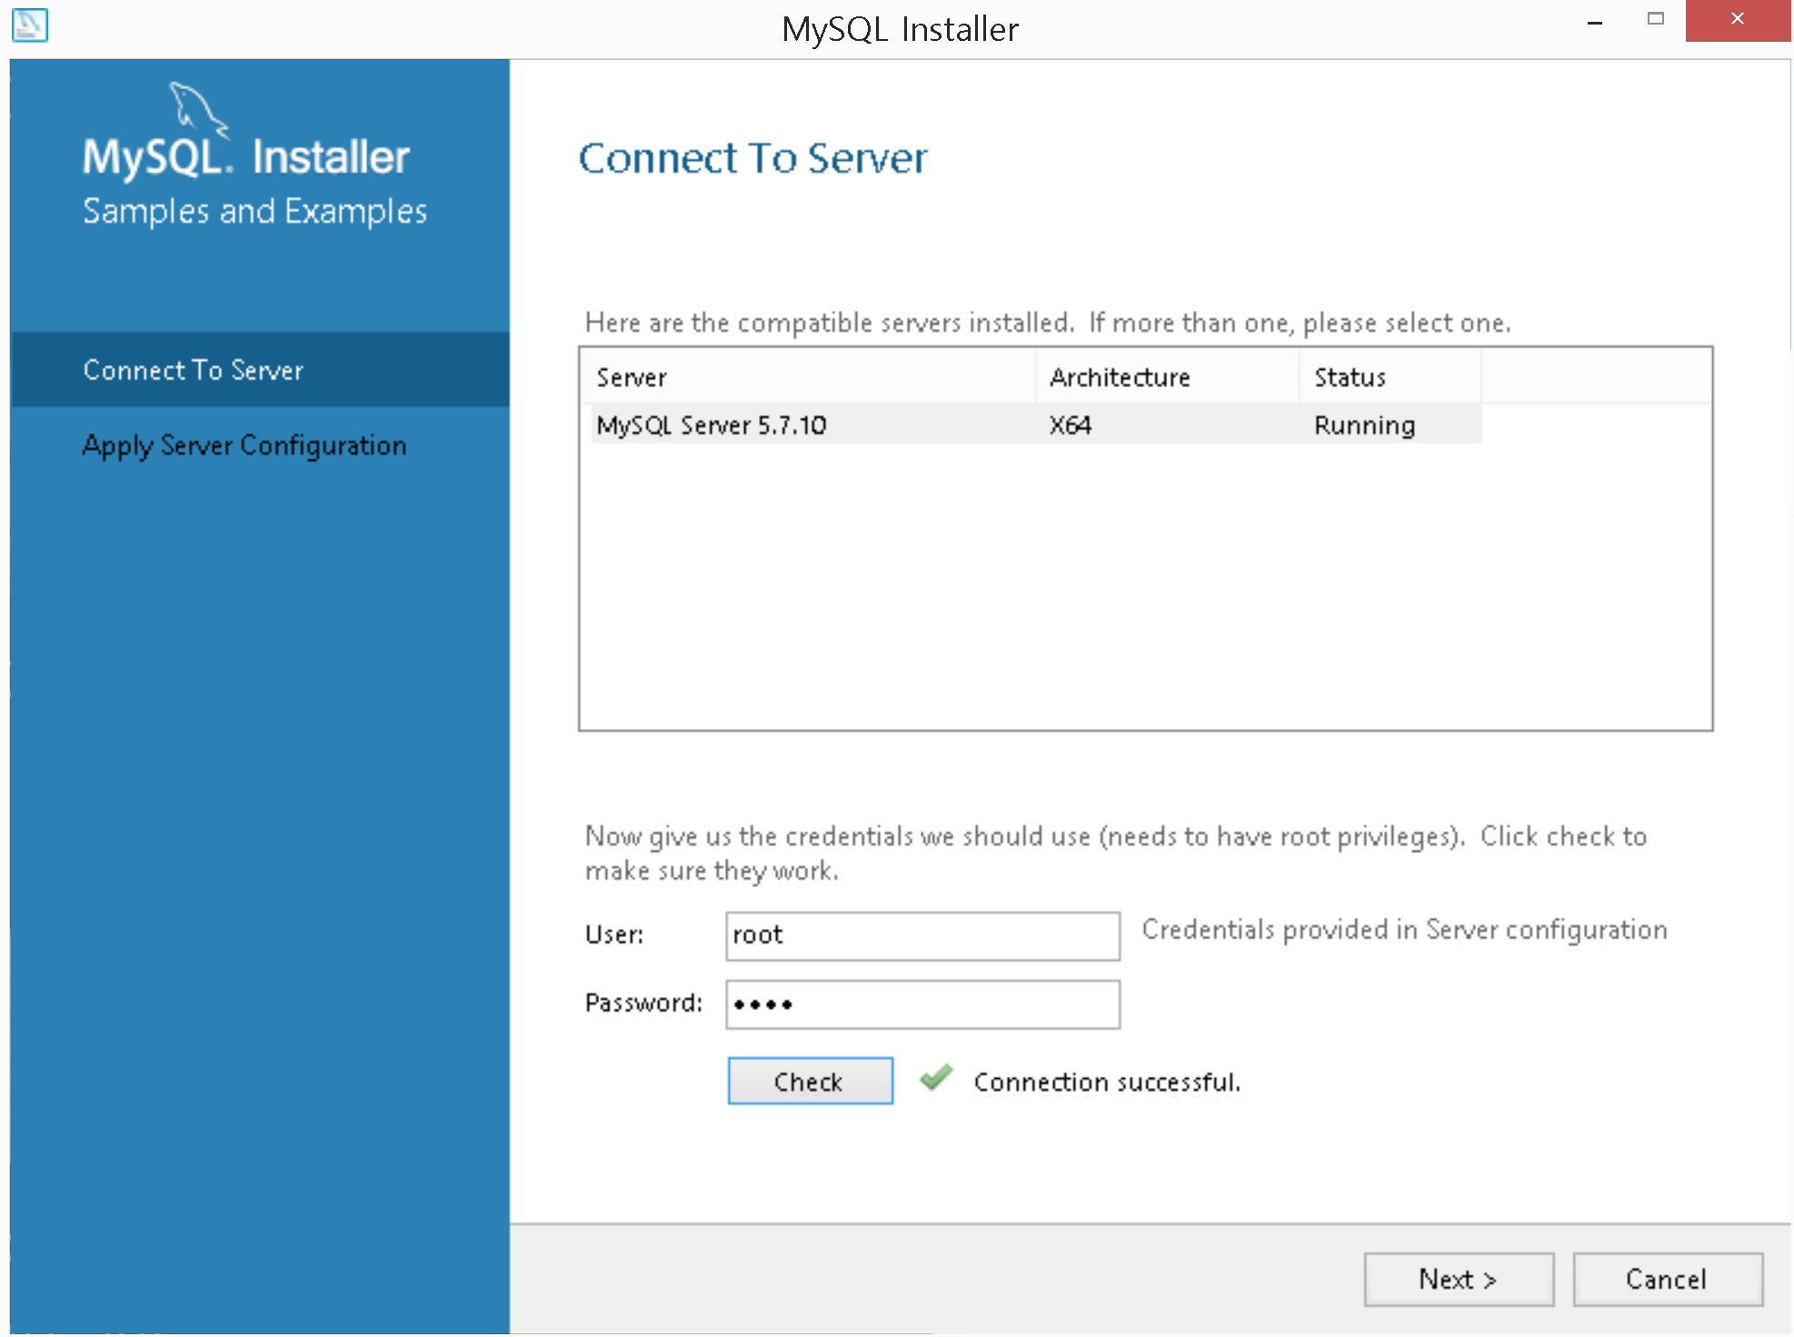

12. Once this configuration is completed, click “Finish”. Finally, you will see the following screen. Click “Finish” to start MySQL Workbench.

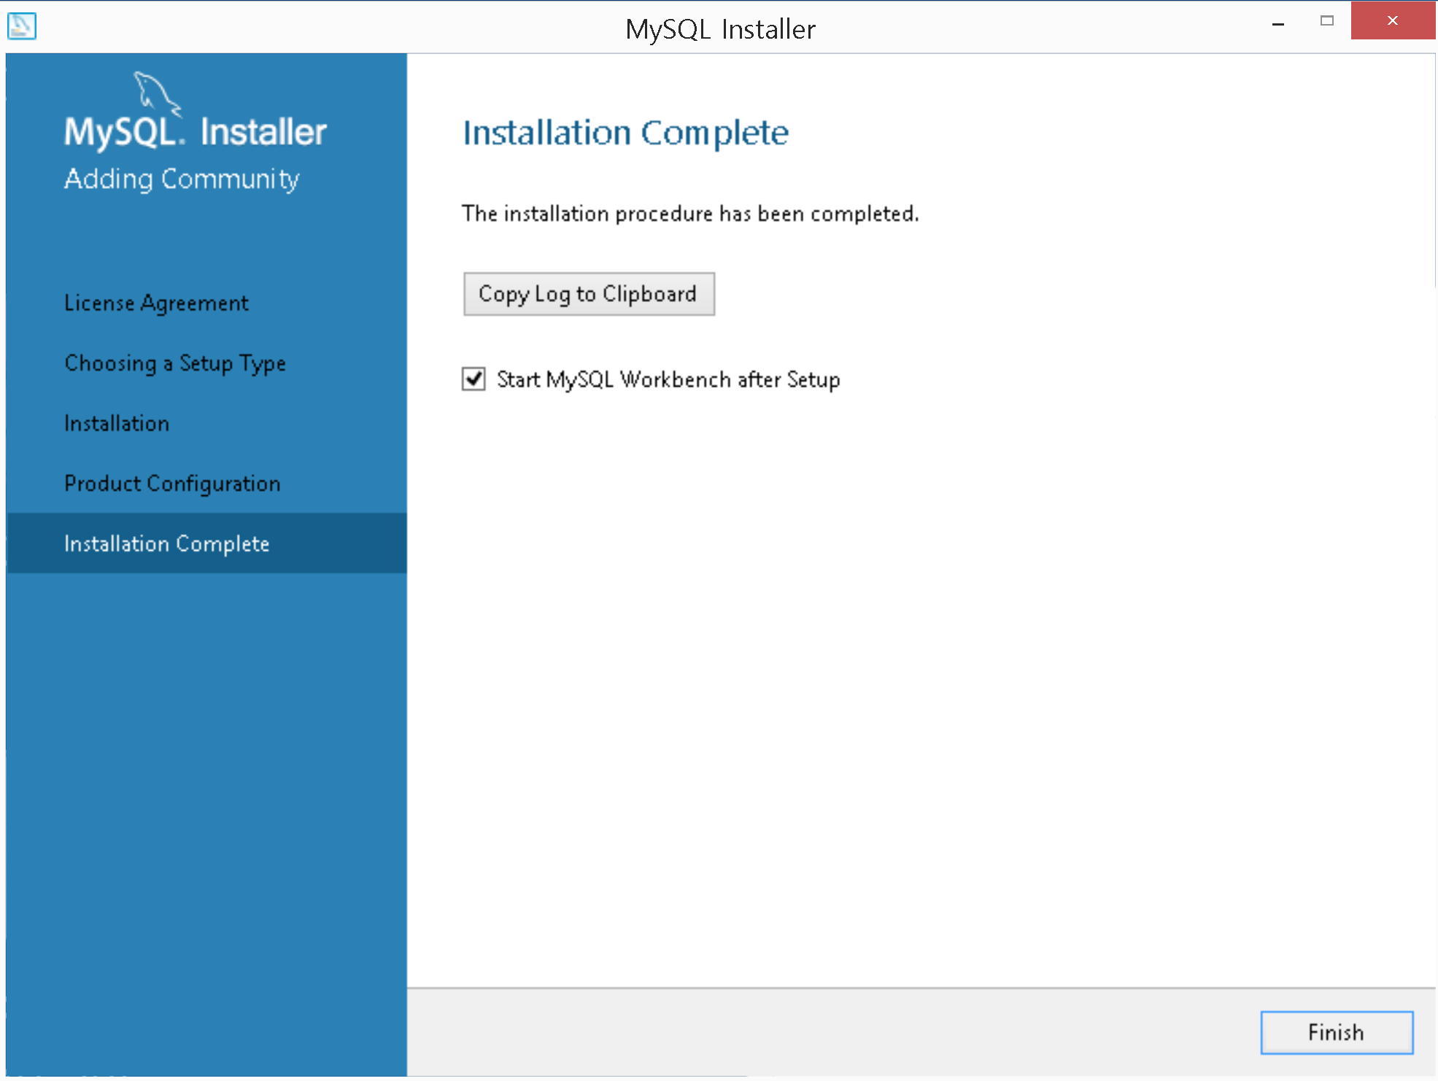

**Step2- Execute MySQL WorkBench**

1. In MySQL program group, execute “MySQL Workbench”. Double click “Local instance MySQL8.0” to connect to the instance.

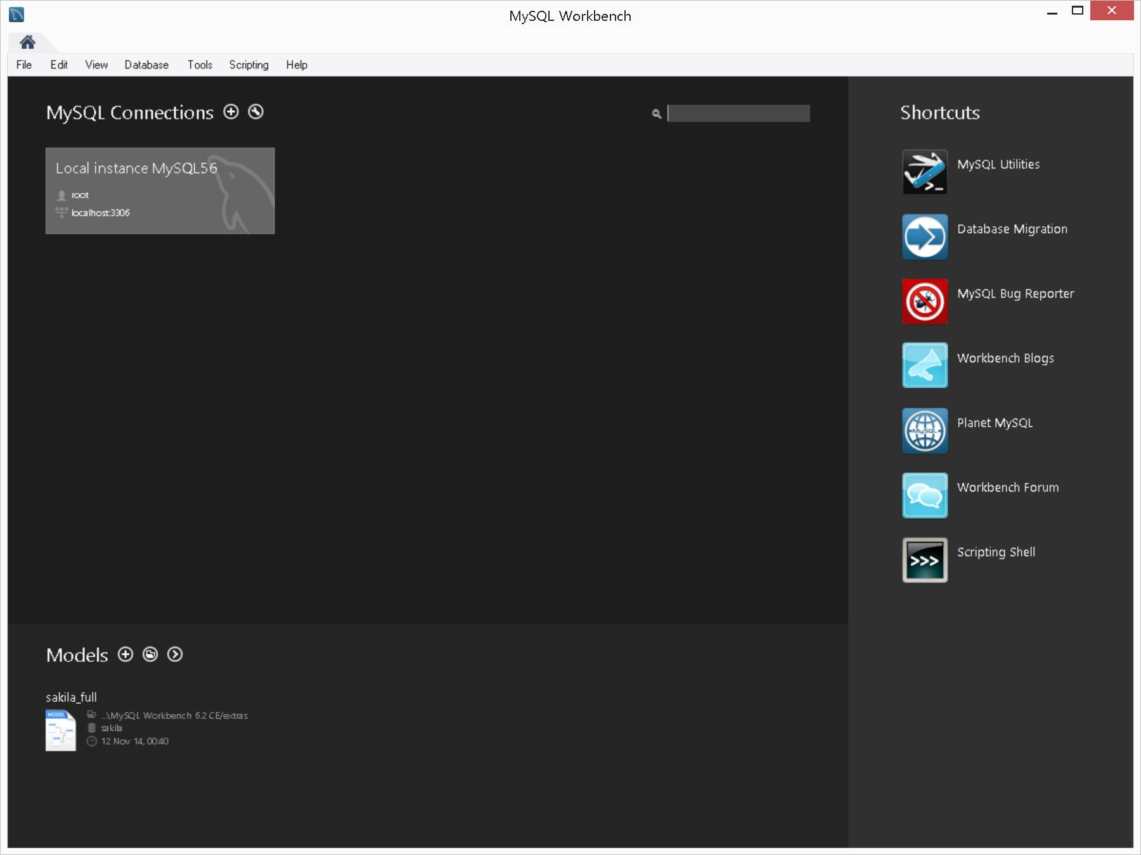

If you don’t see a connection, you can create it by clicking “+” button and referencing the following window. You need to provide the connection name and the password by clicking “Store in Vault”. You can click “Test connection” to see whether it works fine or not.

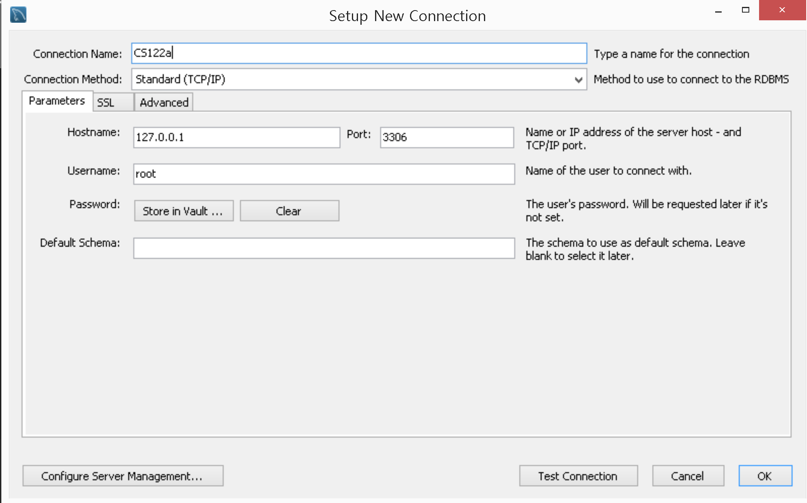

2. You will see the following window.

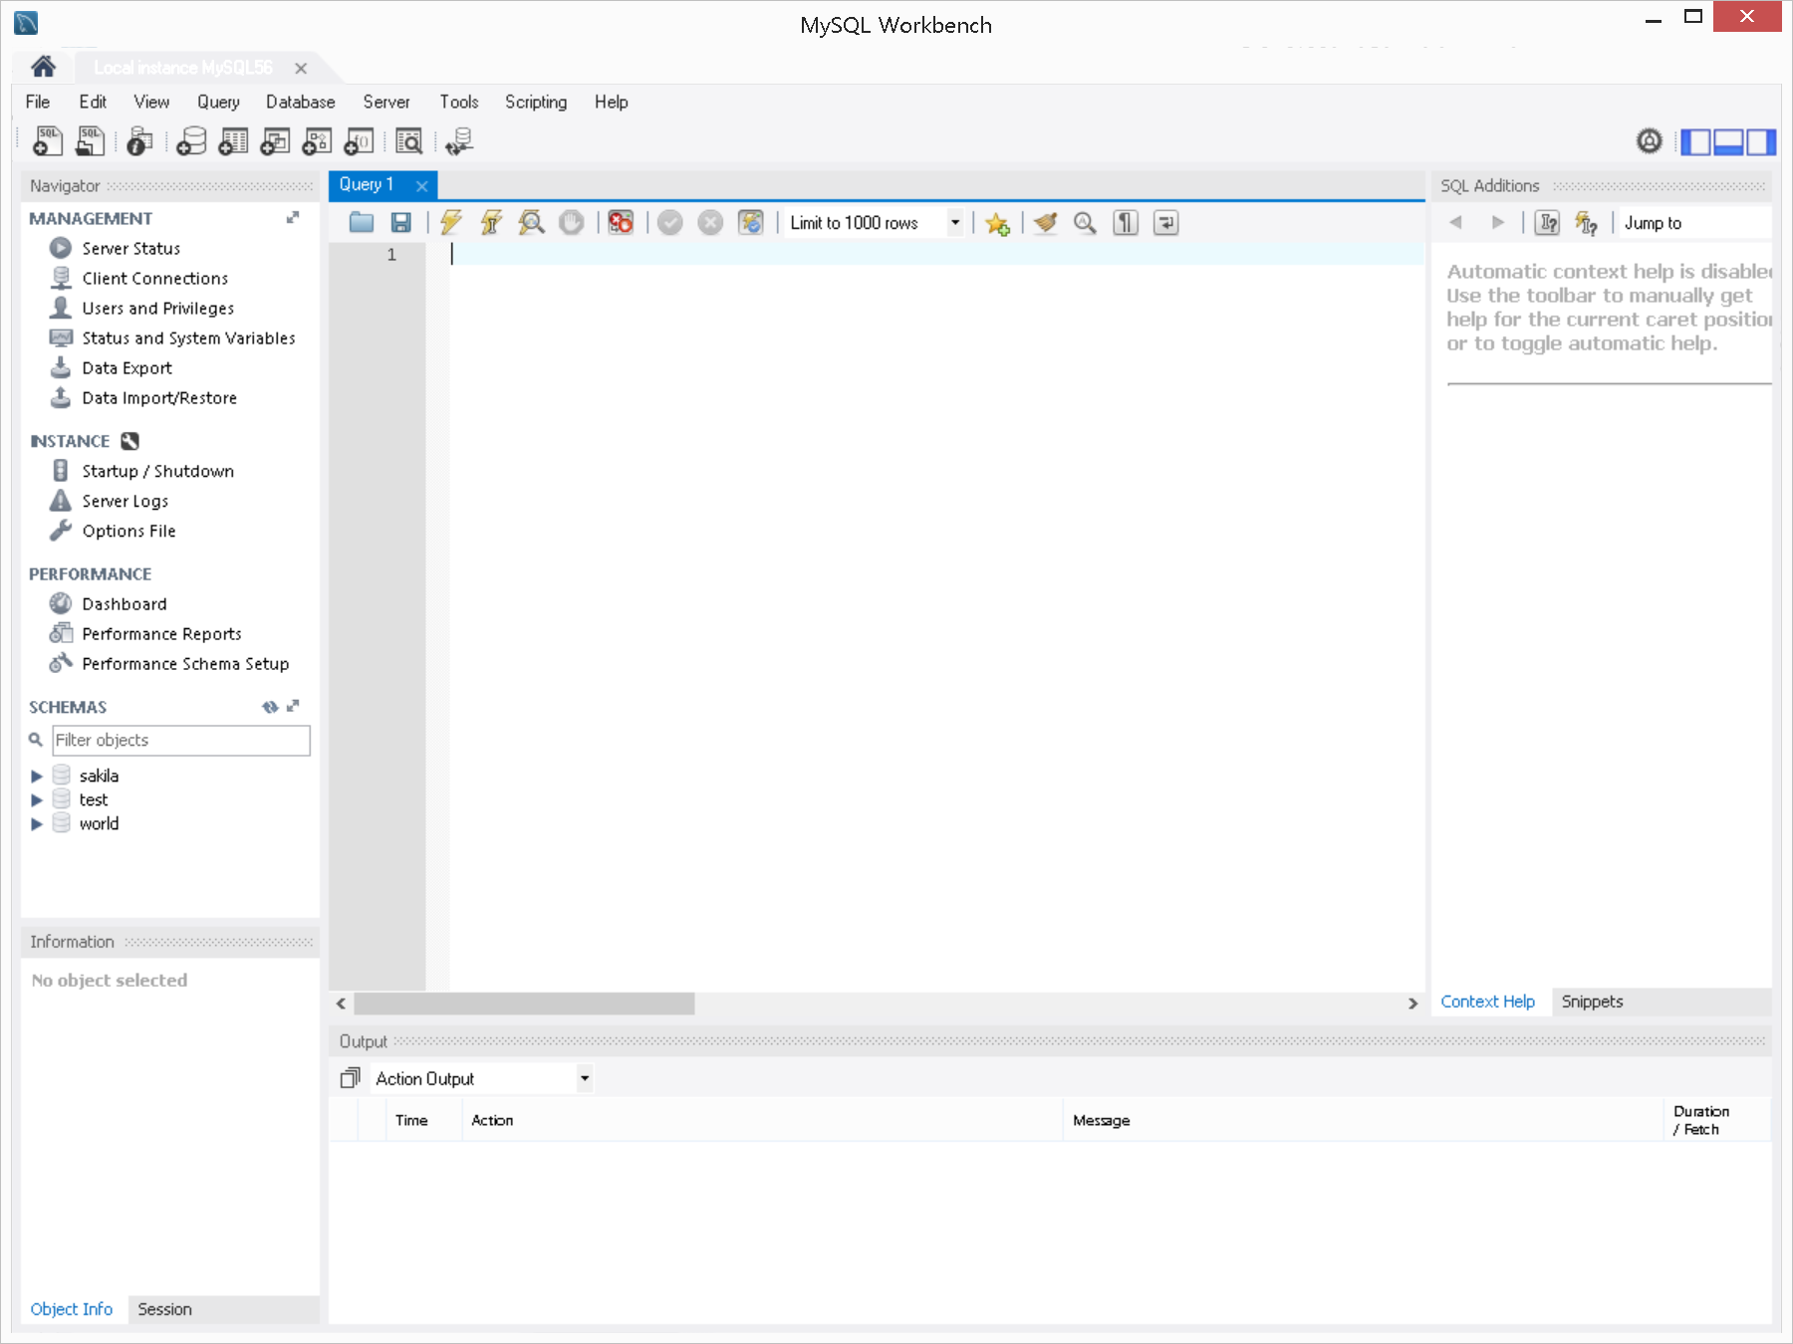

**Step3- Create a Database and Tables, and Insert tuples**

Given below is the schema for the example data. There are three tables.

* Boats (bid, bname, color)
* Reserves (sid, bid, date)
* Sailors (sid, sname, rating, age)

The field types are as follows:

bid: INTEGER, bname: VARCHAR, color: VARCHAR,

sid: INTEGER, bid: INTEGER, date: date ,

sname: VARCHAR, rating: INTEGER, age: DECIMAL

Also, there are Boats2, Reserves2, and Sailors2 table. These will contain slightly different data on the same schema to help you to practice SQL statements.

The following scripts will be used to create the schema named “cs122a”, three tables, and populate some data. The script is also available on the class Web page.

-- The Begin of the script

CREATE DATABASE IF NOT EXISTS `cs122a` DEFAULT CHARACTER SET latin1;

USE `cs122a`;

-- Table structure for table `Boats`

DROP TABLE IF EXISTS `Boats`;

CREATE TABLE `Boats` (

`bid` int(11) NOT NULL,

`bname` varchar(45) DEFAULT NULL,

`color` varchar(15) DEFAULT NULL,

PRIMARY KEY (`bid`)

) ENGINE=InnoDB DEFAULT CHARSET=latin1;

-- Dumping data for table `Boats`

ALTER TABLE `Boats` DISABLE KEYS;

INSERT INTO `Boats` VALUES (101,'Interlake','blue'),(102,'Interlake','red'),(103,'Clipper','green'),(104,'Marine','red');

ALTER TABLE `Boats` ENABLE KEYS;

-- Table structure for table `Boats2`

DROP TABLE IF EXISTS `Boats2`;

CREATE TABLE `Boats2` (

`bid` int(11) NOT NULL,

`bname` varchar(45) DEFAULT NULL,

`color` varchar(15) DEFAULT NULL,

PRIMARY KEY (`bid`)

) ENGINE=InnoDB DEFAULT CHARSET=latin1;

-- Dumping data for table `Boats2`

ALTER TABLE `Boats2` DISABLE KEYS;

INSERT INTO `Boats2` VALUES (103,'Clipper','green'),(104,'Marine','red'),(105,'InterClipper','blue'),(106,'InterMarine','red');

ALTER TABLE `Boats2` ENABLE KEYS;

-- Table structure for table `Reserves`

DROP TABLE IF EXISTS `Reserves`;

CREATE TABLE `Reserves` (

`sid` int(11) DEFAULT NULL,

`bid` int(11) DEFAULT NULL,

`date` date DEFAULT NULL

) ENGINE=InnoDB DEFAULT CHARSET=latin1;

-- Dumping data for table `Reserves`

ALTER TABLE `Reserves` DISABLE KEYS;

INSERT INTO `Reserves` VALUES (22,101,'1998-10-10'),(22,102,'1998-10-10'),(22,103,'1998-10-08'),(22,104,'1998-10-07'),(31,102,'1998-11-10'),(31,103,'1998-11-06'),(31,104,'1998-11-12'),(64,101,'1998-09-05'),(64,102,'1998-09-08'),(74,103,'1998-09-08'),(NULL,103,'1998-09-09'),(1,NULL,'2001-01-11'),(1,NULL,'2002-02-02');

ALTER TABLE `Reserves` ENABLE KEYS;

-- Table structure for table `Reserves`

DROP TABLE IF EXISTS `Reserves2`;

CREATE TABLE `Reserves2` (

`sid` int(11) DEFAULT NULL,

`bid` int(11) DEFAULT NULL,

`date` date DEFAULT NULL

) ENGINE=InnoDB DEFAULT CHARSET=latin1;

-- Dumping data for table `Reserves2`

ALTER TABLE `Reserves2` DISABLE KEYS;

INSERT INTO `Reserves2` VALUES (22,103,'1998-10-10'),(22,104,'1998-10-10'),(22,105,'1998-10-08'),(22,106,'1998-10-07'),(31,103,'1998-11-10'),(31,104,'1998-11-06'),(31,105,'1998-11-12'),(64,104,'1998-09-05'),(64,105,'1998-09-08'),(74,105,'1998-09-08'),(NULL,104,'1998-09-09'),(108,NULL,'2001-01-11'),(108,NULL,'2002-02-02');

ALTER TABLE `Reserves2` ENABLE KEYS;

-- Table structure for table `Sailors`

DROP TABLE IF EXISTS `Sailors`;

CREATE TABLE `Sailors` (

`sid` int(11) NOT NULL,

`sname` varchar(45) NOT NULL,

`rating` int(11) DEFAULT NULL,

`age` decimal(5,1) DEFAULT NULL,

PRIMARY KEY (`sid`)

) ENGINE=InnoDB DEFAULT CHARSET=latin1;

-- Dumping data for table `Sailors`

ALTER TABLE `Sailors` DISABLE KEYS;

INSERT INTO `Sailors` VALUES (22,'Dustin',7,45.0),(29,'Brutus',1,33.0),(31,'Lubber',8,55.5),(32,'Andy',8,25.5),(58,'Rusty',10,35.0),(64,'Horatio',7,35.0),(71,'Zorba',10,16.0),(74,'Horatio',9,35.0),(85,'Art',4,25.5),(95,'Bob',3,63.5),(101,'Joan',3,NULL),(107,'Johannes',NULL,35.0);

ALTER TABLE `Sailors` ENABLE KEYS;

-- Table structure for table `Sailors2`

DROP TABLE IF EXISTS `Sailors2`;

CREATE TABLE `Sailors2` (

`sid` int(11) NOT NULL,

`sname` varchar(45) NOT NULL,

`rating` int(11) DEFAULT NULL,

`age` decimal(5,1) DEFAULT NULL,

PRIMARY KEY (`sid`)

) ENGINE=InnoDB DEFAULT CHARSET=latin1;

-- Dumping data for table `Sailors2`

ALTER TABLE `Sailors2` DISABLE KEYS;

INSERT INTO `Sailors2` VALUES (22,'Dustin',7,45.0),(31,'Lubber',8,55.5),(64,'Horatio',7,35.0),(71,'Zorba',10,16.0),(74,'Horatio',9,35.0),(85,'Art',4,25.5),(95,'Bob',3,63.5),(101,'Joan',3,NULL),(107,'Johannes',NULL,35.0),(108,'Sandy',NULL,36.0),(109,'James',5,38.0);

ALTER TABLE `Sailors2` ENABLE KEYS;

-- The end of the script

1. In Query 1, copy and the paste the above script. If you can’t see “Query 1” tab, create one by clicking File -> New Query Tab. Execute the script by clicking “the thunder shaped icon”.

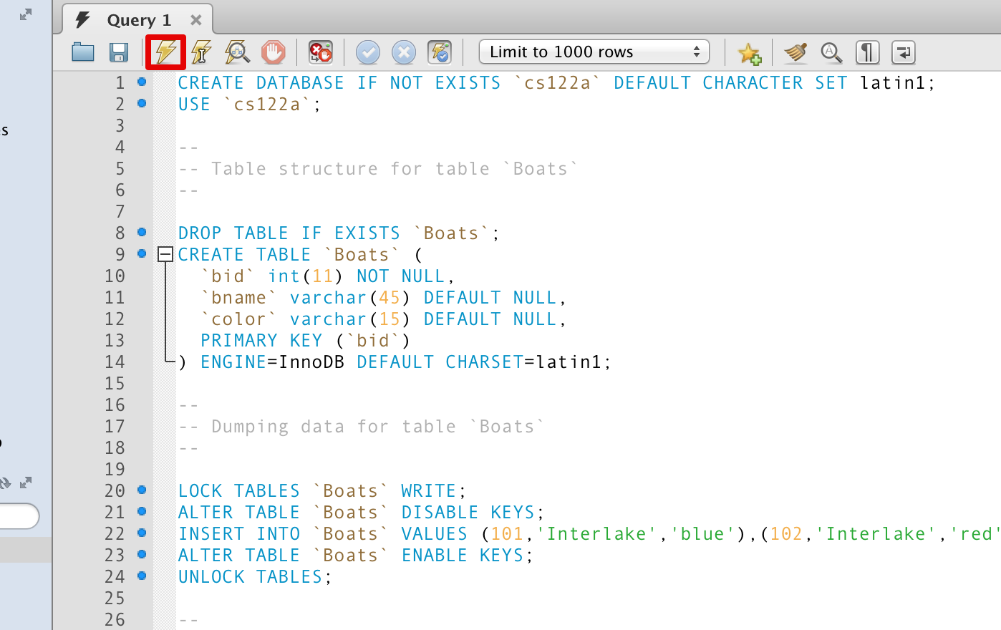

2. In the left pane, click “Refresh” button and you will see the “cs122a” schema and its Tables.

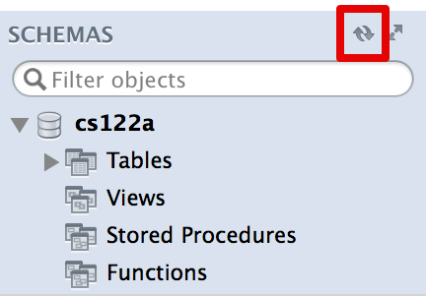

**Step4- SQL queries**

1. In order to form queries, type in the query in the ‘Query’ tab and click on the thunder shaped icon. You can execute the following query by choosing “File” -> “New Query Tab”, type “SELECT * FROM cs122a.Boats;”, and then click on the thunder shaped icon. You will see your results in the box below.

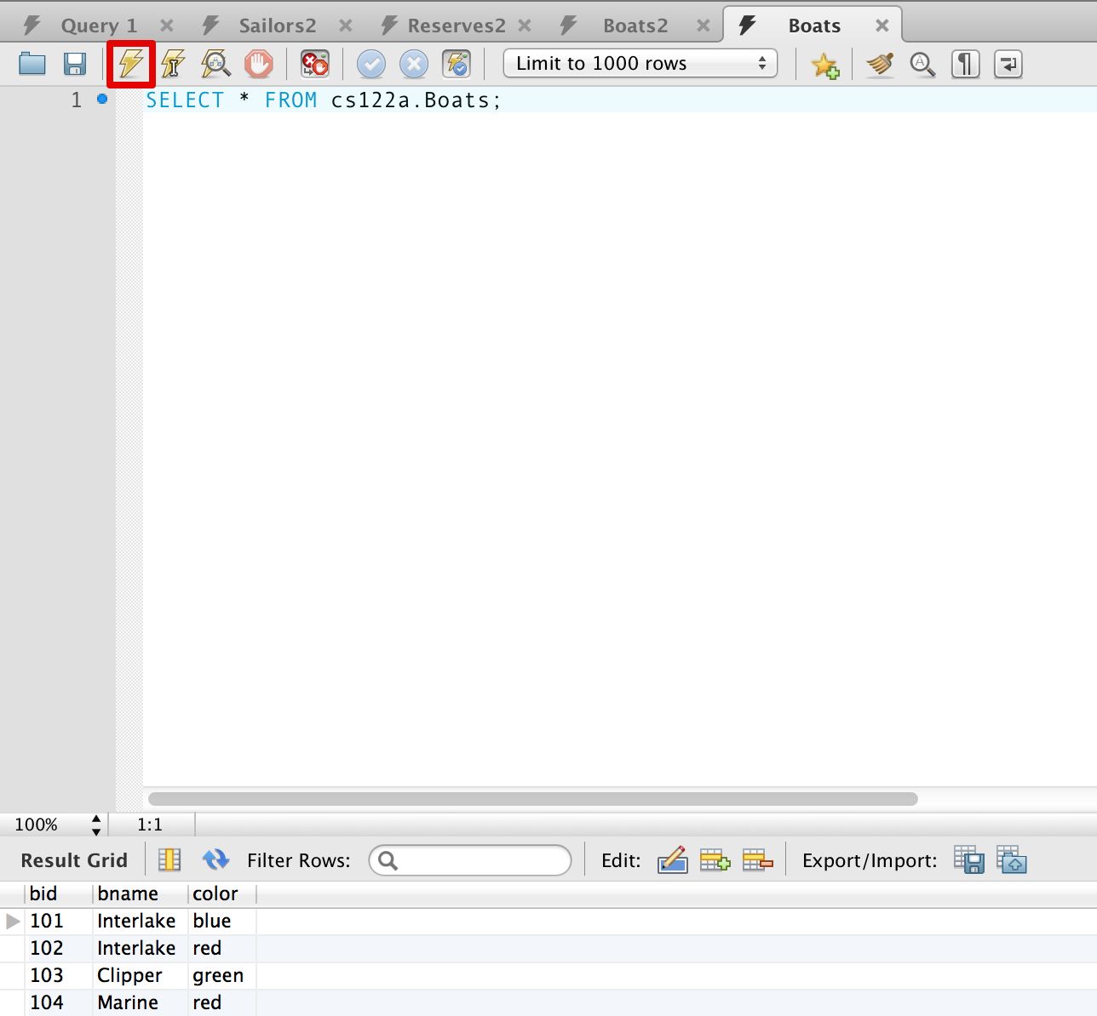

2. You can export the result into a CSV file by clicking “Export” button.

