**University Database**

Group:

Benjamin Evans, Abraham Ponce

**Project Description**

Design and implement a university database from a set of requirements.

**Design**

First we created an ER Diagram.

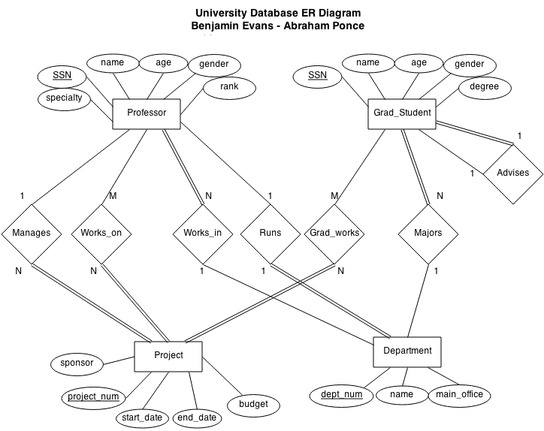

(In the diagram we assume that a professor can run more than one department and that student advisers only advise one graduate student since neither was specified in the requirements)

**Tables**

We then translated the diagram into tables and created SQL statements for them.

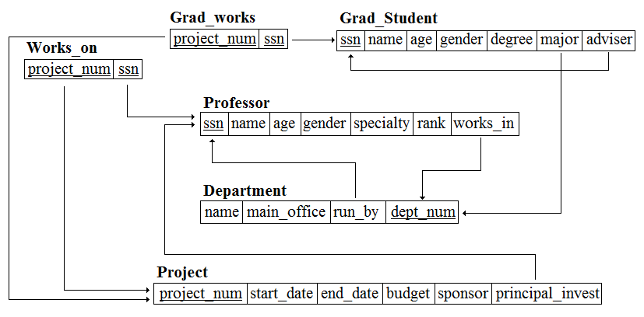

drop table if exists Grad_Student Cascade;

drop table if exists Project Cascade;

drop table if exists Professor Cascade;

drop table if exists Department Cascade;

drop table if exists Grad_works Cascade;

drop table if exists Works_on Cascade;

CREATE TABLE Grad_Student(

ssn Integer primary key,

name varchar(32) Not Null,

age Integer Not Null,

gender char(1) Not Null,

degree varchar(32) Not Null,

adviser Integer Null Unique,

major Integer Not Null

);

INSERT INTO Grad_Student values(111, 'Seth', 21, 'M', 'M.S.', null, 100);

INSERT INTO Grad_Student values(222, 'Beth', 21, 'M', 'Ph.D', null, 300);

INSERT INTO Grad_Student values(333, 'Tom', 21, 'M', 'Ph.D', 222, 300);

INSERT INTO Grad_Student values(444, 'Pam', 21, 'M', 'M.S.', 111, 100);

INSERT INTO Grad_Student values(555, 'Mike', 21, 'M', 'M.S.', null, 100);

INSERT INTO Grad_Student values(666, 'Jann', 21, 'M', 'Ph.D', null, 200);

INSERT INTO Grad_Student values(777, 'Jim', 21, 'M', 'M.S.', 555, 100);

INSERT INTO Grad_Student values(888, 'Tim', 21, 'M', 'Ph.D', 666, 200);

CREATE TABLE Project(

project_num Integer Primary key,

start_date Date Not Null,

end_date Date Not Null,

budget Integer Not Null,

sponsor varchar(32) Not Null,

principal_invest integer Not NULL

);

INSERT INTO Project values(10, '2014-01-25', '2014-04-25', 3000, 'NASA', 123);

INSERT INTO Project values(20, '2014-05-01', '2014-06-01', 4000, 'CCP', 456);

INSERT INTO Project values(30, '2014-10-30', '2014-11-30', 5000, 'NSA', 654);

INSERT INTO Project values(40, '2013-09-30', '2013-12-15', 6000, 'SpaceX', 321);

CREATE TABLE Professor(

ssn Integer Primary key,

name varchar(32) Not Null,

specialty varchar(32),

rank varchar(32),

age Integer Not Null,

gender char(1) Not Null,

works_in Integer Not Null

);

INSERT INTO Professor values(123, 'Bill', 'A.I.', 'Rank 1', 55, 'M', 100);

INSERT INTO Professor values(321, 'Jill', 'Database', 'Rank 2', 57, 'F', 100);

INSERT INTO Professor values(789, 'Paul', 'Compilers', 'Rank 2', 42, 'M', 100);

INSERT INTO Professor values(456, 'Kate', 'English', 'Rank 1', 51, 'F', 200);

INSERT INTO Professor values(890, 'Jeff', 'English', 'Rank 2', 62, 'M', 200);

INSERT INTO Professor values(654, 'Lisa', 'History', 'Rank 1', 45, 'F', 300);

INSERT INTO Professor values(198, 'John', 'History', 'Rank 2', 39, 'M', 300);

INSERT INTO professor values(190, 'Juan', 'Embedded', 'Rank 2', 59, 'M', 100);

INSERT INTO professor values(291, 'Jane', 'Algorithms', 'Rank 3', 44, 'F', 100);

INSERT INTO professor values(374, 'Lane', 'History', 'Rank 3', 37, 'M', 200);

INSERT INTO professor values(697, 'Anne', 'English', 'Rank 2', 63, 'F', 200);

INSERT INTO professor values(156, 'Dave', 'History', 'Rank 2', 41, 'M', 300);

INSERT INTO professor values(784, 'Katy', 'English', 'Rank 3', 33, 'F', 300);

CREATE TABLE Department(

dept_num Integer primary key,

name varchar(32) Not Null,

main_office varchar(32) Not Null,

run_by integer Not Null

);

INSERT INTO Department values(100, 'Computer Science', 'Office 1', 123);

INSERT INTO Department values(200, 'History', 'Office 2', 654);

INSERT INTO Department values(300, 'English', 'Office 3', 456);

CREATE TABLE Grad_works(

project_num Integer Not Null,

ssn Integer Not Null,

Primary Key(project_num,ssn)

);

CREATE TABLE Works_on(

project_num Integer Not Null,

ssn Integer Not Null,

Primary Key(project_num,ssn)

);

INSERT INTO Grad_works values(10,111);

INSERT INTO Works_on values(10,123);

INSERT INTO Grad_works values(20,222);

INSERT INTO Works_on values(20,456);

INSERT INTO Grad_works values(30,666);

INSERT INTO Works_on values(30,654);

INSERT INTO Grad_works values(40,555);

INSERT INTO Works_on values(40,321);

-- Adding foreign keys

ALTER TABLE Grad_Student

ADD Foreign Key (major) References Department(dept_num) On Delete Restrict ON Update Cascade;

ALTER TABLE Grad_Student

ADD Foreign Key (adviser) References Grad_Student(ssn) ON Delete Restrict ON Update Cascade;

ALTER TABLE Project

ADD Foreign Key (principal_invest) References Professor(ssn) ON Delete Restrict On Update Cascade;

ALTER TABLE Professor

ADD Foreign Key (works_in) References Department(dept_num) ON Delete Restrict ON Update Cascade;

ALTER TABLE Department

ADD Foreign Key (run_by) References Professor(ssn) ON Delete Restrict On Update Cascade;

ALTER TABLE Grad_works

ADD Foreign Key (project_num) References Project(project_num) ON Delete Cascade On Update Cascade;

ALTER TABLE Grad_works

ADD Foreign Key (ssn) References Grad_Student(ssn) ON Delete Cascade On Update Cascade;

ALTER TABLE Works_on

ADD Foreign Key (project_num) References Project(project_num) ON Delete Cascade On Update Cascade;

ALTER TABLE Works_on

ADD Foreign Key (ssn) References Professor(ssn) ON Delete Cascade On Update Cascade;

**Stored Procedures and Triggers**

Next we created two stored procedures and two triggers.

CREATE FUNCTION female_faculty() RETURNS real AS'

DECLARE

count REAL := 0;

total REAL := 0;

BEGIN

SELECT COUNT(gender) INTO count FROM professor WHERE gender=''F'';

SELECT COUNT(*) INTO total FROM professor;

RETURN (count/total) * 100;

END;

' LANGUAGE 'plpgsql';

CREATE OR REPLACE FUNCTION total_people(Integer) RETURNS Integer AS '

DECLARE

project_id ALIAS FOR $1;

total_grad Integer := 0;

total_prof Integer := 0;

PI Integer := 0;

total Integer := 0;

BEGIN

SELECT count(project_num) INTO total_grad FROM Grad_works

WHERE project_num = project_id;

SELECT count(project_num) INTO total_prof FROM Works_on

WHERE project_num = project_id;

total := total_grad + total_prof;

SELECT count(project_num) INTO PI FROM Works_on

WHERE project_num = project_id and ssn=(select ssn from Project where project_num = project_id);

IF PI = 0

THEN

total := total+1;

END IF;

RETURN total;

END;

' LANGUAGE 'plpgsql';

CREATE FUNCTION faculty_restrict() RETURNS trigger AS'

DECLARE

ssncheck INTEGER;

count INTEGER := 0;

row_data works_on%ROWTYPE;

BEGIN

FOR row_data IN SELECT * FROM works_on WHERE project_num = NEW.project_num

LOOP

SELECT ssn into ssncheck FROM professor WHERE SSN=row_data.SSN;

IF FOUND THEN

count := count + 1;

END IF;

END LOOP;

RAISE NOTICE ''Professors working on project is %'', count;

IF count < 4 THEN

IF TG_OP = ''UPDATE''

THEN UPDATE works_on SET project_num = NEW.project_num WHERE ssn=NEW.ssn;

END IF;

ELSE

RAISE EXCEPTION ''Too many professors working on that project.'';

END IF;

RETURN NEW;

END;

' LANGUAGE 'plpgsql';

CREATE TRIGGER faculty_restrict

BEFORE INSERT OR UPDATE ON works_on

FOR EACH ROW EXECUTE PROCEDURE faculty_restrict();

CREATE OR REPLACE FUNCTION student_restrict() RETURNS trigger AS'

DECLARE

total INTEGER := 0;

BEGIN

SELECT count(project_num) INTO total FROM Grad_works

WHERE ssn = NEW.ssn;

IF total > 2 THEN

RAISE EXCEPTION ''Student cannot work on more than 2 projects'';

END IF;

RETURN NEW;

END;

' LANGUAGE 'plpgsql';

CREATE TRIGGER student_restrict

AFTER INSERT ON Grad_works

FOR EACH ROW EXECUTE PROCEDURE student_restrict();

**Member Contribution**

We split the work as best we could. Abraham created the ER diagram and Benjamin helped revise it. Benjamin created the tables and the SQL statements and Abraham helped revise it.

We each created one procedure and one trigger.

We collaborated on the JDBC part of the project.

We believe the contribution to be a 50/50 split between the two group members.

**User Manual**

1. Download the DBPanel.java and JDBCProject.java from CSNS
2. Open your Eclipse Java IDE.
3. Create a new project.

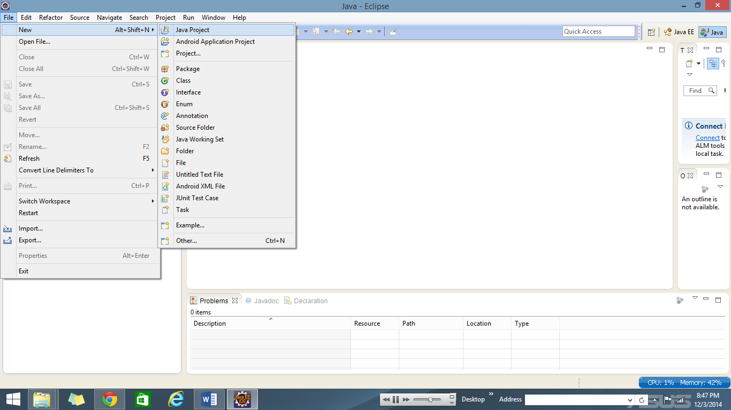

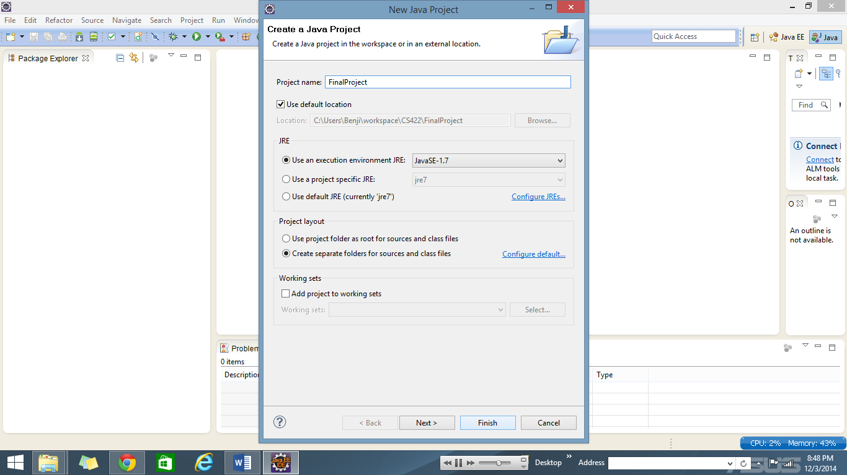

1. Place the DBPanel.java and JDBCProject.java into the src folder

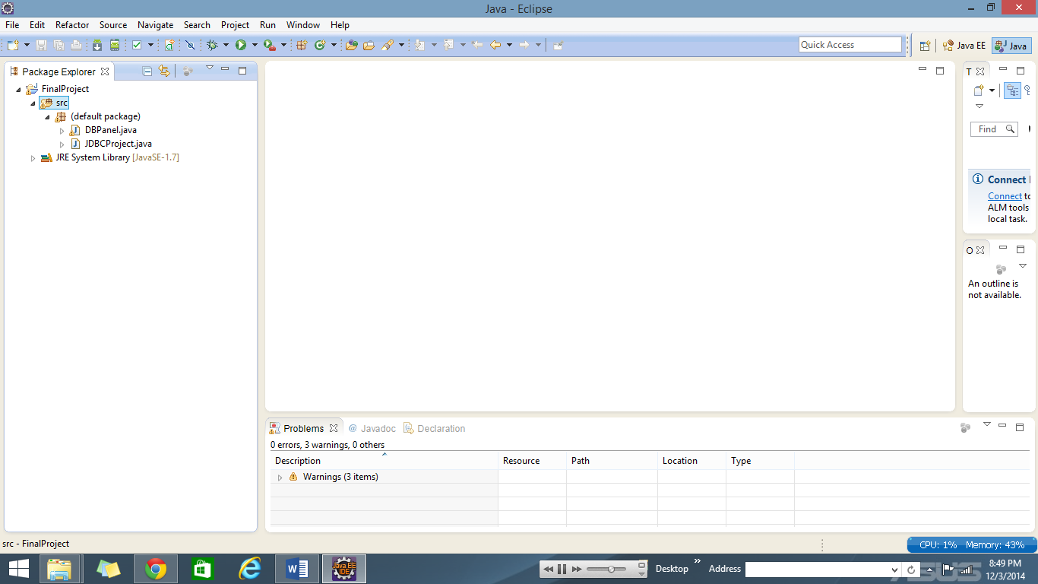

1. Right click the project, hover over build path and select add external archives

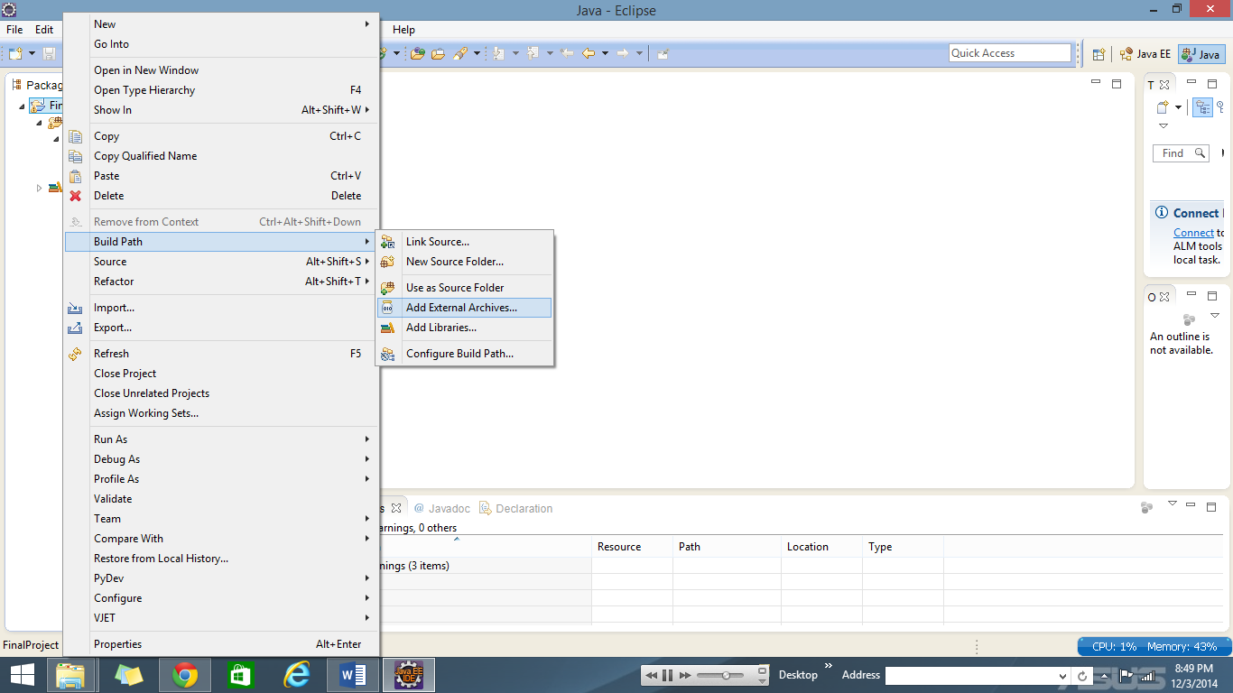

1. Navigate to where the postgresql jdbc jar file is located on your local machine and select it and press ok

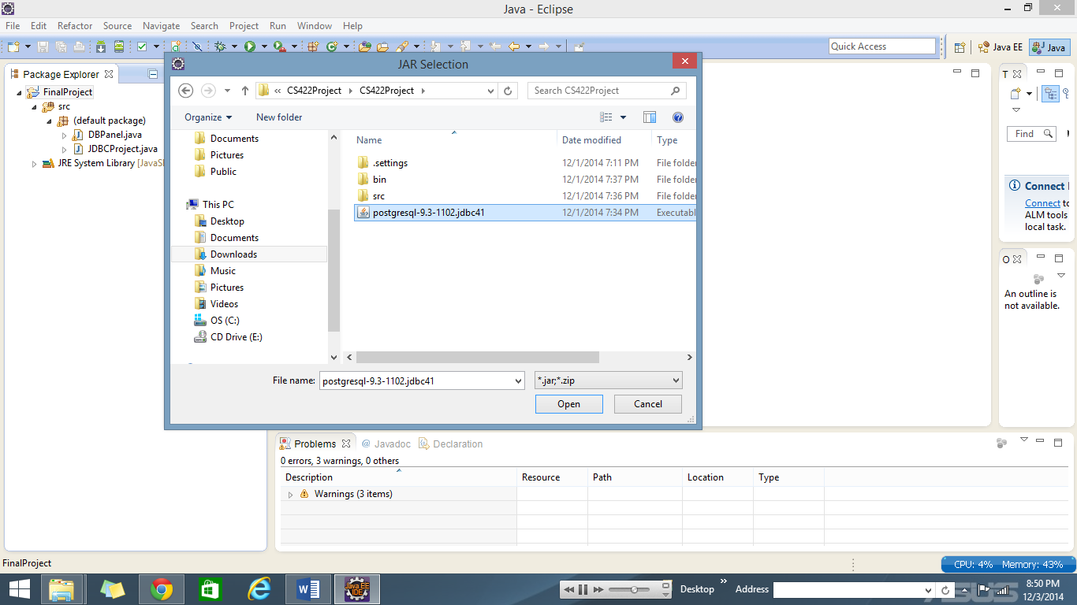

1. In the package explorer right click the JDBCProject.java file hover over run as and select java application

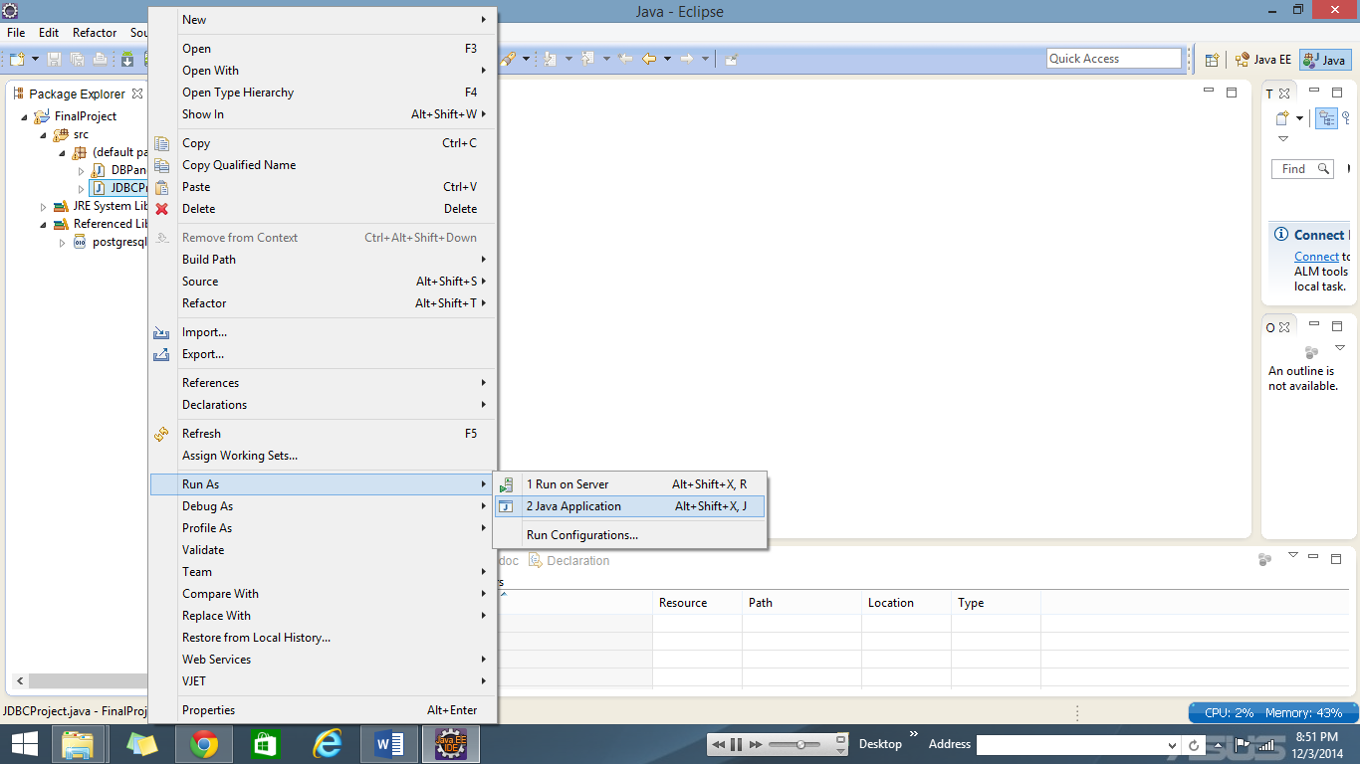

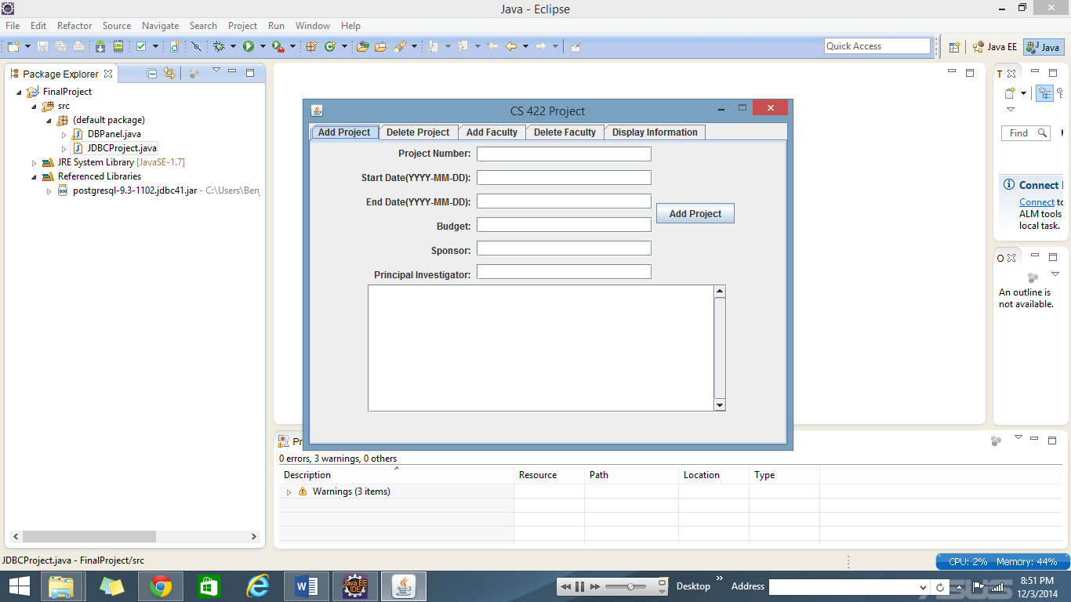

1. To add a project click on the Add Project and fill out each input field. When you have completed all the fields click the Add Project button. The status of your insert will be displayed in the text panel below

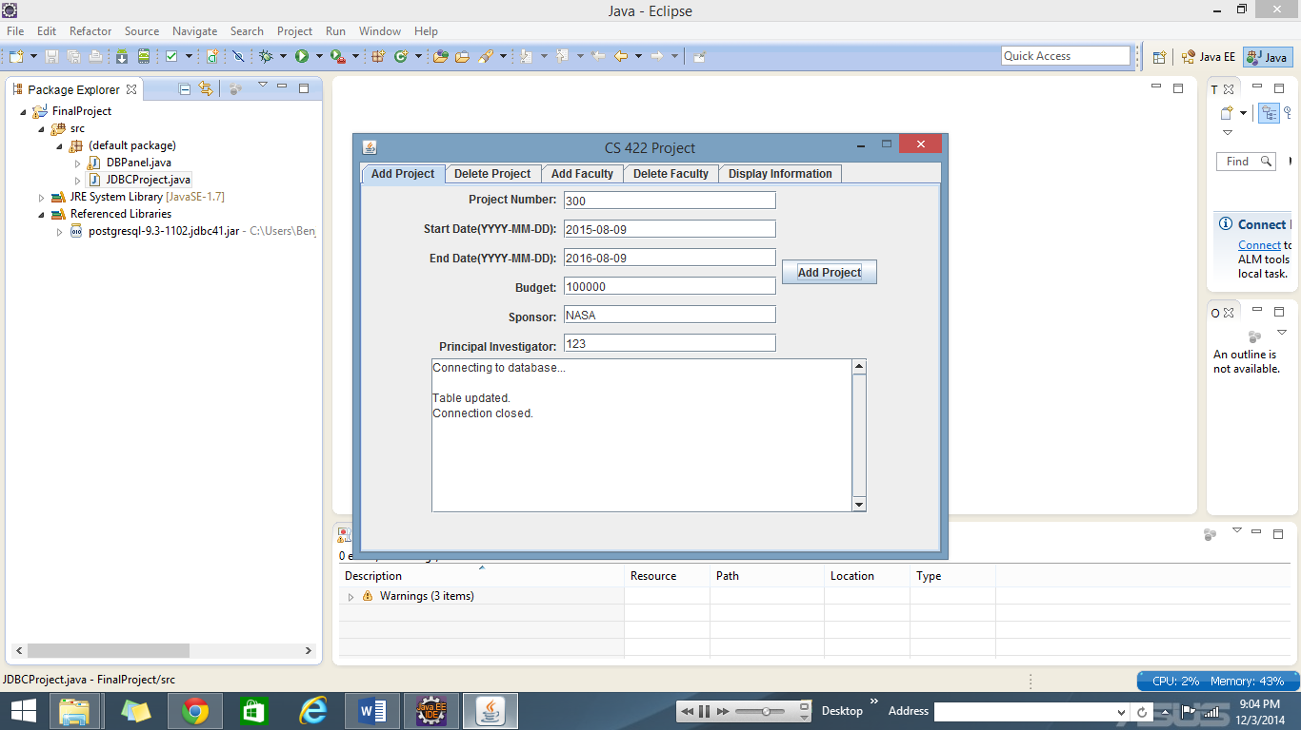

1. To delete a project click the Delete Project tab, enter the Id of the project you wish to delete, and click the Delete Project button. The status of your delete will be displayed in the text panel below.

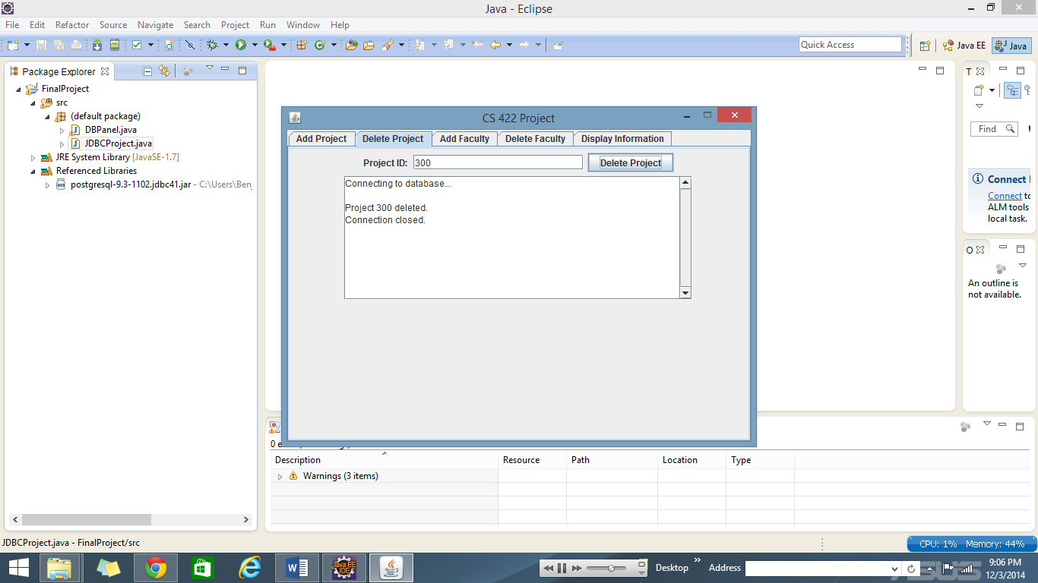

1. To add a Faculty member click the Add Faculty tab, fill out all the input fields and click the Add Faculty button. The status of your insert will be displayed in the text panel below.

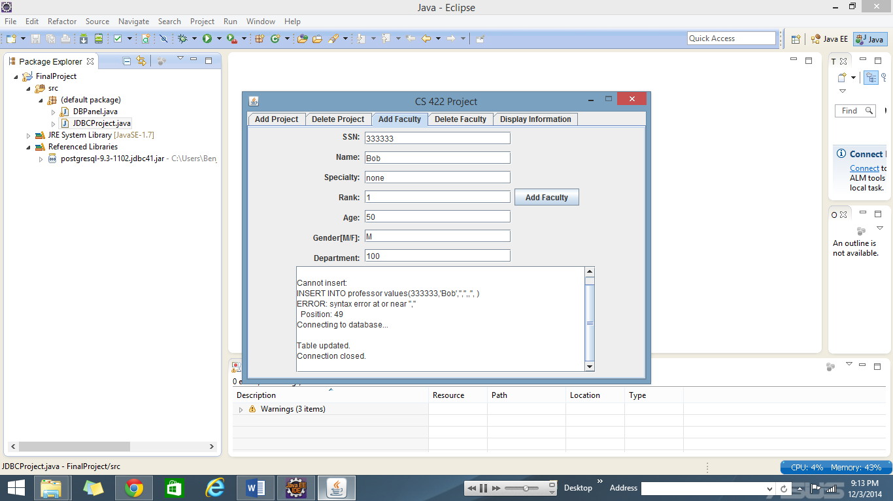

1. To delete a Faculty member click the Delete Faculty tab, fill out all the input fields and click the Delete Faculty button. The status of your delete will be displayed in the text panel below.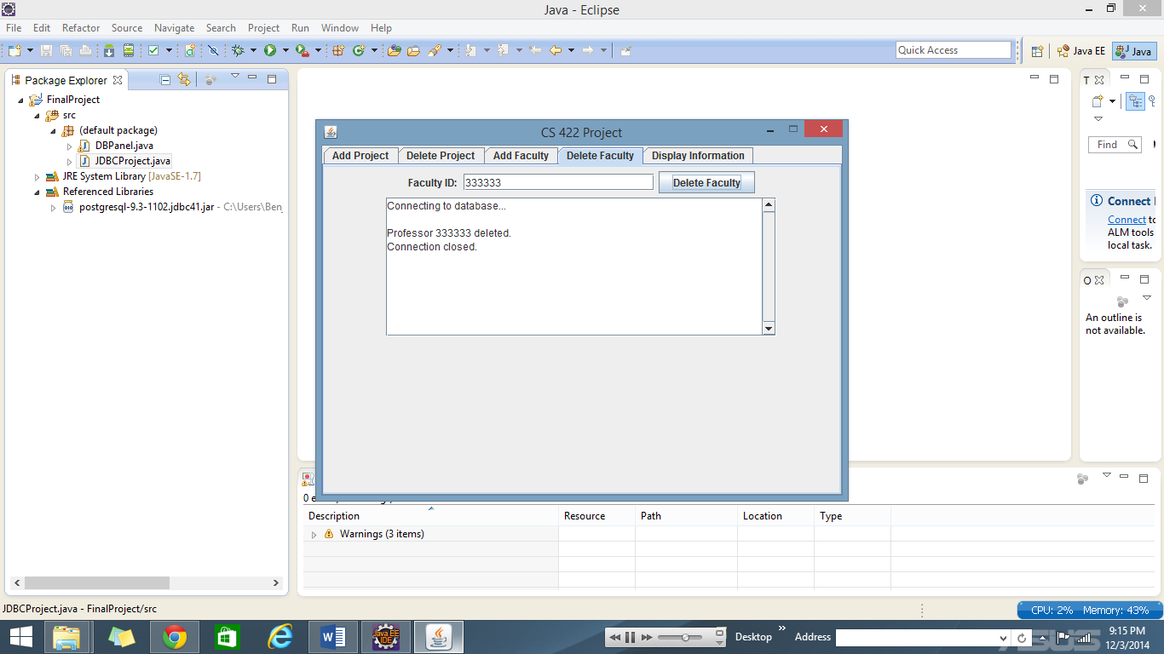
2. To display the data that is in a certain table first click the Display Information tab. Select the table that you wish to view by selecting it in the drop down menu and click the Display button; the data will then be displayed in the text panel below. If you wish to view another table simple click the Clear button (which will clear the results in the text panel) and follow the previous instructions for displaying a table.

