**PROJECT PROPOSAL 1**

**Scrum Board** **Application**

**Scope**

**Project aims to create an interactive scrum or Kanban board to assist software developers plan and manage projects.**

**Features/Requirements**

**-Create a grid representing a scrum board with categories to do, dev, test, release**

**-Create to do list notes that can add tasks with information**

**-Delete to do lists or tasks from the sticky note.**

**-Create drag and drop functionality for the notes to be able to drag them into to different categories.**

**-Create a calendar feature that tracks tasks on different day and can set deadlines.**

**-Add customisable features such as the ability for users to change color and font of sticky notes, text and background.**

**-Create avatars that can be dragged and dropped on the notes to represent which user does which task.**

**-Create name of project**

**-Add team members to project.**

**-Commit button that stores layout in database for each day.**

**-Input of tasks for back log list generation**

**-Input of task to done pile**

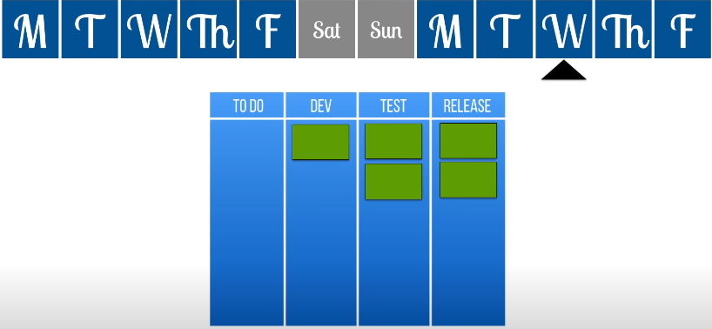

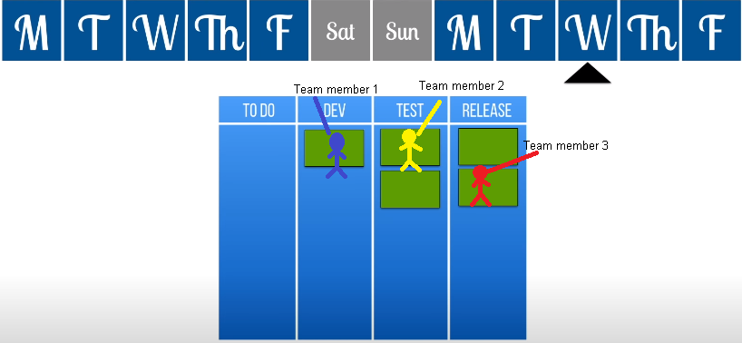

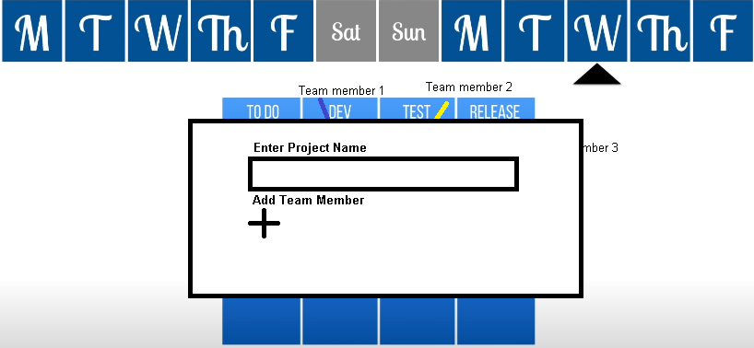

**Tools/Platforms** 

**Javascript**   
**HTML**

**CSS**

**SQL or MongoDB**

**Project Proposal 2**

**VCme (Victorian Curriculum & me), (play on of "VCE")**

**A virtual exam study app where students can meet and prepare for the exam along with other students of the same learning can be promoted via study tools, discussions, help, guides, and free study material.**

**Student Essential Application for year 12's.**

**Able to:**

**-Set up online meetings with other students (due to Coronavirus occurrence) or with teachers in a small group**

**-Search for online resources for particular subjects and study tips from past students**

**-Course List for YR 12**

**-Notice Board from coordinators/teachers in a particular subject**

**-Calendar has pre set dates, (GAT, SACS, EXAMS) pre set by the VTAC and VCAA. This would also include student daily periods, teachers are able to remove classes if they are away. (job/unidays)**

**-ATAR calculator**

**-Student reports and results for sacs and practice exams**

**5 Key Features:**

**Calendar**

**Noticeboard**

**Student**

**Subjects**

**Meetings**