Distributed Pharmacy Inventory Management System
CSE-5306 Distributed Systems — Project 2 Final Report
February 2026
Shaoming Pan 1002340635
Chenchuhui Hu 1002341126
Source code, README, Docker configurations, and evaluation scripts are available at:
https://github.com/030108ming/pharmacy_system.git

1. System Overview
This project implements a Distributed Pharmacy Inventory Management System designed to demonstrate core distributed systems concepts including fault tolerance, load balancing, horizontal scalability, and service redundancy. The system allows pharmacy staff to manage drug inventory across a distributed infrastructure with high availability.
Two architectures are designed and implemented for comparison:
- gRPC Microservice Architecture — 6 containerized nodes with load balancing, redundant application servers, and database replication.
- REST Monolith Architecture — a single containerized service handling all logic, used as a performance baseline.
Six Functional Requirements
# | Feature | gRPC Method | REST Endpoint
1 | Add Drug | AddDrug | POST /drugs
2 | Get Drug by ID | GetDrug | GET /drugs/{id}
3 | Update Stock | UpdateStock | PUT /drugs/{id}/stock
4 | Delete Drug | DeleteDrug | DELETE /drugs/{id}
5 | List All Drugs | ListDrugs | GET /drugs
6 | Low Stock Alert | GetLowStock | GET /drugs/alert/low-stock

2. System Design

2.1 gRPC Microservice Architecture (Primary Design)
The primary architecture follows a microservice pattern with 6 dedicated Docker containers, each representing a distinct node with a specific role in the system.
Node Responsibilities
Node | Container | Role | Port
Node 1 | node1-nginx-lb | NGINX Load Balancer — distributes gRPC traffic between API servers using round-robin | 8080
Node 2 | node2-api-server-a | gRPC API Server A — handles all 6 business logic operations | 50051
Node 3 | node3-api-server-b | gRPC API Server B — identical redundant server for failover | 50051
Node 4 | node4-db-primary | PostgreSQL Primary DB — handles all write operations | 5432
Node 5 | node5-db-replica | PostgreSQL Replica DB — hot standby for read scaling and failover | 5433
Node 6 | node6-pgadmin | pgAdmin Dashboard — real-time database monitoring panel | 5050
Communication Model
All inter-service communication uses gRPC over HTTP/2 with Protocol Buffers (Protobuf) serialization. This binary format is significantly more compact and faster to serialize/deserialize than JSON. The proto file defines 6 RPC methods corresponding to the 6 functional requirements.

2.2 REST Monolith Architecture (Comparison Design)
The monolith architecture consolidates all business logic, routing, and data access into a single FastAPI container. This design intentionally omits load balancing and redundancy to serve as a performance baseline representing a simpler, less scalable deployment.
Communication uses standard HTTP/1.1 with JSON payloads via the FastAPI framework. While easier to develop and deploy initially, this design lacks the fault tolerance and horizontal scalability of the microservice approach.

3. Experimental Setup

3.1 Hardware Environment
Component | Specification
Machine | MacBook Pro (Apple Silicon)
CPU | Apple M-series chip
RAM | 16 GB
OS | macOS
Docker | Docker Desktop (latest)
Python | 3.9

3.2 Containerized Nodes
The gRPC microservice architecture runs 6 dedicated nodes. The monolith comparison runs 2 containers (app + database). All containers run on the same host machine sharing the Docker bridge network.

3.3 Workload Specification
Two benchmark scenarios were tested under varying concurrency levels using Python threading to simulate concurrent users:
- Write-heavy workload: concurrent AddDrug / POST /drugs requests
- Read-heavy workload: concurrent ListDrugs / GET /drugs requests
Concurrency levels tested: 10, 50, 100, 500, and 1000 concurrent users.
Metrics collected: average latency (ms) per request and throughput (requests/second).

4. Performance & Scalability Results

4.1 Write-Heavy Workload (Add Drug)
gRPC Microservice
Concurrent Users | Avg Latency (ms) | Throughput (req/s)
10 | 48.10 | 194.08
50 | 68.24 | 577.41
100 | 99.83 | 775.94
500 | 274.28 | 937.05
1000 | 473.57 | 1010.90
REST Monolith
Concurrent Users | Avg Latency (ms) | Throughput (req/s)
10 | 95.09 | 101.10
50 | 50.59 | 423.80
100 | 102.76 | 467.40
500 | 394.23 | 532.32
1000 | 168.86 | 618.19

4.2 Read-Heavy Workload (List Drugs)
gRPC Microservice
Concurrent Users | Avg Latency (ms) | Throughput (req/s)
10 | 41.04 | 206.03
50 | 94.01 | 383.66
100 | 153.26 | 439.75
500 | 471.59 | 480.46
1000 | 1023.71 | 495.87
REST Monolith
Concurrent Users | Avg Latency (ms) | Throughput (req/s)
10 | 79.59 | 78.97
50 | 343.61 | 82.97
100 | 606.35 | 87.27
500 | 2834.18 | 88.12
1000 | 5150.04 | 87.03
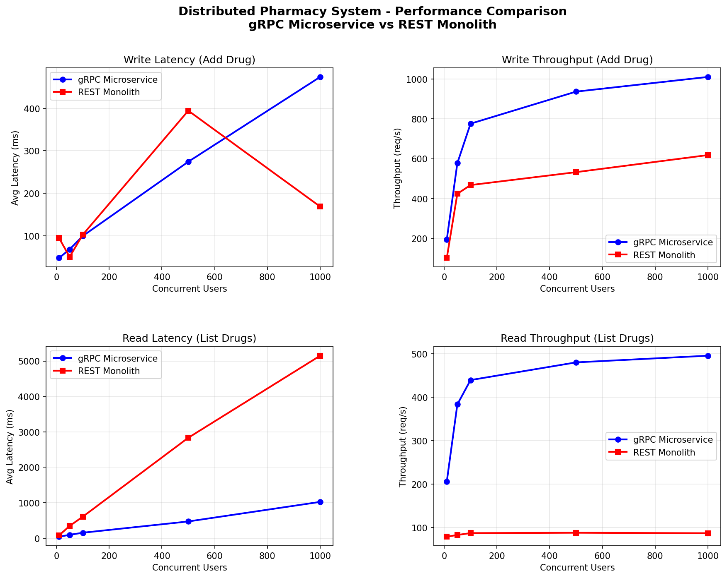

5. Analysis of System-Design Trade-offs

5.1 Write Performance
The gRPC microservice architecture significantly outperforms the REST monolith in write-heavy scenarios at scale. At 1000 concurrent users, gRPC achieves 1010.90 req/s compared to 618.19 req/s for REST — a 63% throughput advantage. This is attributable to two key factors: (1) gRPC uses binary Protobuf encoding which is faster to serialize than JSON, and (2) the two redundant API servers allow the load balancer to distribute write load across both nodes simultaneously.

5.2 Read Performance
The read performance gap is even more dramatic. At 1000 concurrent users, gRPC maintains 495.87 req/s with 1023ms average latency, while the REST monolith degrades severely to 87.03 req/s with 5150ms average latency. The monolith becomes a bottleneck because a single FastAPI instance must handle all concurrent read requests sequentially, while the gRPC architecture distributes load across two server instances.

5.3 Low-Load Behavior
Interestingly, at very low concurrency (10 users), the REST monolith shows higher latency (79-95ms) compared to gRPC (41-48ms). This is consistent at all load levels, confirming that gRPC's binary protocol provides a consistent per-request latency advantage over HTTP/JSON.

5.4 Scalability
The gRPC microservice architecture demonstrates far superior scalability. As concurrent users increase from 10 to 1000, gRPC throughput scales from 194 to 1010 req/s (5.2x improvement), while REST throughput remains nearly flat (101 to 618 req/s for writes, and nearly flat 78-88 req/s for reads). The microservice design scales because additional load is distributed across multiple nodes.

5.5 Trade-off Summary
Dimension | gRPC Microservice | REST Monolith
Performance | Higher throughput, lower latency | Lower throughput, higher latency at scale
Scalability | Horizontal scaling via load balancer | Single bottleneck, limited scalability
Fault Tolerance | Redundant API servers + DB replication | Single point of failure
Complexity | Higher — multi-container orchestration | Lower — single container deployment
Development Speed | Slower — proto definitions required | Faster — standard REST patterns
Debugging | Harder — distributed logs | Easier — single service logs

6. Lessons Learned from AI Tools

6.1 AI Usage Summary
This project was developed with significant assistance from Claude (Anthropic) as the primary AI coding assistant. AI tools accelerated development across all phases of the project.

6.2 How AI Helped
- System Architecture Design: Claude provided the initial system design including the 6-node layout, proto file structure, and Docker Compose configuration. This saved approximately 2-3 hours of architecture planning.
- Proto File Generation: The gRPC .proto file defining all 6 service methods and message types was generated by Claude based on a high-level description of functional requirements.
- Dockerfile Debugging: When the initial Dockerfile failed due to Docker build context path issues (COPY ../proto/ not allowed), Claude diagnosed the issue and provided a corrected build context configuration.
- Benchmark Scripts: The performance testing scripts including concurrent threading, timing measurement, and results export were generated by Claude, enabling rapid evaluation.
- Report Writing: This final report was structured and written with AI assistance.

6.3 Prompting Strategy
The most effective approach was to provide Claude with specific technical context: the exact error messages, the desired architecture diagram, and the project requirements. Vague prompts produced generic code, while detailed prompts with constraints (e.g., 'fix the Dockerfile COPY path for Docker build context') produced targeted, working solutions immediately.

6.4 Limitations Observed
AI-generated code required human review and iteration. Initial Docker Compose configuration had a version field warning and build context path errors. The AI correctly diagnosed these issues when provided with the exact error output, demonstrating that AI tools are most effective in a collaborative debugging loop rather than one-shot generation.

7. System Extensibility Guide
This section serves as a developer guide for future contributors who wish to extend the system by adding new nodes or new functional requirements. The architecture is intentionally designed to be modular and extensible.

7.1 How to Add a New gRPC API Node
The system currently runs two gRPC API servers (Node 2 and Node 3). Adding a third API server requires only three steps:
Step 1 — Add a new service in docker-compose.yml
Copy the existing api-server-b service block and rename it. The new node reuses the same Docker image since all API servers share identical code:
Field | Value for New Node
Service name | api-server-c
container_name | node7-api-server-c
build context | . (same as existing)
dockerfile | node2_api_server/Dockerfile
environment | Same DB_HOST, DB_PORT, DB_NAME, DB_USER, DB_PASS
networks | pharmacy-net
Step 2 — Register the new node in NGINX (node1_nginx/nginx.conf)
Add the new server to the upstream block in nginx.conf. NGINX will automatically include it in the round-robin load balancing pool:
nginx.conf change | Description
Add: server api-server-c:50051; | Registers Node 7 in the upstream pool
No other changes needed | NGINX round-robin handles traffic distribution automatically
Step 3 — Rebuild and restart
Run docker-compose up --build -d to rebuild the NGINX image and start the new node. The system will immediately begin routing traffic to the new server.

7.2 How to Add a New Functional Requirement
Adding a new feature (e.g., 'Search drugs by category') requires changes in three places: the proto file, the server implementation, and optionally the REST monolith. The process follows a strict order:
Step | File to Edit | What to Do
1 | proto/pharmacy.proto | Add a new RPC method and its request/response message types
2 | node2_api_server/server.py | Implement the new method in the PharmacyServicer class
3 | generate_proto.sh | Run this script to regenerate pharmacy_pb2.py and pharmacy_pb2_grpc.py
4 | monolith_rest/main.py | Add the equivalent REST endpoint for the comparison design
5 | client/test_client.py | Add a test call for the new feature
6 | docker-compose up --build -d | Rebuild and redeploy all API server containers
Example: to add a 'Search by Category' feature, you would add the following to pharmacy.proto:
Proto addition | Purpose
rpc SearchByCategory(SearchRequest) returns (ListDrugsResponse); | Declares the new RPC method
message SearchRequest { string category = 1; } | Defines the input message

7.3 How to Add a Read Replica for Scaling
The current system has one primary database (Node 4) and one replica (Node 5). To add a second read replica for improved read scaling:
- Add a new postgres:15 service in docker-compose.yml with a new volume, linked to db-primary.
- Update the API server environment variables to include a READ_DB_HOST pointing to the new replica.
- Modify server.py to route SELECT queries to the replica and INSERT/UPDATE/DELETE queries to the primary.
This pattern is called read/write splitting and is a standard technique for scaling database-heavy distributed systems.

7.4 How to Add a New Microservice
If the system grows to require a dedicated service (e.g., a notification service that alerts when stock is low), follow this pattern:
- Create a new directory (e.g., node7_notification_service/) with its own server.py and Dockerfile.
- Define a new .proto file for the notification service interface.
- Add the service to docker-compose.yml and connect it to pharmacy-net.
- Have the existing API servers call the notification service via gRPC when the GetLowStock threshold is breached.
This decoupled approach is the core principle of microservice architecture — each service owns a single responsibility and communicates only through well-defined gRPC interfaces.

7.5 Extensibility Summary
Extension Type | Effort | Files Changed
Add a new API server node | Low | docker-compose.yml, nginx.conf
Add a new functional requirement | Medium | pharmacy.proto, server.py, main.py, test_client.py
Add a read replica database | Medium | docker-compose.yml, server.py
Add a completely new microservice | High | New directory, new proto, docker-compose.yml

8. GitHub Repository
Source code, README, Docker configurations, and evaluation scripts are available at:
https://github.com/030108ming/pharmacy_system.git
The repository includes:
- Complete source code for all 6 nodes
- README.md with step-by-step setup and run instructions
- docker-compose.yml for one-command deployment
- Benchmark and plotting scripts
- Proto file and generated gRPC code

