**Name : AJIBODE BENJAMIN AANUOLUWAPO**

**Course code: com 316**

**Course title: introduction to c#**

**Solution**

1. Question1

using System;

namespace App

{

class Ordering

{

static void Main(string[] args)

{

Console.Write("Enter the 1st number: ");

int number1 = int.Parse(Console.ReadLine());

Console.Write("Enter the 2nd number: ");

int number2 = int.Parse(Console.ReadLine());

Console.Write("Enter the 3rd number: ");

int number3 = int.Parse(Console.ReadLine());

int min = Math.Min(Math.Min(number1, number2), number3);

int max = Math.Max(Math.Max(number1, number2), number3);

int middle = (number1 + number2 + number3) - min - max;

Console.WriteLine("Numbers in ascend order:" + min+ ", " + middle+ ", " + max);

}

}

}

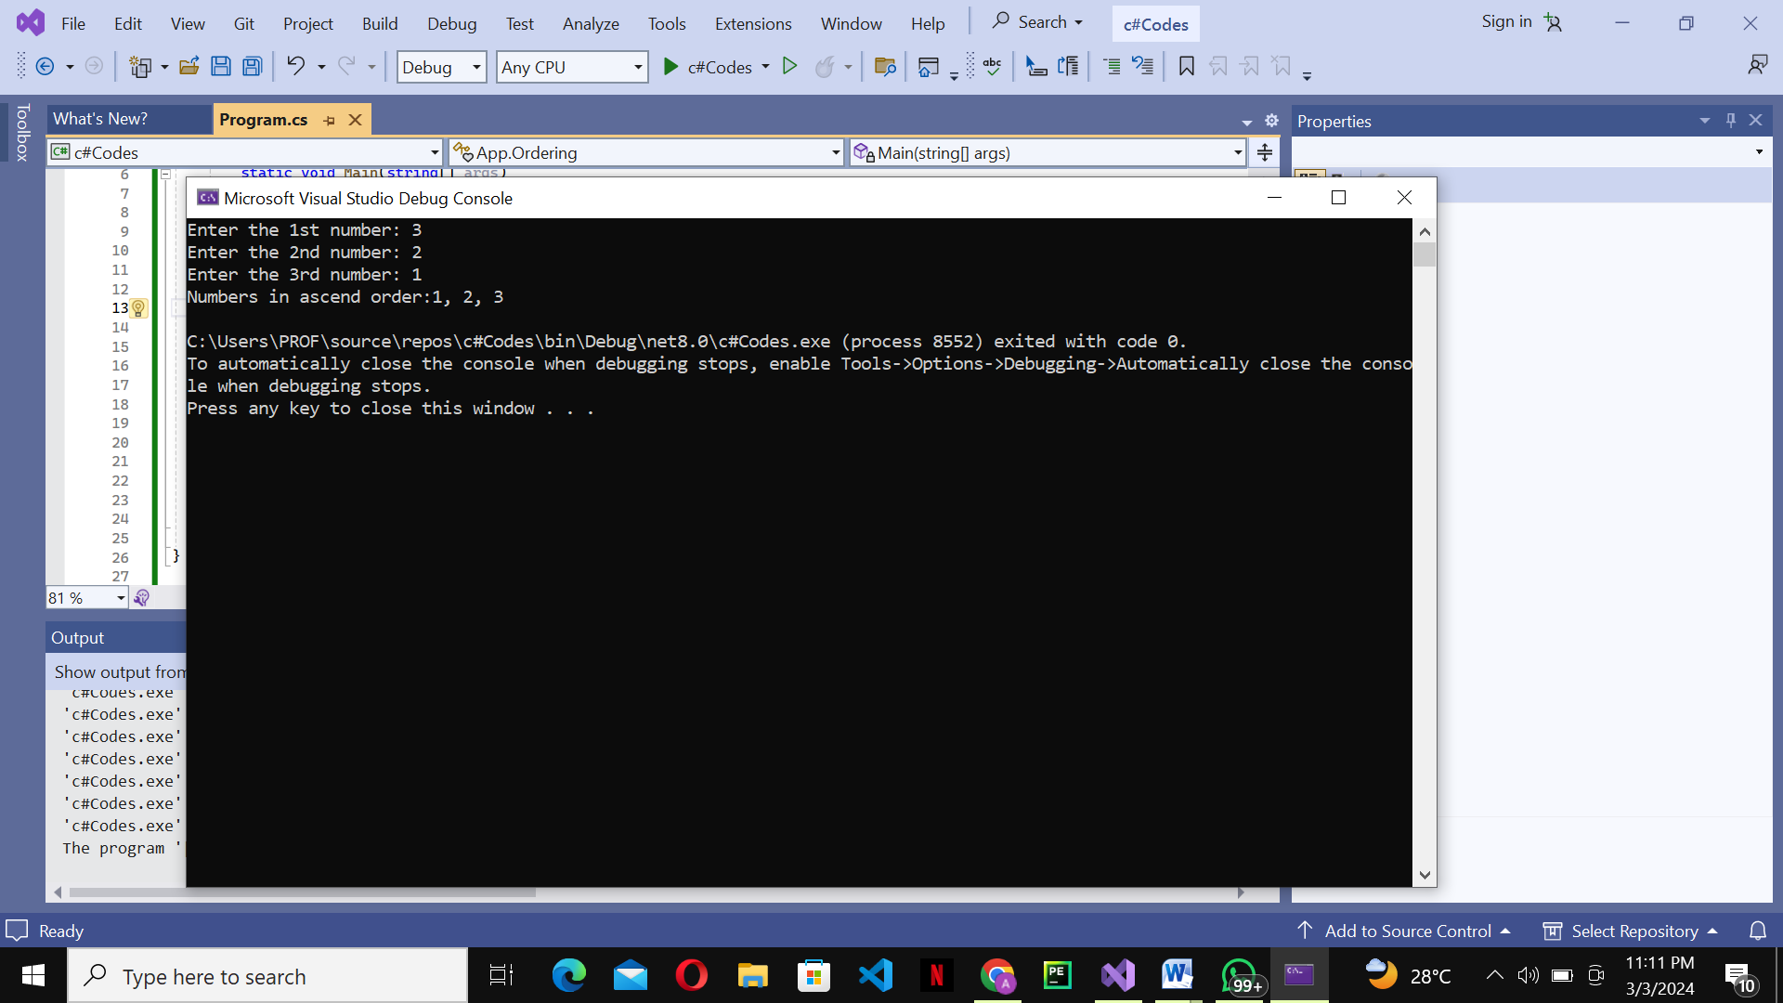

1. Question 2   
   using System;

namespace Testing

{

class CheckIt

{

static void Main(string[] args)

{

int[] array = { 1, 3, 54, 13, 42 };

int size = array.Length;

int index = smallestIndex(array, size);

if (index != -1)

{

Console.WriteLine("The smallest element is at index: " + index);

}

else

{

Console.WriteLine("Array is empty or size is invalid.");

}

}

static int smallestIndex(int[] array, int size)

{

if (size <= 0)

{

return -1;

}

int minIndex = 0;

for (int i = 1; i < size; i++)

{

if (array[i] < array[minIndex])

{

minIndex = i;

}

}

return minIndex;

}

}

}

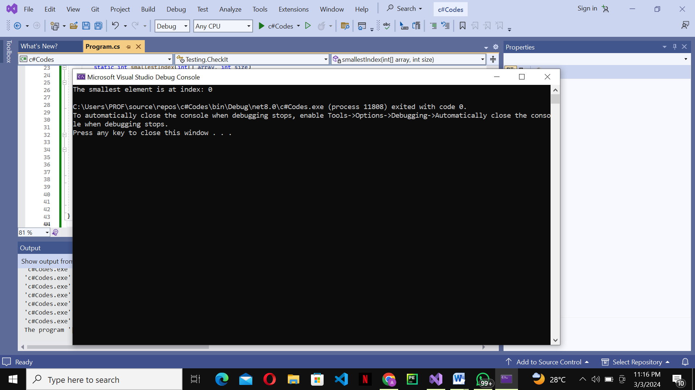

1. Question 3   
   using System;

namespace Upper

{

class UpCase

{

public static void Main(string[] args)

{

Console.WriteLine("please input a string");

string input=Console.ReadLine();

char[] arr = input.ToCharArray();

for(int i=0; i<arr.Length; i++)

{

arr[i] = char.ToUpper(arr[i]);

Console.Write(arr[i]);

}

}

}

}

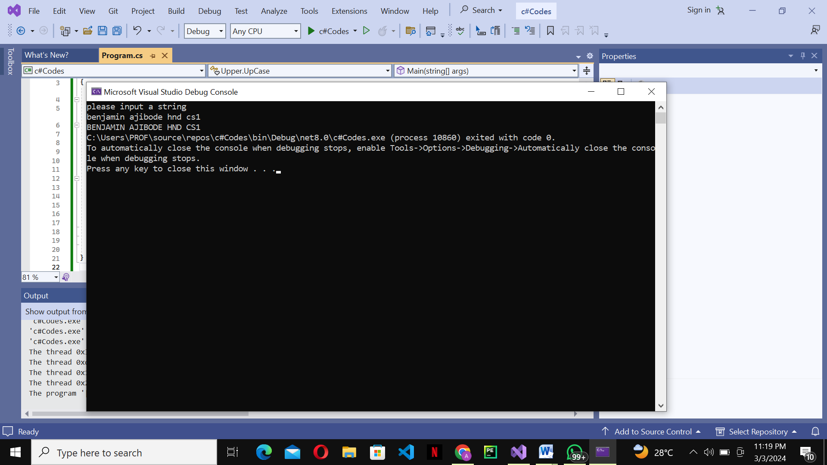

1. Question 4   
   using System;

namespace Matric

{

class Matrics

{

static void Main(string[] args)

{

Console.Write("Number of rows (N): ");

int N = int.Parse(Console.ReadLine());

Console.Write("Number of columns (M): ");

int M = int.Parse(Console.ReadLine());

int[,] matrix1 = new int[N, M];

int[,] matrix2 = new int[N, M];

Console.WriteLine("Enter elements for the first matrix:");

ReadMatrix(matrix1);

Console.WriteLine("Enter elements for the second matrix:");

ReadMatrix(matrix2);

int[,] result = AddMatrices(matrix1, matrix2);

Console.WriteLine("Result Matrix:");

PrintMatrix(result);

}

static void ReadMatrix(int[,] matrix)

{

for (int i = 0; i < matrix.GetLength(0); i++)

{

for (int j = 0; j < matrix.GetLength(1); j++)

{

Console.Write("Enter element at position [{0}, {1}]: ", i, j);

matrix[i, j] = int.Parse(Console.ReadLine());

}

}

}

static int[,] AddMatrices(int[,] matrix1, int[,] matrix2)

{

int[,] result = new int[matrix1.GetLength(0), matrix1.GetLength(1)];

for (int i = 0; i < matrix1.GetLength(0); i++)

{

for (int j = 0; j < matrix1.GetLength(1); j++)

{

result[i, j] = matrix1[i, j] + matrix2[i, j];

}

}

return result;

}

static void PrintMatrix(int[,] matrix)

{

for (int i = 0; i < matrix.GetLength(0); i++)

{

for (int j = 0; j < matrix.GetLength(1); j++)

{

Console.Write(matrix[i, j] + " ");

}

Console.WriteLine();

}

}

}

}

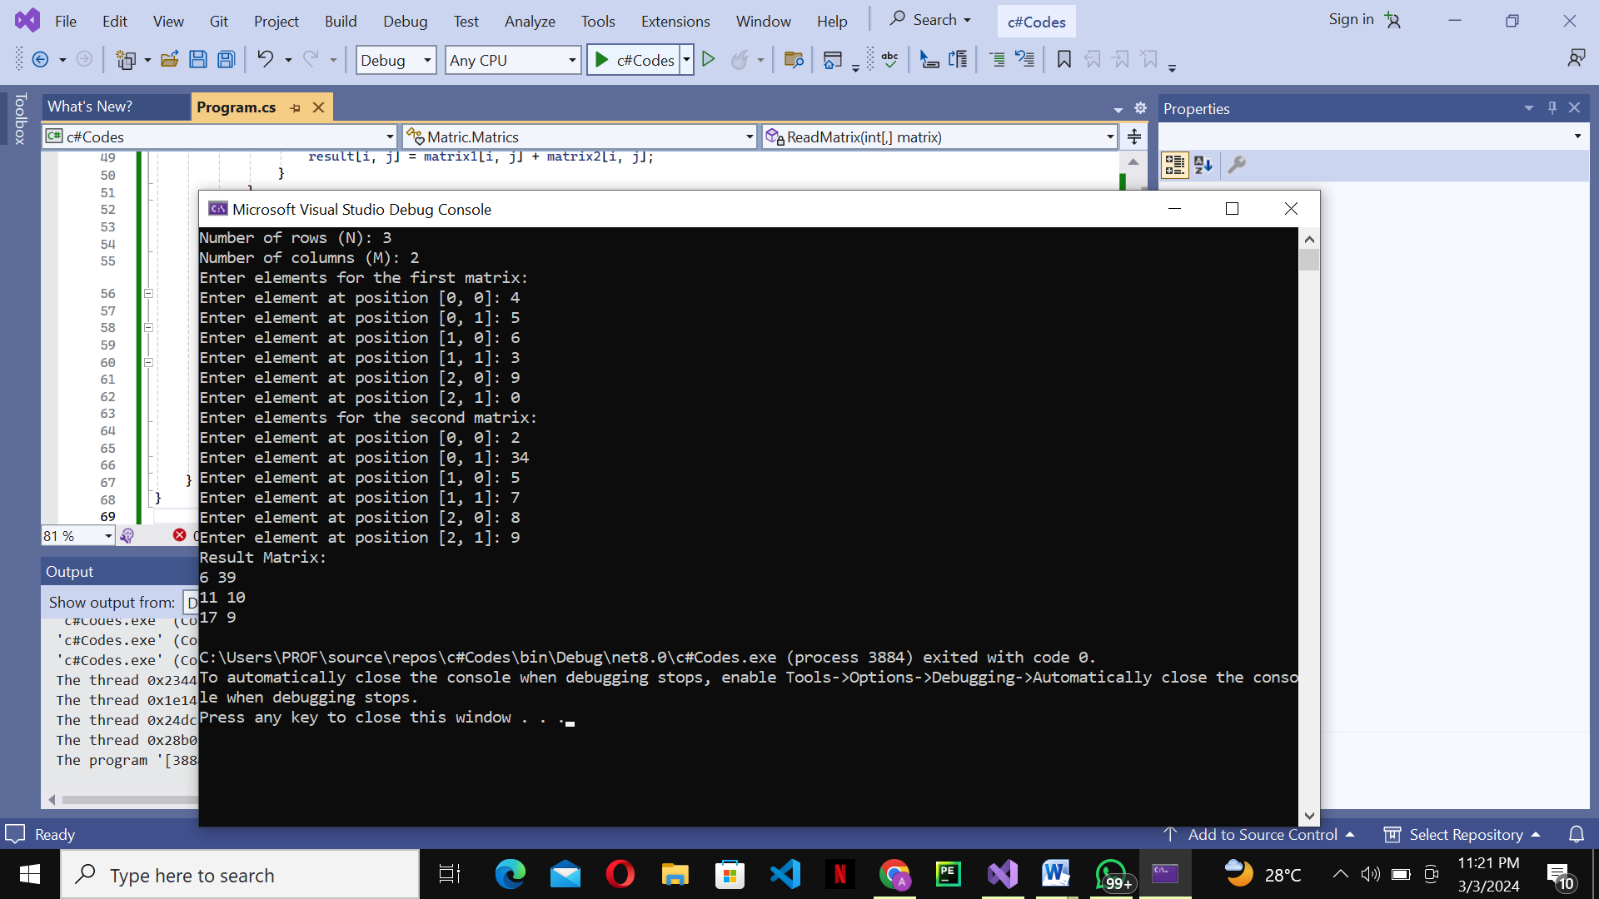

1. Question 5   
   using System;

namespace Array {

class Arr

{

static void Main(string[] args)

{

float[] alpha = new float[50];

for (int i = 0; i < 25; i++)

{

alpha[i] = i * i;

}

for (int i = 25; i < 50; i++)

{

alpha[i] = 3 * i;

}

Console.WriteLine("the Array elements:");

for (int i = 0; i < alpha.Length; i++)

{

Console.Write(alpha[i] + "\t");

if ((i + 1) % 10 == 0)

{

Console.WriteLine();

}

}

}

}

}

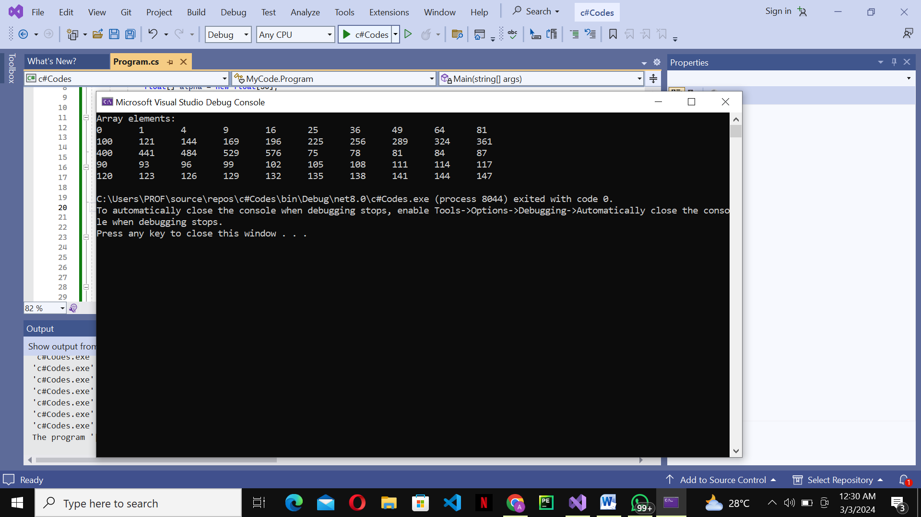

1. Question 6   
     
   using System;

namespace CheckIf

{

class Test

{

public static void Main(string[] args)

{

Console.WriteLine("Enter your value");

int value = int.Parse(Console.ReadLine());

if (value > 0)

{

Console.WriteLine(numb + " is a positive value");

}

else if (value < 0)

{

Console.WriteLine(numb + " is a negative value");

}

else

{

Console.WriteLine(numb + "your value is zero");

}

}

}

}

