**Victoria University UTMS design documentation**

**GROUP MEMBERS**

1. KAVUMA BENJAMIN VU-BIT-2201-0706-DAY
2. KABOYO SHANON VU-BIT-2407-1905-DAY
3. ARINDE JOHN KERRY VU-BIT-2407-1999-DAY
4. NAKAZIBWE SWABULAH VU-BIT-2407-2408-DAY
5. NYANZI ARAFAT BCS-2407-2408-DAY
6. MUKISA ANDREW VU-BIT-2407-1730-DAY

**QUESTION ONE**

**ABSTRACTION**

Used in the user abstract class; interface for transport services to hide the implementation details and showing the essential details

**Encapsulation**

Used in the **private fields** with getter for **driver and user**

**Inheritance**

Used in student, lecturer, transportofficer, extend user

**Polymorphism**

Used in **bus, van implement serviceable, trackable, schedulable**

**Interfaces**

Requesttransport, shows customer user behaviour

**Overriding**

**AssignDriver()overloaded and parameter sets**

**Overloading**

**assignDriver() overloaded by parameter sets**

**Below are the codes used to display the way students, lecturers are transported and the time scheduled its boarded**

**The codes also display the track records and routes the vehicles take**

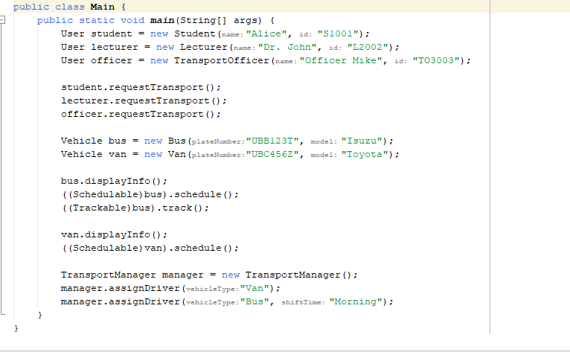

**Below is the display of our codes showing how a student carried her transportation procedure**

