**GROUP MEMBERS**

1. KAVUMA BENJAMIN VU-BIT-2201-0706-DAY
2. KABOYO SHANON VU-BIT-2407-1905-DAY
3. ARINDE JOHN KERRY VU-BIT-2407-1999-DAY
4. NAKAZIBWE SWABULAH VU-BIT-2407-2408-DAY
5. NYANZI ARAFAT BCS-2407-2408-DAY
6. MUKISA ANDREW VU-BIT-2407-1730-DAY

Victoria University’s Faculty of Science and Technology is organizing its first annual Innovation and Technology Exhibition to showcase students’ creativity, research, and technological capabilities. To manage participant registration efficiently and prevent issues such as data loss and duplicate entries, a Java-based desktop application was developed to digitize and automate the registration process.

**Objective of the study**

* Replace manual paper forms and spreadsheets with a reliable software system.
* Ensure fast, secure CRUD operations.
* Integrate with a Microsoft Access database using the UCanAccess JDBC driver.
* Provide a graphical user interface (GUI) for university staff.
* Include project prototype image upload and display functionality.

**PROCESS**

We created an electronic registration form for students to register their names into the school system using java codes

This system replaces error-prone manual registration with a secure, user-friendly Java application, ensuring robust data handling for the Innovation and Technology Exhibition.

Below are some of the codes and the display of the codes

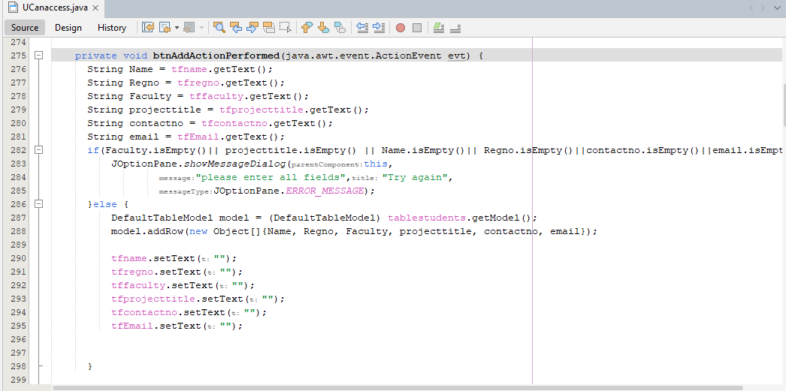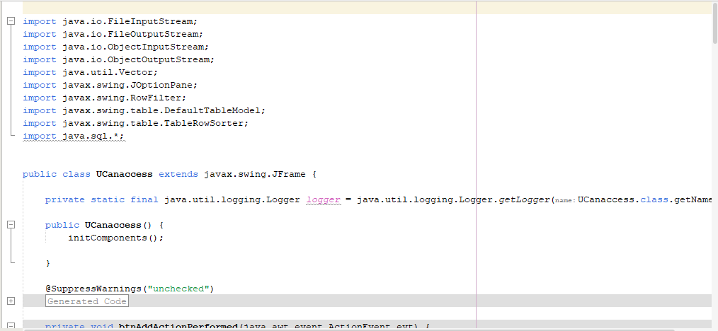

Below is the design layout

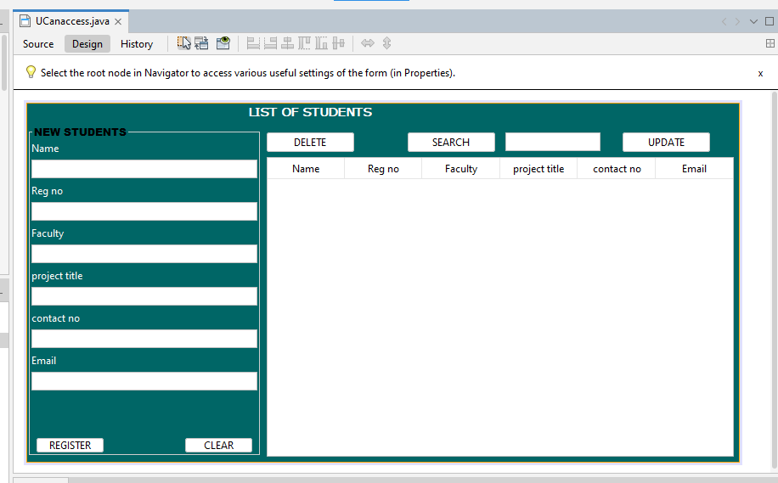

Below is the process of registering and info the fields are not filled in, the message will pop up showing please enter all fields

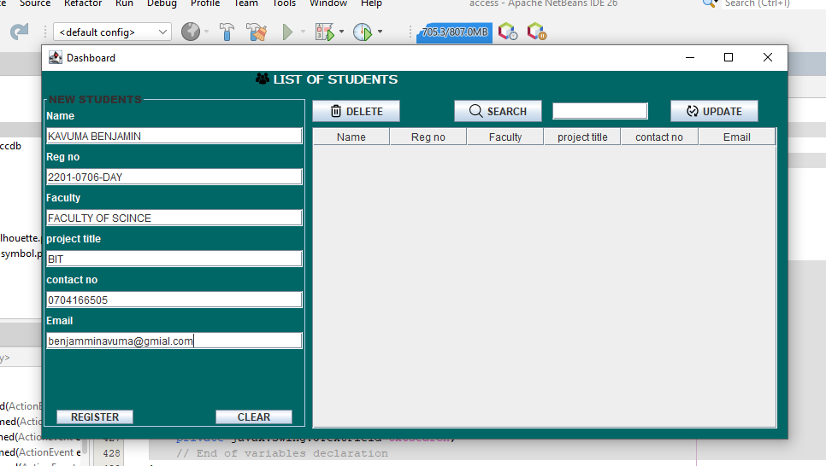

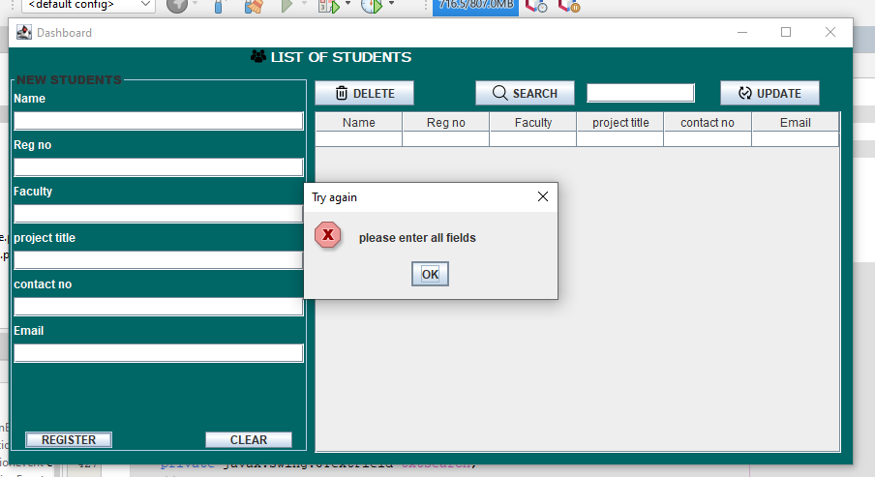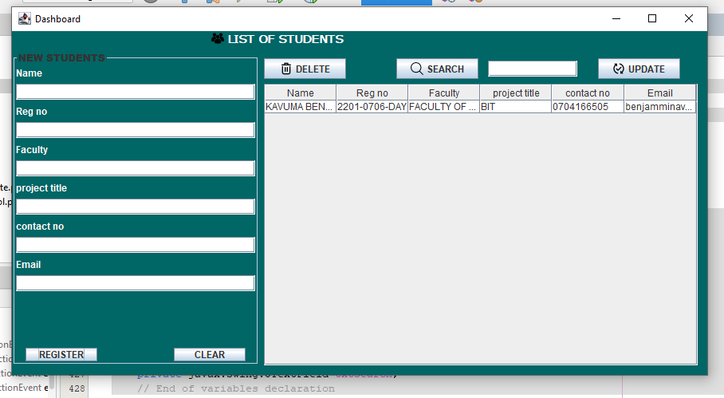

The image shows how the search button functions in the dashboard once a wanted name is typed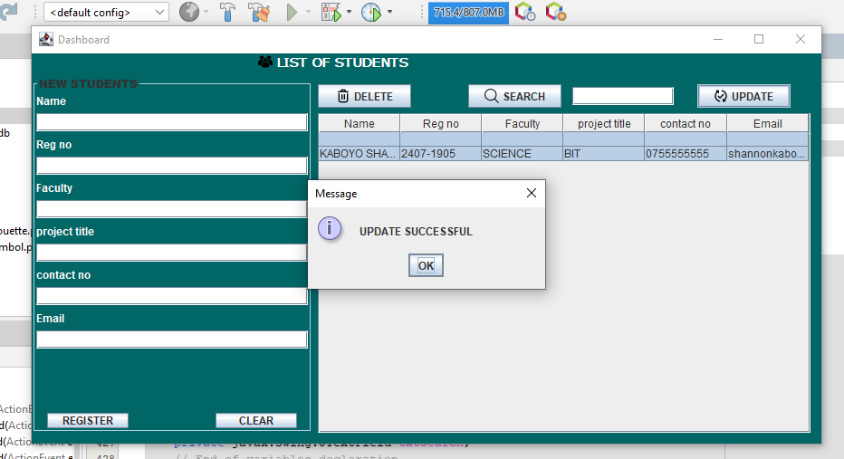

Below shows the update button function

