**Etudiant 1** : Nom : BenKaba Prénom : Marwa

**Rapport RMI:**

**Objectif :**

Développer un service RMI simple permettant d'inverser une chaîne de caractères.

1. **Server** **:**

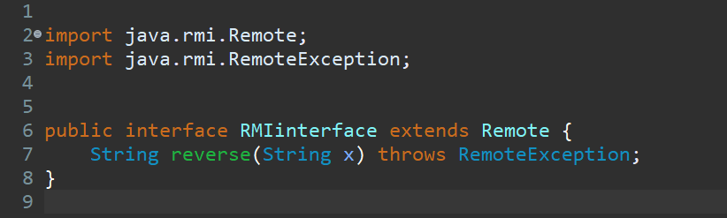**1. Creating the RMI Interface** (Contract between the server and the client) :

Explanation of Code :

1. **import java.rmi.Remote;**: This imports the Remote interface from the java.rmi package. Any interface that is going to be used for RMI communication must extend this interface. This tells Java that the methods in this interface will be invoked remotely.
2. **import java.rmi.RemoteException;**: RemoteException is the exception thrown by RMI methods in case of network failures or other communication problems. By declaring throws RemoteException, you make sure the client can handle this exception.
3. **public interface RMIinterface**: To define the behavior.
4. **String reverse(String x) :** Abstract Method « The reverse method takes a String as input and returns the **reversed version** of that string.».

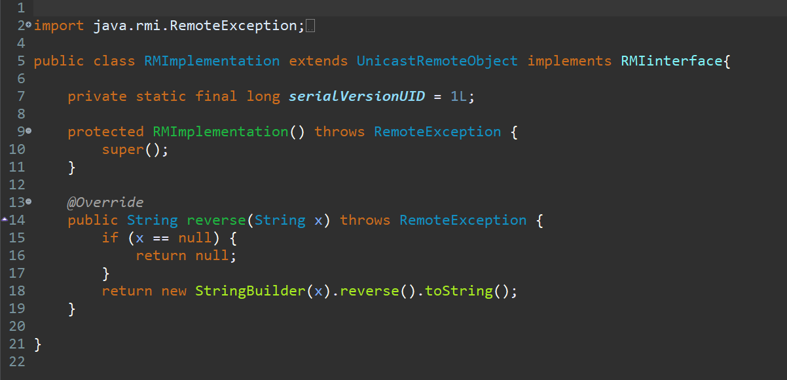**2.** **Class: RMImplementation :**

Explanation of Code :

1. **Extending UnicastRemoteObject:** to enable the object to be

accessed remotely via RMI.

1. **implementing RMIinterface :** todefine the contract of **reverse** method
2. **String reverse(String x) :** If Client input=emptyString : return Null, else return new StringBuilder(x) .reverse().toString()

«method will reverse the clientInput » .

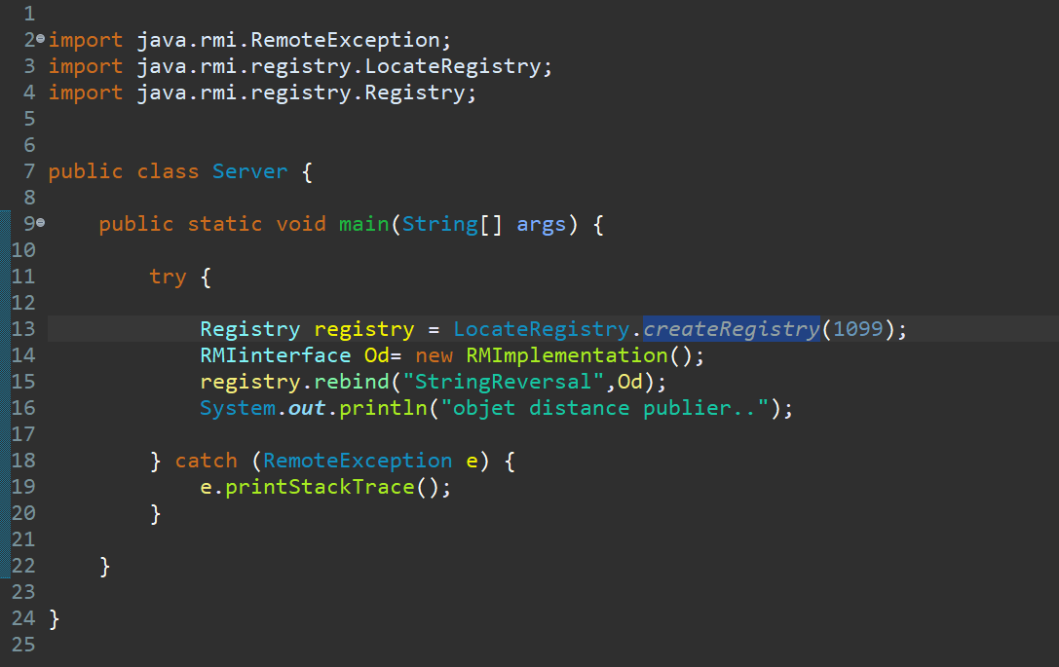**3.Server Class ‘’ mainClass’’ :**

**a. Import the packages**: java.rmi.RemoteException;

java.rmi.registry.LocateRegistry;

java.rmi.registry.Registry;

**b.** **Create the RMI Registry :** The default port for the RMI registry is **1099**, but there was a charge (or issue) with this port. Therefore, I changed it to port 2000, and later returned it to port 1099.

1. 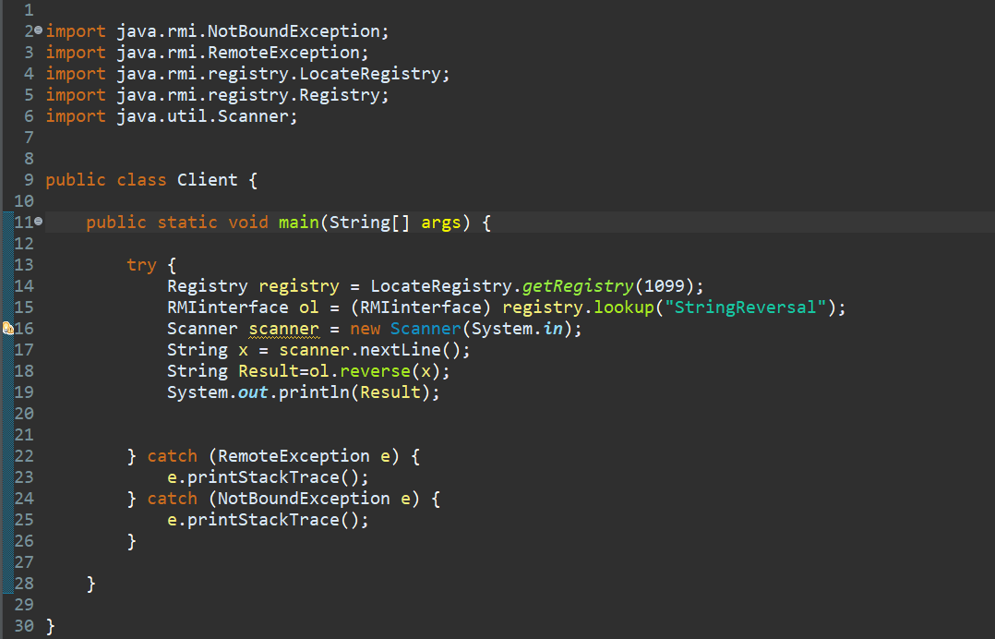**Client :**
2. **Import the packages**: import java.rmi.NotBoundException;

import java.rmi.RemoteException;

import java.rmi.registry.LocateRegistry;

import java.rmi.registry.Registry;

import java.util.Scanner;

1. **NotBoundException:**

catch (NotBoundException e) {

e.printStackTrace();

}